DocChat
Architecture & High-Level Design
A Retrieval-Augmented Generation (RAG) chatbot for PDF documents
Prepared from the project source repository • August 2026

Contents
1. Purpose & Scope
2. System Overview
3. High-Level System Architecture
4. Component Diagram
5. Data Flow — PDF Ingestion & Indexing
6. Sequence Diagram — Ask-a-Question Flow
7. Deployment Diagram
8. Technology Stack
9. Design Notes & Observations

1. Purpose & Scope
This document describes the architecture of DocChat, a single-service Retrieval-Augmented Generation (RAG) chatbot that lets a user upload a PDF and ask natural-language questions about its contents. It is derived directly from the current state of the project's source code, dependency manifest, and deployment configuration (not from the README alone, which describes an earlier design).
The goal is to give a reader unfamiliar with the codebase a clear picture of the moving parts — the UI, the retrieval-augmented pipeline, the data stores, and the external services — and how a request travels through them, without needing to read the source line by line.

2. System Overview
DocChat is a Python / Streamlit web application. It combines three retrieval-augmented generation building blocks into a single process:
- PDF ingestion & structure-aware chunking — extracts text with PyMuPDF and splits it either by detected numbered clauses/“Article N” headings, or by fixed-size windows as a fallback.
- Hybrid retrieval — a ChromaDB vector index (semantic similarity) is combined with a BM25 keyword index via LangChain's EnsembleRetriever, weighted 50/50.
- Grounded generation — retrieved chunks are fed into a cloud LLM (via the OpenRouter API) through a prompt template that constrains the model to answer only from the supplied context and to say so plainly when the answer is not present.
Everything (UI rendering, document processing, retrieval, and orchestration of the LLM call) runs inside one Streamlit process, deployed as a single web service on Render.com. There is no separate backend API, task queue, or database server — persistence is to the local filesystem (ChromaDB directories, a pickled chunk cache, and a JSON chat-history file).

3. High-Level System Architecture
The diagram below shows the application as six horizontal layers, from the user's browser down to the external services it depends on. Arrows show the direction data flows through the stack; the dashed line in layer 4 marks that chunked documents are consumed by both retrievers, not passed sequentially.
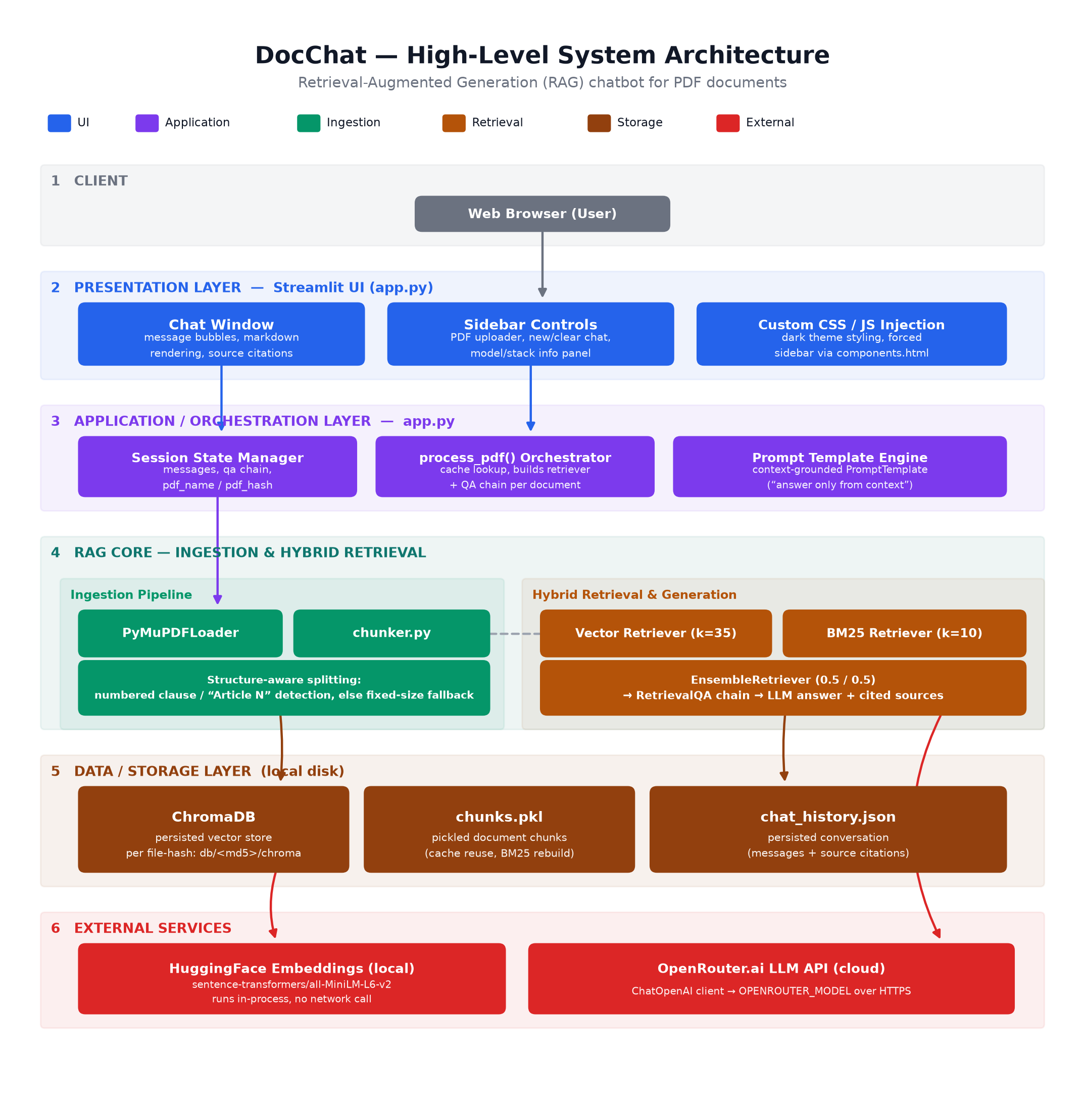
Figure 1 — High-level layered architecture of DocChat.

Layer summary
Layer | Responsibility
1. Client | The end user's web browser; the only external actor that interacts directly with the application.
2. Presentation | Streamlit UI defined in app.py: the chat window, sidebar (PDF upload, new/clear chat, stack info), and injected CSS/JS for the dark theme and forced sidebar.
3. Application / Orchestration | app.py's session-state management, the process_pdf() function that wires up caching and retrievers per document, and the grounded PromptTemplate.
4. RAG Core | Ingestion (PyMuPDFLoader + chunker.py) and hybrid retrieval (Chroma vector search + BM25, merged by EnsembleRetriever) feeding a RetrievalQA chain.
5. Data / Storage | Local disk: a ChromaDB directory and a pickled chunk list per uploaded file (keyed by MD5 hash), plus a single chat_history.json for conversation persistence.
6. External Services | The HuggingFace sentence-transformer embedding model (runs locally, in-process) and the OpenRouter.ai hosted LLM (accessed over HTTPS).

4. Component Diagram
This view maps the layered architecture onto actual files in the repository: which modules are wired into the running app, what they persist to disk, what configures the deployment, and — importantly — which scripts exist in the repo but are not part of the deployed application.
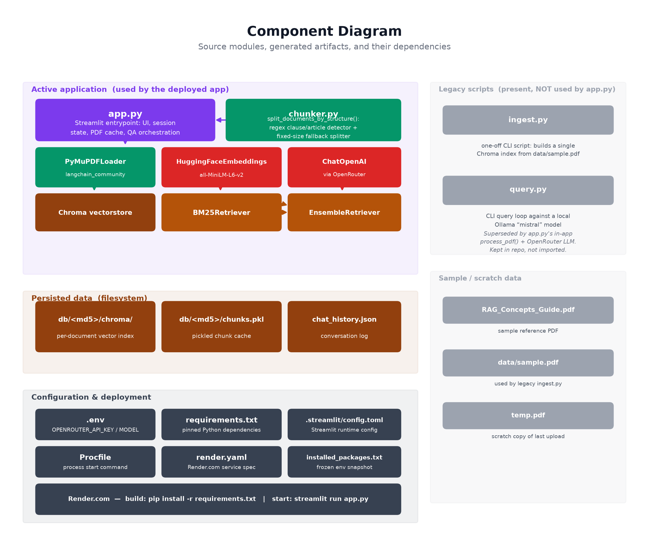
Figure 2 — Source modules, generated artifacts, and their dependencies.

Notable finding: legacy scripts
ingest.py and query.py implement an older, standalone design (a local Ollama “mistral” model, a single hard-coded Chroma index) described in the current README. Neither script is imported by app.py — the deployed application instead builds its retrieval pipeline in-process via process_pdf() and calls a cloud LLM through OpenRouter. The two scripts, and the README's setup instructions, reflect an earlier iteration of the project and would need updating (or removal) to avoid confusing future contributors.

5. Data Flow — PDF Ingestion & Indexing
Triggered every time a user uploads a PDF from the sidebar. The file's bytes are hashed (MD5) to form a cache key; if that hash was ingested before, DocChat reuses the persisted vector index and chunk cache instead of reprocessing the file, which makes re-uploading the same PDF near-instant.
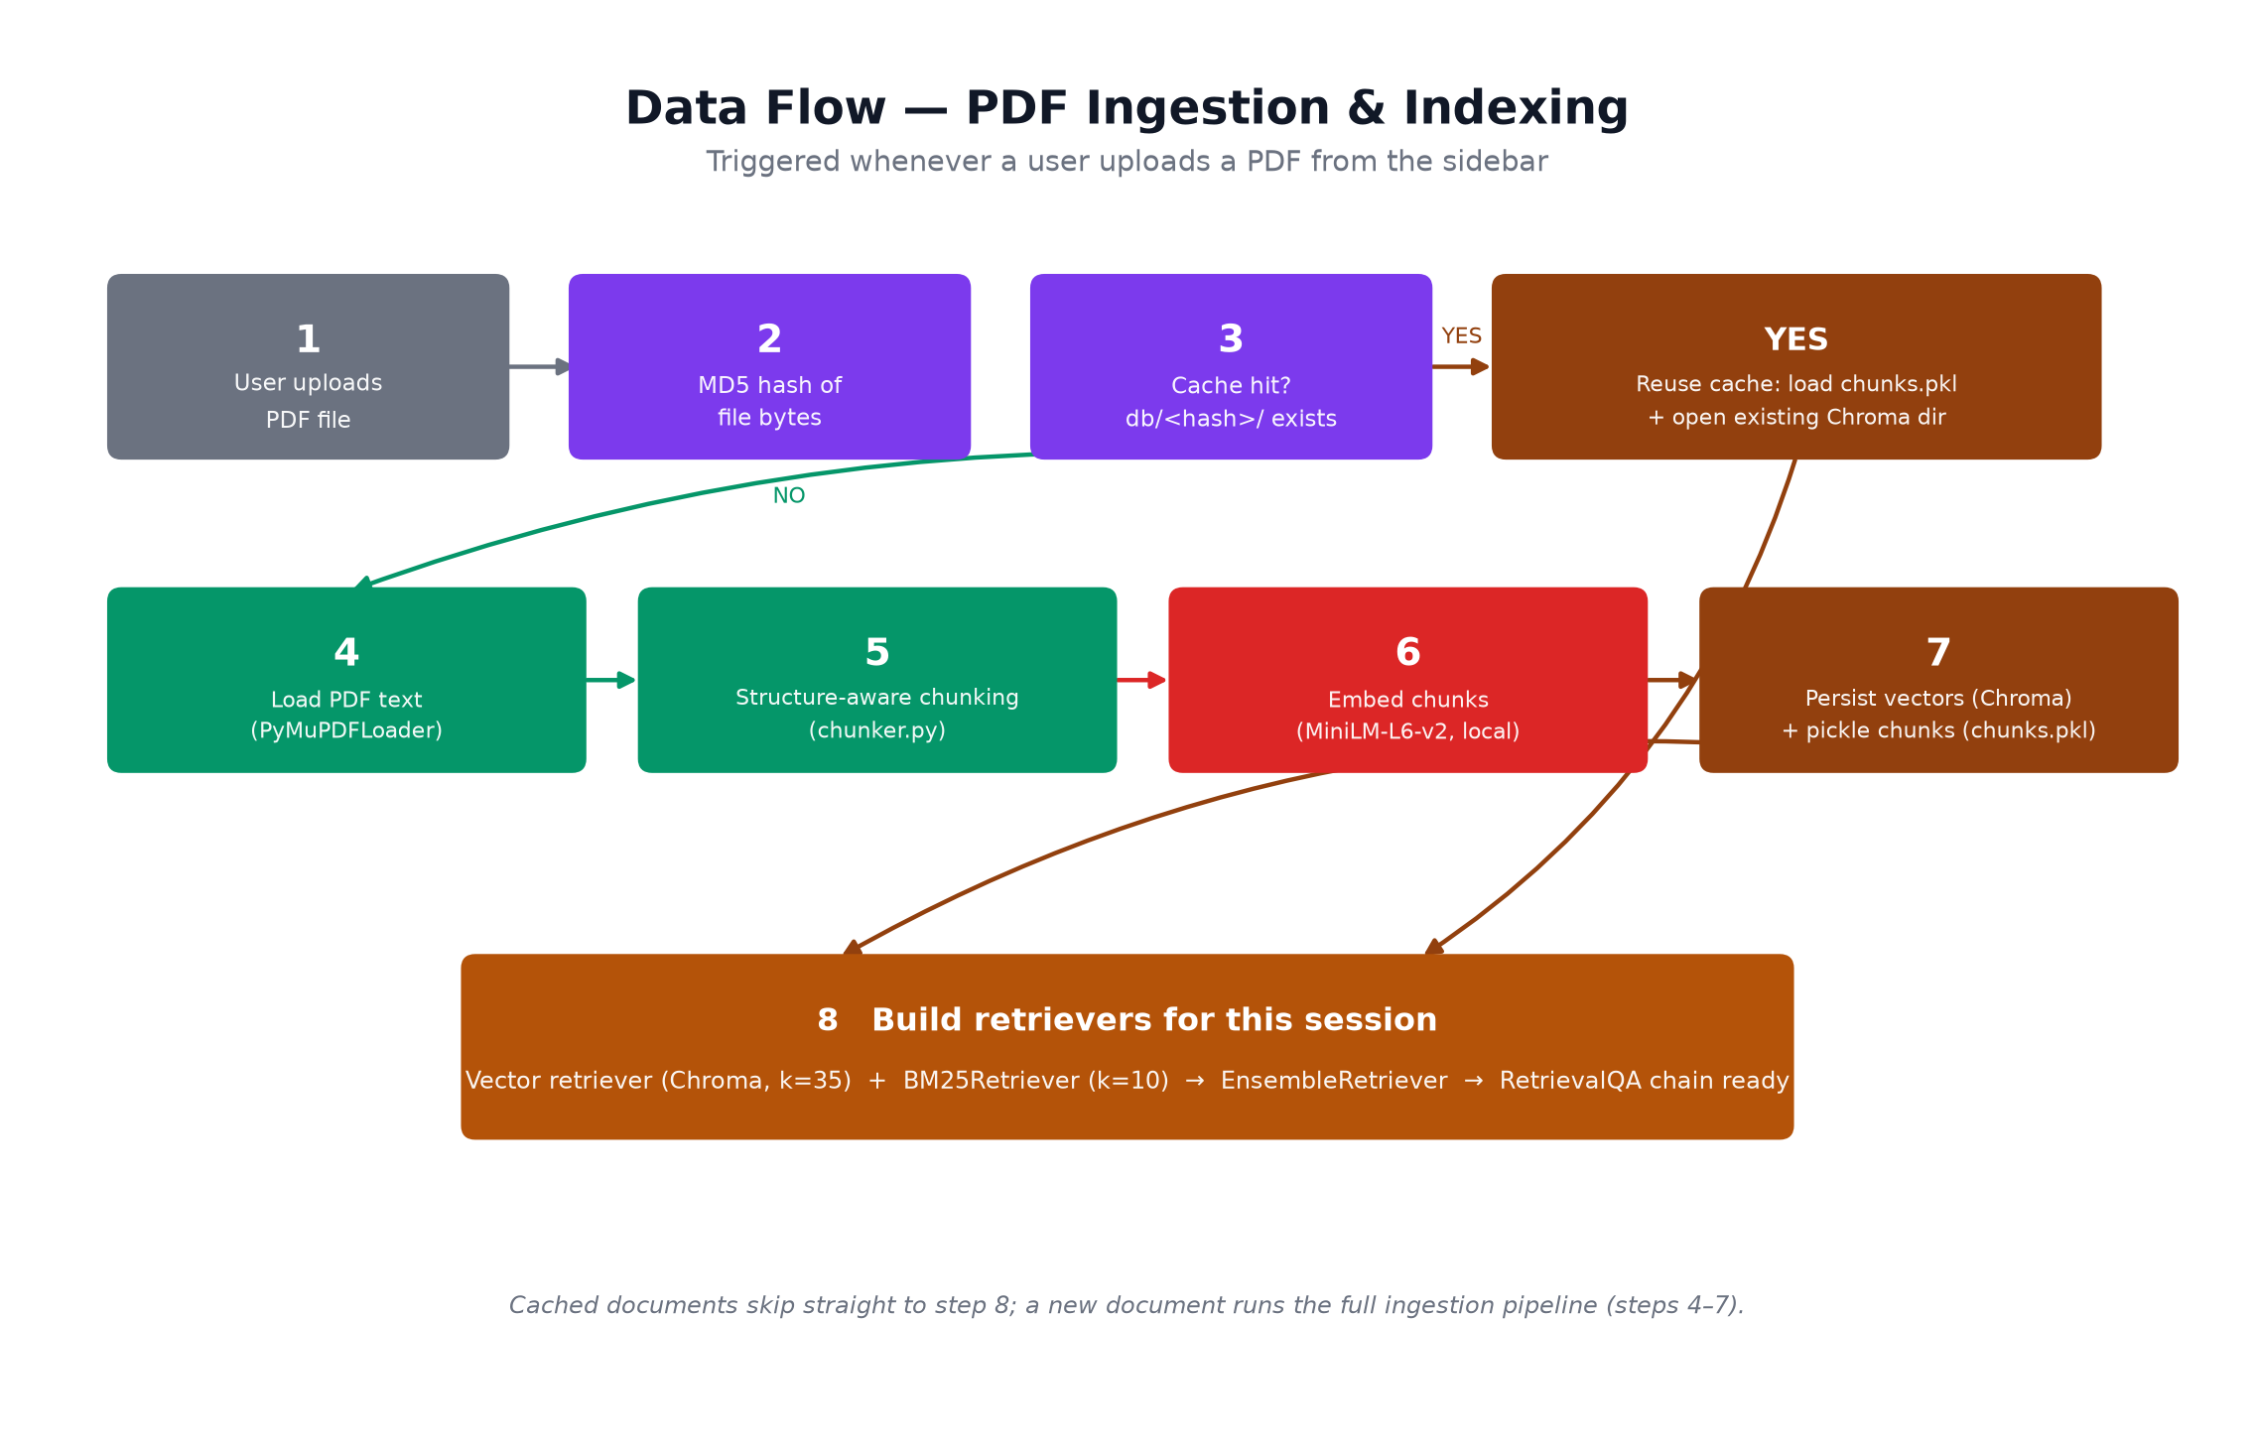
Figure 3 — Ingestion and indexing pipeline, with the cache-hit shortcut.
Step 5 (“Structure-aware chunking”) is the one piece of custom document-processing logic in the project: chunker.py first looks for numbered legal-style clauses (“20. Protection in respect of...—”) or explicit “Article/Section/Chapter” headings. If at least 8 such headings are found, the document is split section-by-section (each chunk labelled, e.g., “Article 14: Equality before law”, so retrieval can match queries like “Article 14” even though that literal phrase never appears in the source text). Otherwise it falls back to a fixed 800-character / 150-character-overlap splitter suitable for prose documents.

6. Sequence Diagram — Ask-a-Question Flow
Once a document has been indexed, each chat message follows the same request path. Both retrievers run for every query — DocChat does not choose between semantic and keyword search, it always blends them.
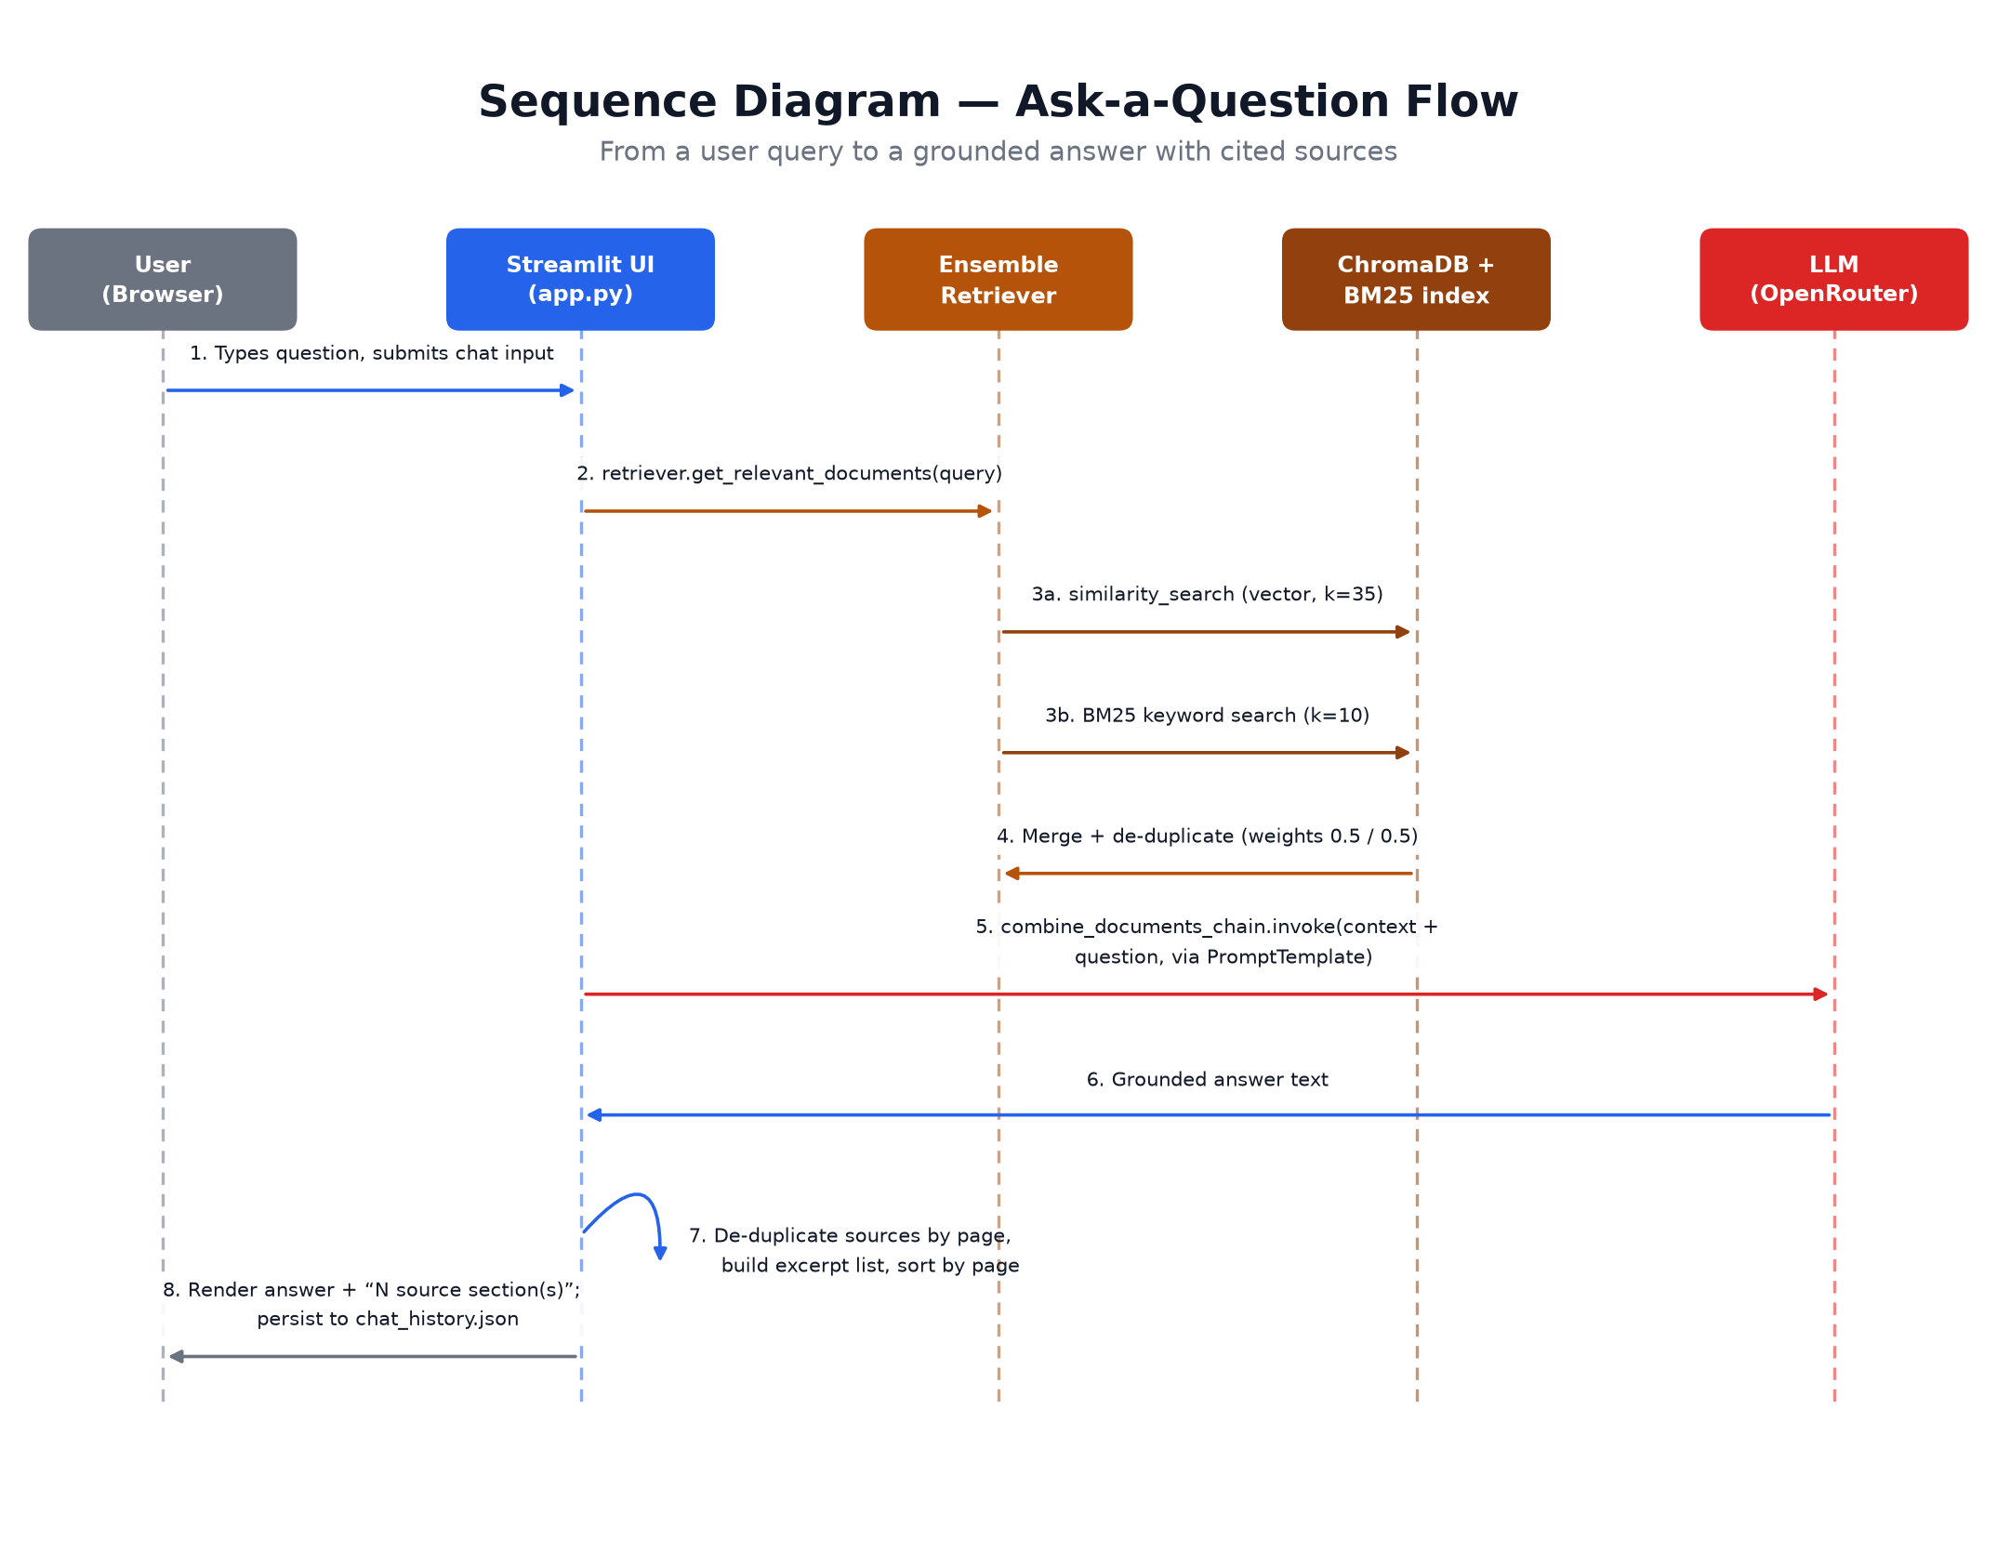
Figure 4 — Interaction sequence for answering a user's question.
Sources shown to the user (the “📄 N source section(s)” expander under each answer) are built client-side in app.py from the retrieved documents' metadata: pages are de-duplicated, the section heading and a short excerpt are extracted, and the list is sorted by page number before rendering — the LLM itself does not generate the citations.

7. Deployment Diagram
DocChat is deployed as a single Render.com web service (render.yaml / Procfile). There is no separate application server, load balancer, or managed database — the Streamlit process itself serves HTTP traffic and runs the RAG pipeline in the same process.
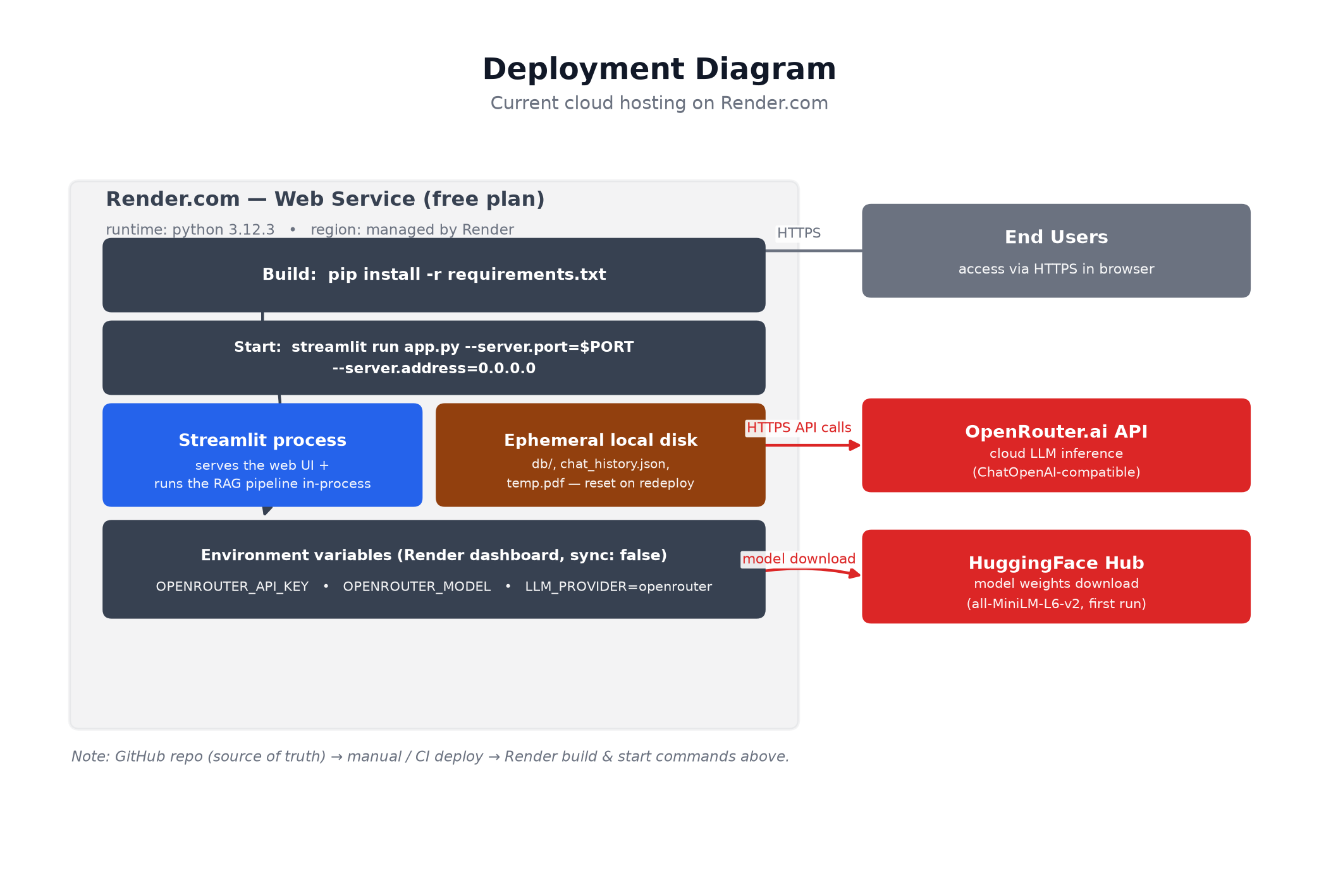
Figure 5 — Current cloud deployment topology.

Operational implications
- Ephemeral storage: the vector indexes, chunk cache, and chat_history.json live on the container's local disk. A redeploy or restart on Render's free plan wipes them, so every user effectively starts from a clean cache after a deploy.
- Two network dependencies at runtime: OpenRouter.ai (required for every answer) and, on a cold start, the HuggingFace Hub to download the embedding model weights. If either is unreachable, uploads or answers will fail.
- Secrets: OPENROUTER_API_KEY and OPENROUTER_MODEL are supplied as Render environment variables (sync: false) rather than committed to source control; a local .env file fills the same role for development.

8. Technology Stack
Concern | Technology | Notes
Web UI / app framework | Streamlit 1.55 | Single-page chat app; custom CSS/JS injected for a dark theme and a forced-open sidebar.
Orchestration | LangChain 0.1.x (core, community, openai) | RetrievalQA chain, PromptTemplate, EnsembleRetriever.
PDF parsing | PyMuPDF (pymupdf) | Loads per-page text via PyMuPDFLoader.
Chunking | Custom (chunker.py) + langchain_text_splitters | Structure-aware regex splitter with a RecursiveCharacterTextSplitter fallback.
Embeddings | sentence-transformers, all-MiniLM-L6-v2 | Runs locally/in-process on CPU; no external API call.
Vector store | ChromaDB 1.5 | Persisted to disk per document (keyed by file MD5 hash).
Keyword search | rank-bm25 (BM25Retriever) | In-memory BM25 index rebuilt from the cached chunks.
LLM | OpenRouter.ai via langchain-openai's ChatOpenAI | Cloud-hosted; model selected by the OPENROUTER_MODEL env var.
Runtime | Python 3.12, CPU-only PyTorch build | requirements.txt pins a CPU wheel to avoid pulling CUDA packages on Render.
Hosting | Render.com Web Service (free plan) | Build: pip install -r requirements.txt. Start: streamlit run app.py.

9. Design Notes & Observations
A few characteristics of the current design are worth calling out explicitly, since they shape how the system behaves and where it would need to change to scale beyond a single-user demo:
- Single-process, single-user session state. Streamlit's st.session_state and the on-disk chat_history.json are not scoped per browser session — concurrent users on the same deployed instance would share chat history and “currently loaded document” state.
- Per-file caching, not per-user. The db/<md5>/ cache keys purely on file content, so uploading the same PDF twice (by the same or different users) reuses the same index — efficient, but means there is no per-user data isolation.
- No authentication layer. Anyone who can reach the Render URL can upload documents and query the LLM, which also means anyone can exhaust the configured OpenRouter quota.
- README / legacy-script drift. The committed README still documents the original Ollama + Mistral, single-PDF design; the actual deployed behavior (OpenRouter cloud LLM, MD5-keyed multi-document cache, hybrid retrieval) is undocumented outside the source and this report.
- Retrieval breadth. The vector retriever pulls k=35 candidates and BM25 pulls k=10, a wide net for a 50/50 ensemble — reasonable for precision-sensitive documents (e.g. legal text) at some latency/token cost per query.

End of document.

