***Quadriplegics Wheelchair Control by Head Motion using Accelerometer***

***A report submitted in partial fulfilment of the***

***Requirement for the award of degree of***

***BACHELORS OF ENGINEERING***

***in***

***ELECTRONICS AND COMMUNICATION ENGINEERING***

***SECTION-2 GROUP-1***

***Submitted By***

**Sushant Kumar 19BEC1078**

**Rajarshi Nath 19BEC1075**

**Sameer 19BEC1077**

***Under the guidance of***

**Mr. Anshul Sharma**

**Mr. Divneet Singh Kapoor**

**Mr. Khushal Thakur**

**Assistant Professors, Academic Unit – 1**



**Academic Unit-4**

**Table of Contents**

List of Figures………………………………………………… i

Abstract……………………………………………………….. iii

Chapter 1. Problem Identification……………………………. 1

Chapter 2. Feature Finalization……………………………….. 2

Chapter 3. Design Flow………………………………………. 3

Chapter 4. Simulation and outcome…………………………... 4

Chapter 5. Conclusion and future scope……………………… 5

References ………………………………………………… 6

Cost Analysis………………………………………………….. 7

Archives Project Submission Form…………………………… 8

List of Figures

Figure 1.1: Pie chart of disabled population in India

Figure 1.2: Graphical representation of types of disabled in India

Figure 1.3: Testing Motors

Figure 1.4: Components being fitted in Chassis

Figure 1.5: Logic being uploaded to Microcontroller

Figure 1.6: Final Product

**Abstract**

*“****Quadriplegics Wheelchair Control by Head Motion using Accelerometer****”*

*This wheelchair is designed for the disabled who depend on other for helping them to go from one place to another. This concept helps them move on wheelchairs from one place to another on their own without any external help. They can simply control the wheel chair by simple gesture be it hands or even* *head. This removes the limitations of wheelchair needing some external help to move and make it freely to move for them with limited mobility.*

*This project is divided into two parts: -*

*One is used to monitor gesture and send it to the module controlling the drives for wheelchair,*

**Arduino Uno** *is being used to monitor the data and act accordingly,*

*Two* **NRF24L01** *units are used for the communication of a signal from the* **MPU6050** *unit, which is used to accurately detect the movements of hands or head, the data is sent wirelessly to the Uno and it responds accordingly to the hand movement .***Chapter 1**

**Problem Identification**

*Census 2001 has revealed that over 21 million people in****India****are suffering from one or the other kind of****disability****. This is equivalent to 2.1% of the population(as shows in the figure 1.1). Among the total****disabled****in the country, 12.6 million are males and 9.3 million are females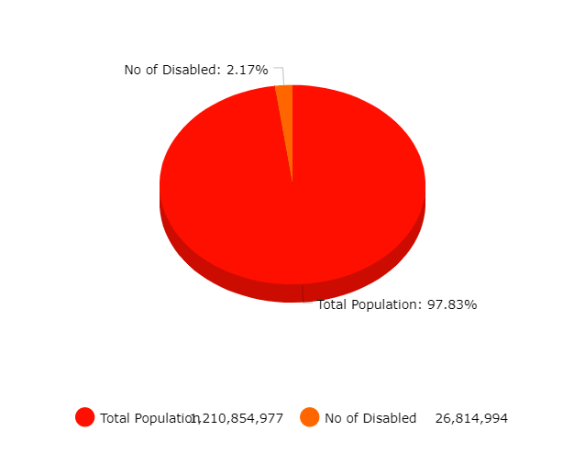*

*Out of these disabled, the huge chunk of people are those who are disabled in movement(as shown in figure 1.2)*

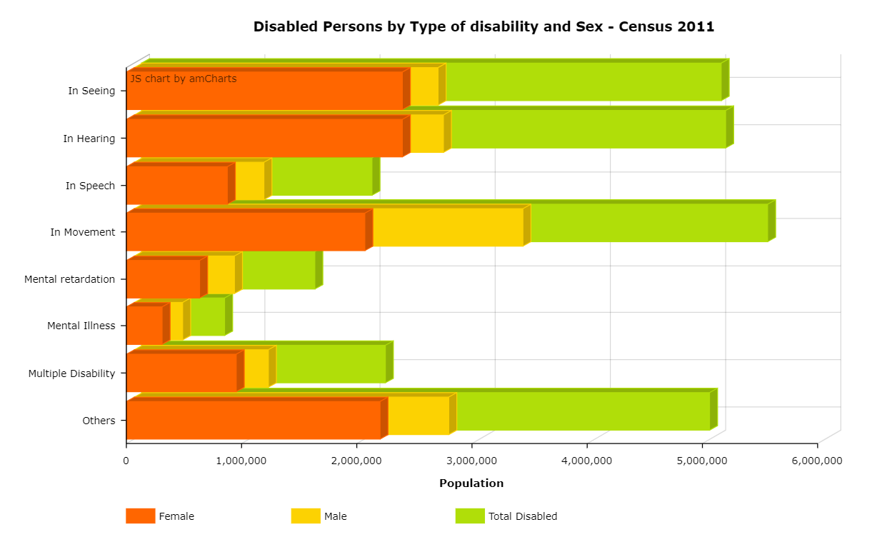

***figure 1.2***

*Therefore this problem is huge and as the only way to move for physically disabled people is by external means which mainly includes the use of wheelchairs. This method is effective but comes with a very big hindrance which is the need of external help to move from one place to another which is quite problematic when no one is around and in case of an emergency they are left hopeless.*

*To tackle this problem we came up with this idea of making the wheelchair self-controlled by the user only and limiting the need of external help .*

# Chapter 2 Feature finalization

**Capabilities**

*This model of the wheel chair is capable of doing great things. It can help those with motion disability to feel mobile again, by virtually giving them a sense of true mobility and that too* ***independently,***

***I .*** *This machine is smooth enough to maneuver the whole wheel chair accurately just by some slight movements of the head. The movements are so smooth that even constant use won’t cause strains in the shoulders or the neck.*

***II .*** *More elevation of the controller will increase the speed of the chair, so that the user can move at the required pace. This will reduce frustration of the user, as they get more controls.*

***III .*** *Keeping in mind the safety of the user and the machine , this wheel chair has an auto-stop feature in case the elevation of the head exceeds a certain angle .*

*Limitation*

*1. Cost of Installing state-of-the-art features in machine results in a higher price tag for the resulting product. The cost of an intelligent product (wheelchair in our case) that makes our lives convenient is high because some of the technology is relatively new. The cost of maintenance and repair of the technology can be expensive as well.*

*2. To introduce something entirely alien to anyone is quite tough as well as it needs extensive learning for how to use the product and how to keep it fully functional and in good shape*

*3. Currently the product is in the initial stage and further research and development is needed which requires a lot of funding and a proper facility as well*

**Chapter 3**

**Design Flow**

**Block Diagram**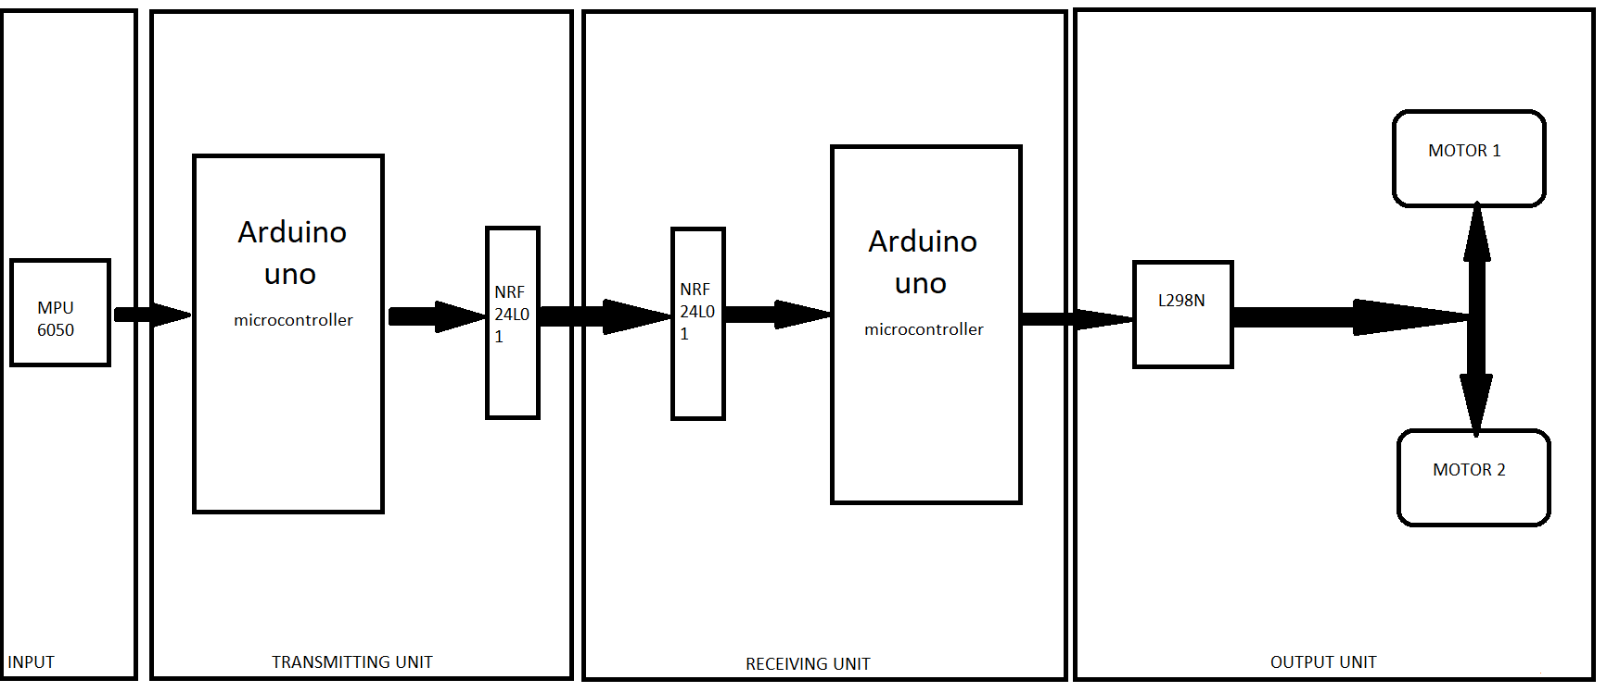

*Flowchart of the working of the complete module*

**Materials Requirement**

Materials listed below are used for both the receiver and sender module

1.) 12V Lithium-Ion Rechargeable Battery 18650

2.) DC 3-6V, Drive Gear Motor

3.) **NRF24L01** 2.4 GHz Rf Wireless Transceiver X 2

4.) OTH20 170 Points Solderless Mini Breadboard X 2

5.) MPU-6050 3 Axis Gyroscope and Accelerometer Module

6.) L298N Dual H Bridge DC Motor Driver

7.) Jumper Wires Male to Male, male to female, female to female

8.) Arduino Uno R3 ATmega328P X 2

# 

# Chapter 4

**Simulation and Outcome**

**Circuit Diagram**

**1. Pin out of NRFl201 unit.**

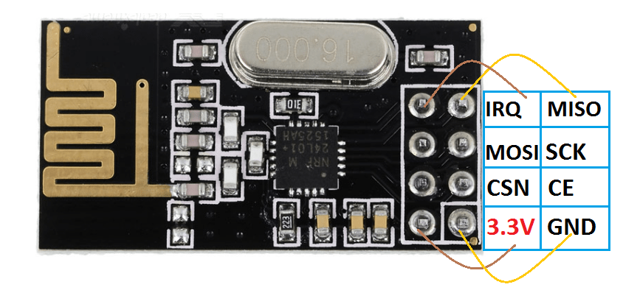

**2. Circuit Diagram of the receiver module**

*Arduino with* **NRf24l01** *and L298n H bridge with the Gear motors (refer to link 1 & 2 in the reference section)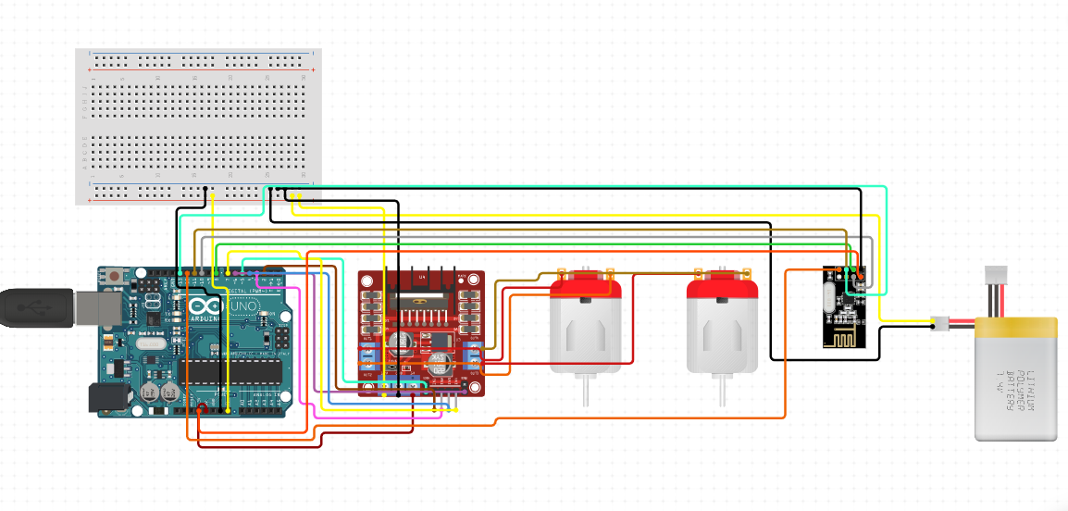*

**3. Circuit Diagram of the Transmitter module**

*Arduino with* **NRf24l01** *and MPU 6050 MEMS unit (refer to link 4 in the reference for more information)*

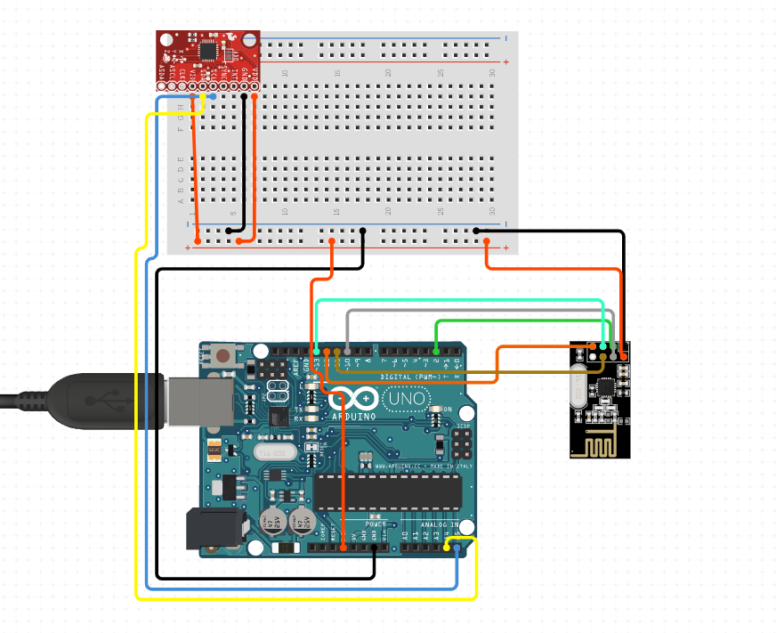

**Project lifecycle**

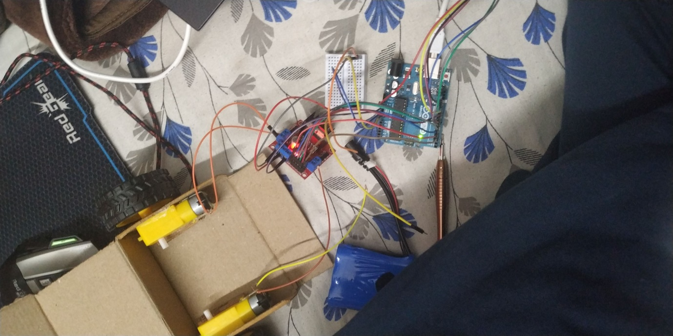**Figure 1.3**

*Description – Motors being tested, by connecting them to the motor driver and the Arduino.*

**Figure 1.4**

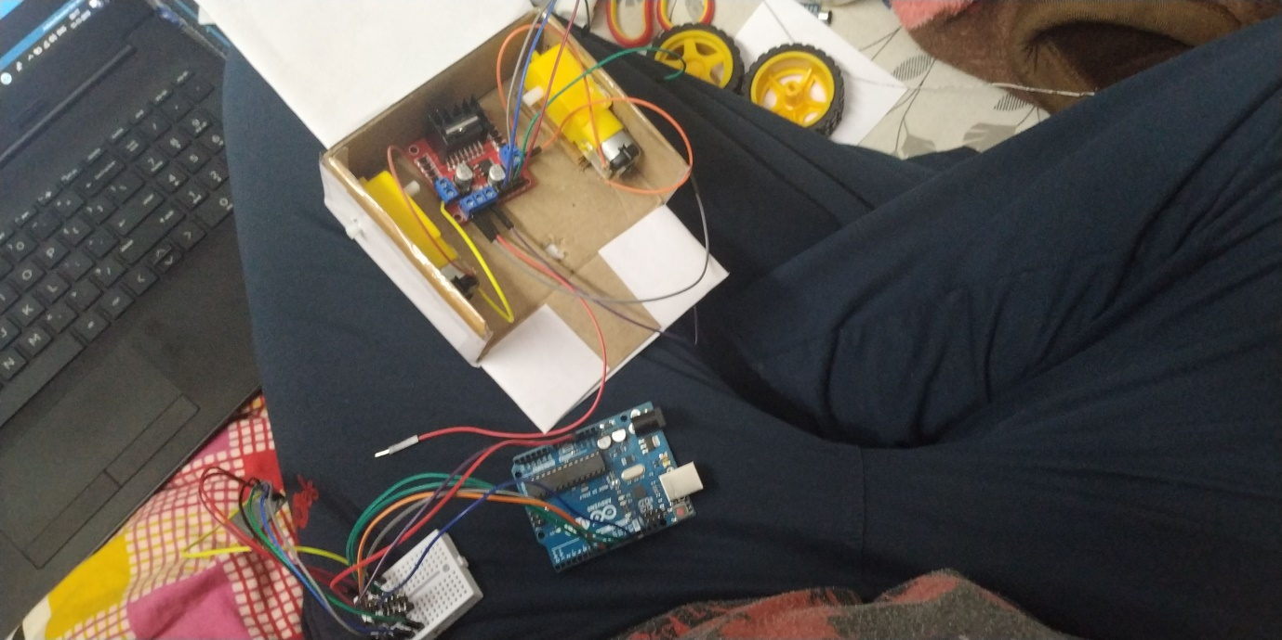

*Description – All the componenets being fitted in the chassis of the model.*

**Figure 1.5**

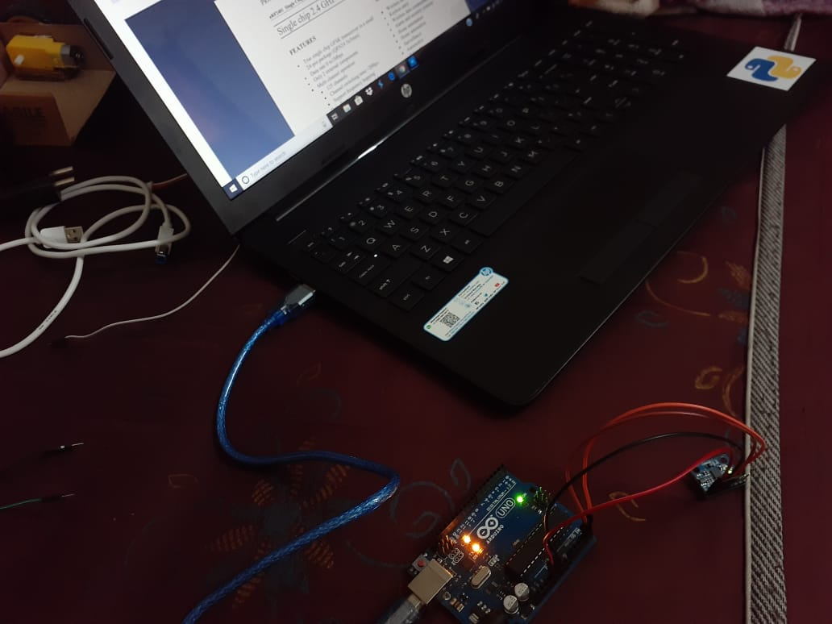

*Description – The designed code with proper logic being uploaded to the Arduino UNO Board , which connects the Accelerometer cum Gyroscope Module (****MPU6050****)*

**Figure 1.6**

*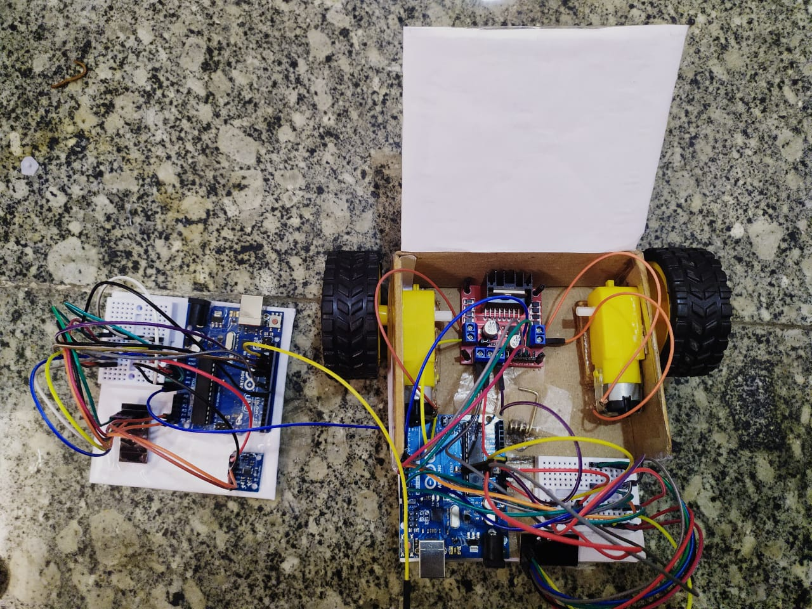Description – The Assembled Model with the Transmitter and the Receiver , placed side by side Starting from the left of the image from the viewer’s perspective .*

# Chapter 5

**Conclusion and Future Scope**

*The current model of the our project is nothing more than just a prototype which proves that our idea can be implemented and there is a huge scope in further development of it*

*Through this project we were able to learn the working of wireless communication in Arduino and the use and implementation of Gyro sensor in the circuitry as well as the use of different libraries thus used in the programming of the code itself*

*As for the future of this concept the basic changes needed are, making the complete unit small and more precise and cutting the cost heavily addition of high power motors and a central high capacity battery for the wheelchair are needed with a small form factor sender unit which is to worn by the user . These are the big and important changes that are needed to be done in order to make this concept usable*

**References**

1. <https://howtomechatronics.com/tutorials/arduino/arduino-dc-motor-control-tutorial-l298n-pwm-h-bridge/>
2. <https://www.instructables.com/id/How-to-Use-L298n-to-Control-Dc-Motor-With-Arduino/>
3. <https://www.youtube.com/watch?v=RospGi-iDG4&t=10s>
4. <https://www.electronicwings.com/arduino/mpu6050-interfacing-with-arduino-uno>

**Cost Analysis**

**Materials**

1.) 12V Lithium-Ion Rechargeable Battery 18650

2.) DC 3-6V, Drive Gear Motor X 2

3.) NRF24L01 2.4Ghz Rf Wireless Transceiver X 2

4.) OTH20 170 Points Solderless Mini Breadboard X 2

5.) MPU-6050 3 Axis Gyroscope and Accelerometer Module

6.) L298N Dual H Bridge DC Motor Driver

7.) Jumper Wires Male to Male, male to female

8.) Arduino Uno R3 ATmega328P X 2

**Financial summary**

|  |  |  |  |
| --- | --- | --- | --- |
| **S. No.** | **Component / Material/Services** | | **Price (in Rs.)** |
| 1. | 12V Lithium-Ion Rechargeable Battery 18650 x2 | | 700.00/- |
| 2. | DC 3-6V, Drive Gear Motor X 2 | | 364.00/- |
| 3. | **NRF24L01** 2.4Ghz Rf Wireless Transceiver X 2 | | 278.00/- |
| 4. | OTH20 170 Points Solderless Mini Breadboard X 2 | | 112.00/- |
| 5. | MPU-6050 3 Axis Gyroscope and Accelerometer Module | | 219.00/- |
| 6. | L298N Dual H Bridge DC Motor Driver | | 199.00/- |
| 7. | Jumper Wires Male to Male, male to female, female to female | | 190.00/- |
| 8. | Arduino Uno R3 ATmega328P x 2 | | 838.00/- |
| **Total** | | **2900.00/-** | |

**ARCHIVES PROJECT SUBMISSION FORM**

Project Code: **CU/Aug-2019/Sem____/UID______________ (To be filled by Office)**

Project Name: ________________________________________

Team Members:

|  |  |  |  |  |
| --- | --- | --- | --- | --- |
| **S. No.** | **Name** | **UID** | **Semester** | **Contact No.** |
| 1. |  |  |  |  |
| 2. |  |  |  |  |
| 3. |  |  |  |  |
| 4. |  |  |  |  |
| 5. |  |  |  |  |

**Section to be filled by team leader**

**Status (Please tick, whichever applicable)**

|  |  |  |  |
| --- | --- | --- | --- |
| Working |  | Not Working |  |

Team leader Details:

Name _______________________________ UID ______________________

Sign ________________________________ Date ______________________

**Section to be filled by Project Examiner(s)**

**Status (Please tick, whichever applicable)**

|  |  |  |  |
| --- | --- | --- | --- |
| Working |  | Not Working |  |

Project Examiner Signatures:

Internal _______________________________ Employee ID ______________

External _______________________________ Employee ID ______________

Date __________________________________