LEVEL TEST – 1

NAME - susheel kumar

REG NO - 192325007

COURSE - JAVA

COURSE CODE – CSA0987

1. WRITE A PROGRAM FOR EVEN FIBNOCCI SERIES UPTO N.

1. WRITE A PROGRAM FOR COMPOSITE NUMBERS B/W A AND B.

1. WRITE A PROGRAM FOR NO.OF FACTORS IN GIVEN NUMBER.

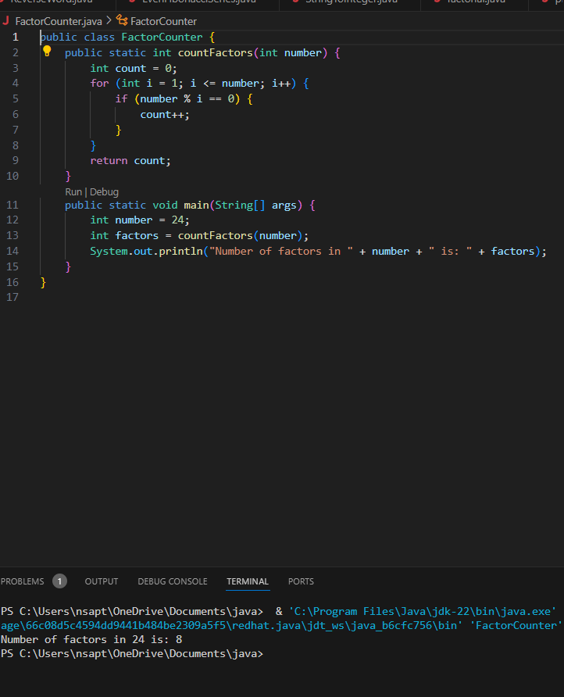

1. WRITE A PROGRAM FOR REVERSE A NUMBER USING LOOPS. A screen shot of a computer

   Description automatically generated
2. WRITE A PROGRAM FOR MARTIX MULTIPLICATIONS(3\*3)

1. WRITE A PROGRAM FOR RIGHT ANGLED TRIANGLED IN PATTERN.

1. WRITE A PROGRAM FOR INVERTED PYRAMID IN PATTERN

