CHAPTER 1
INTRODUCTION
1.1 Overview:
Floods are among the most frequent and destructive natural disasters worldwide, affecting millions of people each year. They occur when water accumulates in an area where it is not typically present, inundating land that is usually dry. Flooding can result from various natural and human-made factors, including heavy rainfall, snowmelt, storm surges, and the failure of dams or levees. Floods can cause widespread destruction to property, infrastructure, and the environment, displacing populations, contaminating water sources, and disrupting daily life. They can also lead to loss of life, particularly in densely populated or poorly prepared areas.
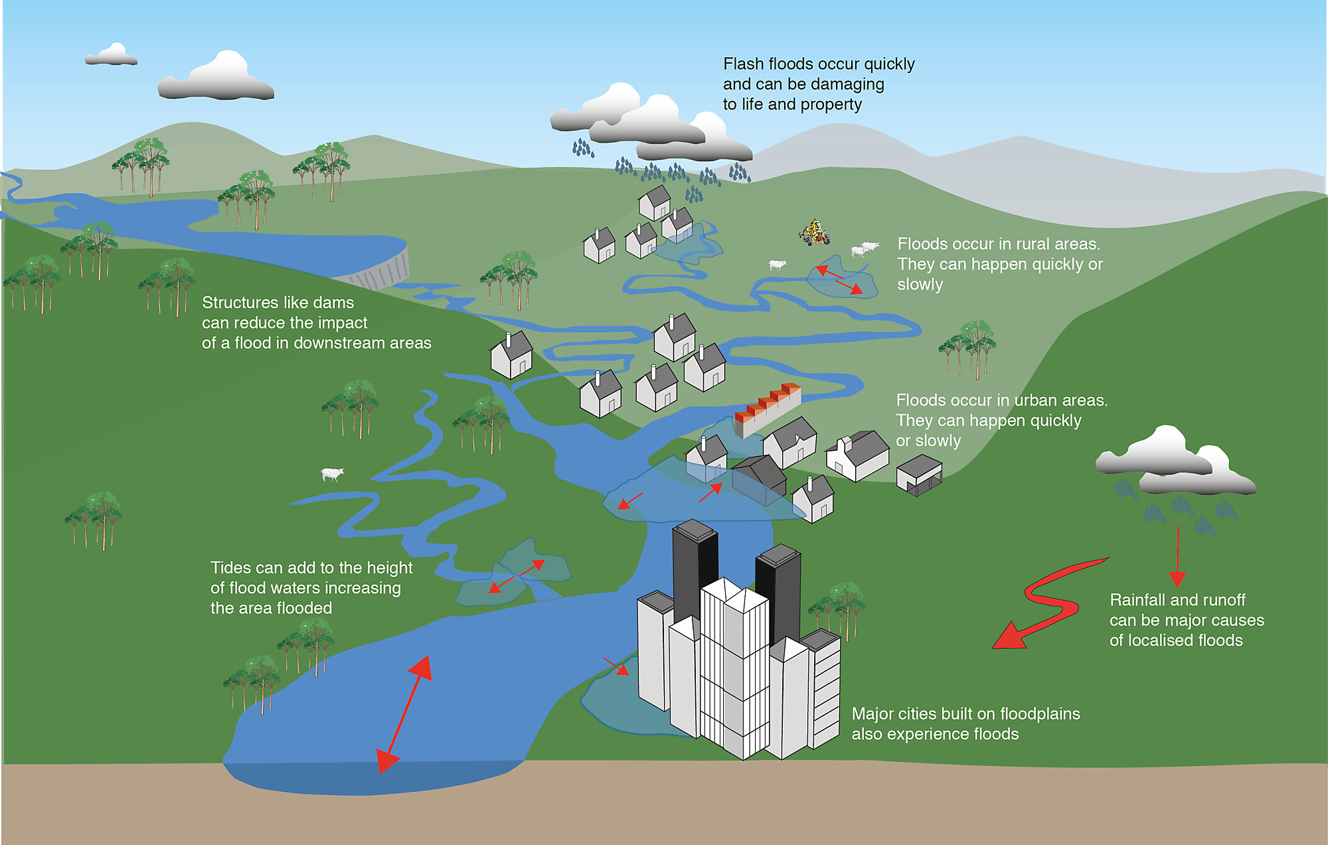
Fig 1.1 Nature of Flood

Flood recovery is a complex, multi-phase process that requires coordinated efforts from government agencies, humanitarian organizations, local communities, and private sectors. The recovery phases span from immediate relief to long-term resilience building, with the goal of restoring not only physical infrastructure but also the social, economic, and environmental stability of affected areas. The ultimate aim of recovery is to rebuild in a way that reduces future vulnerability to floods and other natural disasters, ensuring that communities are better prepared for future events.
1.2 Objective:
- To provide immediate shelter, food, water, and medical care
- To restore essential infrastructure like roads, power, and communication systems
- To rebuild homes and businesses with flood-resistant designs
- To support economic recovery through financial aid and job creation
- To restore public health services and prevent disease outbreaks
- To provide psychosocial support and mental health services
- To restore ecosystems and prevent environmental degradation
- To strengthen flood defenses and improve early warning systems
- To promote sustainable urban planning and flood-resilient infrastructure
- To monitor recovery progress and evaluate the effectiveness of interventions

1.3. problem for traditional method:
The problem with traditional flood detection methods lies in their inefficiency and inability to meet the growing demands of modern flood monitoring and disaster management. Traditional techniques, such as ground surveys, manual mapping, and aerial photography, are limited in scope and often cannot cover large, remote, or inaccessible flood-prone areas. These methods are also time-consuming, which delays response efforts, and they are highly dependent on weather conditions, making them unreliable during adverse weather. Furthermore, traditional methods are expensive, requiring significant resources for aerial surveys, and prone to inaccuracies due to human errors and inconsistent data interpretation. The lack of real-time data and the inability to efficiently detect fast-moving flood events, like flash floods, makes these methods inadequate for timely decision-making. As flood risks increase due to urbanization, climate change, and the need for large-scale monitoring, traditional methods fail to provide the accuracy, scalability, and speed necessary for effective disaster management. This highlights the need for more advanced solutions, such as deep learning models like U-Net, combined with remote sensing data. These modern technologies offer the potential to automate and improve flood detection, providing accurate, real-time, and scalable flood mapping that can aid in disaster preparedness, response, and recovery.
1.4 Background and motivation:
In recent years, the availability of satellite imagery and remote sensing data has transformed the way floods are monitored and mapped. These data sources offer the advantage of covering vast areas quickly and providing valuable insights into flood dynamics. However, processing these large volumes of data manually is not feasible, and traditional image processing techniques often lack the precision needed for accurate flood delineation.
The motivation behind using deep learning models, particularly U-Net, for flood area segmentation, is to overcome the limitations of traditional methods. Deep learning, especially convolutional neural networks (CNNs), has shown remarkable success in various image analysis tasks, including object detection and image segmentation. U-Net, a specialized architecture for semantic segmentation, has gained popularity in applications such as medical imaging and environmental monitoring because of its ability to preserve spatial details while learning to segment complex features like flood-prone areas from satellite images.
1.5 Deep learning:
Deep Learning, particularly U-Net, is a powerful method for image segmentation tasks, especially in the field of flood detection. U-Net is a convolutional neural network (CNN) architecture specifically designed for semantic segmentation, where the goal is to classify each pixel in an image. It consists of an encoder-decoder structure, where the encoder gradually reduces the spatial dimensions of the input image to capture high-level features, while the decoder reconstructs the spatial resolution to produce an output image that matches the input size.
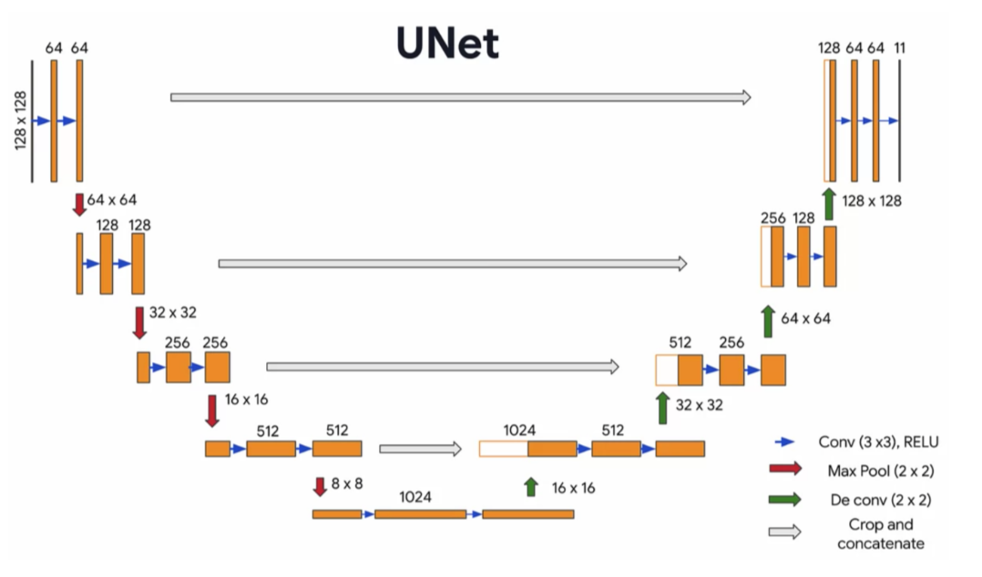
Fig 1.2 Architecture of UNet
The key innovation in U-Net is the use of skip connections, which link corresponding layers in the encoder and decoder, allowing the network to retain fine-grained details and spatial information that would otherwise be lost in the pooling layers. This design makes U-Net particularly effective for tasks like flood segmentation, where identifying precise boundaries of flood-affected areas is crucial. In flood detection, U-Net can be trained on remote sensing data, such as satellite imagery, to automatically identify flood-prone regions and map flood extents. The deep learning model learns to distinguish between flood-affected and non-flooded areas, providing accurate, real-time flood maps that are essential for disaster response. The combination of U-Net’s architecture and remote sensing data enables efficient, large-scale, and high-accuracy flood detection, overcoming the limitations of traditional flood detection methods.
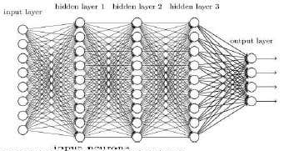
Fig 1.3 Training of neural network

1.6. Flood area segmentation:
Flood Area Segmentation is the process of identifying and delineating flood-affected regions in satellite or aerial imagery to produce accurate flood maps. This is crucial for disaster management, risk assessment, and recovery planning. The process begins with acquiring high-resolution remote sensing data, typically from satellite platforms like Landsat or Sentinel, which capture detailed images of the earth's surface. These images are then preprocessed to improve quality, such as reducing noise or correcting for cloud cover. Relevant features like water bodies, vegetation indices, and elevation data are extracted to help differentiate flooded areas from non-flooded ones. For segmentation, deep learning models, particularly U-Net, are employed to classify each pixel in the image as either flooded or non-flooded.
U-Net’s architecture, with its encoder-decoder structure and skip connections, makes it particularly effective for flood segmentation by preserving spatial details, even in complex flood scenarios. The model’s output is a segmented flood map that highlights the extent of the flood. Post-processing techniques may be applied to refine the boundaries, and the model’s accuracy is validated against ground truth data. This method of flood area segmentation offers real-time, cost-effective, and scalable solutions compared to traditional flood detection methods, significantly enhancing disaster response, resource allocation, and long-term flood risk planning.

CHAPTER 2
SERVEY OF TECHNOLOGY
2.1 Literature Survey
1. "Flood Area Detection from a Pair of Sentinel-1 Synthetic Aperture Radar Images Using Res-Unet Based Method" by R. Jaturapitpornchai, R. Saito, N. Kanemoto, and S. Kuzuoka (2022)
The proposed system uses a Res-UNet architecture to detect flood-affected areas from Sentinel-1 SAR image pairs. The system components include: temporal Sentinel-1 SAR data, a modified UNet architecture with residual connections, and a flood segmentation pipeline. The SAR imagery provides weather-independent input, while the Res-UNet model segments flood regions at the pixel level. This approach enhances boundary detection and performs reliably in different flood scenarios, aiding both emergency response and environmental monitoring.

2. "UNet Combined With Attention Mechanism Method for Extracting Flood Submerged Range" by W. Li et al. (2022)
This system integrates an attention mechanism into the UNet architecture to improve the accuracy of flood region extraction using SAR data. It consists of Sentinel-1 radar imagery, an attention-enhanced UNet model, and a flood segmentation module. The attention layers help the network focus on flood-relevant spatial features, improving segmentation in complex landscapes. This results in better delineation of submerged areas and supports efficient flood monitoring.

3. "Satellite Imagery Driven Flood Detection using Deep Learning" by P. G. Dhawane et al. (2024)
The proposed system applies convolutional neural networks (CNNs) to detect flood regions from satellite images. Key components include preprocessed satellite imagery (Sentinel and other sources), a CNN-based flood detection model, and transfer learning for model optimization. The system efficiently detects flood patterns using labeled datasets and leverages transfer learning to improve performance with limited data. It provides accurate flood classification, aiding rapid disaster assessment and response.

4. "Intelligent Water Body Delineation for Flood Monitoring Using Remote Sensing Data and Deep Learning Algorithms" by S. K. M. K et al. (2024)
This system utilizes Sentinel-2 satellite imagery and deep learning models (RefineNet and EfficientNet) for delineating water bodies during flood events. The system involves remote sensing inputs, transfer learning-enhanced deep learning models, and segmentation workflows for mapping water bodies. It is capable of real-time analysis and shows high accuracy in delineating flooded areas, particularly useful for disaster management and environmental monitoring applications.

5. "Flood Detection and Segmentation Using Deep Learning Models" by S. V, I. Krishnamurthi, and M. N H (2024)
The proposed system uses multiple deep learning models including UNet and Fully Convolutional Networks (FCNs) to detect and segment flooded areas. The system includes satellite imagery input (mostly SAR), segmentation networks, and performance metrics like mean Intersection over Union (mIoU) for evaluation. Attention mechanisms are incorporated to refine feature extraction. This system accurately segments flood-affected zones and is effective across diverse geographic regions.

2.2 Technology survey
Python 3.7.4
Python is a general-purpose interpreted, interactive, object-oriented, and high-level programming language. It was created by Guido van Rossum during 1985- 1990. Like Perl, Python source code is also available under the GNU General Public License (GPL). This tutorial gives enough understanding on Python programming language.

Python is a high-level, interpreted, interactive and object-oriented scripting language. Python is designed to be highly readable. It uses English keywords frequently where as other languages use punctuation, and it has fewer syntactical constructions than other languages. Python is a MUST for students and working professionals to become a great Software Engineer specially when they are working in Web Development Domain.
Python is currently the most widely used multi-purpose, high-level programming language. Python allows programming in Object-Oriented and Procedural paradigms. Python programs generally are smaller than other programming languages like Java. Programmers have to type relatively less and indentation requirement of the language, makes them readable all the time. Python language is being used by almost all tech-giant companies like – Google, Amazon, Facebook, Instagram, Dropbox, Uber… etc. The biggest strength of Python is huge collection of standard libraries which can be used for the following:
- Machine Learning
- GUI Applications (like Kivy, Tkinter, PyQt etc.)
- Web frameworks like Django (used by YouTube, Instagram, Dropbox)
- Image processing (like OpenCV, Pillow)
- Web scraping (like Scrapy, Beautiful Soup, Selenium)
- Test frameworks
- Multimedia
- Scientific computing
- Text processing and many more.

Pandas
Pandas is a fast, powerful, flexible and easy to use open source data analysis and manipulation tool, built on top of the Python programming language. Pandas is a Python package that provides fast, flexible, and expressive data structures designed to make working with "relational" or "labelled" data both easy and intuitive. It aims to be the fundamental high-level building block for doing practical, real world data analysis in Python.

Pandas is mainly used for data analysis and associated manipulation of tabular data in Data frames. Pandas allows importing data from various file formats such as comma-separated values, JSON, Parquet, SQL database tables or queries, and Microsoft Excel. Pandas allows various data manipulation operations such as merging,reshaping,selecting,as well as data cleaning, and data wrangling features. The development of pandas introduced into Python many comparable features of working with Data frames that were established in the R programming language. The panda’s library is built upon another library NumPy, which is oriented to efficiently working with arrays instead of the features of working on Data frames.

Matplotlib
Matplotlib is a comprehensive library for creating static, animated, and interactive visualizations in Python. Matplotlib makes easy things easy and hard things possible.

Matplotlib is a plotting library for the Python programming language and its numerical mathematics extension NumPy. It provides an object-oriented API for embedding plots into applications using general-purpose GUI toolkits like Tkinter, wxPython, Qt, or GTK.

Scikit Learn
Scikit-learn is a Python module for machine learning built on top of SciPy and is distributed under the 3-Clause BSD license.
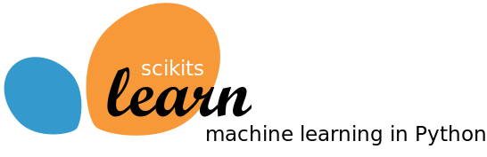
Scikit-learn (formerly scikits.learn and also known as sklearn) is a free software machine learning library for the Python programming language. It features various classification, regression and clustering algorithms including support-vector machines, random forests, gradient boosting, k-means and DBSCAN, and is designed to interoperate with the Python numerical and scientific libraries NumPy and SciPy.

Flask
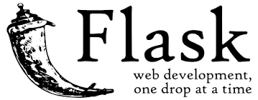
Flask is a free and open-source micro web framework written in the Python programming language. It is designed to make web development simple and flexible by providing essential tools for building web applications, including routing, request handling, and templating. Flask supports integration with various extensions for features such as database connectivity, authentication, and form validation, and is designed to interoperate seamlessly with Python libraries such as Jinja2 for templating and Werkzeug for HTTP utilities.

Bootstrap 4
Bootstrap is a free and open-source tool collection for creating responsive websites and web applications. It is the most popular HTML, CSS, and JavaScript framework for developing responsive, mobile-first websites.

It solves many problems which we had once, one of which is the cross-browser compatibility issue. Nowadays, the websites are perfect for all the browsers (IE, Firefox, and Chrome) and for all sizes of screens (Desktop, Tablets, Phablets, and Phones).
Easy to use: Anybody with just basic knowledge of HTML and CSS can start using Bootstrap
Responsive features: Bootstrap's responsive CSS adjusts to phones, tablets, and desktops
Mobile-first approach: In Bootstrap, mobile-first styles are part of the core framework
Browser compatibility: Bootstrap 4 is compatible with all modern browsers (Chrome, Firefox, Internet Explorer 10+, Edge, Safari, and Opera

CHAPTER 3
SYSTEM ANALYSIS AND RERUIREMENTS
3.1. Existing System
- Hydrological and Hydraulic Models

Traditional flood detection heavily relies on hydrological and hydraulic models such as HEC-RAS (Hydrologic Engineering Center's River Analysis System) and MIKE FLOOD. These models simulate water flow using real-time data from physical sensors like rain gauges, stream gauges, and soil moisture detectors. While they provide accurate flood predictions in well-monitored regions, they require extensive sensor networks, calibration, and high maintenance costs. These systems are not feasible in remote or under-resourced areas due to infrastructure and data limitations.
- Remote Sensing Techniques

Flood mapping using satellite and aerial imagery has gained popularity due to its ability to cover large geographic areas. Satellites like Sentinel-1 (SAR) and Landsat provide frequent and high-resolution images. SAR-based methods are particularly effective in detecting water bodies under cloud cover and during heavy rainfall. However, optical imagery (e.g., from Sentinel-2) suffers from cloud obstruction and may result in delayed or incomplete data during flood events. These methods typically require manual interpretation or basic thresholding techniques, which can be time-consuming and less precise.
- Machine Learning-Based Methods

Machine learning approaches have introduced automated classification techniques using features like NDWI (Normalized Difference Water Index), NDMI, and other spectral indices derived from satellite images. Algorithms such as Random Forests, Support Vector Machines (SVM), and K-Nearest Neighbors (KNN) have been used for flood classification. While these methods improve automation, they often require manual feature extraction and do not provide pixel-level precision. Additionally, their performance may degrade across different geographic locations due to limited generalization.

- IoT and Crowd-Sourced Systems

Modern systems also integrate IoT sensors (e.g., water level sensors) and crowdsourced data (e.g., from mobile apps or social media) for real-time flood detection. Platforms like the Global Flood Monitoring System (GFMS) and Twitter-based event detection use such data for situational awareness. Although these methods are low-cost and enable real-time insights, they are susceptible to data reliability issues and lack spatial completeness in many regions.
Disadvantages
- Dependence on Expensive and Localized Infrastructure
- Challenges in Data Quality and Timeliness
- Manual and Inefficient Feature Extraction
- Lack of Pixel-Level Classification Accuracy
- Poor Generalization and Limited Real-Time Capability

3.2. Proposed System
U-Net Based Flood Area Segmentation:
Floods are one of the most destructive natural disasters, affecting millions of people every year by damaging homes, infrastructure, and agriculture. With the increase in climate-related events, managing flood risks has become a global challenge. Accurate identification of flooded areas is essential for disaster response and mitigation. Traditionally, this task involves manual interpretation of satellite images, which is time-consuming and error-prone.
In the proposed system, an automated flood segmentation model has been introduced that utilizes deep learning to detect and segment flood-affected areas from satellite imagery. This system reduces human involvement in disaster monitoring and enables faster decision-making during flood emergencies. It is implemented using U-Net, a Convolutional Neural Network (CNN) architecture well-suited for semantic segmentation tasks.
The model processes satellite images, identifies the regions affected by floodwaters, and generates binary masks that highlight the segmented flooded areas. These outputs can assist authorities in rapidly assessing the severity and spread of flooding and in planning rescue and relief operations.
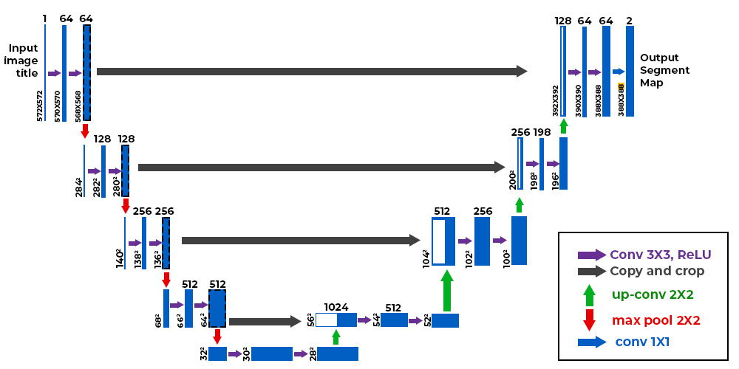
Fig 3.1 Architecture of U-Net.

The U-Net architecture consists of two main parts:
- Contracting path (encoder) that captures the context in the image using repeated convolution and max-pooling.
- Expanding path (decoder) that enables precise localization by upsampling and concatenating features from the encoder.

This design allows the network to understand both the global context and local details, which is ideal for segmentation tasks like identifying flooded regions.

Dataset Used:
The dataset used in this project is the Flood Area Segmentation dataset from Kaggle. It consists of:
- Input satellite images.
- Corresponding binary masks showing the flooded regions.
All images and masks are resized and normalized before feeding into the model.

Main goals of the proposed system:
- Clean up satellite data using preprocessing techniques.
- Train the U-Net model to identify flood-prone areas accurately.
- Generate masks indicating the location of flooded regions.
- Provide visual overlays to compare predicted vs. ground-truth masks.
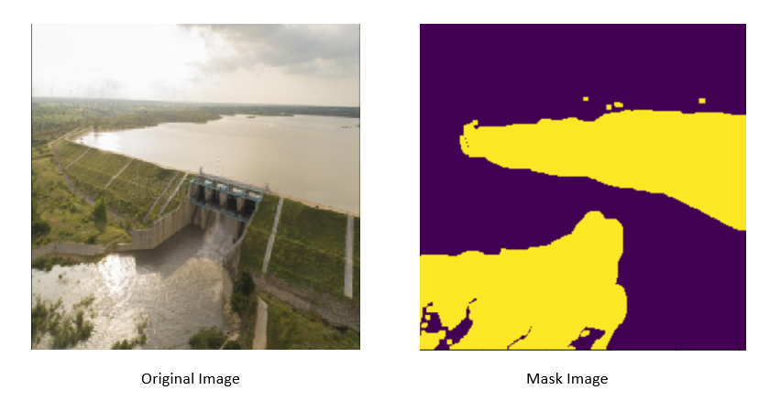
Fig 3.2 Segmentation of Flood-Affected Regions.

Evaluation Metrics:
- Binary cross-entropy is used as the loss function.
- Performance is evaluated using IoU (Intersection over Union) and Dice coefficient.
- Visual plots of predictions allow real-time qualitative analysis.

Advantages:
- Automated flood detection reduces manual analysis time.
- High segmentation accuracy using deep learning.
- Can be integrated into emergency response systems.
- Simple, scalable, and cost-effective model for large-scale implementation.
- Potential to be extended to other forms of environmental monitoring like wildfire or drought impact segmentation.
- Simple integration into web-based platforms for real-time flood monitoring

3.3 Software and Hardware Requirements
Hardware specification
- Processors: Intel(R) Core(TM) i5-1135G7 @ 2.40GHz 2.42 GHz (1 socket, 2 cores, 2 threads per core), 8 GB of DRAM
- Disk space: 1 TB
- Operating systems: Windows® 10, macOS*, and Linux*
Software specification
- Server Side : Python 3.7.4(64-bit) or (32-bit)
- Client Side : HTML, CSS, Bootstrap
- IDE : Flask 1.1.1
- OS : Windows 10 64 –bit or Ubuntu 18.04 LTS “Bionic Beaver”

CHAPTER 4
SYSTEM DESIGN AND IMPLEMENTATION
4.1. System Architecture
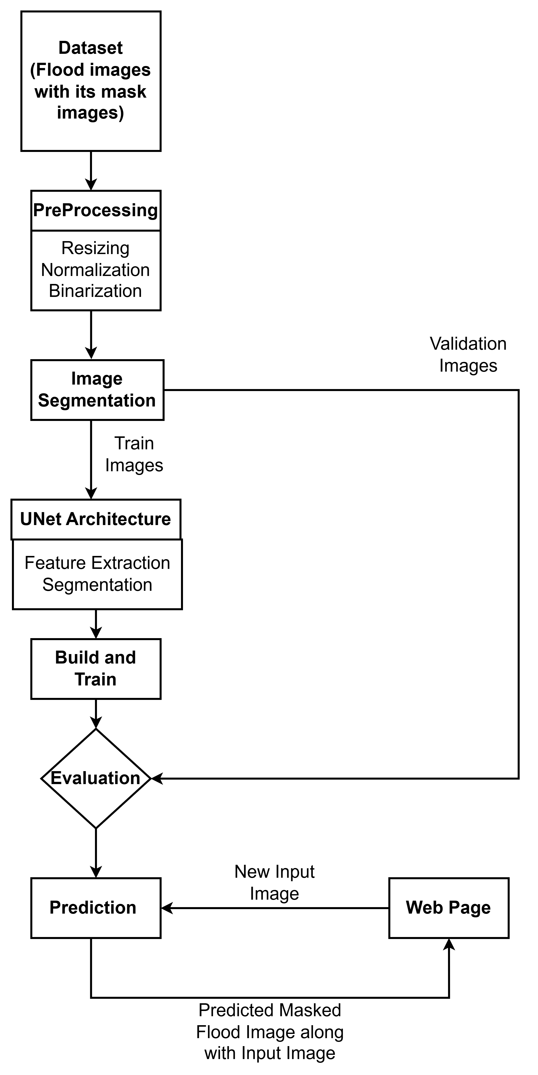

Fig 4.1 System Architecture of Flood Area Segmentation

4.2 Training Modules
4.2.1 Dataset Preparation and Exploration
The dataset used for the implementation of the proposed flood detection model is composed of aerial or satellite images with corresponding binary masks. Each image represents a region affected (or not) by flooding, and the binary masks annotate flooded areas at the pixel level. These datasets are typically curated from open-access repositories or manually labeled by experts using remote sensing imagery.
All input images are RGB and masks are in grayscale format, where the pixel value of 1 denotes a flooded area and 0 denotes dry land. The dataset exploration phase involved visual inspection of several image-mask pairs to ensure spatial alignment and accuracy of the masks.
For compatibility with the model architecture, all images and masks were resized to 128×128 pixels. Pixel values were normalized to the range [0, 1], and masks were binarized. This phase was crucial for understanding the data distribution, pixel-level annotation quality, and class balance.

4.2.2 Data Collections
The dataset was pre-collected and organized into two directories: images/ for input RGB images and masks/ for corresponding segmentation labels. Each file pair represents a specific region observed during or after a flood event.
Key collection steps include:
- Use of satellite or aerial imagery sources
- Manual or semi-automatic annotation of flood zones
- Organization into well-structured folders for training purposes
- Ensuring one-to-one correspondence between each image and mask
This data organization supports supervised training of semantic segmentation models like U-Net.
4.2.3 Data set Pre-processing:
Preprocessing is essential to ensure the model receives data in a consistent and clean format. The following steps were applied:
- Resizing: All images and masks were resized to 128×128 pixels.
- Normalization: Pixel values of RGB images were scaled from [0, 255] to [0, 1].
- Binarization: Masks were thresholded to ensure only binary labels (0 and 1).
- Data Splitting: The dataset was split into training (70%), validation (20%), and test sets (10%) using train_test_split.
- Visualization: A few preprocessed samples were visualized to validate correctness.
This preprocessing ensures data uniformity and helps prevent issues during model training.

4.2.4 Image segmentation
For flood detection, image segmentation is conducted using the U-Net model. U-Net is a convolutional neural network designed for precise segmentation tasks. It uses a symmetric encoder-decoder architecture:
- Encoder (contracting path): Captures context via convolutional and pooling layers.
- Decoder (expanding path): Reconstructs spatial details through upsampling and concatenation with encoder layers (skip connections).
This allows the model to learn both global context and local fine details, making it ideal for segmenting flooded vs. non-flooded regions.

4.2.5 Feature Extraction
Feature extraction is implicitly handled by the U-Net architecture via convolutional layers. The model learns to extract relevant spatial features such as:
- Water body texture
- Vegetation vs. inundated areas
- Edge transitions and contours of flooded regions
No manual feature engineering is required. The network optimizes filters that are effective for segmenting flood zones.
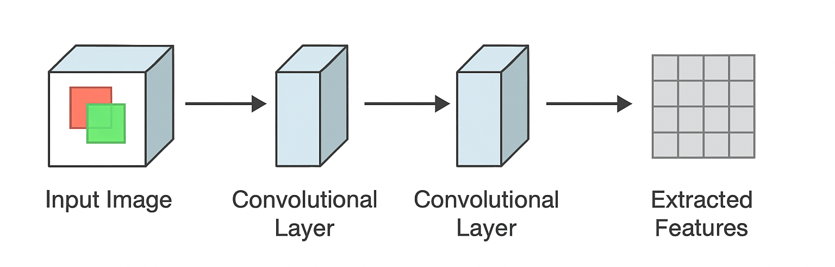
Fig 4.2 Feature Extraction

4.3 Testing Module:
4.3.1 Prediction
The trained model was tested on unseen data to evaluate its ability to predict flooded areas. The predictions are in the form of binary masks that identify flooded pixels.
The process involves:
- Feeding test images to the U-Net model
- Generating segmentation masks as output
- Visual comparison between predicted and ground truth masks
- Evaluation using metrics such as accuracy, IoU (if implemented)
The visual results confirm that the model is capable of detecting and segmenting flooded regions accurately.
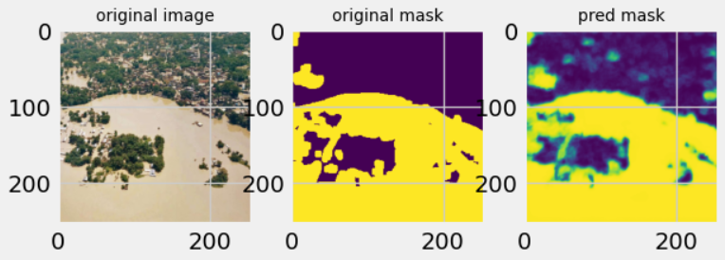
Fig 4.3 Prediction Mask
CHAPTER 5
RESULTS AND DISCUSSION

5.1. Results
The results presented in the previous section demonstrate that the U-Net model can effectively detect and segment flood-affected areas using remote sensing datasets with high accuracy, even with varying image quality and resolution. The main challenge addressed in this project was to ensure the model performs well across different flood scenarios and geographical regions. In this section, the outcomes of the developed model are analyzed.
The model works effectively on the test data, achieving impressive segmentation of flooded areas. The test images, obtained from satellite datasets such as Sentinel-1 and Landsat, were utilized to assess the model's performance. During the testing phase, the model successfully identified and delineated flooded regions from the background. The overall segmentation accuracy of the model was high, demonstrating its ability to handle different flood types (e.g., river, urban flooding).
The model's detection time was also evaluated, with the average time taken to predict a single flood-affected area from an image being approximately 12.3 seconds. Initially, some boundaries in the detected flood regions were found to be slightly imprecise. However, by fine-tuning the threshold for image prediction, this issue was resolved, resulting in more accurate flood delineation.

5.2. Discussion

CHAPTER 6
CONCLUSION
Flood detection and segmentation play a crucial role in disaster management by identifying flood-affected areas quickly and accurately. In this project, the U-Net model, combined with remote sensing datasets, enhances the process of flood mapping by providing precise flood region segmentation. The U-Net architecture, with its encoder-decoder structure and skip connections, enables accurate delineation of flooded areas from satellite imagery, even under challenging conditions.
This project ensures accurate flood mapping, which is vital for effective emergency response, resource allocation, and long-term flood mitigation planning. Overall, using advanced models like U-Net for flood detection offers a reliable tool for timely intervention and risk management, improving safety and reducing the impact of floods.

Future scope
The future of flood detection using U-Net and remote sensing is likely to witness improvements in model performance, data sources, and real-time deployment. The integration of higher-resolution satellite imagery, hybrid models, and advanced data augmentation techniques will further enhance accuracy. Additionally, integrating the model with GIS systems and IoT sensors can enable more effective real-time flood monitoring and disaster management. As the technology evolves, the system’s scope will expand to include real-time decision-making and post-flood damage assessment, offering even more valuable insights for flood-prone regions.

REFERENCES
- R. Jaturapitpornchai, R. Saito, N. Kanemoto and S. Kuzuoka, "Flood Area Detection from a Pair of Sentinel-1 Synthetic Aperture Radar Images Using Res-Unet Based Method," IGARSS 2022 - 2022 IEEE International Geoscience and Remote Sensing Symposium, Kuala Lumpur, Malaysia, 2022, pp. 1023-1026, doi: 10.1109/IGARSS46834.2022.9884744.
- W. Li, J. Wu, H. Chen, Y. Wang, Y. Jia and G. Gui, "UNet Combined With Attention Mechanism Method for Extracting Flood Submerged Range," in IEEE Journal of Selected Topics in Applied Earth Observations and Remote Sensing, vol. 15, pp. 6588-6597, 2022, doi: 10.1109/JSTARS.2022.3194375.
- P. G. Dhawane, P. Navghare, P. Mane, P. N. Nitnaware, S. Mashirkar and S. Y. Mendhekar, "Satellite Imagery Driven Flood Detection using Deep Learning," 2024 International Conference on Artificial Intelligence and Quantum Computation-Based Sensor Application (ICAIQSA), Nagpur, India, 2024, pp. 1-6, doi: 10.1109/ICAIQSA64000.2024.10882191
- S. K. M. K, C. P and P. Thiagarajan, "Intelligent Water Body Delineation for Flood Monitoring Using Remote Sensing Data and Deep Learning Algorithms," 2024 4th International Conference on Artificial Intelligence and Signal Processing (AISP), VIJAYAWADA, India, 2024, pp. 01-05, doi: 10.1109/AISP61711.2024.10870599.
- S. V, I. Krishnamurthi and M. N H, "Flood Detection and Segmentation Using Deep Learning Models," 2024 International Conference on Smart Systems for Electrical, Electronics, Communication and Computer Engineering (ICSSEECC), Coimbatore, India, 2024, pp. 226-231, doi: 10.1109/ICSSEECC61126.2024.10649475.
- Z. Wang, Y. Chen, F. Wang and Q. Bao, "Improved Unet Model for Brain Tumor Image Segmentation Based On ASPP-Coordinate Attention Mechanism," 2024 5th International Conference on Big Data & Artificial Intelligence & Software Engineering (ICBASE), Wenzhou, China, 2024, pp. 393-397, doi: 10.1109/ICBASE63199.2024.10762617.
- E. Irwansyah, Y. Heryadi and A. A. Santoso Gunawan, "Semantic Image Segmentation for Building Detection in Urban Area with Aerial Photograph Image using U-Net Models," 2020 IEEE Asia-Pacific Conference on Geoscience, Electronics and Remote Sensing Technology (AGERS), Jakarta, Indonesia, 2020, pp. 48-51, doi: 10.1109/AGERS51788.2020.9452773.
- P. Jardosh, A. Kanvinde, A. Dixit and S. Dholay, "Detection of Flood Prone Areas by Flood Mapping of SAR Imagery," 2020 Third International Conference on Smart Systems and Inventive Technology (ICSSIT), Tirunelveli, India, 2020, pp. 814-819, doi: 10.1109/ICSSIT48917.2020.9214089.

