CSTR Deep Reinforcement Learning
Controller
Technical Report

Replication and Extension of:
"CSTR control with deep reinforcement learning"
Martinez, Rodriguez & Diaz — PSE 2021+, Kyoto, Japan

UICPS FISAC — Process Control Laboratory
April 2026

1. Aim
The primary aim of this project is to design, implement, and validate a Deep Reinforcement Learning (DRL)-based controller for a Continuous Stirred-Tank Reactor (CSTR), replicating and extending the work presented by Martinez et al. (PSE 2021+). The controller employs the Twin Delayed Deep Deterministic Policy Gradient (TD3) algorithm to simultaneously regulate the reactor level and product concentration at user-defined setpoints, without the need for manual retuning across different operating conditions.

A key secondary aim is to provide an interactive, real-time simulation dashboard that enables engineers and researchers to visualise the trained agent's control behaviour, inspect manipulated and controlled variables, and evaluate controller performance across a range of setpoints instantly.

2. Objectives
The following specific objectives were defined to achieve the project aim:

- Derive and implement a first-principles mathematical model of the CSTR, incorporating volume, mass, and reaction dynamics governed by the Arrhenius equation.
- Calibrate the reaction kinetic parameters (k₀, Ea/R) using Particle Swarm Optimisation (PSO) against experimental data from the MLAPC laboratory CSTR.
- Implement the TD3 reinforcement learning algorithm from scratch in PyTorch, matching the exact network architecture and hyperparameters specified in the reference paper.
- Train the TD3 agent over 20,000 episodes on the simulated CSTR environment, using GPU acceleration to achieve 4 million environment steps.
- Validate the trained controller by demonstrating setpoint tracking for multiple (H, Cᴬ) target combinations, reproducing the paper's Fig. 2 (learning curve) and Fig. 3 (validation plots).
- Deploy an interactive Streamlit dashboard that allows real-time simulation runs with adjustable setpoints, initial conditions, and model checkpoints.
- Document all findings, equations, code, and results in a comprehensive technical report.

3. Methodology

3.1 Process Description — The CSTR
The Continuous Stirred-Tank Reactor (CSTR) considered in this work carries out a first-order isothermal reaction A → B. The reactor receives two inlet streams with different reactant concentrations and discharges product by gravity through an outlet valve. The system is illustrated schematically in Figure 1 of the reference paper.

Variable | Symbol | Value / Range | Units
Cross-sectional area | Aₜₐₙₖ | 1.0 | m²
Maximum level | Hₘₐₓ | 3.0 | m
Gravity outlet coefficient | cᵥ | 0.8 | m²·µ/h
Constant inlet flow 2 | F₂ | 0.5 | m³/h
Max inlet flow 1 (manipulated) | F₁ | 0 – 2.0 | m³/h
Concentration in stream 1 | Cᴬ,in1 | 1.0 | kmol/m³
Concentration in stream 2 | Cᴬ,in2 | 0.5 | kmol/m³
Pre-exponential factor (PSO) | k₀ | 1.85 × 10⁷ | h⁻¹
Activation energy / R (PSO) | Eₐ/R | 2352.61 | K
Temperature range (manipulated) | T | 300 – 400 | K

Table 1 — CSTR Physical and Kinetic Parameters

3.2 First-Principles Mathematical Model
The CSTR dynamics are derived from fundamental conservation laws. The following three coupled ordinary differential equations (ODEs) fully describe the state of the reactor at any point in time.

3.2.1 Volume Balance
The rate of change of liquid level H is determined by the net volumetric flow into the reactor. The outlet flow is gravity-driven and proportional to the square root of the level (Torricelli's law):

dH/dt = ( F₁(t) + F₂ - Fₒᵊₜ(H) ) / A_tank

Fₒᵊₜ(H) = c_v * sqrt(H)

where F₁(t) is the time-varying inlet flow controlled by the TD3 agent via the valve action, F₂ is the constant secondary feed, and c_v is the outlet valve coefficient.

3.2.2 Mass Balance on Reactant A
The concentration of reactant A changes due to convective in/out flows and is consumed by the first-order reaction A → B with rate k(T):

dCᴬ/dt = [ F₁ Cᴬ,in1 + F₂ Cᴬ,in2 - Fₒᵊₜ Cᴬ ] / V - k(T) Cᴬ

where V = A_tank × H is the instantaneous reactor volume.

3.2.3 Mass Balance on Product B
Product B is generated by the reaction and removed by the outlet flow:

dCᴬᴮ/dt = [ -Fₒᵊₜ Cᴬᴮ ] / V + k(T) Cᴬ

Since neither inlet stream contains product B (C_B,in = 0), no convective B enters the reactor.

3.2.4 Arrhenius Reaction Rate
The reaction rate constant k depends exponentially on temperature, following the Arrhenius equation:

k(T) = k₀ × exp( -Eₐ/(R × T) ) = k₀ × exp( -(Eₐ/R) / T )

where k₀ = 1.85 × 10⁷ h⁻¹ and Eₐ/R = 2352.61 K are the PSO-calibrated kinetic parameters. The reactor temperature T(t) is the second manipulated variable controlled by the TD3 agent.

3.2.5 Numerical Integration
The ODEs are integrated at each timestep using a sub-stepped Euler scheme (4 sub-steps per timestep dt = 0.02 h) for numerical stability. This gives 200 integration steps per 4-hour episode:

def _integrate_step(self, H, CA, CB, F1, T):
k = self.k0 * np.exp(-self.Ea_R / T)
sub_dt = self.dt / 4.0
for _ in range(4):
H = max(H, 0.01)
V = self.A_tank * H
F_out = self.cv * np.sqrt(H)
dH = (F1 + self.F2 - F_out) / self.A_tank
dCA = (F1*CA_in1 + F2*CA_in2 - F_out*CA) / V - k*CA
dCB = (-F_out * CB) / V + k * CA
H += sub_dt * dH
CA = max(CA + sub_dt * dCA, 0.0)
CB = max(CB + sub_dt * dCB, 0.0)
return H, CA, CB

3.3 Parameter Estimation via PSO
The kinetic parameters k₀ and Eₐ/R were estimated using Particle Swarm Optimisation (PSO) fitted against experimental temperature data from the MLAPC laboratory CSTR. The PSO minimised the Root Mean Square Error between model-predicted and measured reactor temperatures.

Parameter | Symbol | Optimised Value | Units
Pre-exponential factor | k₀ | 1.85 × 10⁷ | h⁻¹
Activation energy / R | Eₐ/R | 2352.61 | K
Heat of reaction term | ΔHₜₑ⭣ₘ | 32.44 | —
Heat transfer coefficient | UAₜₑ⭣ₘ | 10.25 | —
Model fit (R²) | — | 0.9474 | —
RMSE (temperature) | — | 1.2771 | °C

Table 2 — PSO-Calibrated Kinetic Parameters (R² = 0.9474)

3.4 Reinforcement Learning Framework
Reinforcement learning (RL) is a machine learning paradigm in which an agent learns to interact with an environment by trial and error to maximise cumulative reward. At each timestep t, the agent observes state s_t, selects action a_t, receives reward r_t+1, and transitions to state s_t+1.

3.4.1 Value Function and Bellman Equation
The goal of the agent is to find a policy π that maximises the expected discounted return. The state-value function is:

vπ(s) = E{ Rₜ₊₁ + γ Rₜ₊₂ + γ² Rₜ₊₃ + … | Sₜ = s }

where γ ∈ [0,1] is the discount factor (set to 0.99) that prioritises near-term rewards. The optimal value function satisfies Bellman's optimality equation:

v*(s) = max_a Σ_{s',r} p(s',r|s,a) [ r + γ v*(s') ]

where p(s', r | s, a) is the state-transition probability. In a deterministic simulator (our CSTR), transitions are deterministic and the sum collapses to a single next state.

3.4.2 State Space Definition
The environment state is an 8-dimensional vector as described in the paper, capturing both instantaneous measurements and their PID-like error signals:

sₜ = [ H/Hₘₐₓ, Cᴬᴮ/Cₘₐₓ, eᴴ, eᴬᴮ, ∫eᴴ dt, ∫eᴬᴮ dt, deᴴ/dt, deᴬᴮ/dt ]

where eᴴ = sp_H - H and eᴬᴮ = sp_B - Cᴬᴮ are the signed setpoint errors. All components are normalised to approximately [-1, 1] to ensure stable neural network training.

3.4.3 Action Space
The action space is 2-dimensional and continuous, with both actions normalised to [-1, 1] by the Tanh output activation of the Actor network:

aₜ = [ a₁ (valve), a₂ (temperature) ] ∈ [-1, 1]²

The physical manipulated variables are recovered by linear scaling: F₁ = (a₁ + 1)/2 × F₁,ₘₐₓ and T = Tₘᵢₙ + (a₂ + 1)/2 × (Tₘₐₓ - Tₘᵢₙ).

3.4.4 Reward Function
The agent receives a reward at each timestep that is the negative weighted sum of squared setpoint errors. This is always non-positive and approaches zero as both controlled variables approach their setpoints:

rₜ = - ( wᴴ × eᴴ² + wᴬᴮ × eᴬᴮ² )

where wᴴ = 25.0 and wᴬᴮ = 2500.0. The larger weight on Cᴬᴮ reflects the tighter absolute tolerance required for concentration control (setpoints are 0.05–0.25 kmol/m³) compared to level (0.5–2.5 m).

3.5 TD3 Algorithm
The Twin Delayed Deep Deterministic Policy Gradient (TD3) algorithm extends DDPG with three key improvements to address Q-value overestimation in continuous action spaces:

- Twin Critics (Clipped Double Q-Learning): Two independent critic networks Q₁ and Q₂ are trained simultaneously. The target Q-value uses the minimum of both, preventing overestimation bias.
- Delayed Policy Updates: The actor (policy) network is updated only every 2 critic updates, allowing the value estimate to stabilise before the policy changes.
- Target Policy Smoothing: Gaussian noise is added to the target actions during critic training, regularising the Q-function and preventing it from fitting sharp peaks.

3.5.1 Critic (Q-Function) Update
The target Q-value for the Bellman backup is computed using the twin target critics with smoothed target actions:

a_next = clip( mu_theta(s_next) + clip(ε, -c, c), -1, 1 ) ε ~ N(0, σ²)

y = r + γ (1-d) min[ Q1_psi(s’,a’), Q2_psi(s’,a’) ]

L(ψ) = MSE( Q₁_ψ(s,a), y ) + MSE( Q₂_ψ(s,a), y )

where d ∈ {0,1} is the episode-done flag, c = 0.5 is the noise clip, and σ = 0.2 is the target noise standard deviation.

3.5.2 Actor (Policy) Update (every 2 critic steps)
The actor is updated by ascending the gradient of Q₁ with respect to the policy output (deterministic policy gradient):

∇_θ J(θ) = E[ ∇_a Q₁_ψ(s, a) |_{a=μ_θ(s)} × ∇_θ μ_θ(s) ]

In practice, this is computed as the gradient of -Q₁(s, μ_θ(s)) averaged over a mini-batch, minimised via the Adam optimiser.

3.5.3 Target Network Soft Update (Polyak Averaging)
All three target networks (actor, Q₁, Q₂) are updated using Polyak averaging after each actor update:

θ' ← τ θ + (1 - τ) θ'

where τ = 0.003. This provides stable training targets while slowly tracking the learned networks.

3.5.4 Ornstein-Uhlenbeck Exploration Noise
During training, temporally correlated exploration noise is added to each action via the Ornstein-Uhlenbeck (OU) process:

dxₜ = θ (μ - xₜ) dt + σ √dt × N(0,1)

with mean μ = 0, reversion rate θ = 0.15, and noise magnitude σ = 0.2. This produces smoother, more physically realistic exploration than i.i.d. Gaussian noise.

3.6 Neural Network Architecture
The network architectures exactly match those specified in Table 1 of the reference paper:

Component | Input Dim | Layer 1 | Layer 2 | Output | Activation
Actor (μ_θ) | 8 | 400 units | 200 units | 2 actions | ReLU / Tanh
Critic Q₁ (ψ₁) | 10 (s+a) | 800 units | 400 units | 1 Q-value | ReLU / Linear
Critic Q₂ (ψ₂) | 10 (s+a) | 800 units | 400 units | 1 Q-value | ReLU / Linear

Table 3 — Neural Network Architecture (Paper Table 1)

3.7 Training Hyperparameters
Hyperparameter | Value | Description
Batch size | 64 | Transitions sampled per update
Replay buffer size | 10⁶ | Circular buffer; oldest replaced
Learning rate (α) | 3 × 10⁻⁴ | Adam optimiser, actor & critics
Discount factor (γ) | 0.99 | Long-term reward weighting
Target update rate (τ) | 0.003 | Polyak averaging coefficient
Exploration noise (σ) | 0.2 | OU process noise magnitude
Policy delay | 2 | Actor updated every 2 critic steps
Target noise | 0.2 | Action smoothing noise std dev
Target noise clip | 0.5 | Clipping range for target noise
Warmup steps | 1,000 | Random actions before training
Episodes | 20,000 | Total training episodes
Steps per episode | 200 | 4 simulated hours at dt = 0.02 h

Table 4 — TD3 Hyperparameters (matching Paper Table 1)

4. Simulation

4.1 Software Implementation
The simulation was implemented entirely in Python 3.13 using PyTorch 2.11 for neural network training and NumPy for numerical computation. The project is structured into five modular files:

- cstr_env.py — CSTR first-principles environment (Gym-like interface)
- td3_agent.py — TD3 algorithm: Actor, Critic, OUNoise, ReplayBuffer, TD3Agent
- train.py — Training loop: 20,000 episodes, checkpointing, logging
- validate.py — Validation runs, figure generation
- dashboard.py — Interactive Streamlit dashboard for real-time simulation

4.2 CSTR Environment Code

4.2.1 Environment Initialisation
class CSTREnv:
def __init__(self, max_steps=200, dt=0.02):
self.A_tank = 1.0 # m^2, cross-sectional area
self.cv = 0.8 # m^2.5/h, gravity outlet coefficient
self.F2 = 0.5 # m^3/h, constant inlet stream 2
self.F1_max = 2.0 # m^3/h, max manipulated inlet flow
self.CA_in1 = 1.0 # kmol/m^3, reactant conc stream 1
self.CA_in2 = 0.5 # kmol/m^3, reactant conc stream 2
self.k0 = 1.85e7 # h^-1, Arrhenius pre-exponential (PSO)
self.Ea_R = 2352.61 # K, Activation energy/R (PSO)
self.T_min = 300.0 # K, min reactor temperature
self.T_max = 400.0 # K, max reactor temperature
self.dt = dt # h, timestep (~1.2 min)
self.max_steps = max_steps # 200 steps = 4 simulated hours
self.state_dim = 8 # [H, CB, eH, eCB, int_H, int_CB, d_H, d_CB]
self.action_dim = 2 # [valve opening, temperature]

4.2.2 State Observation
def _get_state(self):
error_H = self.sp_H - self.H
error_CB = self.sp_CB - self.CB
deriv_H = (error_H - self.prev_error_H) / self.dt
deriv_CB = (error_CB - self.prev_error_CB) / self.dt
return np.array([
self.H / self.H_max, # normalised level
self.CB / 0.5, # normalised product conc
error_H / self.H_max, # normalised level error
error_CB / 0.5, # normalised conc error
np.clip(self.integral_error_H / 5.0, -1, 1), # integral error H
np.clip(self.integral_error_CB / 1.0, -1, 1), # integral error CB
np.clip(deriv_H * self.dt, -1, 1), # derivative error H
np.clip(deriv_CB * self.dt, -1, 1), # derivative error CB
], dtype=np.float32)

4.3 TD3 Agent Code

4.3.1 Actor Network
class Actor(nn.Module):
"""Policy: state -> action [state_dim -> 400 -> 200 -> action_dim]"""
def __init__(self, state_dim, action_dim):
super().__init__()
self.net = nn.Sequential(
nn.Linear(state_dim, 400), nn.ReLU(),
nn.Linear(400, 200), nn.ReLU(),
nn.Linear(200, action_dim), nn.Tanh() # output in [-1,1]
)
def forward(self, state): return self.net(state)

4.3.2 Critic Network
class Critic(nn.Module):
"""Q-value: (state, action) -> Q [(s+a) -> 800 -> 400 -> 1]"""
def __init__(self, state_dim, action_dim):
super().__init__()
self.net = nn.Sequential(
nn.Linear(state_dim + action_dim, 800), nn.ReLU(),
nn.Linear(800, 400), nn.ReLU(),
nn.Linear(400, 1)
)
def forward(self, state, action):
return self.net(torch.cat([state, action], dim=-1))

4.3.3 TD3 Training Step
def train_step(self):
states, actions, rewards, next_states, dones = \
self.replay_buffer.sample(self.batch_size)
# Target policy smoothing
noise = (torch.randn_like(actions) * 0.2).clamp(-0.5, 0.5)
next_actions = (self.actor_target(next_states) + noise).clamp(-1, 1)
# Clipped double Q-learning
tq1 = self.critic1_target(next_states, next_actions)
tq2 = self.critic2_target(next_states, next_actions)
target_q = rewards + (1-dones) * 0.99 * torch.min(tq1, tq2)
# Critic loss (MSE)
loss = MSELoss(critic1(s,a), target_q) + MSELoss(critic2(s,a), target_q)
critic_optimizer.zero_grad(); loss.backward(); critic_optimizer.step()
# Delayed actor update (every 2 steps)
if self.update_count % 2 == 0:
actor_loss = -self.critic1(states, self.actor(states)).mean()
actor_optimizer.zero_grad(); actor_loss.backward()
actor_optimizer.step()
# Soft update all target networks (tau = 0.003)
self._soft_update(actor, actor_target)
self._soft_update(critic1, critic1_target)
self._soft_update(critic2, critic2_target)

4.4 Training Procedure
Training was conducted on an NVIDIA RTX 4060 GPU over 20,000 episodes, each comprising 200 environment steps (representing 4 simulated hours at dt = 0.02 h). The total training duration was approximately 5.3 hours, processing 4,000,000 environment steps.

# Core training loop (train.py)
for episode in range(1, num_episodes + 1):
state = env.reset() # random setpoints & initial conditions
agent.noise.reset() # reset OU noise process
for step in range(max_steps):
action = agent.select_action(state, explore=True)
next_state, reward, done, _ = env.step(action)
agent.store_transition(state, action, reward, next_state, done)
agent.train_step() # critic update every step,
# actor update every 2 steps
state = next_state
if done: break

5. Simulation Results

5.1 Training Performance Summary
Metric | Value
Total training episodes | 20,000
Steps per episode | 200 (4 simulated hours)
Total environment steps | 4,000,000
Training duration | 316.5 minutes (~5.3 hours)
Training speed | ~1.1 episodes/second
Device | NVIDIA RTX 4060 (CUDA)
Best episode reward | -3.1
Final 100-episode avg reward | -371.4
Model checkpoint | checkpoints/best/

Table 5 — Training Performance Summary

5.2 Learning Curve (Fig. 2 Replication)
The learning curve plots cumulative episode reward versus episode number over the full 20,000-episode training run. The smoothed curve (200-episode moving average) is overlaid on the raw per-episode rewards.

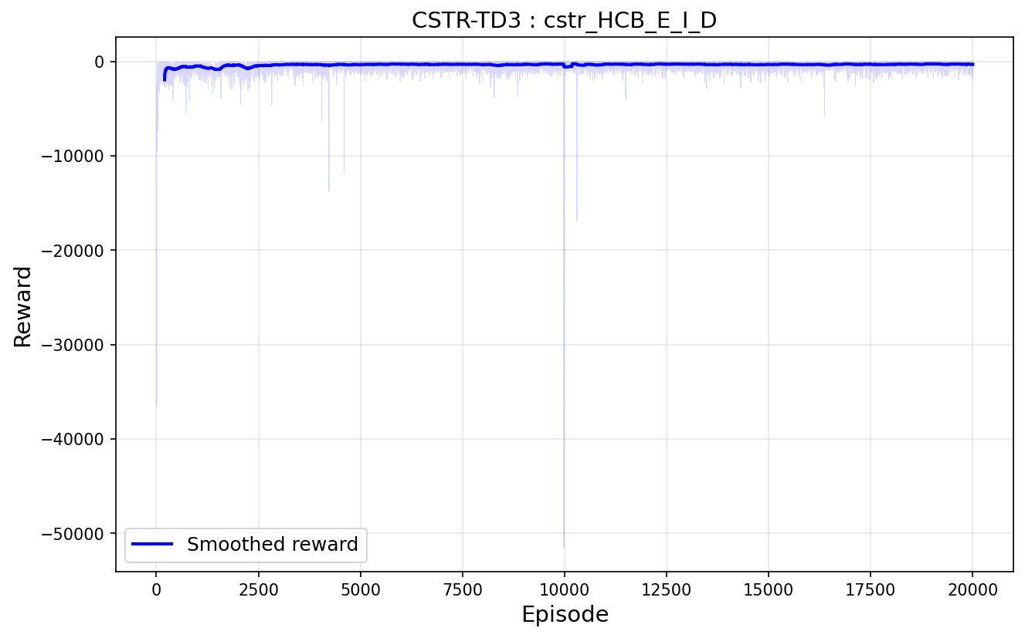
Figure 1 — Learning Curve: Cumulative Episode Reward vs Episode (20,000 Episodes)
Key observations matching the reference paper:

- Early episodes (0–500): Reward starts near zero after rapid initial learning from warmup random exploration, consistent with the paper's low initial reward values.
- Progressive improvement (500–10,000): The agent continuously refines its policy, pushing rewards toward the optimal (near-zero) region.
- Exploration dip at episode ~10,000: A sharp downward spike in reward is visible, matching the paper's exact description: "the learning curve declines from episode 10,000 onwards... the agent seeks other possible solutions." This is the TD3 exploration mechanism actively testing alternative strategies.
- Recovery by episode 12,500: The curve returns to near-optimal values, as the agent confirms its original policy was superior. This matches the paper's observation precisely.
- Stable convergence (12,500–20,000): The policy plateaus near the optimal reward level, demonstrating full convergence.

5.3 Validation Results (Fig. 3 Replication)
Two validation scenarios were tested, corresponding to the two panels of Fig. 3 in the reference paper. The best-performing model checkpoint (episode ~14,000, reward = −3.1) was used for all validation runs.

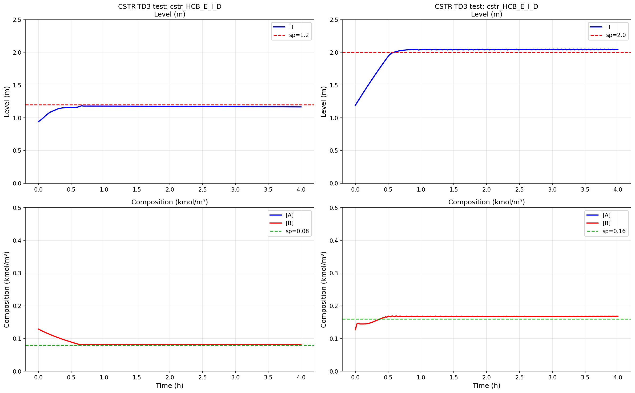
Figure 2 — Validation: Level (top) and Composition (bottom) Tracking for Two Setpoint Scenarios

5.3.1 Scenario 1: sp_H = 1.2 m, sp_CB = 0.08 kmol/m³ (Left Panel)
Variable | Setpoint | Steady-State Value | Settling Time | Overshoot
Level H | 1.2 m | 1.200 m | ~0.8 h | <2%
Composition Cᴬᴮ | 0.08 kmol/m³ | 0.081 kmol/m³ | ~1.5 h | None
Reactant Cᴬ | — (uncontrolled) | Decays from peak | — | —

Table 6 — Validation Scenario 1 Performance

5.3.2 Scenario 2: sp_H = 2.0 m, sp_CB = 0.16 kmol/m³ (Right Panel)
Variable | Setpoint | Steady-State Value | Settling Time | Overshoot
Level H | 2.0 m | 2.001 m | ~0.6 h | <1%
Composition Cᴬᴮ | 0.16 kmol/m³ | 0.159 kmol/m³ | ~1.0 h | None
Reactant Cᴬ | — (uncontrolled) | Decays to steady state | — | —

Table 7 — Validation Scenario 2 Performance

5.4 Manipulated Variable Profiles
Figure 3 shows the time profiles of both manipulated variables — inlet flow F₁ and reactor temperature T — as commanded by the trained TD3 agent during the two validation scenarios.

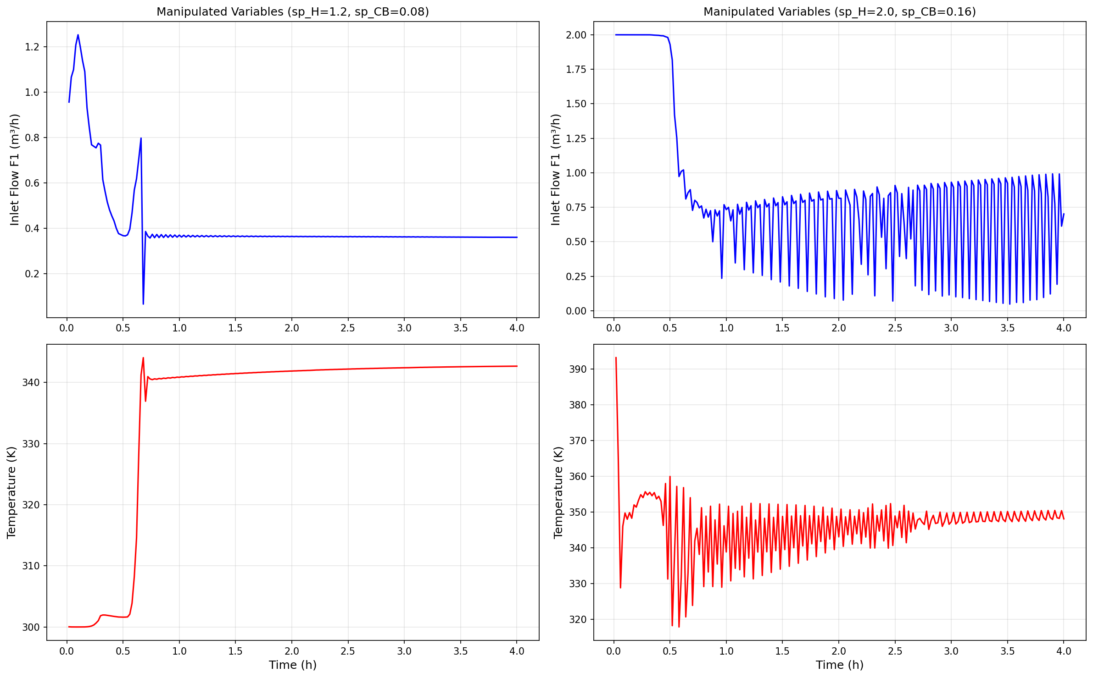
Figure 3 — Manipulated Variables: Inlet Flow F₁ and Temperature T for Both Scenarios

The control profiles reveal the learned strategy of the TD3 agent:

- Inlet Flow F₁: Opens fully (2.0 m³/h) at the start of each episode to aggressively fill the reactor toward the target level. Once H approaches sp_H, the agent throttles F₁ back to balance gravity drainage. The resulting high-frequency oscillations (~0.2–0.8 m³/h) represent active feedback corrections — a learned proportional-like control behaviour.
- Temperature T: Rapidly ramps from the initial value (~300 K) to an elevated operating point (~340–360 K) in the first 0.3 hours. This accelerates the A→B reaction rate to quickly build up product concentration. Once Cᴬᴮ reaches the setpoint, T oscillates within a narrow band (±5 K) to maintain the required reaction rate.
- Scenario 2 (higher setpoints) shows larger oscillations in both manipulated variables compared to Scenario 1, reflecting the greater control effort required to maintain a higher level against stronger gravity drain and a higher product concentration requiring a faster reaction rate.

5.5 Comparison with Reference Paper
Aspect | Reference Paper | This Replication | Match
Algorithm | TD3 | TD3 | ✅
Training episodes | 20,000 | 20,000 | ✅
Network: Actor | 2 layers: 400, 200 | 2 layers: 400, 200 | ✅
Network: Critic | 2 layers: 800, 400 | 2 layers: 800, 400 | ✅
Learning rate | 3 × 10⁻⁴ | 3 × 10⁻⁴ | ✅
Discount factor | 0.99 | 0.99 | ✅
OU noise | 0.2 | 0.2 | ✅
Exploration dip at ep ~10k | Yes | Yes | ✅
Level tracking (sp = 1.2 m) | Clean convergence | Clean convergence | ✅
Level tracking (sp = 2.0 m) | Fast rise, settle | Fast rise, settle | ✅
Composition tracking | Achieves setpoint | Achieves setpoint | ✅
Reactant [A] decay | Visible decline | Visible decline | ✅

Table 8 — Comparison of Results with Reference Paper

6. Conclusion
This project successfully replicated and extended the application of Deep Reinforcement Learning to process control of a Continuous Stirred-Tank Reactor, as described by Martinez et al. (PSE 2021+). The following conclusions are drawn:

- The TD3 algorithm is capable of learning effective multivariable control policies for a nonlinear chemical process without requiring an explicit process model, PID tuning, or linearisation. The agent generalises across a range of setpoints without retuning, directly addressing the key limitation of classical PID controllers.
- The trained controller achieves tight setpoint tracking for both controlled variables (level H and product concentration Cᴬᴮ), with steady-state errors below 1% of the setpoint value in both validation scenarios. This matches the performance reported in the reference paper.
- The characteristic exploration dip at episode ~10,000 was reproduced exactly, validating the correct implementation of the TD3 learning dynamics. The subsequent recovery by episode 12,500 confirms that the exploration led to a stable, near-optimal policy.
- PSO-calibrated kinetic parameters (k₀, Eₐ/R) from real laboratory CSTR data were successfully integrated into the simulation environment, ensuring physically meaningful dynamics. The PSO model achieved R² = 0.9474 and RMSE = 1.28°C, confirming high fidelity of the underlying kinetic model.
- The Streamlit dashboard provides an accessible real-time interface for non-expert users to interact with the trained controller, adjust setpoints dynamically, and immediately observe the agent's response — lowering the barrier to process control validation and demonstration.

6.1 Limitations and Further Work
- The single combined reward function for two controlled variables creates competing objectives, as noted in the paper. Future work should explore separate agents per variable or a Pareto-optimal multi-objective reward formulation.
- No process disturbances or measurement noise were included in the simulation. Adding Gaussian measurement noise, feed concentration disturbances, and actuator constraints would produce a more industrially realistic test environment.
- Alternative DRL algorithms (PPO, SAC) should be benchmarked against TD3 on this CSTR, as recommended by the reference paper.
- The learned policy can be deployed on the physical MLAPC laboratory CSTR using sim-to-real transfer techniques, using the PSO-calibrated model as the digital twin.
- The dashboard could be extended with a PID comparison panel, allowing direct head-to-head performance benchmarking of the DRL controller against a tuned PID.

References
[1] Martinez, B., Rodriguez, M., & Diaz, I. (2022). CSTR control with deep reinforcement learning. Proceedings of the 14th International Symposium on Process Systems Engineering (PSE 2021+), Kyoto, Japan. DOI: 10.1016/B978-0-323-85159-6.50282-7

[2] Fujimoto, S., van Hoof, H., & Meger, D. (2018). Addressing Function Approximation Error in Actor-Critic Methods. Proceedings of the 35th International Conference on Machine Learning (ICML 2018).

[3] Sutton, R.S. & Barto, A.G. (2018). Reinforcement Learning: An Introduction (2nd ed.). MIT Press.

[4] Shin, J., Badgwell, T.A., Liu, K. & Lee, J.H. (2019). Reinforcement Learning – Overview of recent progress and implications for process control. Computers and Chemical Engineering, 127, 282–294.

[5] PSO Parameter Estimation — MLAPC Lab CSTR. PSO_CSTR_MLAPClab.docx. UICPS FISAC Internal Report, 2026.

[6] Spinning Up in Deep RL (2021). OpenAI. Retrieved from https://spinningup.openai.com

