Object Oriented Programming with C++ (PCS-307)

1. WAP to find the average of two number.

PROGRAM.
#include<iostream>
using namespace std;
int main(){
double x, y;
double sum,avg;
cout << "\nEnter two numbers: ";
cin >> x >> y;
sum = x + y;
avg = sum/2;

// Result
cout << "Sum = " << sum << endl;
cout << "Average = " << avg << endl;
return 0;
}

Output:

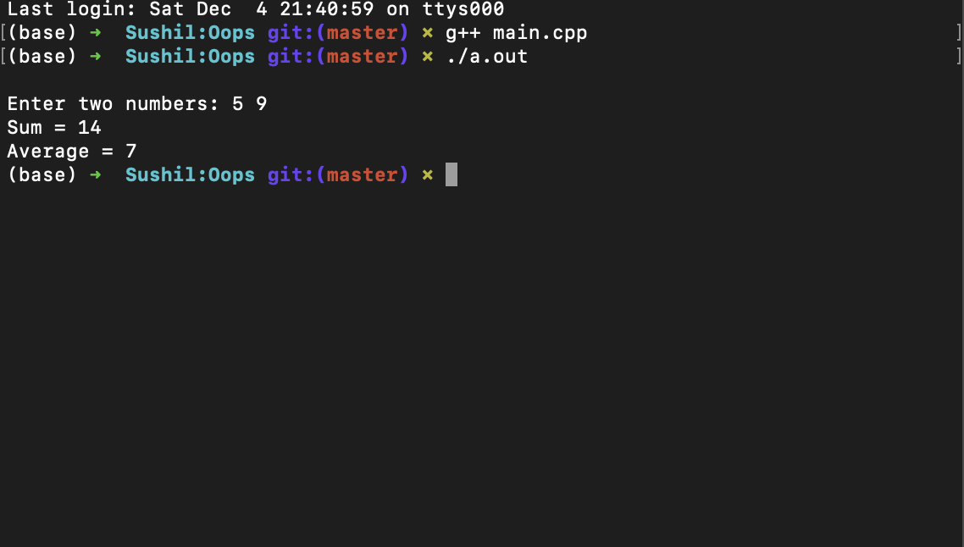

2. WAP for creating the different types of '*' patterns.

PROGRAM:-
#include <iostream>
using namespace std;
int main(){
int n;
cout << "Enter number of rows: ";
cin >> n;

for(int i = 1; i <= n; i++){
for(int j = 1; j <= i; j++){
cout << "* ";
}
cout << endl;
}
return 0;
}

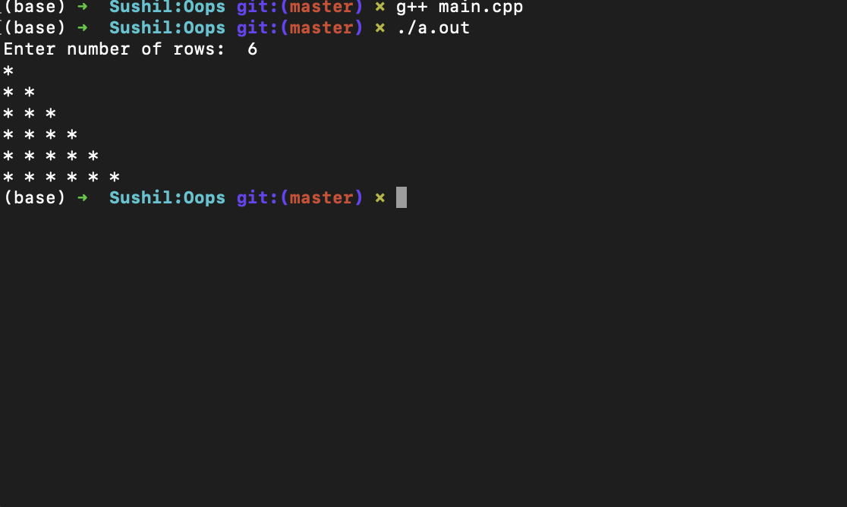
Output:

3. WAP to make a calculator using switch case.

PROGRAM:-
# include <iostream>
using namespace std;
int main() {
char op;
float num1, num2;
cout << "Enter operator: +, -, *, / ";
cin >> op;
cout << "Enter two operands: ";
cin >> num1 >> num2;
switch(op) {
case '+':
cout << num1 << " + " << num2 << " = " << num1 + num2;
break;

case '-':
cout << num1 << " - " << num2 << " = " << num1 - num2;
break;

case '*':
cout << num1 << " * " << num2 << " = " << num1 * num2;
break;

case '/':
cout << num1 << " / " << num2 << " = " << num1 / num2;
break;

default:
cout << "Error! Choose a valid operator;
break;
}
return 0;
}

Output:-
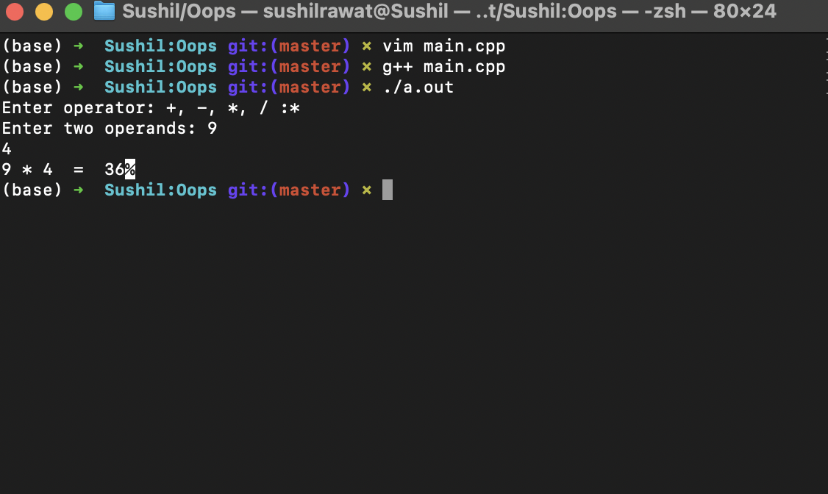

4. WAP to find the factorial of any given number.

PROGRAM:-
#include<iostream>
using namespace std;
int main() {
int n,factorial=1;
cout<<" Enter Number To Find Its Factorial: ";
cin>>n;
for (int a=1;a<=n;a++) {
factorial=factorial*a;
}
cout<<"Factorial of Given Number is ="<<factorial<<endl;
return 0;
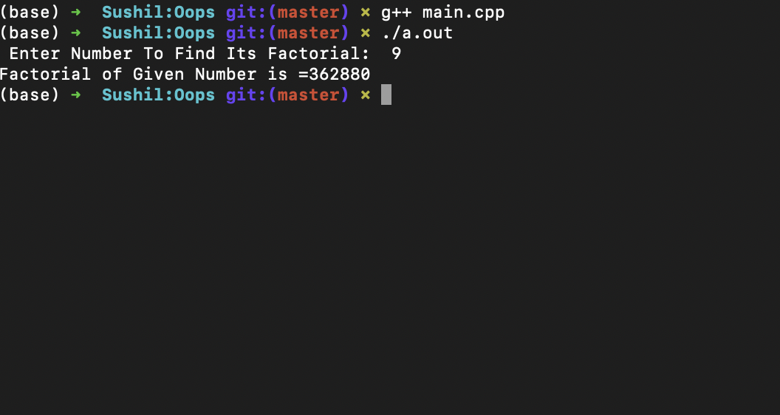
}

5. WAP to find whether a enter year is a leap year or not.

PROGRAM:-

#include<iostream>
using namespace std;
bool leap(int year){
return (year%400==0||year%4==0&&year%100!=0);
}
int main(){
int year;
cout<<"Enter the year you want to check : " ;
cin>>year;
if(leap(year)){
cout<<year<<" is a leap year "<<endl;
}else{
cout<<year<<" is not a leap year "<<endl;
}
return 0;
}

Output:-
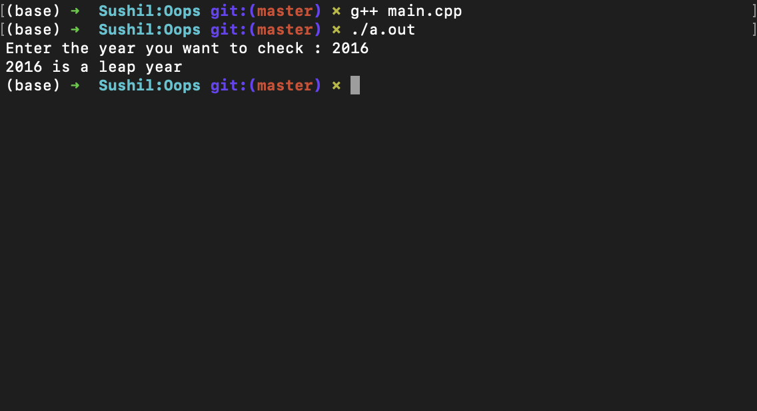

6. WAP to calculate area of square, area of rectangle and area of circle using function overloading.

PROGRAM:-

#include<iostream>
using namespace std;

int area(int a){
return a*a;
}
int area(int l,int b){
return l*b;
}
float area(float r){
return 3.14*r*r;
}
int main(){
int a,l,b;
float r;
cout<<"Enter the side of the square : ";
cin>>a;
cout<<"Enter the length and breath of the rectangle : ";
cin>>l>>b;
cout<<"Enter the radius of the circle : ";
cin>>r;

cout<<"The area of the square is "<<area(a)<<endl;
cout<<"The area of the rectangle is "<<area(l,b)<<endl;
cout<<"The area of the circle is "<<area(r)<<endl;

return 0;
}

Output:-
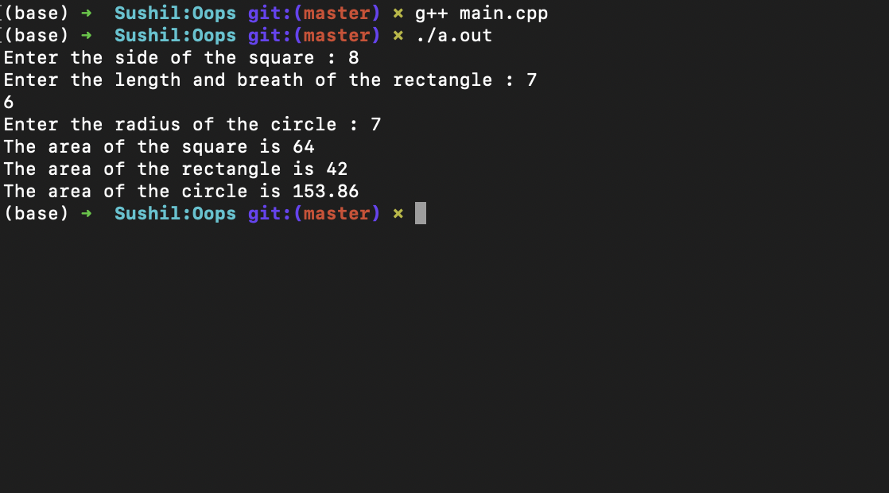

7. WAP to swap the values of any two variable using call by reference.

PROGRAM:-

#include<iostream>
using namespace std;
void swap(int &x,int &y){
int temp=x;
x=y;
y=temp;
}
int main(){
int a,b;
cout<<"Enter 2 numbers : ";
cin>>a>>b;
cout<<"Before swapping the numbers are\n";
cout<<"a = "<<a<<endl<<"b = "<<b<<endl;
swap(a,b);
cout<<"After swapping the numbers are \n";
cout<<"a = "<<a<<endl<<"b = "<<b<<endl;
return 0;
}

Output:-
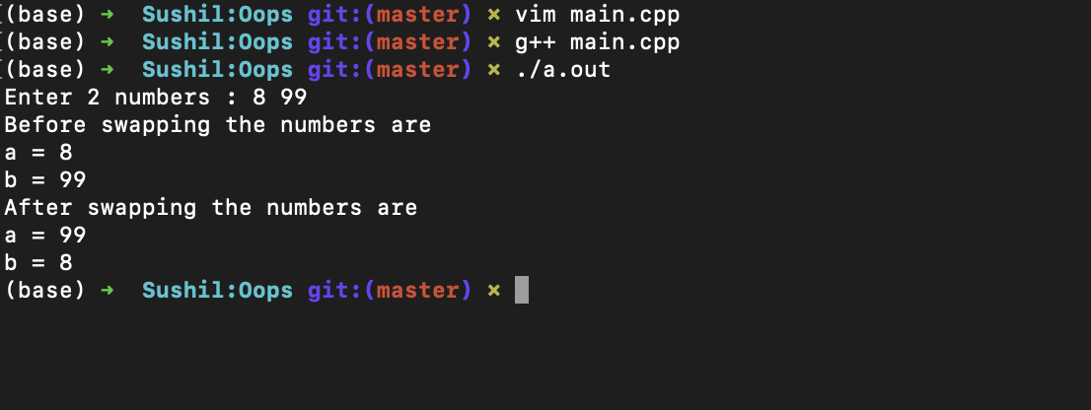

8. WAP for array rotation.

SOLUTION:-

#include<iostream>
using namespace std;
void leftRotatebyOne(int arr[], int n){
int temp = arr[0];
for (int i = 0; i < n - 1; i++)
arr[i] = arr[i + 1];

arr[n-1] = temp;
}
void leftRotate(int arr[], int d, int n){
for (int i = 0; i < d; i++)
leftRotatebyOne(arr, n);
}
void printArray(int arr[], int n){
for (int i = 0; i < n; i++)
cout << arr[i] << " ";
}

int main(){
int arr[] = { 1, 2, 3, 4, 5, 6, 7 };
int n = sizeof(arr) / sizeof(arr[0]);
int r;
cout<<"Enter by how much do you want to rotate : ";
cin>>r;
cout<<"Before rotating the array \n";
printArray(arr, n);
leftRotate(arr, r, n);
cout<<"\nAfter rotating the array \n";
printArray(arr, n);
return 0;
}

Output:-
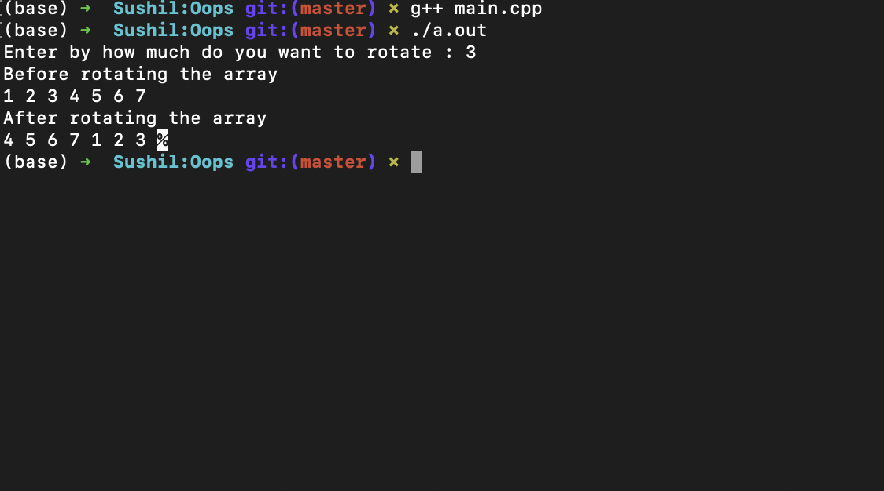

9. WAP that will ask for a temperature in Fahrenheit and display it in Celsius.

PROGRAM:-

#include<iostream>
using namespace std;
int main() {
float f,c;
cout<<"Enter value in fahrenheit : ";
cin>>f;
c = (f-32)*5/9;
cout<<"Value in celcius is : "<<c<<endl;
return 0;
}

Output:-
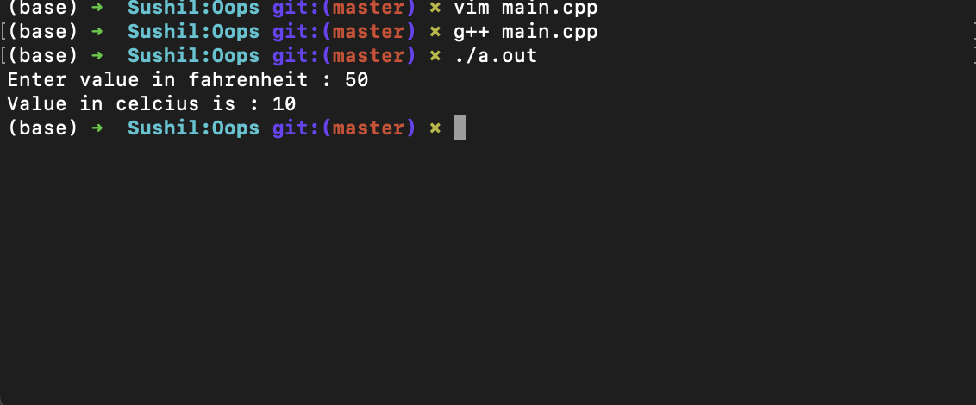

10. WAP to remove the character from 1st string which are present in 2nd string.

SOLUTION:-
#include<iostream>
#include<string>
using namespace std;
int main(){
string str1,str2;
cout<<"Enter the 2 strings : ";
cin>>str1>>str2;
string str="";
int k=0;
for(int i=0;str1[i]!='\0';i++){
int flag=1;
for(int j=0;str2[j]!='\0';j++){
if(str1[i]==str2[j]){
flag=0;
break;
}
}
if(flag)
str[k++]=str1[i];
else
flag=1;
}
str[k]='\0';
for(int i=0;str[i]!='\0';i++)
cout<<str[i];

cout<<endl;
return 0;
}

Output:-
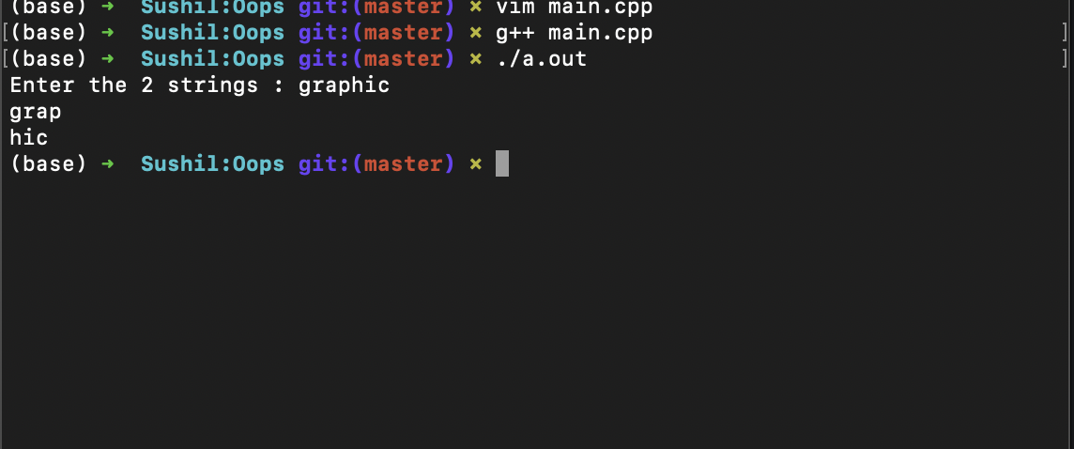

11.WAP the function power() to raise a number m to a power n. the function take double value for m and integer value for n and return the result correctly. Use a default value of 2 for n to make the function to calculate squares when this argument is omitted. Write a main function that gets the values of m and n from the user to test the function.

PROGRAM:-
#include<iostream>
#include<math.h>
using namespace std;
double power(double m,int n=2){
double t=pow(m,n);
return t;
}
int main(){
double num,ans;
int p;
cout<<"Enter the number : ";
cin>>num;

cout<<" enter the power : ";
cin>>p;

if(p==0){
ans=power(num);
cout<<"\nPower of "<<num<<" is "<<ans<<endl;
}else{
ans=power(num,p);
cout<<"\nPower of "<<num<<" is "<<ans<<endl;
}
return 0;
}

Output:-
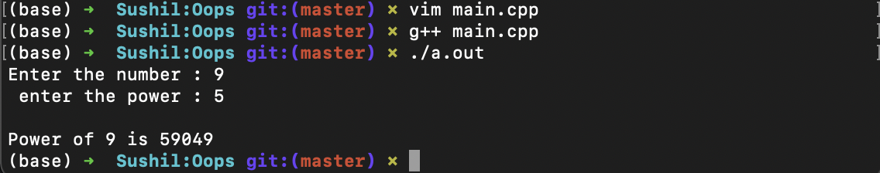

12.Write a C++ program to reverse the array elements, which are entered by the user

ANS:-
#include<iostream>
using namespace std;
void swap(int *x,int *y)
{
int t=*x;
*x=*y;
*y=t;
}
int main()
{
int n;
cout<<"Enter the max length of the array : ";
cin>>n;
int a[n];
cout<<"Enter the array elements \n";
for(int i=0;i<n;i++)
cin>>a[i];
for(int i=0;i<n/2;i++)
swap(&a[i],&a[n-1-i]);
cout<<"After reversing the array elements \n";
for(int i=0;i<n;i++)
cout<<a[i]<<" ";
return 0;
}
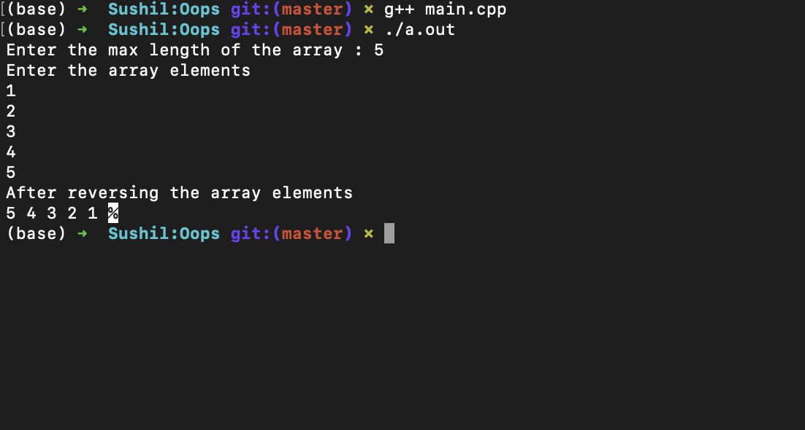
Output:-

13.Write a C++ program to count the duplicate elements in the array.

ANS:-
#include<iostream>
using namespace std;
int main(){
int n , count = 0;
cout<<"Enter the maximum length of the array : ";
cin>>n;
int a[n];
for(int i=0;i<n;i++)
cin>>a[i];
for(int i=0;i<n;i++){
for(int j=0;j<n;j++){
if(a[j]==a[i]&&a[i]!=-999&& i!=j){
a[j]=-999;
count++;
}
}
}
cout<<"The number of duplicate values are : "<<count<<endl;
return 0;
}

Output:-
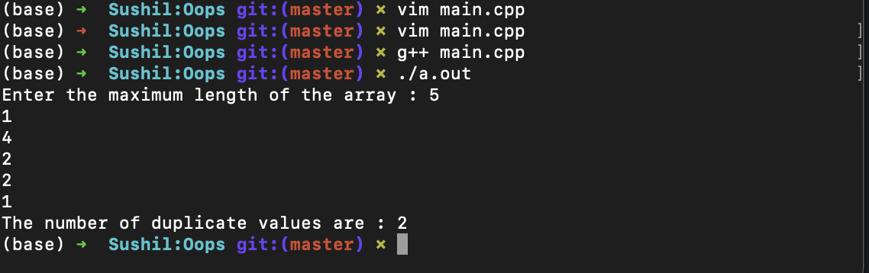

14.Write a C++ program to change every letter in a given string with the letter following it in the alphabet (i.e. a becomes b, p becomes q, z becomes a).

ANS:-

#include<iostream>
#include<string>
using namespace std;

int main(){
string s1;
cin>>s1;
int i=0;

while(i<s1.length()){
if(s1[i]=='z'||s1[i]=='Z')
s1[i]=s1[i]-25;
else
s1[i]=s1[i]+1;
i++;
}
cout<<s1;
return 0;
}

Output:-

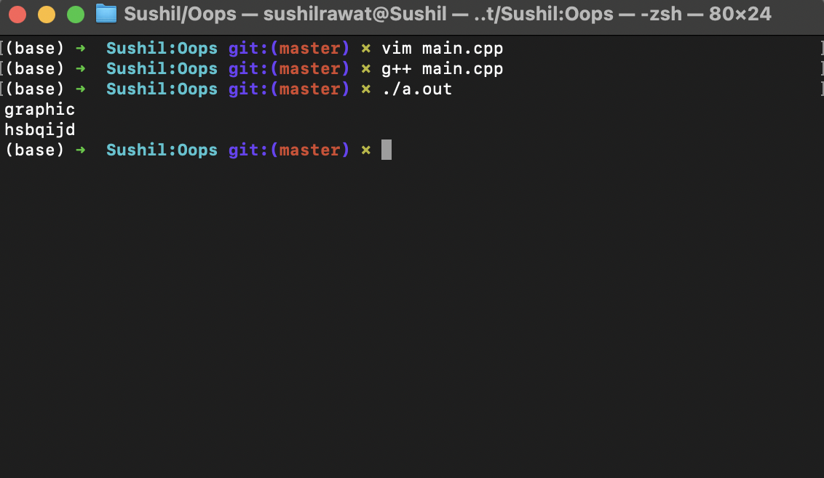

15.Write a C++ program to count palindrome words in a string.

a. With the help of inbuilt functions of c++ libraries.

b. With the character array. (i.e. char ch[20])

c. With the string datatype. (i.e. string s)

ANS:-

Code A:-

Output A:-

Code B:-

Output B:-

Code C:-

Output C:-

16.Write a C++ program to multiply two 4x4 matrices and print the matrix in the tabular form.

i.e. 1 2 3 4

5 6 7 9

10 11 12 13

14 15 16 17

ANS:-
#include<iostream>
#define N 4
using namespace std;
void input(int a[N][N]){
cout<<"Enter the values of the matrix"<<endl;
for(int i=0;i<N;i++)
for(int j=0;j<N;j++)
cin>>a[i][j];
}
void print(int a[N][N]){
cout<<"The matrix is "<<endl;
for(int i=0;i<N;i++){
for(int j=0;j<N;j++)
cout<<a[i][j]<<" ";
cout<<endl;
}
}
void multiply(int a[N][N],int b[][N],int prod[][N]){
for(int i=0;i<N;i++){
for(int j=0;j<N;j++){
int sum=0;
for(int k=0;k<N;k++)
sum+=a[i][k]*b[k][j];
prod[i][j]=sum;
}
}
}
int main(){
int a[N][N],b[N][N],prod[N][N];
cout<<"Enter the elements of the 1st matrix "<<endl;
input(a);
cout<<"Enter the elements of the 2nd matrix "<<endl;
input(b);
multiply(a,b,prod);
print(prod);
return 0;
}

Output:-
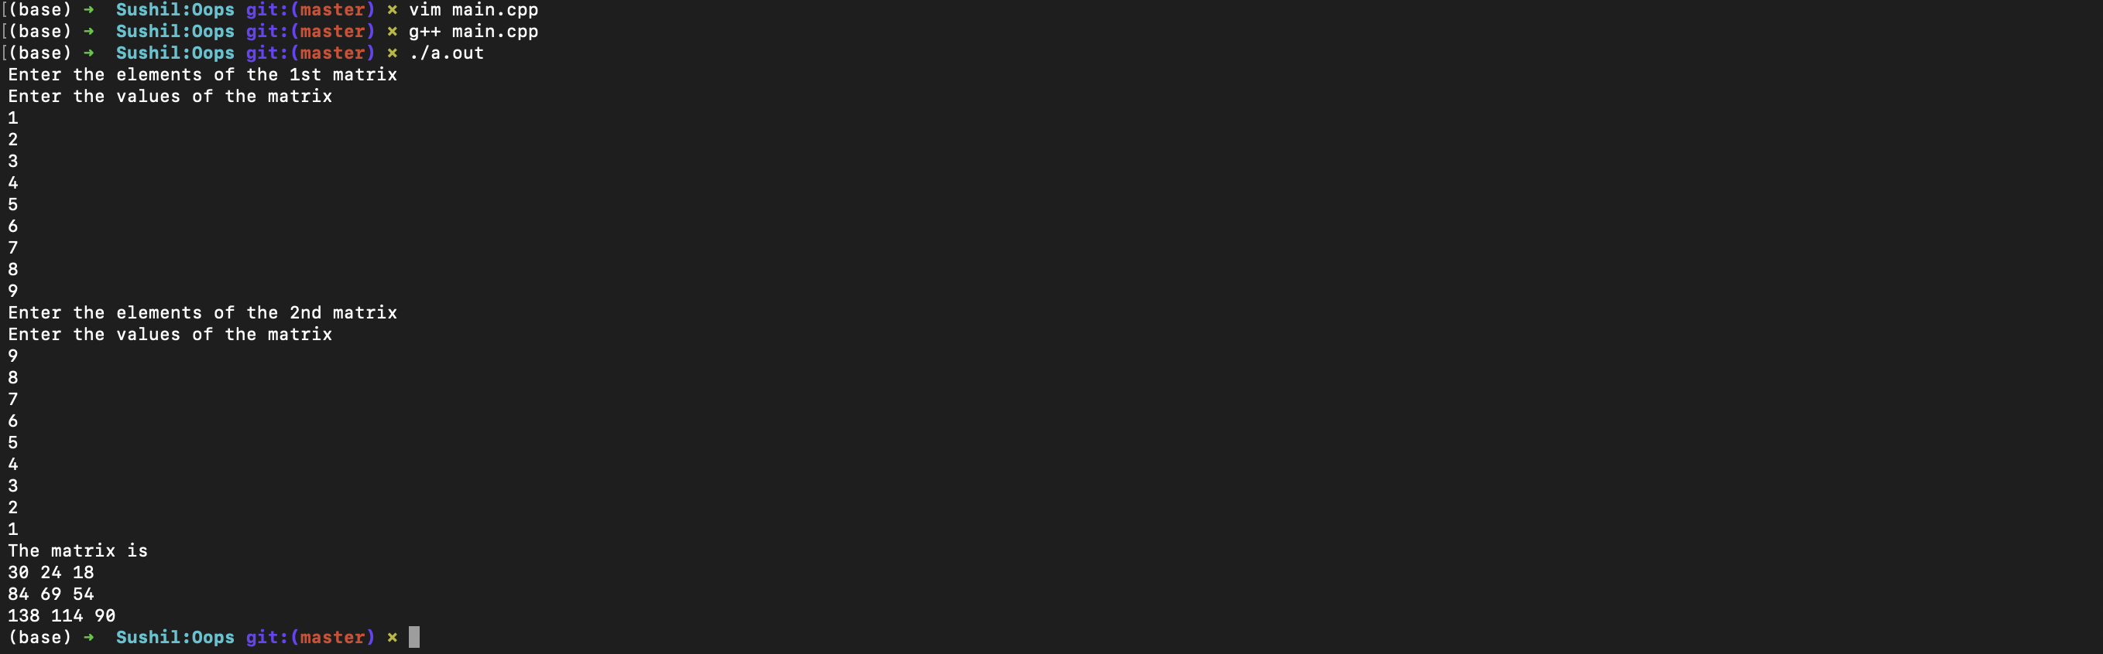

17.Write a C++ program to print the array element’s address with the help of pointers.

ANS:-
#include<iostream>
#include<stdlib.h>
using namespace std;

int main(){
int n;
cout<<"Enter the size of the array : ";
cin>>n;
int *a=(int *)malloc(n*sizeof(int));
cout<<"Enter the array elements "<<endl;
for(int i=0;i<n;i++)
cin>>*(a+i);
cout<<"The address of the array elements are "<<endl;

for(int i=0;i<n;i++)
cout<<"The address of element number "<<i<<" is "<<(long long)(a+i)<<endl;
return 0;
}

Output:-
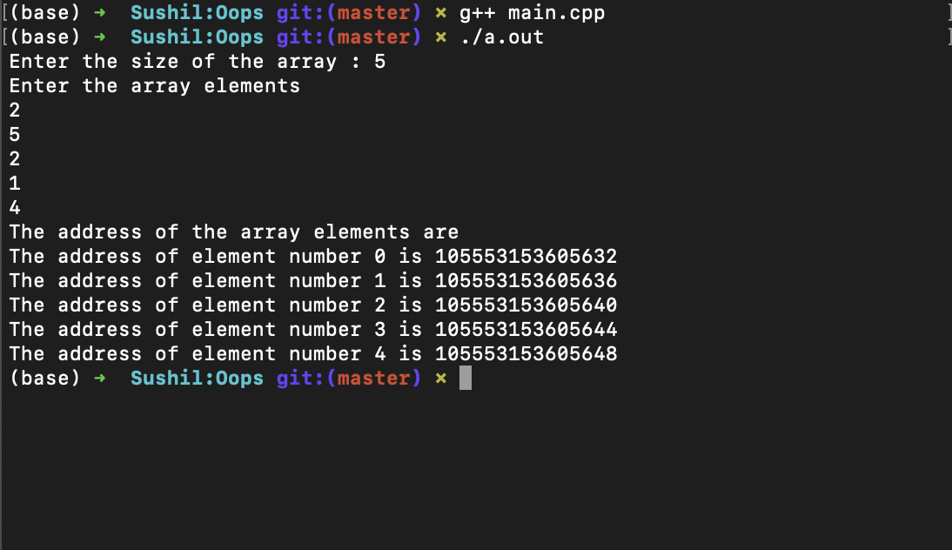

18. An electricity board charges the following rates to domestic users to discourage large consumption of energy:

For the first 100 units – 60P per unit

For the next 200 unit – 80P per unit

For beyond 300 unit – 90P per unit

All users are charged a minimum of rupee 50.00 If the total amount is more than Rs. 300 then an additional surcharge of 15% is added. WAP to read the names of users and no. of units consumed and print out the charges with names.

ANS:-
#include<iostream>
#include<string>
using namespace std;
class data{
public:
string name;
int units;
int charges;
};
int main(){
int n;
cout<<"Enter the number of the users : ";
cin>>n;
data a[n];
for(int i=0;i<n;i++){
int inicharge;
cout<<"Enter the name of the users : ";
cin>>a[i].name;
cout<<"Enter the number of units consumed by the user : ";
cin>>a[i].units;
if(a[i].units<=100)
inicharge=a[i].units*0.6;
else if(a[i].units<=300)
inicharge=60+(a[i].units-100)*0.8;
else
inicharge=220+(a[i].units-300)*0.9;
if(inicharge<=50)
a[i].charges=50;
else if(inicharge>300){
inicharge=inicharge+0.15*inicharge;
a[i].charges=inicharge;
}
else
a[i].charges=inicharge;
}
for(int i=0;i<n;i++){
cout<<"Name : "<<a[i].name<<" ";
cout<<"charges : "<<a[i].charges<<endl;
}
return 0;
}

Output:-
