**GIT-GAMEOFLIFE-REPO, MAVEN INSTALLED WITH SHELL SCRIPT, DEPLOYED ON TOMCAT SERVER**

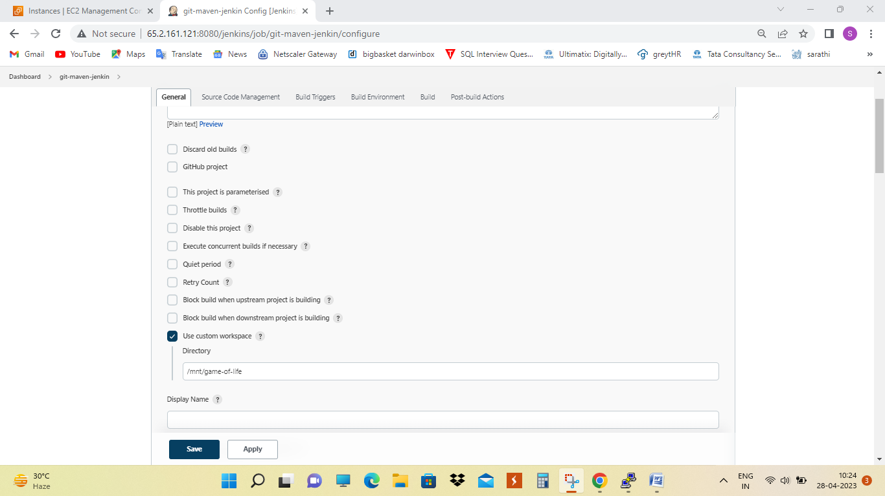

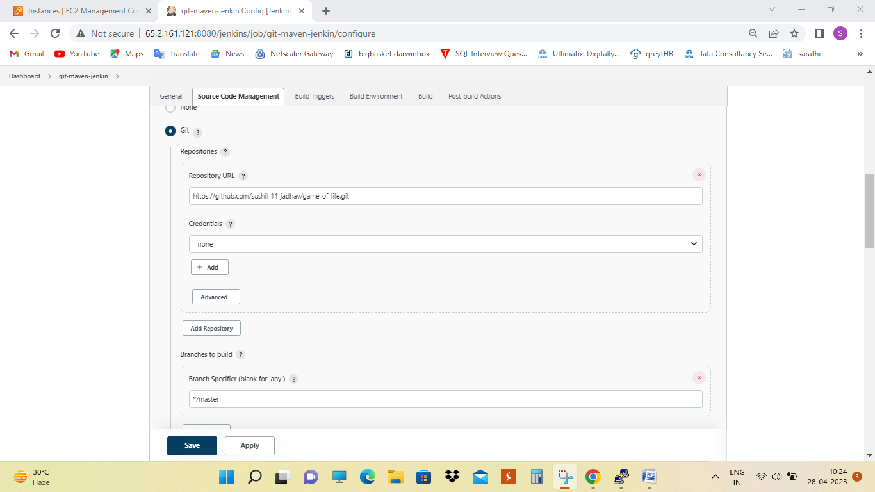

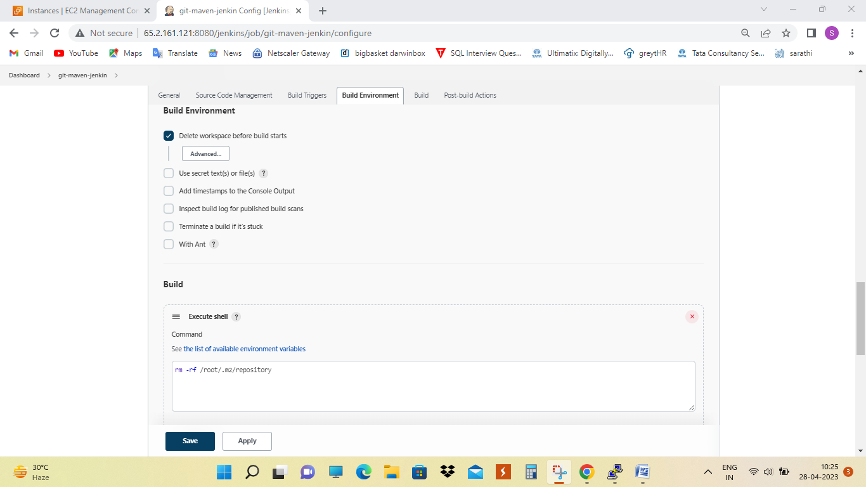

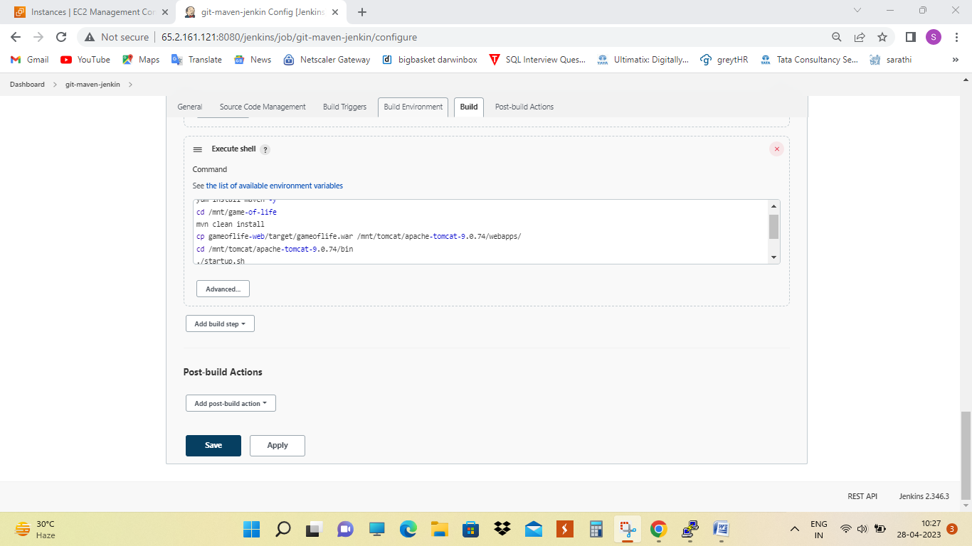

**Output**

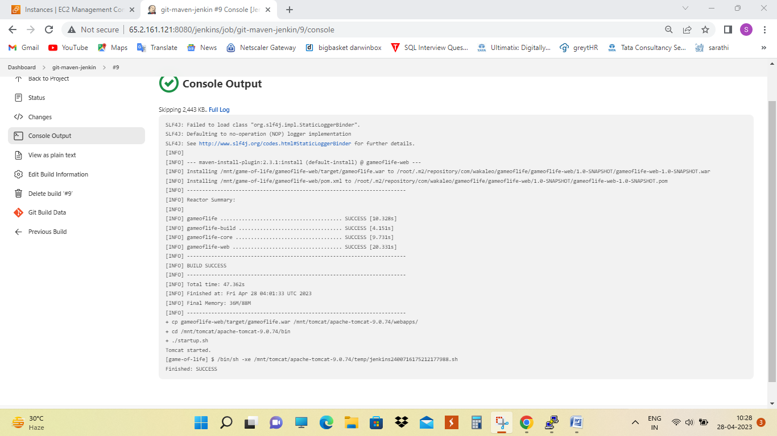

**MY JOBS**

