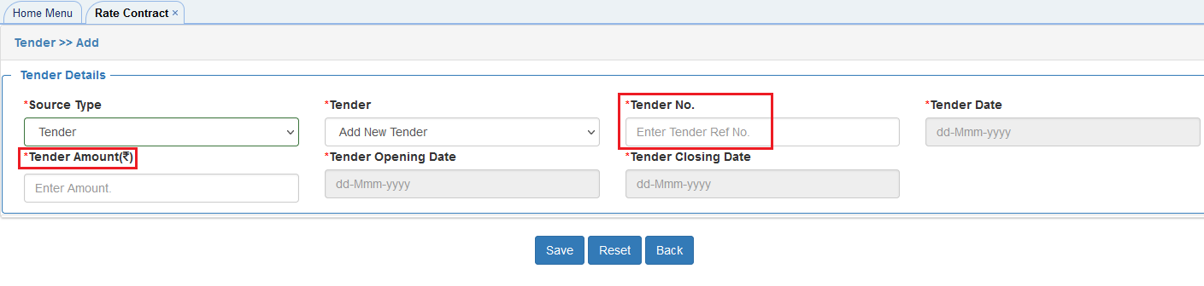

In Tender Amount Field remove mandatory and in Tender No field three or more special characters need to accept (/.-,)

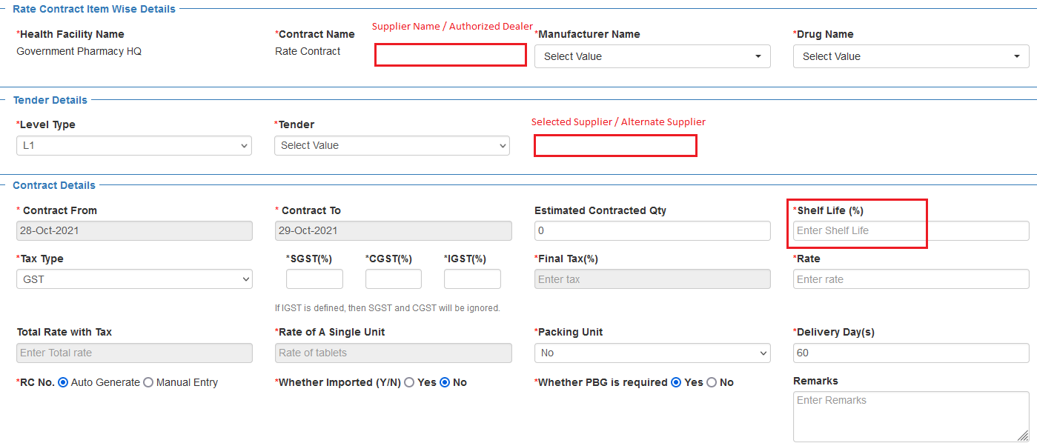

Need to add field to Select Supplier name and Authorized dealer in drop down list

Need to add field to select the Selected or Alternate Supplier in drop down List

Shelf life showing in % above and showing in days below while approving Instead change to (5/6th of the shelf life) Shelf life in days

Change to Rate of A Single unit

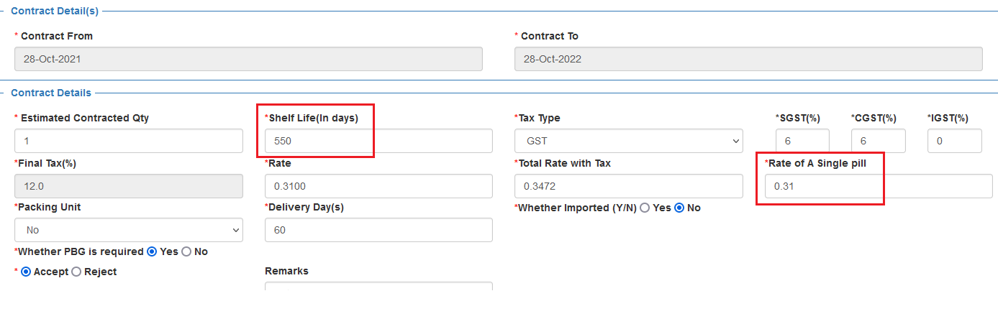

**Approving Screen**

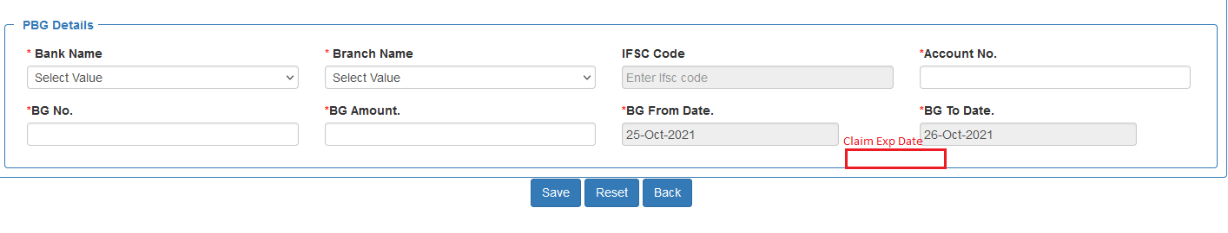

Need to add claim Expiry date filed.

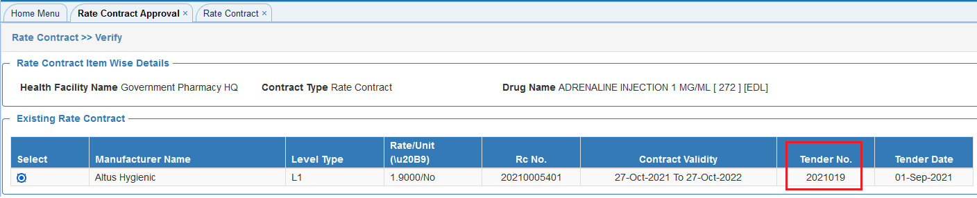

Tender no differently reflecting it should reflect as below

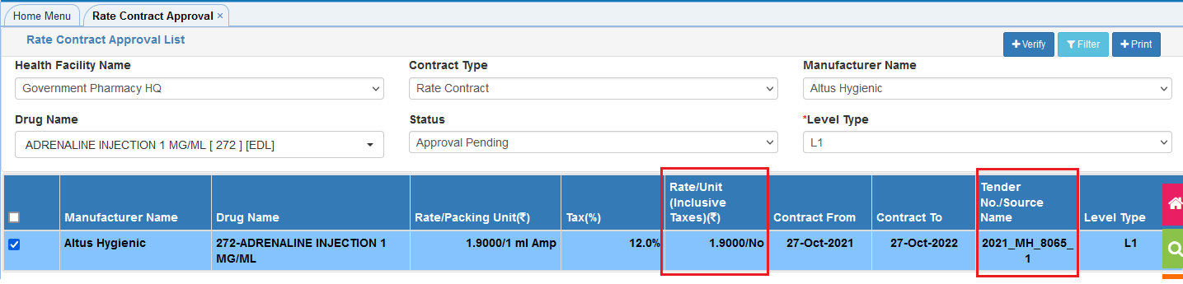

Rate inclusive of taxes showing wrong rate

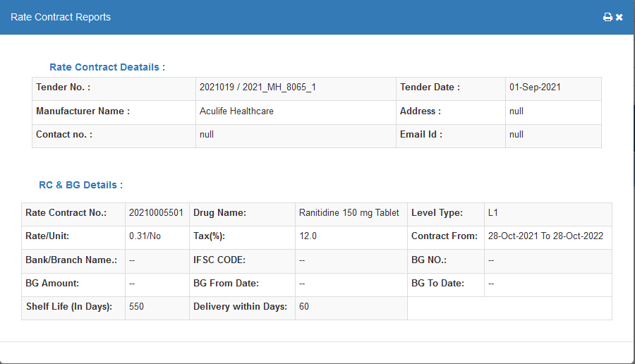

Header should be same as voucher