CAV Analytics Report
Generated: 2026-04-14 10:01:13
Total records: 3

KPI Dashboard
Total Customers: 3 | Total Revenue: $1,800.00
Average LTV: $1,166.67 | Top Channel: SEO
Avg Revenue / Customer: $600.00 | Tracked Months: 2

Charts

Revenue by Channel
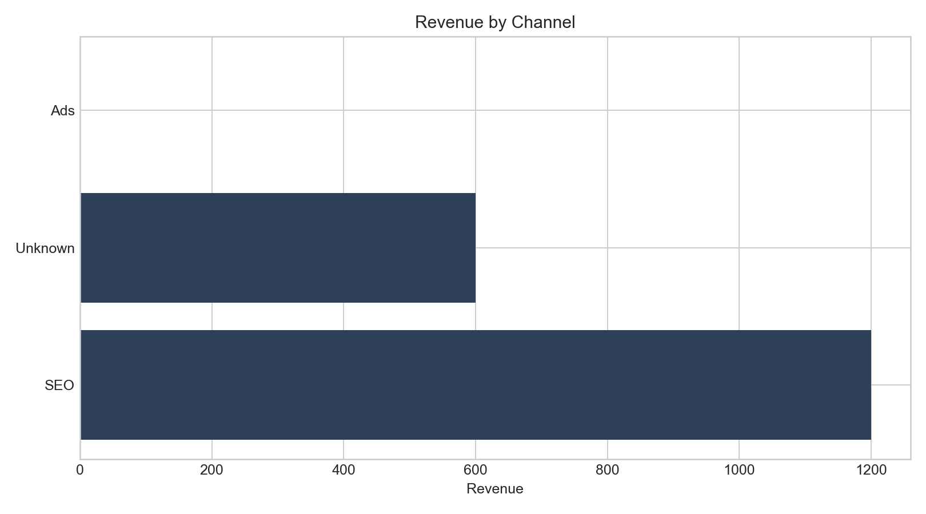

Monthly Acquisitions
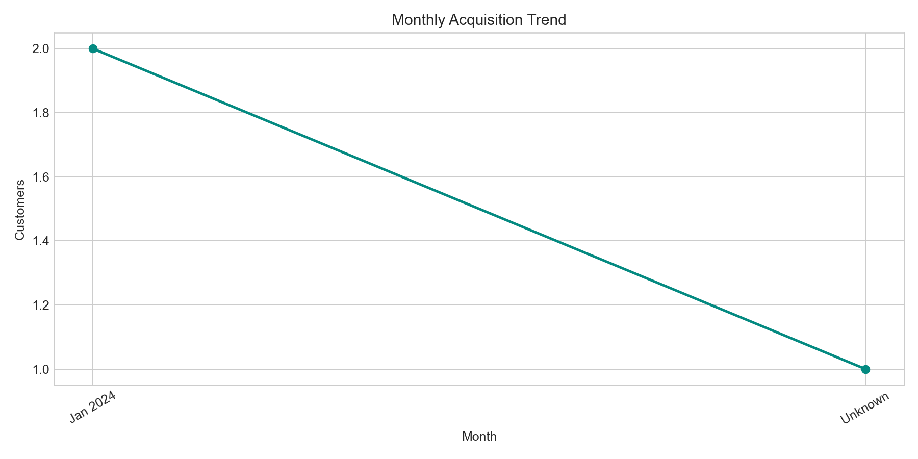

Channel Distribution
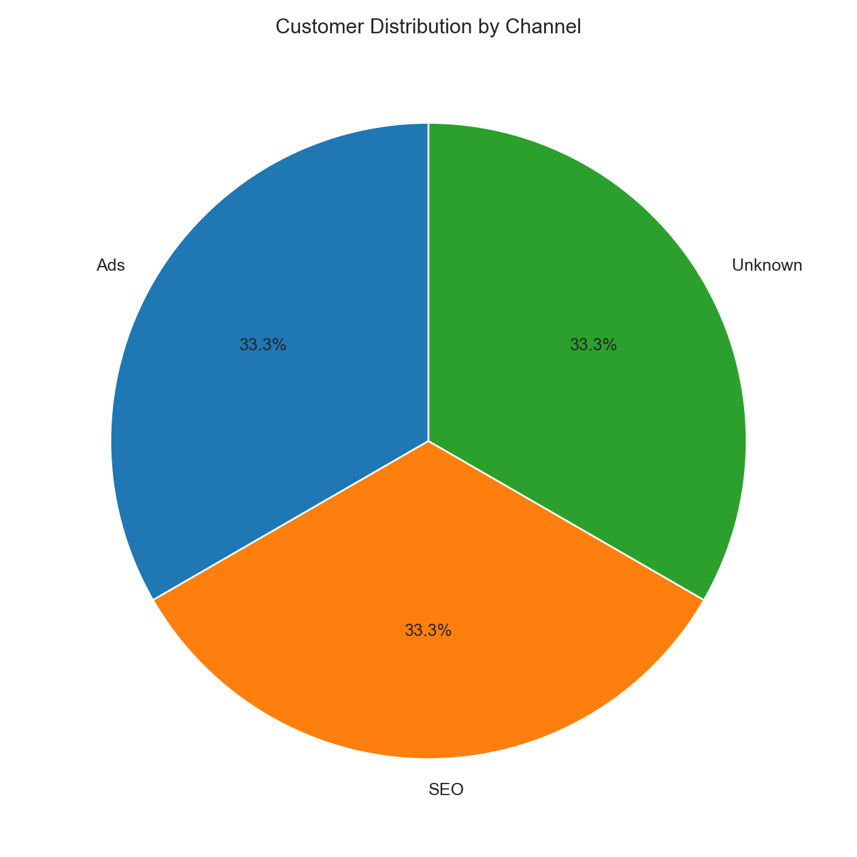

LTV by Channel
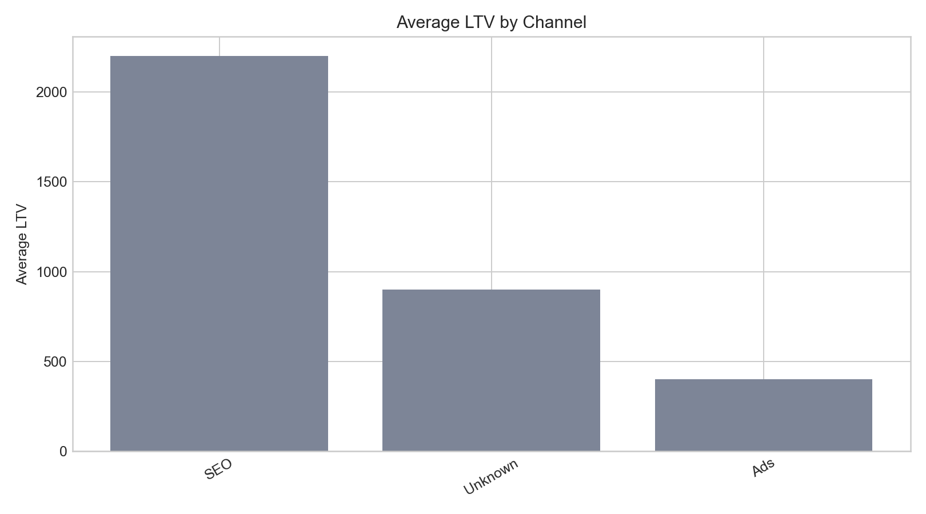

Top 10 Customers by LTV
Customer ID | Name | Channel | Revenue | LTV | Month
C001 | Alice | SEO | $1,200.00 | $2,200.00 | Jan 2024
C002 | Bob | Unknown | $600.00 | $900.00 | Jan 2024
C003 | Carol | Ads | $0.00 | $400.00 | Unknown

Insights
- Top acquisition channel is SEO.
- Average LTV is $1,166.67.
- Highest acquisition month was Jan 2024.

