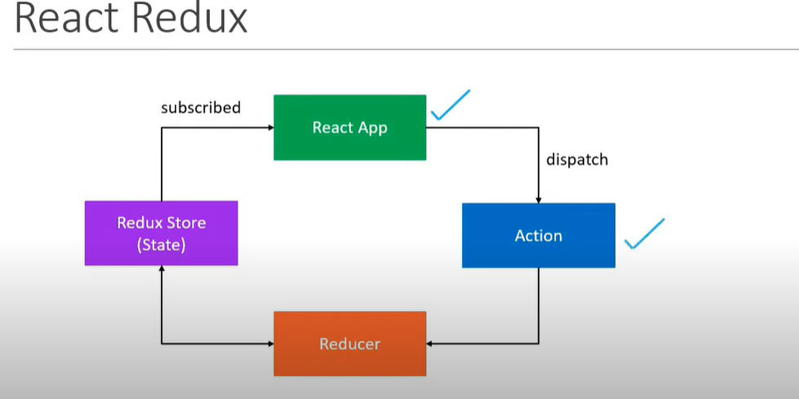

State of the application maintened in redux store and our app will subscribe redux store however app can not directly update state. If application want to update the state is should emit/dispatch action. Once action dispatch our reducer will update the state and updated value will be reflect in app as it is subscribing store.

