What is a Report?

In its simplest form, a report is a list of records (like opportunities or accounts) that meet the criteria you define. But reports are much more than simple lists. To get the data you need, you can filter, group, and do math on records. You can even display them graphically in a chart!

Every report is stored in a folder. Report folders determine how reports are accessed, and who can access them to view, edit, or manage. **Folders can be public, hidden, or shared. You control who has access to the contents of the folder based on roles, permissions, public groups, territories, and license types**. You can make a folder available to your entire organization, or make it private so that only the owner has access.

What is a Dashboard?

A dashboard is a visual display of key metrics and trends for records in your org. Each dashboard component is based on a single source report. You can use the same or different source reports for the various components in a dashboard (for example, use the same report in a bar chart and pie chart). By adding multiple dashboard components to a single dashboard page, you can create a powerful visual display of data on a common theme, such as sales performance or customer support.

Like reports, dashboards are stored in folders. If you have access to a folder, you can view its dashboards. To view the individual dashboard components, you also need access to the underlying reports.

**Each dashboard has a running user, whose security settings determine which data to display in a dashboard.** If the running user is a specific user, all dashboard viewers see data based on the security settings of that user—regardless of their own personal security settings. For this reason, you’ll want to choose the running user wisely, so as not to open up too much visibility. For example, set the sales manager as the running user for a leaderboard for her team. This allows her team members to view the leaderboard for their individual team, but not other teams.

Dynamic dashboards are dashboards for which the running user is always the logged-in user. This way, each user sees the dashboard according to his or her own access level. If you’re concerned about too much access, dynamic dashboards might be the way to go.

What is a Report Type?

**A report type is like a template that makes reporting easier. The report type determines which fields and records are available for use when creating a report. This is based on the relationships between a primary object and its related objects.**

Reports display only records that meet the criteria defined in the report type. Out of the box, Salesforce provides a set of predefined standard report types. Don’t see all the fields you want? You might need to create a custom report type.

**A report type determines which fields and records are available for use when creating a report. Each report type has a primary object relationship and a field layout.**

1. **Primary Object with Related object.**
2. **Primary Object with or without related Object**

You can’t edit standard report types.

# **Types of Filters in Reports**

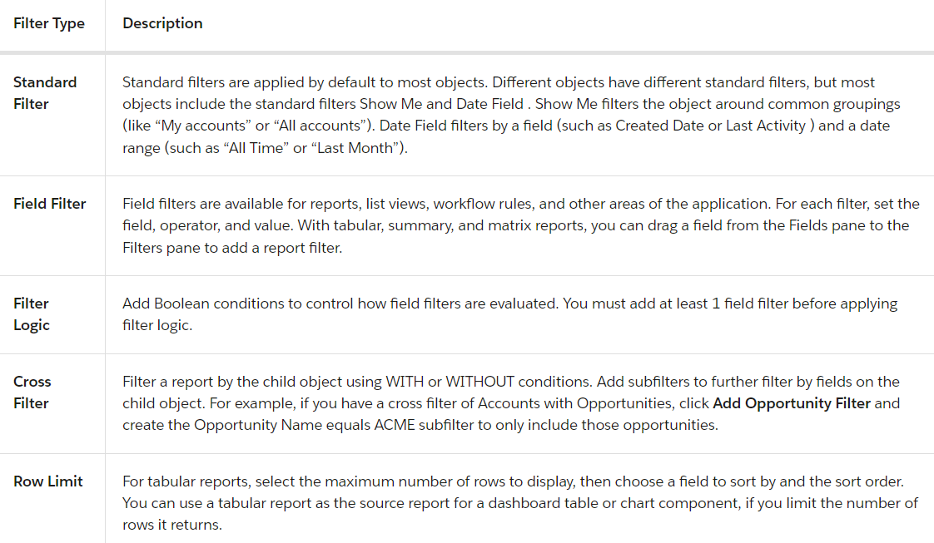

**Every time you add a filter, revisit your filter logic to make sure it’s still correct. Filter logic doesn’t apply to cross filters.**

Format of Reports

There are three formats of Reports available:

1. Tabular
2. Summary
3. Matrix