Heart Disease Risk Prediction – End-to-End MLOps Pipeline
  - MLOps (AIMLCZG523) – Assignment 1
Sushil Dubey
October 2026
Table of Contents

1. Summary
This project builds a binary classifier that predicts whether a patient has heart disease from 13 routine clinical measurements (UCI Heart Disease, Cleveland subset). It also delivers the whole production setup around the model: scripted data acquisition, EDA, a reproducible sklearn pipeline, MLflow experiment tracking, automated tests, a GitHub Actions CI/CD pipeline, a Docker image serving a FastAPI /predict endpoint, Kubernetes manifests (Deployment, LoadBalancer Service, HPA, optional Ingress), and monitoring with Prometheus and Grafana.
Item | Value
Code repository | https://github.com/sushil32/heart-risk-mlops
Video walkthrough | Google Drive Video Link (https://drive.google.com/file/d/1B5Q_ZFFDnhU_ME6vB6uXpXcSQjFW-JAG/view?usp=sharing)
Champion model | Logistic Regression (C = 1.0, class_weight = balanced)
Cross-validated ROC-AUC (5-fold, train split) | 0.908
Hold-out test ROC-AUC / accuracy / recall | 0.960 / 0.902 / 0.929
API access (local K8s) | http://localhost:8080 (Docker Desktop LoadBalancer)
API access (Docker) | http://localhost:8000, Swagger at /docs

2. Setup and installation
Prerequisites: Python 3.11, Docker Desktop (with Kubernetes enabled for section 9), git.
git clone https://github.com/sushil32/heart-risk-mlops.git && cd heart-risk-mlops
python3.11 -m venv .venv && source .venv/bin/activate
pip install -r requirements.txt && pip install -e .
python scripts/download_data.py # fetch + clean the dataset
python scripts/eda.py # EDA figures -> reports/figures
python -m heartrisk.train # train, tune, track (MLflow) and export the champion model
pytest --cov=heartrisk # 24 unit tests
docker compose up -d --build # API + Prometheus + Grafana
./scripts/deploy_k8s.sh # deploy to Docker Desktop Kubernetes
There are two dependency files. requirements.txt has everything needed for training, tracking, tests and lint. requirements-serve.txt has only what the API needs at runtime, which keeps the Docker image small and reduces its attack surface. All versions are pinned, so a fresh environment always resolves the same way.
Repository layout
src/heartrisk/ data.py, features.py, train.py, api.py (installable package)
scripts/ download_data.py, eda.py, load_test.py, make_architecture.py, deploy_k8s.sh
tests/ test_data.py, test_model.py, test_api.py, conftest.py
data/raw, data/processed raw UCI file and cleaned CSV
models/ model.joblib + metadata.json (champion)
k8s/ namespace, deployment+configmap, service+HPA, optional ingress
monitoring/ prometheus.yml, Grafana provisioning + dashboard JSON
.github/workflows/ ci.yml
reports/, screenshots/ figures, EDA summary, model comparison, screenshots

3. Architecture
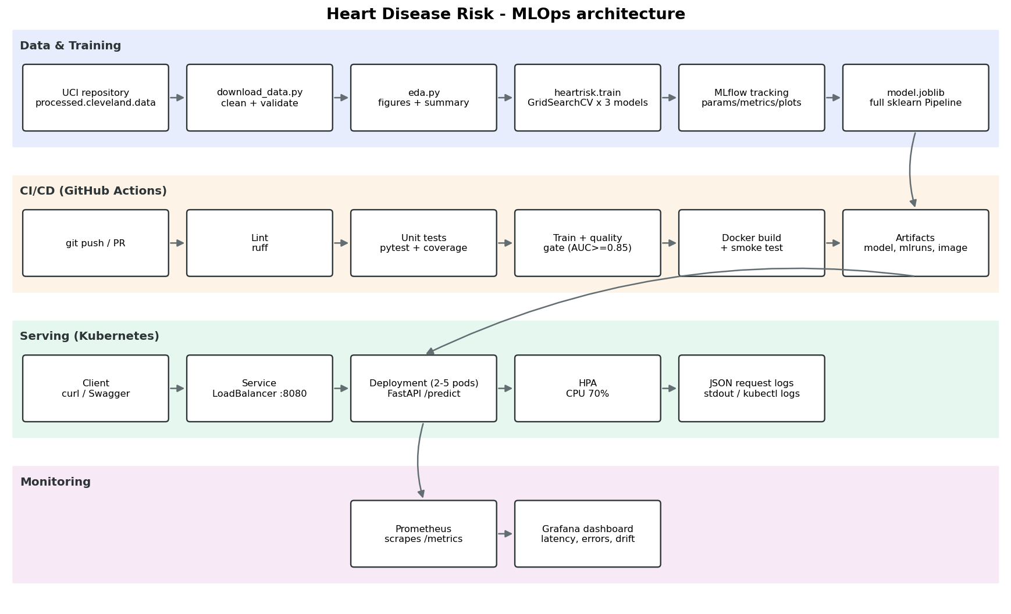
System architecture
There are four layers. (1) Data and training: data is downloaded and validated, EDA figures are produced, three model families are tuned, and every run is tracked in MLflow; the best pipeline is exported as a single artefact. (2) CI/CD: every push runs lint, tests, training with a quality gate, and an image build with a smoke test. (3) Serving: the image runs as a Kubernetes Deployment with two to five replicas behind a LoadBalancer. (4) Monitoring: Prometheus scrapes /metrics, Grafana shows service and model health, and every request is logged as structured JSON.

4. Data acquisition and cleaning
scripts/download_data.py downloads processed.cleveland.data from the UCI repository, records its SHA-256 fingerprint, and writes data/processed/heart_clean.csv. The cleaning logic is in heartrisk.data.clean() and is covered by unit tests. It does the following:
- parses ? as missing and converts every column to numeric;
- validates domain ranges (e.g. cholesterol 100–650 mg/dl, max heart rate 60–230) and allowed category codes (e.g. thal ∈ {3, 6, 7}), setting anything invalid to missing instead of letting it pass silently;
- binarises the target: num > 0 becomes 1 (disease), num = 0 becomes 0;
- removes exact duplicates.
The raw file has 303 rows. Only 6 cells are missing: ca = 4 and thal = 2. These are kept as NaN in the cleaned CSV on purpose and imputed inside the model pipeline, so the imputation statistics are learned only from the training folds. Imputing before the split would leak information from validation and test data into training.

5. Exploratory data analysis
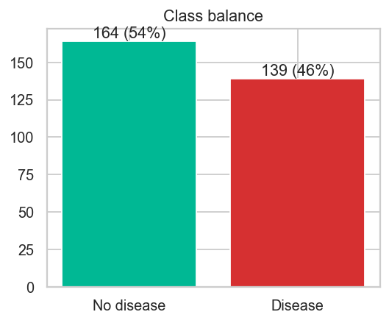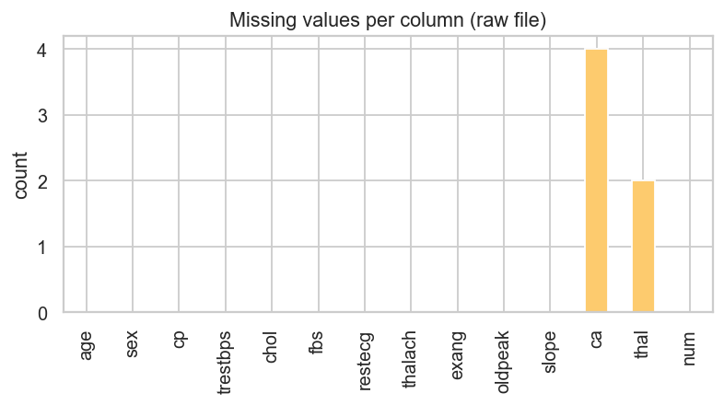
The classes are close to balanced: 164 patients without disease (54%) and 139 with disease (46%). Accuracy is therefore a meaningful metric. ROC-AUC and recall are still tracked because, in a screening setting, missing a sick patient costs more than a false alarm.
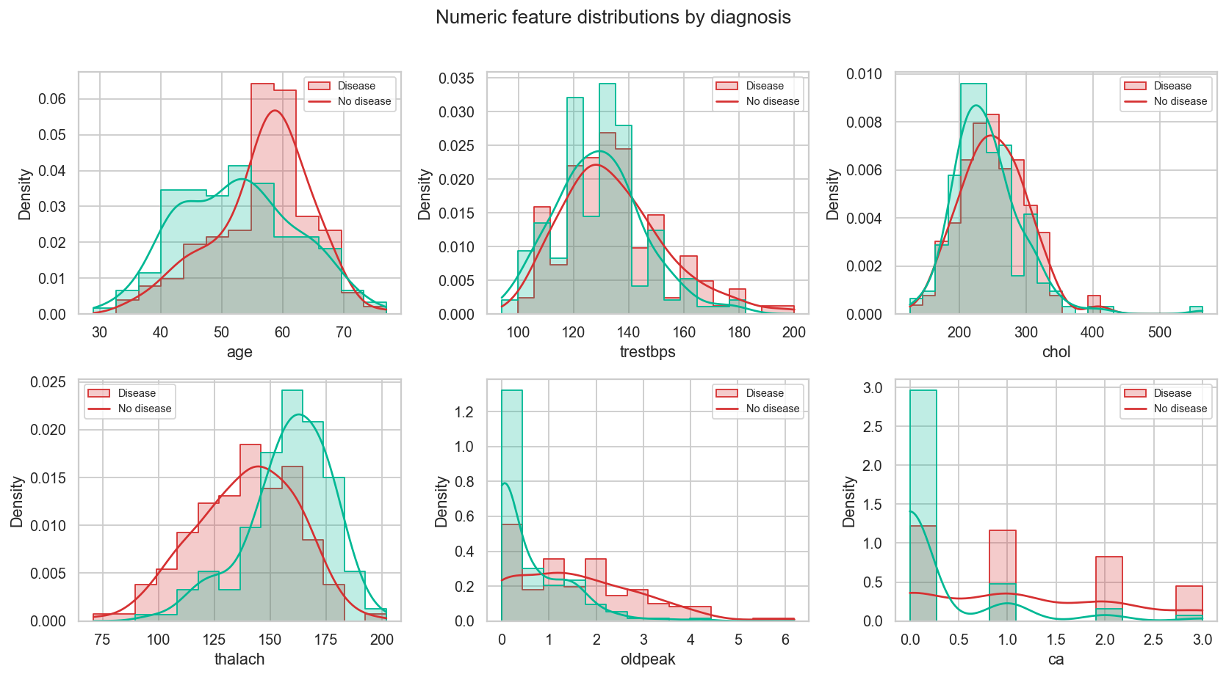
Numeric feature distributions by diagnosis
Patients with disease reach a clearly lower maximum heart rate (thalach), have higher ST depression (oldpeak), and have more major vessels coloured (ca). Age is shifted only slightly. Cholesterol and resting blood pressure barely separate the two classes.
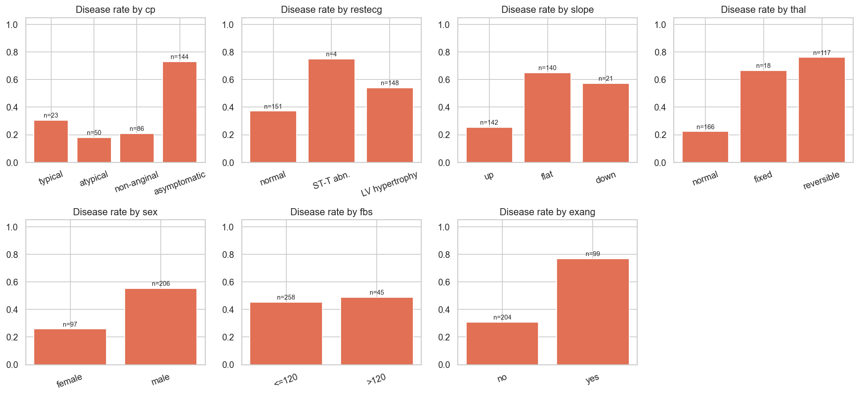
Disease rate per category
Disease rate by category shows strong categorical signals. Asymptomatic chest pain (cp = 4, 73%), a reversible thalium defect (thal = 7, 76%) and exercise-induced angina (77%) go with the highest disease rates. A flat ST slope (65%) and male sex (55% vs 26% for women) also raise risk. Fasting blood sugar is almost uninformative (45% vs 49%).
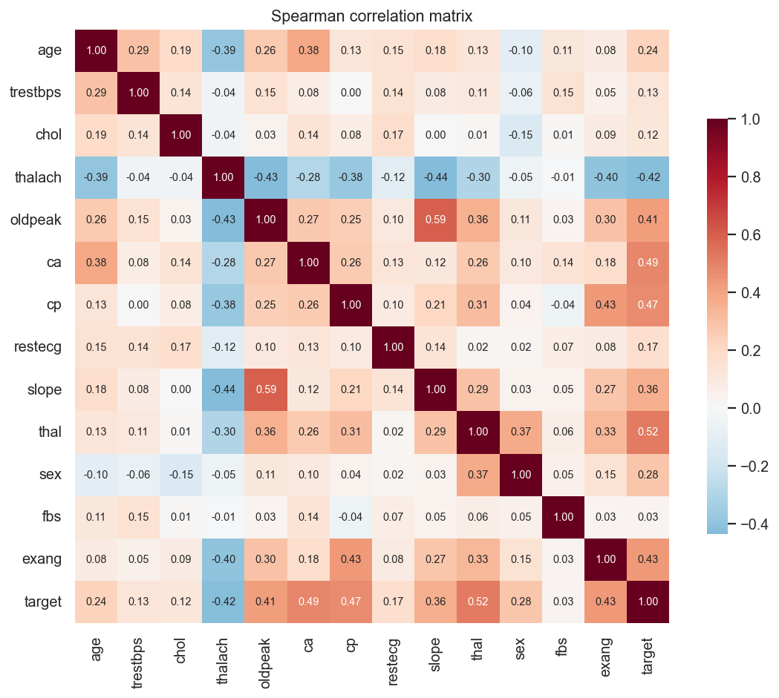
Spearman correlation matrix
The strongest Spearman correlations with the target are thal (0.52), ca (0.49), cp (0.47), exang (0.43), thalach (−0.42) and oldpeak (0.41). No pair of features is so highly correlated that one must be dropped, so all 13 features are kept. Boxplots (eda_boxplots.png) show a few high cholesterol values (up to 564 mg/dl). They are clinically possible, so they are kept, and scaling plus tree models handle them.
Engineered feature. Because thalach is strongly predictive but naturally falls with age, I added a heart-rate reserve ratio, thalach / (220 − age): the share of the age-predicted maximum heart rate the patient reached. Values well below 1 indicate chronotropic incompetence. Its distribution (below) is clearly shifted lower for patients with disease. A coarse age_band feature was also added so the linear model can capture non-linear age risk.
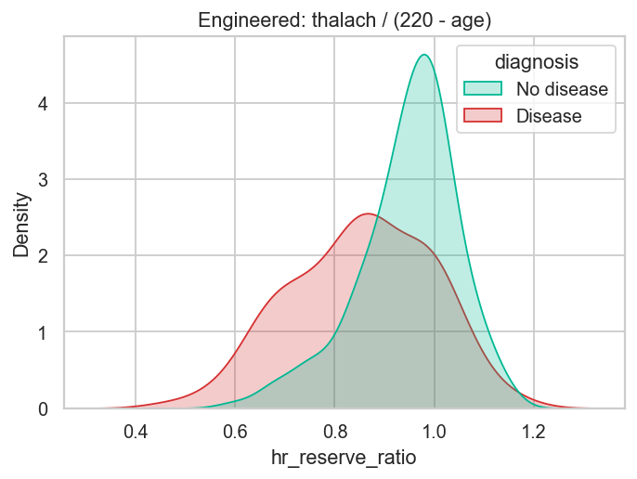
Engineered heart-rate reserve ratio

6. Feature engineering and model development
Pipeline. All preprocessing lives in a single sklearn Pipeline, so training and serving use exactly the same code path:
- ClinicalFeatures (custom transformer): adds hr_reserve_ratio and age_band.
- ColumnTransformer:
  - numeric (age, trestbps, chol, thalach, oldpeak, ca, hr_reserve_ratio): median imputation, then StandardScaler;
  - categorical (cp, restecg, slope, thal, age_band): most-frequent imputation, then OneHotEncoder (handle_unknown="ignore", so an unseen code at inference time does not crash the API);
  - binary (sex, fbs, exang): most-frequent imputation.
- Classifier.
Models and tuning. The data is split 80/20 with stratification (seed 42). Three model families are tuned with GridSearchCV using 5-fold stratified CV on the training split, with roc_auc as the refit metric:
Model | Grid | Grid size
Logistic Regression | C ∈ {0.01, 0.1, 1, 10}, class_weight ∈ {None, balanced} | 8
Random Forest | n_estimators ∈ {200, 400}, max_depth ∈ {None, 4, 8}, min_samples_leaf ∈ {1, 4} | 12
Gradient Boosting | n_estimators ∈ {100, 200}, learning_rate ∈ {0.05, 0.1}, max_depth ∈ {2, 3} | 8
Results (CV = mean of 5 folds on the training split; test = 61-patient hold-out):
Model | CV acc | CV prec | CV recall | CV ROC-AUC | Test acc | Test recall | Test ROC-AUC
Logistic Regression | 0.843 | 0.850 | 0.802 | 0.908 | 0.902 | 0.929 | 0.960
Random Forest | 0.814 | 0.828 | 0.755 | 0.901 | 0.869 | 0.893 | 0.952
Gradient Boosting | 0.826 | 0.836 | 0.783 | 0.878 | 0.902 | 0.929 | 0.968
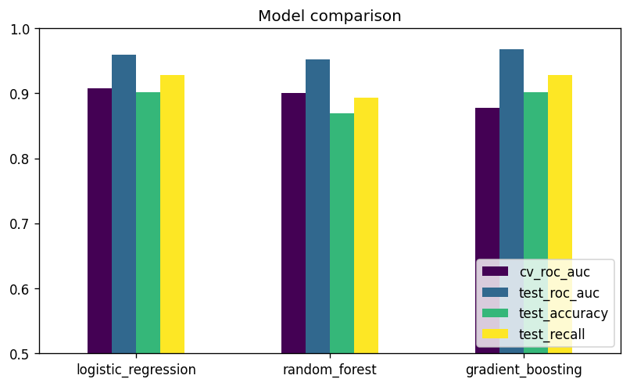
Model comparison
Selection. The champion is chosen by mean CV ROC-AUC, not test score. With only 61 test patients a single misclassification moves accuracy by 1.6 points, so the test set is used only for the final report. Gradient Boosting has the best test AUC but the lowest CV AUC, which points to variance rather than a real advantage. Logistic Regression wins on every CV metric, and it is also the most interpretable and the fastest to serve. Its largest absolute coefficients agree with the EDA: male sex, ca, asymptomatic chest pain, and a reversible thal defect. The champion is refit on all 303 rows before export.
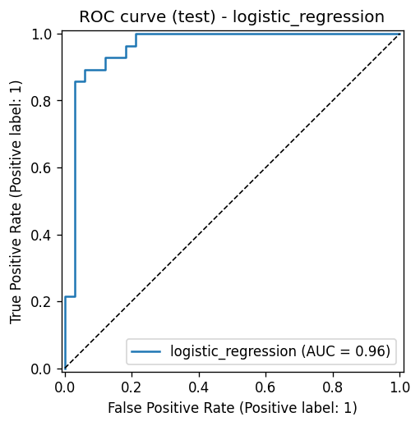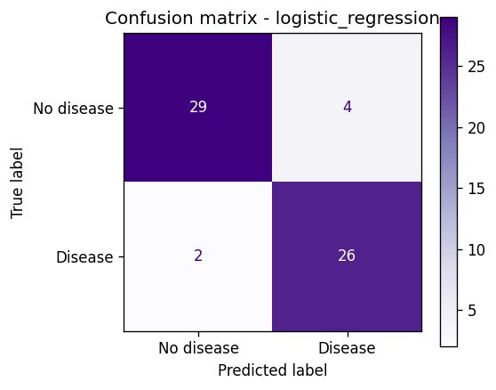

7. Experiment tracking (MLflow)
heartrisk.train logs to the MLflow experiment heart-disease-risk:
- One parent run per model family with: best hyper-parameters, grid size, CV folds, train/test sizes; CV mean and std for accuracy, precision, recall, F1 and ROC-AUC; test metrics; plots (ROC curve, confusion matrix, feature importance); the full cv_results_ CSV; and the fitted pipeline as an MLflow model with input signature, input example and bundled source code (code_paths), so it loads without the repo.
- One nested child run per grid candidate: 28 runs, each with its parameters and CV metrics, so every configuration tried can be inspected and compared in the UI.
- A champion-* run tagged stage=champion that holds the final refit model, metadata.json and the comparison chart.
That gives 32 tracked runs per training execution. The UI is started with mlflow ui --backend-store-uri ./mlruns. In CI the mlruns/ folder is uploaded as a build artifact.
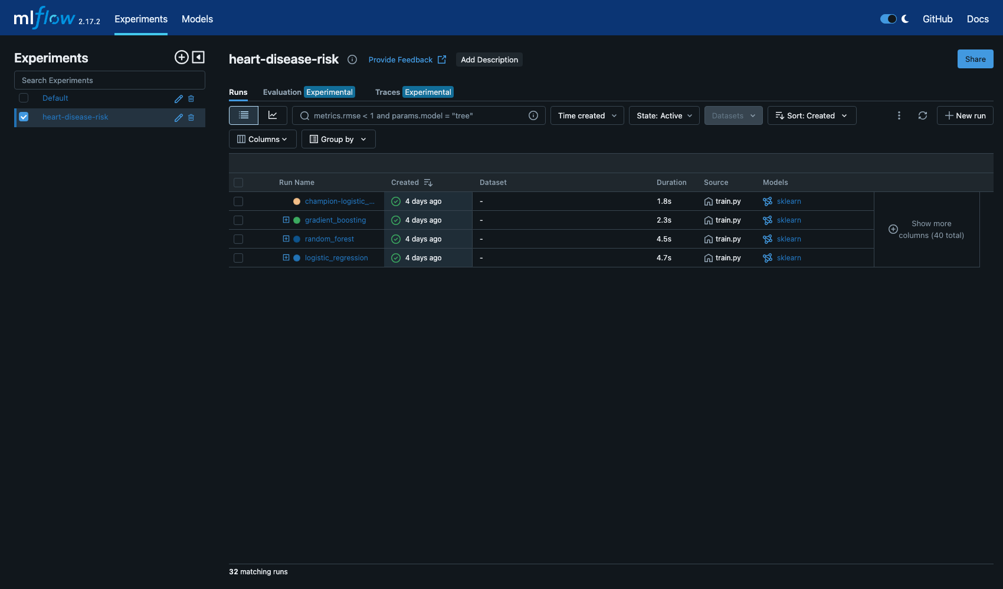
MLflow experiment view

8. Packaging, reproducibility and testing
- Model format: models/model.joblib holds the full sklearn pipeline (feature engineering, preprocessing and classifier), so raw patient JSON goes straight in. models/metadata.json stores the model name, version, training timestamp, feature list, best parameters, metrics and the MLflow run id; the API reports it. The same model is also stored in MLflow format.
- Reproducibility: pinned dependencies, fixed random seeds (split, CV folds and models), the package is installed with pip install -e ., and data is fetched by a script with a checksum log.
- Unit tests (24, pytest):
  - test_data.py: ? parsing, target binarisation, duplicate removal, invalid values become missing, schema, no mutation of the input.
  - test_model.py: engineered feature values, imputation and scaling output, unseen categories, the pipeline learns signal (AUC > 0.7 on synthetic data), metric function, feature-importance alignment, grid naming, and a joblib save/load round-trip with identical predictions.
  - test_api.py: /health, /predict schema and confidence range, optional fields, 422 on invalid or missing inputs, /metrics contents, and structured JSON request logs.
- The tests use a synthetic fixture dataset, so they need no network access and run in about 2 seconds.

9. CI/CD pipeline (GitHub Actions)
.github/workflows/ci.yml runs on every push to main, on pull requests, and on manual dispatch. Each job depends on the previous one, so a failure stops the pipeline with a clear log:
Job | Steps | Artifacts
lint | ruff check (with GitHub annotations), ruff format --check | –
test | install, pytest -v --cov, JUnit XML | test-results/ (JUnit + coverage)
train | download data, EDA, train, quality gate (fails if champion CV ROC-AUC < 0.85), model table in job summary | model/, training-artifacts/ (mlruns, figures, log, clean CSV)
docker | build image with the freshly trained model, run it, wait for /health, POST both samples and check the response, confirm invalid input returns 422, check /metrics | docker-image-and-logs/ (image tarball, container log)
I checked locally that the lint gate fails the build: an over-long line in an early version was rejected before any test ran.
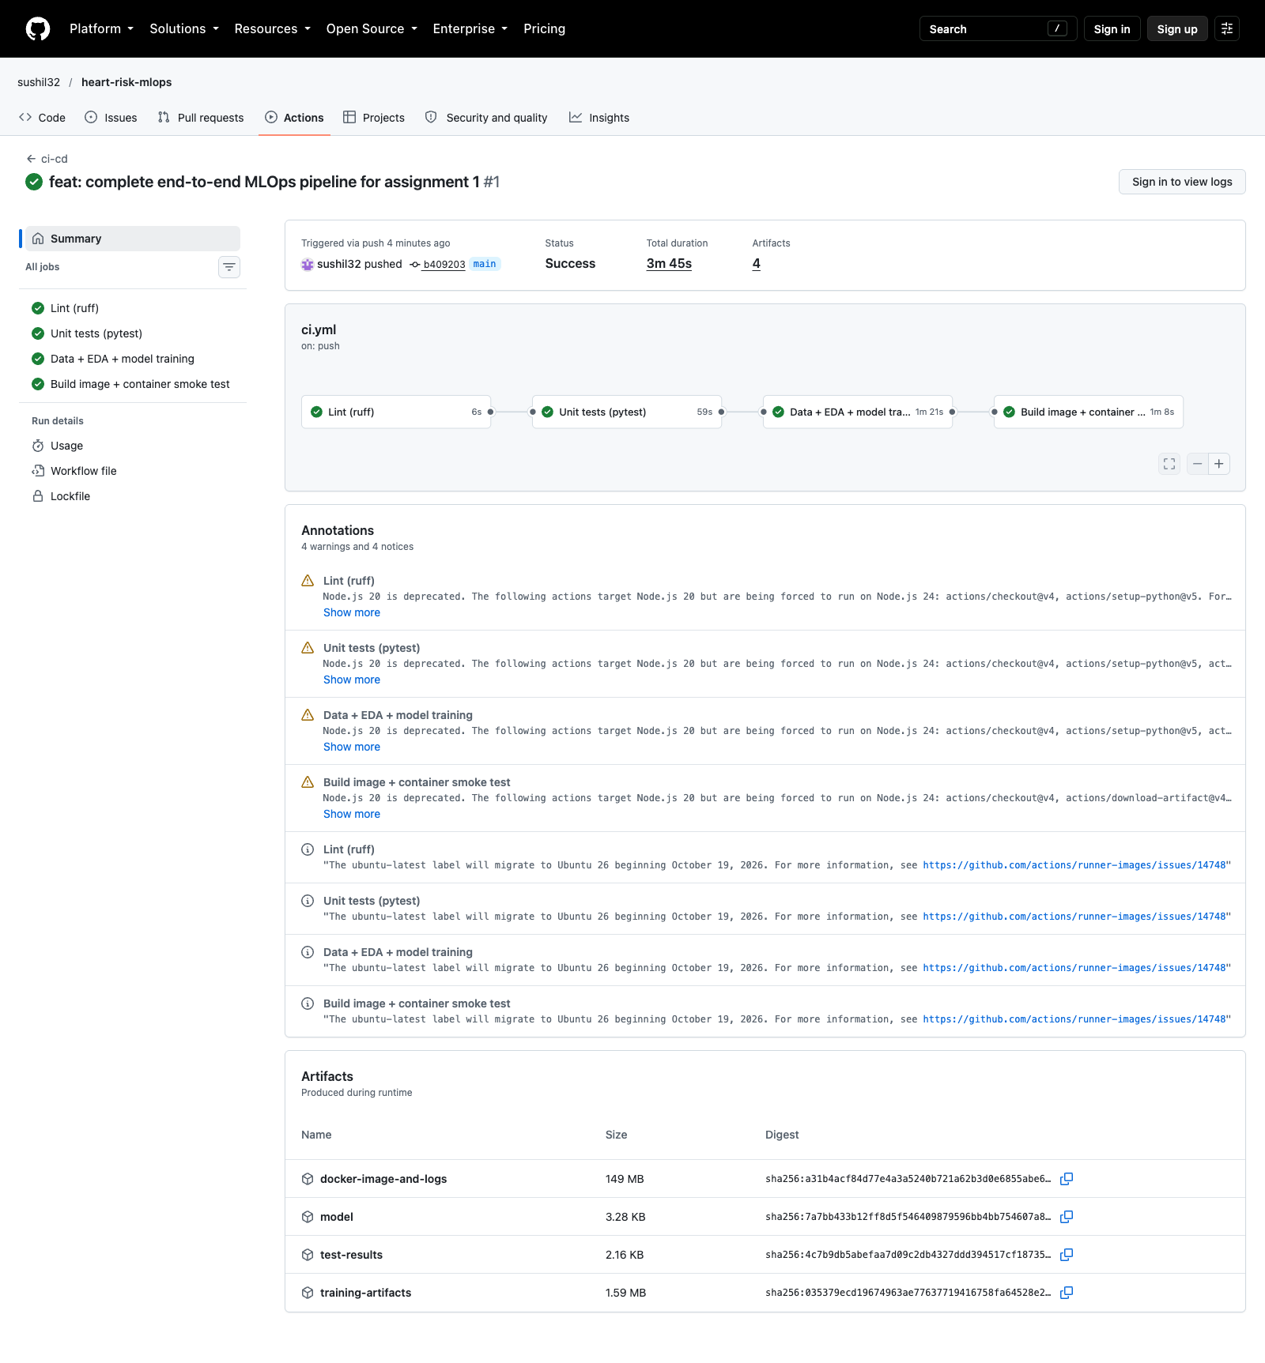
GitHub Actions run

10. Containerisation and deployment
Docker image. Based on python:3.11-slim, it installs only the serving dependencies plus the heartrisk package and copies in the model. It runs as a non-root user (uid 10001), has a HEALTHCHECK, and uses an allow-list .dockerignore so data, venvs and mlruns never enter the build context.
$ curl -X POST localhost:8000/predict -H 'Content-Type: application/json' -d @samples/patient_high_risk.json
{"prediction":1,"label":"heart_disease","confidence":0.9969,"probability_disease":0.9969,
"model_name":"logistic_regression","model_version":"1.0.0"}
$ curl -X POST localhost:8000/predict -H 'Content-Type: application/json' -d @samples/patient_low_risk.json
{"prediction":0,"label":"no_heart_disease","confidence":0.7577,"probability_disease":0.2423, ...}
The request is validated with Pydantic, using clinical ranges and allowed codes; invalid input gets an HTTP 422 with a field-level message. ca and thal are optional because they are the fields most often missing in practice, and the pipeline imputes them.
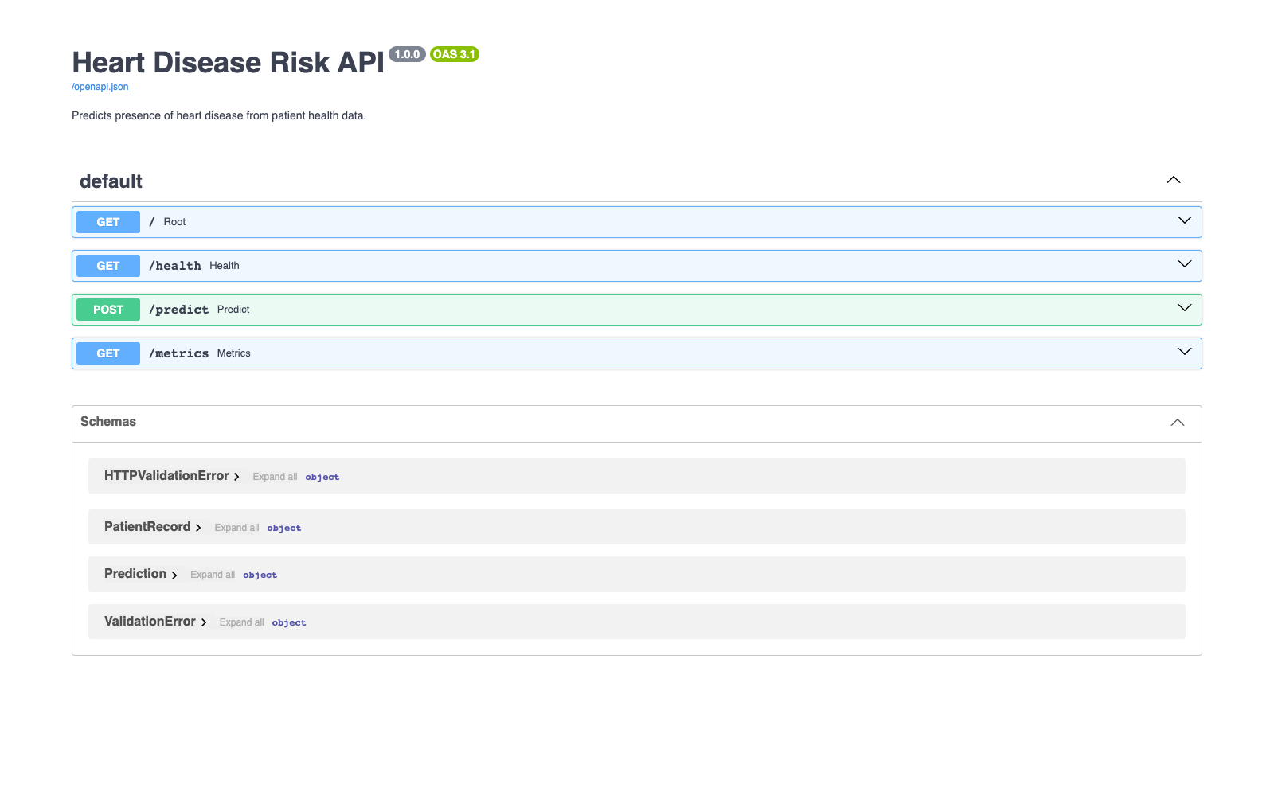
Swagger UI
Kubernetes (Docker Desktop). The manifests in k8s/:
- 00-namespace.yaml: namespace heart-risk.
- 10-deployment.yaml: ConfigMap plus a Deployment with 2 replicas, a zero-downtime rolling update (maxUnavailable: 0), readiness and liveness probes on /health, CPU and memory requests/limits, runAsNonRoot, a read-only root filesystem, and Prometheus scrape annotations.
- 20-service.yaml: a LoadBalancer Service on port 8080 (Docker Desktop publishes it on localhost) and an HPA that scales from 2 to 5 pods at 70% CPU.
- optional/ingress.yaml: an ingress-nginx route for heart-risk.local.
scripts/deploy_k8s.sh builds the image, applies the manifests, waits for the rollout and calls the endpoints.
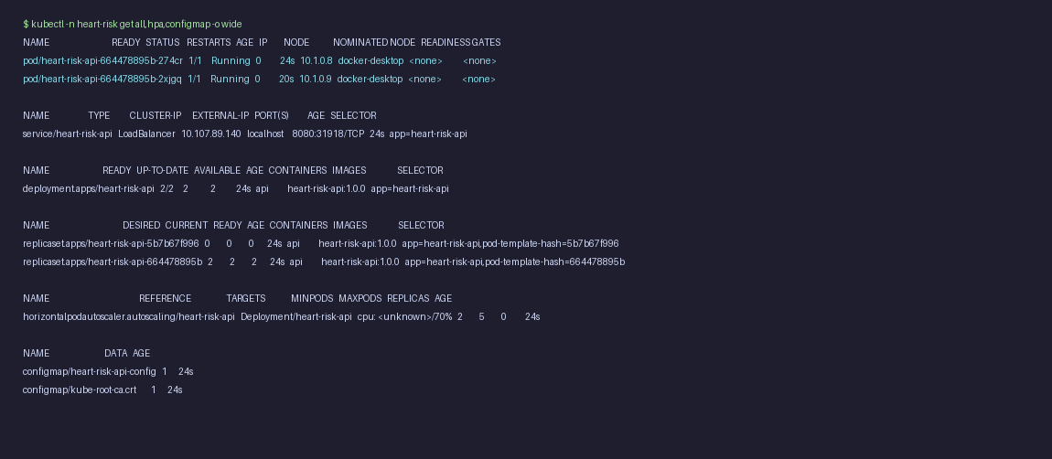
kubectl resources
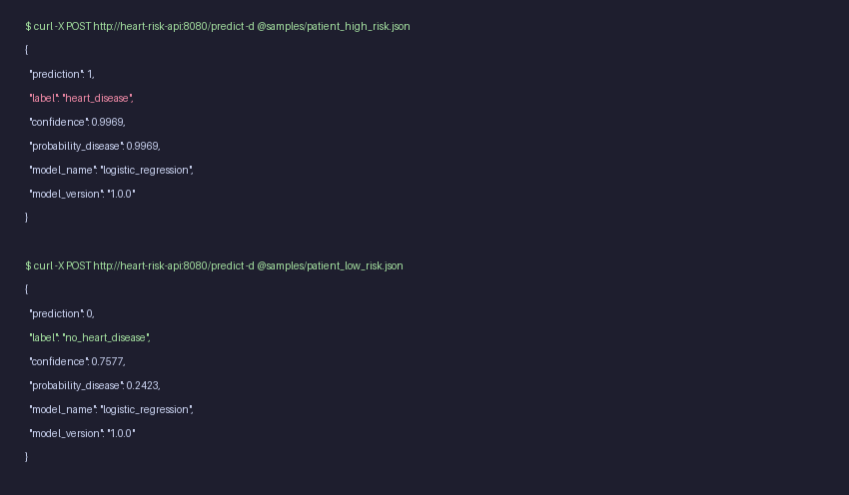
Prediction through the Kubernetes LoadBalancer

11. Monitoring and logging
Logging. An HTTP middleware writes one JSON line per request: timestamp, request id (also returned in the x-request-id header), method, path, status, latency in ms, and client. Each prediction also logs its label and confidence. JSON logs can be read with kubectl logs or docker compose logs and can be shipped to Loki or ELK without parsing rules.
Metrics (/metrics, Prometheus format): heartrisk_http_requests_total{method,path,status}, heartrisk_http_request_duration_seconds (histogram), heartrisk_predictions_total{label}, heartrisk_prediction_confidence (histogram) and heartrisk_model_loaded{model_name,version}.
Dashboard. docker compose up starts the API, Prometheus (5-second scrape interval) and Grafana with the datasource and dashboard already provisioned. Panels: requests/s, error rate, p95 latency, total predictions, traffic by path and status, p50/p95/p99 latency, predicted class mix, positive prediction rate over time (a simple prediction-drift signal: in production a sudden change away from the training base rate of about 46% would trigger an investigation), and the confidence distribution (a rising share of low-confidence predictions suggests input drift). scripts/load_test.py generates realistic traffic with a configurable share of invalid payloads, which is how the screenshot below was produced.
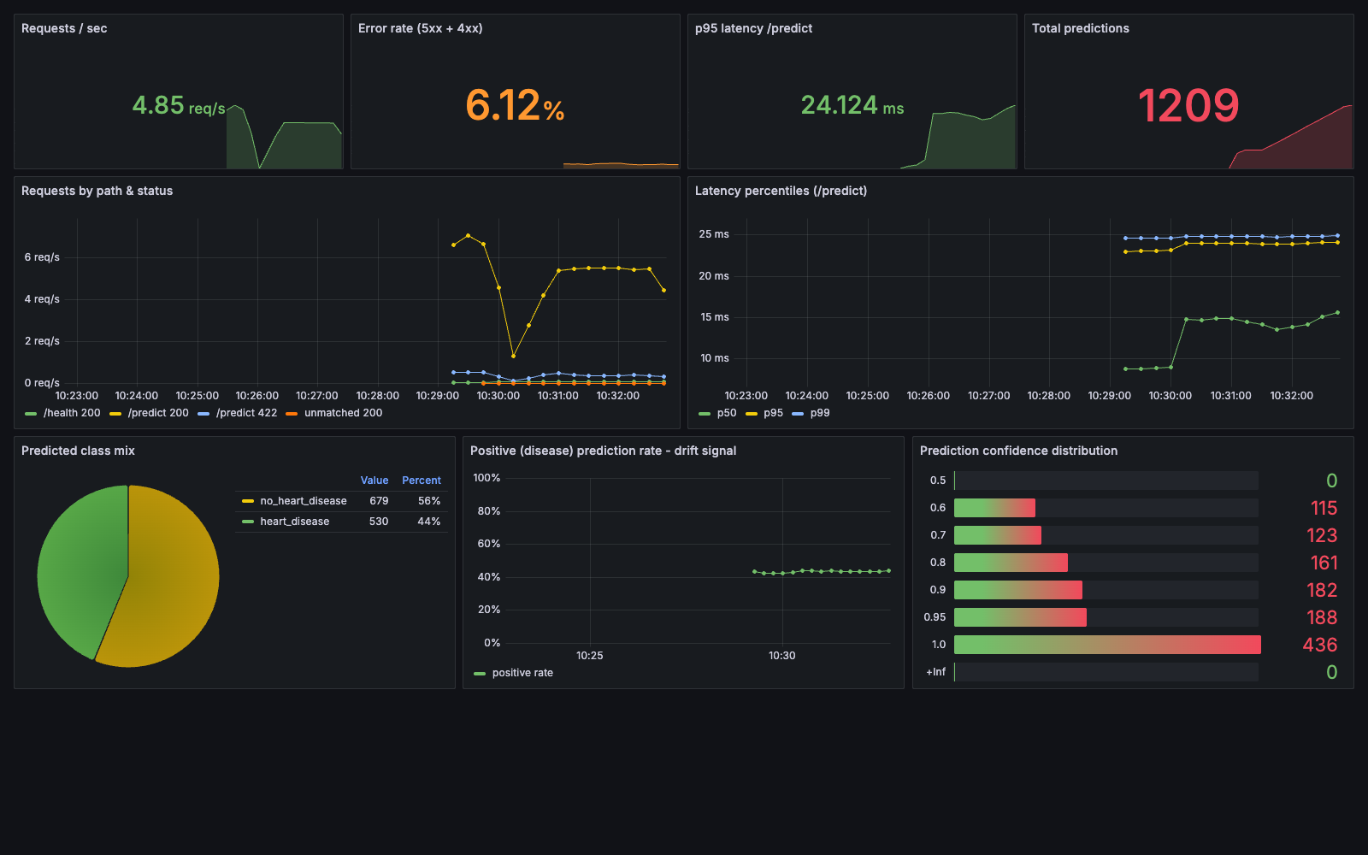
Grafana dashboard
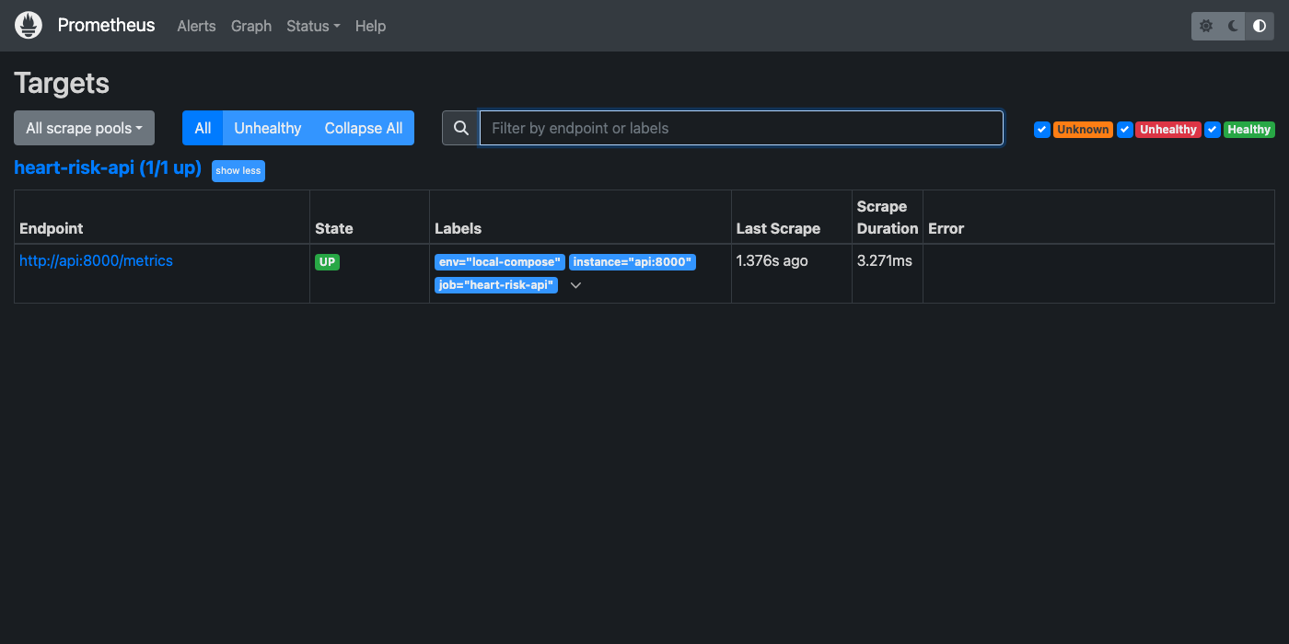
Prometheus targets

12. Design choices, limitations and next steps
- Small dataset (303 rows). CV estimates carry roughly ±0.04 AUC of fold-to-fold spread, which is why a simple, well-regularised model was chosen over a slightly higher test score.
- Threshold. The API uses 0.5. For screening, a lower threshold would raise recall; the threshold could be made configurable through the ConfigMap after review with clinicians.
- Model registry. A local file store is used. A shared MLflow server with a database backend would allow the Model Registry and stage promotion to be used from CI.
- Continuous delivery. The pipeline builds and tests the image. Pushing it to GHCR and running kubectl apply against a cloud cluster (GKE or EKS) would complete continuous deployment.
- Drift. The dashboard tracks prediction drift. Logging input feature distributions and comparing them with training statistics (e.g. a PSI metric) would add data-drift detection.

13. Deliverables checklist
Deliverable | Location
Code, Dockerfile, requirements | src/, Dockerfile, requirements*.txt, pyproject.toml
Cleaned dataset + download script | data/processed/heart_clean.csv, scripts/download_data.py
EDA / training / inference scripts | scripts/eda.py, src/heartrisk/train.py, src/heartrisk/api.py, scripts/load_test.py
Unit tests | tests/
CI workflow | .github/workflows/ci.yml
Deployment manifests | k8s/
Monitoring | docker-compose.yml, monitoring/
Screenshots | screenshots/
Report | REPORT.md, report/REPORT.pdf, report/REPORT.docx
Video demonstration | Google Drive Video (https://drive.google.com/file/d/1B5Q_ZFFDnhU_ME6vB6uXpXcSQjFW-JAG/view?usp=sharing)
Access instructions | README.md sections 4–6

