**Design and Development of Hybrid Vertical Axis Windmill for Energy Efficient Utilization of Wind on Highways**

**Dr.S.Mohan kumar**,

New Horizon College of Engineering, Research Centre,Bangalore,India

***Abstract:*** Wind energy is one of the fastest growing sources of electricity in the world. This can be utilized as it is freely available everywhere. Due to the movement of vehicles, wind energy is enormously produced on the highways which are unused. It can be also used to produce electrical power and to overcome other problems of electricity. The windmill or wind turbines are placed at the middle of the highway since it generates wind energy when the vehicles move on both sides of highway. The generated power from the windmill is utilized for nearby streetlights and various other electricity purposes.

In this work, an efficient Hybrid (Darrieus + Savonius) Vertical Axis Wind Turbine (VAWT) has been designed to produce the electric power higher than the other existing wind turbines with four blades and a generator which generate electricity through the rotation of blades. A microcontroller based wind mill status monitoring system is implemented to know the rpm status of a wind mill and voltage status of a battery. From the demonstration, it has been observed that the hybrid wind turbine has generated an additional power of 0.35 Watts for a wind speed of 3m/s which is efficient than other different types of wind turbines i.e. horizontal, Darrieus and Savonius. The wind currents from the fast moving vehicles rotate the hybrid vertical axis windmill and generate a variable voltage of 0.3-0.6 volts stored in a battery that can be utilized for the purpose like street lighting, traffic signals, road studs etc

**.Keywords: EM Cluster, Univariate outlier, Grubb test, Continuous variables**

# 1.Introduction

In today’s life the wind energy is considered as the fastest growing source of energy. However, it is limited by its variable nature. Nowadays, the vehicle density is increasing by a very fast rate and because of the development in road transportation facilities such as the development of express highways and national highways, where vehicles move in immense speed, large amount of wind energy will be generated by the moving vehicles on these highways [1]. These Highways can provide a considerable amount of wind to drive a turbine due to high vehicle traffic. Due to the pressure difference in the air adjoining the vehicle wind will be generated. One of the greatest challenges of wind energy is dedicating the necessary area for placing the turbines. Energy is very much essential for development of any nation. This work aims to extract this energy in the most efficient manner. Small vertical axis wind turbines can be installed in these areas to extract this power The wind turbines will be placed on the road dividers so that wind flow from both sides of the highway will be acting tangentially in opposite directions on both sides of the turbine. These types of turbines can be installed on express highways and other high speed traffic areas to generate electricity. Ideally, the turbine can be used globally as an unlimited power source for street lights and other public amenities. Also this system can be connected to the grid to supply the increased power demand. The average wind speeds with and without cars must be researched as well as the average speed of wind produced by traffic in these areas. Our aim is to design the turbine which will capture the maximum of wind in any direction by placing it at optimum place and height by considering both the cost and safety of the system. The main objective is to harvest and recapture the maximum amount of wind energy from the automobiles running on the highways.

This system can be used in huge number to generate the huge amount of useful electrical energy. This energy can be stored and transferred to nearest rural places where we can fulfil the demand of electricity. The unused and considerable amount of wind is used to drive the vertical wind turbine, which will use the kinetic energy of the wind to produce the electrical energy. Increased turbulence levels yield greater fluctuations in wind speed and direction.

The wind turbines are more cost effective and are grouped together into wind farms, which provide bulk power to the electrical grid. Offshore wind turbines are larger, can generate more power, and do not have the same transportation challenges of land-based wind installations, as the large components can be transported on ships instead of on roads. Single small turbines are used for homes, telecommunications dishes, or water pumping. Small turbines are sometimes used in connection with diesel generators, batteries, and photovoltaic systems. These systems are called hybrid wind systems and are typically used in remote, off-grid locations where a connection to the utility grid is not available. The vertical axis windmill design is situated at the centre of National Highways so that wind in highways and wind coming through fast moving vehicles are utilised to rotate the propellers of the vertical axis windmill. The conceptual idea of utilising wind from both sides of highways is shown in the fig. 1

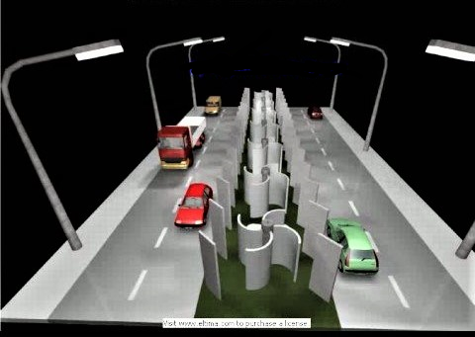

Fig. 1: Conceptual idea of windmill on highways

The propellers of the windmill rotate from the wind generated in highways and in turn rotate the rotor of the generator (dynamo).The principle of the generator used here is to convert the mechanical energy (rotations of the rotor) into electrical energy.

The generated electrical energy from the windmill is not continuous and constant because the wind in highways is neither constant nor continuous. The windmill produces variable power and voltage according to the wind. The variable generated power from the windmill is stored in a Lead-Acid battery and then it is utilised for several purposes of electricity in highways like highway street lights, emergency backup lights and mobile phone charging etc.,

**2. Works related to horizontal axis wind turbines (HAWT) and vertical axis wind turbines (VAWT).**

Wind turbines can be categorised by the orientation of their axis of rotation into two groups: Horizontal axis wind turbines (HAWT) and Vertical axis wind turbines (VAWT). Both types of wind turbine are shown in figure 2.a and 2.b. The horizontal axis wind turbine was invented before the vertical axis wind turbine, which led to its popularity and wide use. HAWT are the most common type of wind turbines built across the world. VAWT is a type of wind turbine which have two or three blades and in which the main rotor shaft runs vertically. They are however used less frequently as they are not as effective as HAWT. The horizontal axis wind turbines are the most common and have blades rotate on an axis parallel to the ground. Horizontal axis wind turbines utilize air foil design to generate the spinning of the blades. Unlike traditional horizontal axis wind turbine (HAWT), vertical axis wind turbine effectively captures turbulent winds which are typical in urban settings. The other major classification for wind turbines are vertical axis wind turbines. The Vertical Axis Wind Turbine (VAWT) is the most popular of the turbines that people are adding to make their home a source of renewable energy [2-7]. While it is not as commonly used as the Horizontal Axis Wind Turbine, they are great for placement at residential locations and more. These turbines spin on a vertical axis. Vertical turbines spin on the vertical axis and come in various shapes sizes and colours. Its movement is similar to a coin spinning on the edge. The main difference between the VAWT and HAWT is the position of blades. In HAWT, blades are on the top, spinning in the air while in VAWT, generator is mounted at the base of the tower and blades are wrapped around the shaft.

Vertical Axis Wind Turbines are designed to be economical and practical, as well as quiet and efficient [8-10]. They are great for use in residential areas whereas the HAWT is best for use at a business location. In a vertical axis turbine the main components, such as a generator can be kept at the base of the turbine allowing easier maintenance to be done. The blades are connected at both ends to the rotor and prevent high levels of stress in the blades so the blades can be made lighter. The orientation of the rotor allows the turbine to be self-starting and can produce power at low wind speeds which also allows the turbines to be shorter and capture wind outside of the traditional wind capture zone height.

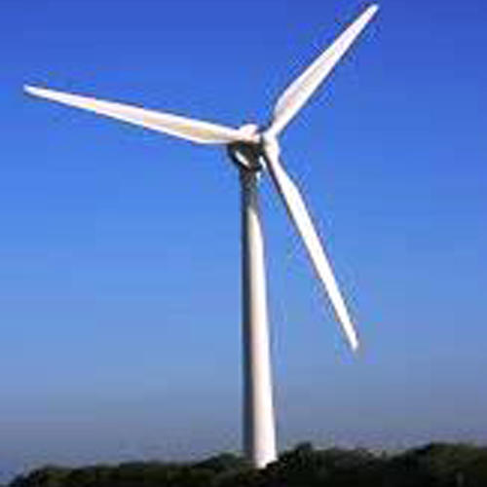

Fig. 2.a.: Horizontal axis wind turbine

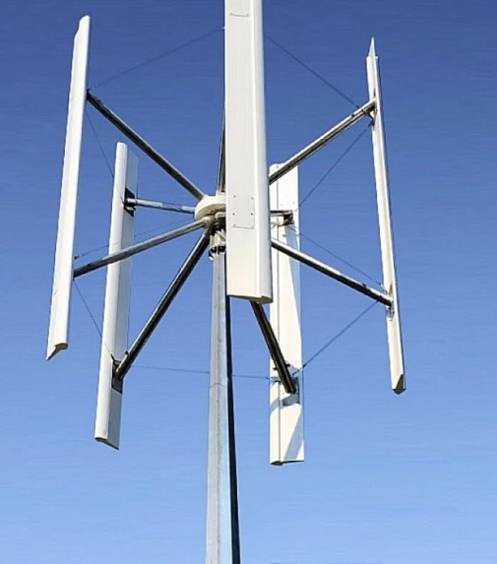

Fig. 2.b: Vertical axis wind turbine

**Fig. 2.b: Vertical axis wind turbine**

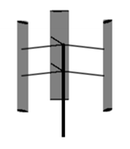

Fig 3.a: Darrieus type VAWT

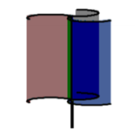

Fig 3.b: Savonius type VAWT

There are multiple components of a basic vertical axis wind turbine that can be altered to improve the performance of the device. The material used to construct the blades will also be carefully analysed for weight, cost, and strength. Blade design will be very important to ensure the ability of the turbine to catch the wind most effectively and adapt when the wind changes direction. In addition to the efficiency of the turbines, safety must also be taken into consideration. These mechanisms will have moving blades that could be harmful if vehicles or humans were to enter the blades path of rotation. To ensure safety for highway travellers, the tower of the turbine must be tall enough to avoid any traffic that may need to pull over to the side of the road.

Vertical axis wind turbines are advocated as being capable of catching the wind from all directions. There have been two distinct types of vertical axis wind turbines: The Darrieus type and the Savonius type [6] as shown in figure 3. The Darrieus type rotor was researched and developed extensively by Sandia National Laboratories in the USA in 1980’s. The first aerodynamic vertical axis wind turbine was developed by Georges Darrieus in France and first patented in 1927 [7]. Its principle of operation depends on the fact that its blade speed is a multiple of the wind speed. Darrieus wind turbine is a lift type device. Lift propelled wind turbines have blades that resemble wings you see on airplanes. These blades move at right angles to the wind direction, at a higher speed than the actual wind speed. They work with the wind, like a sail, instead of against the wind. This is why these kinds of turbines are fundamentally more suitable for harvesting wind energy. Moreover, the blades cover only a fraction of the rotor surface. This means much less material is needed for the rotor. Aside from these advantages, the most important feature of the lift propelled turbine is its high efficiency.

The Savonius wind turbine was invented by the Finnish engineer Sigurd Johannes Savonius in 1922. Savonius turbine is a drag type device, consisting of two or three scoops. Looking down on the rotor from above, a two-scoop machine would look like an "S" shape in cross section. Because of the curvature, the scoops experience less drag when moving against the wind than when moving with the wind. The differential drag causes the Savonius turbine to spin. Because they are drag-type devices, Savonius turbines extract much less of the wind's power than other similarly-sized lift-type turbines. Much of the swept area of a Savonius rotor may be near the ground.

Savonius turbines are used whenever cost or reliability is much more important than efficiency. Most anemometers are Savonius turbines for this reason, as efficiency is irrelevant to the application of measuring wind speed. Much larger Savonius turbines have been used to generate electric power on deep-water, which need small amounts of power and get very little maintenance. Design is simplified because, unlike with horizontal axis wind turbines no pointing mechanism is required to allow for shifting wind direction and the turbine is self-starting. Savonius and other vertical-axis machines are good at pumping water and other high torque, low rpm applications. The most important application of the Savonius wind turbine is the Flettner Ventilator, which is commonly seen on the roofs of vans and buses and is used as a cooling device. Several GPS based methods [12-14] are used for monitoring the vehicle's movement on the highways for efficient utilization of windmill.

**2.1 Problems identified in existing models**

* Power generated from Darrieus type and Savonius type depends on the design of the blades.
* If blade rotation space is large then power generated will be more (Power ∝ Swept area).
* Initial wind speed should be high (>10m/s).
* Maintenance is very complicated for Savonius type Vertical Axis Wind Turbine.
* Horizontal axis wind turbine is not Omni directional (i.e. It can rotate only in one direction).

**3. Construction of proposed Hybrid Wind Mill**

The following components that are required to make hybrid vertical axis wind turbine are

* PVC (Polymerizing Vinyl Chloride) Pipe 30 cm length and 4 inch diameter.
* ACP (Aluminium composite panel) Sheet 30cm length and 4 cm breadth.
* T shaped CPVC Fittings and 4 Elbows of CPVC.
* 4 L-Clamp Steel
* Plate washer 2 inch width and 2 inch diameter
* Few number of screws

3.1 Design Steps

The steps to make a Vertical axis Wind turbine are

Step 1:

Take a PVC Pipe having 4inch diameter and 30 cm length. Axially divide it into 4 equal parts using an angle grinder. Make holes on one side of the PVC using 6mm drill bit. An angle grinder, also known as a side grinder or disc grinder, is a handheld power tool used for grinding (abrasive cutting) and polishing. The four pieces of PVC pipes are shown in Fig. 4.

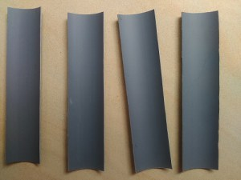

Fig. 5: Rectangular pieces of ACP sheet

(welded together with GI nut as shown

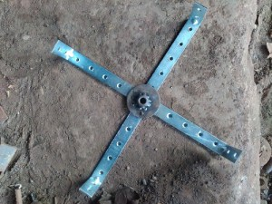

Fig. 6: Propeller made with L-clamp steel

Step 4:

GI Plate washer in 2 “diameter is taken and GI nut is taken that suits the dynamo pulley which is to rotate freely. Then we have to weld the GI nut at the centre of the plate washer and weld all 4 L clamps on the plate washer. Then the propeller frame is ready. The combined PVC pieces and ACP sheet obtained are shown in Figure.7

Angle grinders typically have an adjustable guard and a side-handle for two-handed operation. Angle grinders may be used for removing excess material from a piece. The angle grinder has large bearings to counter side forces generated during cutting, unlike a power drill, where the force is axial.

Step 2:

Cut 4 pieces of ACP Sheet having 30 cm in length and 6 cm in width Mark holes on ACP from PVC Pieces and make holes using 6mm drill bit. The four pieces of ACP sheet are shown in Fig. 5

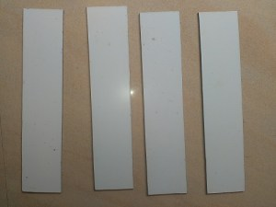

Fig. 5: Rectangular pieces of ACP sheet

Step 3:

4 steel L-clamps and cut it into required length (12 cm * 6 cm) using an angle grinder. These L clamps are welded together with GI nut as shown in Fig. 6.

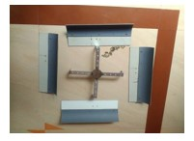

Fig. 7: Joined pieces of PVC and ACP sheet

Step 5:

Then the CPVC pipes are arranged in such a way that it forms a square shape for the base of the vertical axis wind turbine. The joining of CPVC pipes to form as a base is shown in Fig. 8.

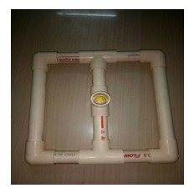

Fig. 8: Basement of Windmill

Step 6:

A small dynamo is placed with inside at the top of the CPVC pipe which is used to convert the mechanical energy into the electrical energy. The dynamo is fitted into the CPVC pipe as shown in Fig. 9.

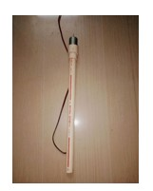

Fig. 9: Dynamo placed inside CPVC pipe

Step 7:

The propeller is exactly placed on the CPVC pipe which contains the dynamo with the help of GI nut as it is on the propeller. Then the pipe containing propeller is placed on the basement of the windmill. Then after successful completion of designing the vertical axis wind turbine it looks as shown in Fig. 10.

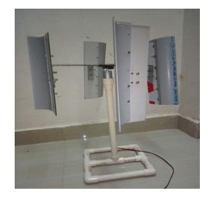

Fig. 10: Over all view of Hybrid vertical axis wind turbine

**4. Hardware Implementation of the Model**

The fig 11 represents block diagram of system connecting hardware components and vertical axis windmill.

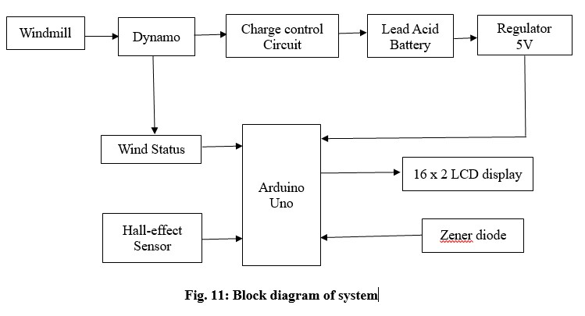

The end wires coming through generator of the wind mill is connected to bridge rectifier in order to convert Alternating Currents (A.C) to Direct Currents (D.C) to store in a 12.7 voltage Lead-Acid battery. If the generator is directly connected to the positive and negative terminals of the battery, the propeller of wind turbine rotates with the rotor of the generator due to voltage difference and causes reverse charging. To avoid this reverse charging an interface of charge control circuit is used in between the generator, bridge rectifier and Lead-Acid battery.

The charge control circuit consists of relays and capacitors in order to store and then discharge into the battery. Also the relays are connected to the conventional power which are used for the electricity purposes and hence this system is switched in case of failure in traditional power supply. The general principle behind the controller is that it monitors the voltage of the battery in your system and avoids reverse charging from battery to windmill. It either sends power from the turbine into the batteries to recharge them, or dumps the power from the turbine into a secondary load if the batteries are fully charged (to prevent over-charging and destroying the batteries). The yellow LED is used to indicate low voltage on battery and the green LED is used to indicate when the battery is charged and power is being dumped to the dummy load.

To check the working of the system, the whole system output is measured through the microcontroller Arduino Uno. Programming in Arduino Uno can be done through Arduino IDE. To describe the working description of the system and to show the output of the system Arduino Uno is interfaced to the 16 x 2 LCD display. The analog pins A3 and A4 of Arduino Uno are connected to the RESET and ENABLE pins of LCD display. Also the 8, 9, 10, 11 pins of Arduino Uno are connected to the d0,d1,d2,d3 pins of LCD display. The LCD display will have 2 rows and 16 columns.

The microcontroller Arduino Uno and LCD display require power supply from external source for their working. The Arduino Uno requires 5v power supply and LCD display requires 3.0 to 5.0 v power supply. This power can be obtained from the 12.7v Lead-Acid battery. The voltage in the battery is reduced to 5v through the voltage regulator LM7805.LM 7805 gives a constant 5v power supply irrespective of the input power given to it. In fact voltage regulators like 78xx are used to give output of voltage mentioned in xx of LM78xx.Thus power supply of 5v to Arduino Uno is obtained and hence power to LCD display is obtained from the Arduino Uno.

The remaining voltage on the battery and the status of wind from the windmill can be found using the microcontroller Arduino Uno and it is displayed on the LCD display .To find the remaining voltage residing on the battery 5.1v Zener diode and the terminals of the battery are connected to the Analog pin A1 and ground pins of the Arduino Uno. The analog information obtained from this A1 pin is programmed to display the voltage status on the battery. The voltage information on the battery is shown on the LCD display as shown in fig 12.

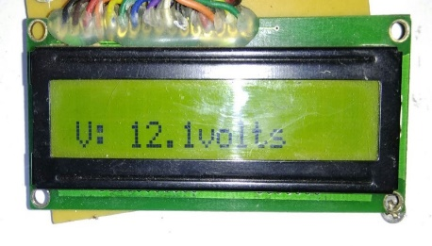

Fig. 12: Voltage status of the battery

The wind status from the windmill and the battery charging status can be found using the terminal wires coming out from the generator. These terminals are connected to the analog pin A0 and ground pin of Arduino. If this analog pin A0 gives analog information then there I a flow of current through the end terminals of generator. A switch interface is created at the end terminal of generator and terminals connecting to analog pin and ground pin of Arduino .The working of wind status is such that if the propellers of the wind turbine is not rotating due to lack of wind then there is no current flowing through the terminals of generator and hence LCD display shows NO WIND. Also if the propeller is rotating due to the wind currents in highways, current flows through the terminals and LCD display shows WIND:YES and displays that battery is charging. The wind status when there is wind and no wind are shown in fig 13.

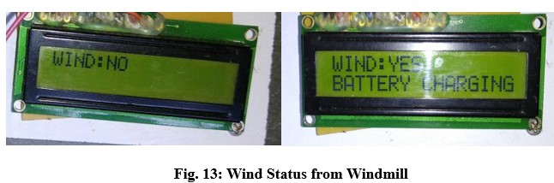

The RPM (Revolutions per Minute) of the wind turbine can be found through Hall Effect sensor. This sensor works on the principle of magnetic field applied to it generates a voltage difference. The Hall Effect sensor has an analog pin, a digital pin and vcc and ground pin. It requires 5v power supply which is drawn from a 5v power supply in from Arduino and ground pin of sensor is connected to ground pin of Arduino. Also the digital pin of Hall-effect sensor D0 is connected to the 2 digital pin of Arduino which is also an interrupt pin (INT0).

This Hall Effect sensor is placed at the base stand near the propeller and a magnet is attached to the back end of the propeller such that its magnetic field reaches to the sensor. Therefore when the propeller rotates magnet also rotates and the sensor detects the magnetic field for every rotation and sends this information to the interrupt pin of the Arduino. The RPM of the windmill can be calculated from the interrupts countered to Arduino and a counter is initiated with respect to time. The RPM can be found by using the formula.

RPM = 60 *1000/ (millisecond – passed time)*counter

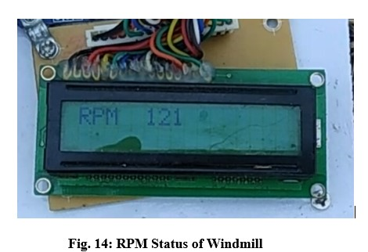

The above connections to hardware components from windmill makes the whole system to utilize the power generated from windmill for electricity purposes. Therefore the working of the system consists of displaying the remaining voltage in the battery and the wind status of the windmill and displays whether the battery is charging or not charging and also calculates the revolutions of the propeller per minute and it displays on the LCD display as shown in fig14.

**5. Results and Discussion**

5.1 Power Calculation

Energy generated by windmill is given by

Energy E = 1/2 mv^2

The power in the wind is given by the rate of change of energy

Power P=dE/dt = 1/2 dm/dt v^2 (1)

As mass flow rate and rate of distance is given by relation

dm/dt = ρ x A x dx/dt and dx/dt = v (2)

Therefore we get

dm/dt = ρ x A x v (3)

Substituting eq (3) in eq (1) we get

P = 1/2 x ρ x A x v2 (4)

Where, ρ is Air density (1.23kg⁄m3)

A is Swept Area and

v is wind velocity

Theoretical Calculation

Swept Area is calculated by A= l x d = 0.12 m x 0.30 m = 0.036 sq.m, Let us assume average wind speed in atmosphere is 13 kmph i.e., 3.6 m/s. Substituting the values in (4), we get Power, P = (1/( 2) x 1.23 x 0.036 x 3.6 x 3.6 x 3.6) =1.03 watts. Power generated from Windmill is 1.03 watts, when it is calculated theoretically.

Practical Calculation

The Average RPM (Revolutions per Minute) attained by the windmill is 160 rpm.

Wind speed can be calculated by using below relation

v = (3.14 x D x RPM) / 60 (5)

v = (3.14 x 0.37 x 160) / 60 = 3.09 m/sec

Where, D is diameter of Vertical Axis Wind Mill, RPM - revolutions per minute

Speed attained by windmill is 3.09 m/sec, Power Generated by Wind Mill is calculated by, Substitute eqn (5) in eqn (4)

P = (0.5 x 1.23 x 0.036x 3.09 x 3.09 x 3.09) = 0.65 watts

Power generated from windmill is 0.65 watts, when it is calculated practically.

The wind currents from highways and fast moving vehicles rotate the vertical axis windmill and the generator generates a variable voltage of 0.3-0.6 volts when measured with a Digital Multi Meter (DMM). This generated voltage varies because wind is not constant throughout the day so we have placed a charge control circuit in order to get this variable voltage stored into the 12v battery which can be used for electricity purposes. Since the wind is not constant throughout the day, the system is held in highways and different rpm values are noted at different times in a day. The results of different rpm values are shown in figures. The average value of these rpm values gives an average rpm value of 160 rpm. The fig 6.1 shows different rpm at different times in a day

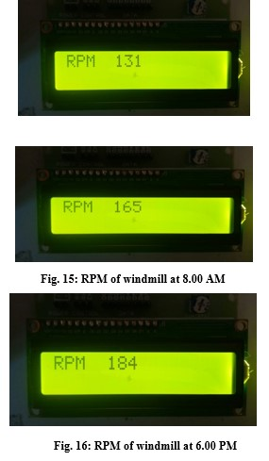

Fig. 16: RPM of windmill at 6.00 PM

This rpm is used to calculate the power generated from the windmill which is calculated in previous chapter and the average generated power in a minute is 0.65 watts which is comparatively larger than any other previous wind turbine models.The table shows output power by different wind turbine models with the proposed system.

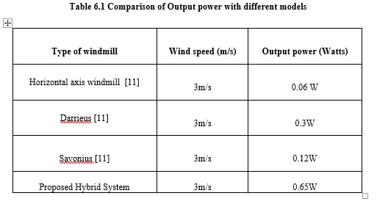

**6. Conclusion and Future Scope**

The field of wind energy has tremendous scope for innovation, translating to real world applications and tremendous economic opportunity. It is crucially important for India, as our economy continues to evolve, and we must ensure every Indian has access to opportunity, decent jobs and livelihood. For that we will need greater resources. Clean, sustainable, renewable and equally important, domestic sources of energy are essential to fulfil the potential of India in the coming years and it is certain that wind energy will play a major part in shaping India's future. Wind power has emerged as the biggest source of renewable energy in the world.

The proposed model of Hybrid (Darrieus + Savonius) wind mill will be a good source of renewable energy on highways. The wind energy generated by the moving vehicles on highways can be utilized to generate electrical energy, which can be stored in a battery and used for purposes like street lighting, traffic signals, road studs etc. The wind mill is designed by selecting the appropriate battery and the charge controller system by diverting excess power to a dump load (excess load is given to ground). This design concept is meant to be sustainable and environmentally friendly. If these types of turbines can be installed on long high speed express highways a considerable amount of electrical energy can be generated, which can solve the issue of energy crisis to a large extend. The power generated from windmill can be used for various purposes on highways.

In future, Wind Mill can be placed on street lights for generating of electricity and can be used for that street light. Now a day’s people are using solar energy for generation of electricity in homes, in future we can add Wind Mill and use that energy for home appliances. Wind Mill can also be used near railway track, not only on highways. Wind Mills can be used to control Rain clouds near coastal regions.

Extensive data is collected on wind patterns produced by vehicles on both sides of the highway. Using the collected data, a wind turbine is designed to be placed on the medians of the highway. Although one turbine may not provide adequate power generation, a collective of turbines on a long strip of highway has potential to generate a large amount of energy that can be used to power streetlights. This design concept is meant to be sustainable and environmentally friendly. Additionally, a wind turbine powered by artificial wind has a myriad of applications. Theoretically any moving vehicle can power the turbine such as an amusement park ride. The highway wind turbine can be used to provide power in any city around the globe where there is high vehicle traffic.

**7.References**

[1]Shweta Singh, Sarita Singh and Priyanka Srivastava, “Vertical axis wind turbine for Generation of Electricity through Highway Windmill”, A Journal of Physical Sciences, Engineering and Technology (ISSN: 2229-7111), Vol.7, Issue-2, 2015.

[2] Devendrappa V.,Chandan M.K., Arun S.P., “Highway Power Generation using Low cost Vertical axis wind turbine”, International Journal of Research of Science and Computing,Vol.7,Issue-5,2012.

[3] Ragheb M., “Study on Vertical axis wind turbine”, International Journal of Engineering Research (IJER), 21st march 2015.

[4] Abdel Azim El-Sayed A.F., “Dynamics of Vertical axis wind turbine”, International Journal of Rotating Machinery, 1995, Vol.2, pp.33-4.

[5] Selvam M., Ramesh R., Palaniswamy R., “Design and Analysis of Vertical axis wind turbine”, International Journal of Development Research (IJDR), Vol.4, Issue-2, pp.313-315, February, 2014.

[6] Mithun Raj K.K., Ashok S., “Design and Simulation of Vertical axis wind turbine for Highway Wind Power Generation”, International Journal of Electrical and Electronic Engineering (ISSN: 2321-2055) IJEEE, Vol.7, Issue-1, January 2015.

[7] Sunil Shukla, Sharma P.K., “Vertical axis wind turbine for design performance study of Generate Electricity on Highway”, International Journal of Advance Engineering Research Development (ISSN: 2348-4470), vol.3, Issue-12, December 2016.

[8] Nikam D.A., Kherde S.M., “Design and Development of Vertical axis wind turbine blade”, International Journal of Engineering Research and Application(IJERA) ISSN:2248-9622, National Conference on Engineering Research Trends in Engineering and Technology (NCERT),3rd November 2015.

[9] Niranjana S.J., “Power Generation by Vertical axis wind turbine”, International Journal of Engineering Research in Management and Technology (ISSN: 2278-9359), Vol.4, Issue-7, July 2015.

[10] Ramachandran S., Sathya Narayana S.U., “Design and Development of Free Flow Vertical axis wind turbine”, International Journal of Engineering Research &Technology (IJERT) ISSN: 2278-0181 Vol.3, Issue-6, June 2014.

[11] Patil H.S., “Experimental work on Horizontal axis PVC turbine blade of power windmill”, International Journal of Mechanical Engineering (ISSN: 2277-7059), Vol.2, Issue -2.

[12] G. Arul Elango, G.F. Sudha, Bastin Francis, Weak signal acquisition enhancement in software GPS receivers – Pre-filtering combined post-correlation detection approach, Applied Computing and Informatics, Volume 13, Issue 1, 2017, Pages 66-78, ISSN 2210-8327.

[13] Arul Elango, G.F. Sudha, Weak GPS acquisition via compressed differential detection using structured measurement matrix, International Journal on Smart Sensing and Intelligent Systems. Volume 9, Issue 4, ISSN (Online) 1178-5608, DOI: 10.21307/ijssis-2017-944, December 2016.

[14] G. Arul Elango, G.F Sudha, Design of complete software GPS signal simulator with low complexity and precise multipath channel model, Journal of Electrical Systems and Information Technology, Volume 3, Issue 2, 2016, Pages 161-180, ISSN 2314-7172.