**GPS Navigator based Vehicle Headlight Intensity Controller on Highways**

**D.V Manjunatha1, Alva's Engineering College, Mangalore, India.**

**K.Prem Chand, 2 G.Gayathri3, G. Radhika4, M.Deepa.**

Sree Vidyanikethan Engineering College, Tirupathi, India**1**

Sree Vidyanikethan Engineering College, Tirupathi, India**2**

Sree Vidyanikethan Engineering College, Tirupathi, India**3**

Sree Vidyanikethan Engineering College, Tirupathi, India**4**

***Abstract*** *-*A number of factors are considered during the analysis of automobile transportation with respect to increasing safety. One of the safety factors related to Road accidents during night time on highways due to glaring effect from the opposite vehicle's head light is considered to be as major concern in saving person's life. One of the vital factors for night-time travel is temporary blindness due to increase in headlight intensity. This problem arises when both drivers are using a higher headlight intensity setting. Also, increased speed of the vehicles due to decreased traffic levels at night increases the cause of accidents. As in the traditional systems, every vehicle would sense the incoming headlight’s intensity breach and regulates their own headlight accordingly. As a result of this, the opposite vehicle would be benefited, but the high beam of the incoming vehicle would still remain causing temporary blindness to the source vehicle. Hence the problem of temporary blindness is not completely eradicated.In order to avoid accidents due to temporary driver blindness, a micro controller based light intensity control using GPS has been proposed to quickly transmit the location and the distance between two vehicles through RF module. The low latency allows quicker headlight intensity adjustment to minimize temporary blindness. Experiments conducted shows that there is a possibility to automatically attenuate light intensity from on-coming traffic infractions of a second vehicle at significantly about 10 meters thereby reducing driver discomfort and mitigating accidents significantly

***Keywords*: EM Cluster, Univariate outlier, Grubb test, Continuous variables**

# 1.Introduction

Road transportation has offered many advantages both to society and to people by providing movements of goods and individuals and making easy access to various social and economic services. The quick rise in motorization along with expansion of road network has brought with it the challenge of facing adverse factors such as the increase in road accidents. In order to avoid these circumstances caused by glare while night driving, many approaches were prevalent from long time which proposed an electronic, mechanical design solutions to cater these issues. The current headlights systems which are present in many of the low/high end automobiles do offer a provision to manually alter the intensity of operation of their own headlights. The headlights , tail lights of an automotive light system can be categorically fall into the below categories. Halogen headlights, LED headlights, tungsten filament headlights, etc. Each of the categories has their own intensity levels at high beam and low beam mode of operation.

The user manually switches the mode either to high beam or low beam during the runtime of the vehicle. The user should have the intelligence to operate the headlights based on the road conditions and simultaneously concentrate on his driving as well. Hence the manual operation of the headlights is a laborious process which is prevalent in all the low end automobiles in market. If the switch over from High beam to low beam 2 is not done during the presence of an incoming vehicle, then the opposite vehicle will suffer from the temporary blindness caused by the high beam from the source vehicle. The prevention of the temporary blindness is traditionally taken up as a challenge and many researches happened to solve the existent crisis. Main aim to develop the hardware system using RF module based GPS navigator based light intensity controller .WSN refers to a group of spatially dispersed and dedicated sensors for monitoring and recording the physical conditions of the environment and organizing the collected data at a central location. The design and development is focused on using the on board MCU and light sensor to communicate wirelessly. HF module as a powerful wireless communication mechanism that is cost effective monitoring and controlling solution.

# 2.Related Works

The intensity can be varied in accordance with environment. In that situation, further studies have been proposed in different literature is given below.

Amiya Kumar Tripathy, et.al [1,4] Wi lights has mentioned about Wireless Solution to Control Headlight Intensity. A number of factors are considered during the analysis of automobile transportation with respect to increasing safety. One of the vital factors for night-time travel is temporary blindness due to increase in the headlight intensity. While headlight intensity provides better visual acuity, it simultaneously affects oncoming traffic. This problem is encountered when both drivers are using a higher headlight intensity setting. Also, increased speed of the vehicles due to decreased traffic levels at night increases the severity of accidents. In order to reduce accidents due to temporary driver blindness, a wireless sensor network (WSN) based controller could be developed to transmit sensor data in a faster and an efficient way between cars. Low latency allows faster headlight intensity adjustment between the vehicles to drastically reduce the cause of temporary blindness.

Further studies have to be done to deal with the effects of streetlights, climatic changes, etc. which causes problems while driving vehicles at night. Okrah. S.K Williams, E.A Kumassah. and Pushkar Sevekar F [2,3] proposed design and implementation of automatic headlight dimmer for Vehicles using Light Dependent Resistor (LDR) Sensor Headlights of vehicles pose a great danger during night driving. The drivers of most vehicles use high, bright beam while driving at night. This causes a discomfort to the person travelling from the opposite direction and therefore experiences a sudden glare for a short period of time. This is caused due to the high intense headlight beam from the other vehicle coming towards the one from the opposite direction. In this work, an automatic headlight dimmer which uses a Light Dependent Resistor (LDR) sensor has been designed to dim the headlight of on-coming vehicles to avoid human eye effects. This automatically switched the high beam into low beam, therefore reducing the glare effect by sensing the light intensity value of approaching vehicle and also eliminated the requirement of manual switching by the driver which was not done at all times. MATLAB software was employed in designing the work. The Keil software was also employed to program the microcontroller. The system device was able to automatically switch the headlight to low beam when it sensed a vehicle approaching from the opposite side using LDR sensor. It was observed that the maximum spread angle of the headlight was 135.

At the time the spread light from other sources reached the sensor, its intensity would be very much reduced below the triggering threshold level. The sensitivity of a photo detector determined the relationship between the light falling on the device and the resulting output signal. A server module could be included to this system for receiving and storing headlight rays parameters information in a database application.

An automatic headlight dimmer which uses a LDR sensor has been designed to dim the headlight of on-coming vehicles to avoid human eye effects automatically S M Asaduzzaman, et.al [4] proposed Automatic High Beam Controller for Vehicles. The number of vehicles on our roads is burgeoning day by day. This is turn forced almost all this vehicle manufactures to think about the extra safety instruments and electronic controls to attach with these products for giving the users a safety derived in all road conditions through a mass flow traffic. If asked, one should always mention that the right driving is very cumbersome due to the dazzling light problems and the frequent dipping of headlights by manual means that often causes fatigue to the driver particularly at the time of peak traffic. So naturally to get rid of this perennial problem, an automatic mechanism has to come up to dip the headlamp automatically whenever required. For keeping a motor vehicle under perfect control and reins of the driver, different types of controls and accessories are provided in an automobile around the driver's seat, on the dashboard and at the footboard. Simply, an automatic high beam controller is a unit, which can automatically judge when the headlight beam needs to be lowered, and which dip the headlamp from which beam to a dipped beam. Our work proposes an effective automatic control of the vehicle headlamps based on the detection of head lights and tail lights under night time road conditions. This work is about to control high beam or low beam automatically. In this device IR technology is used to detect an object. So opposite object must have to carry an IR-Tx so that IR-Rx of receiving device will detect the opposite object Jyotiraman De [5] proposed Universal adaptive Headlight System.

In the proposed work, an attempt has been made to come up with a system which would sense the intensity of the headlight of the oncoming vehicle and depending on the threshold headlight intensity being set in the system it would automatically reduce the intensity of the headlight of the oncoming vehicle using RF module, thus reducing the condition of temporary blindness caused due to excessive exposure to headlights.

# 3. Proposed System design

The proposed system consists of interconnection of various system blocks as shown in the Fig 1, each and every block has their own purpose sorted out in collecting the real time data to suppress the temporary blind conditions. The various blocks to be explained and the interaction between them shall also mark the feature of this module’s functionality

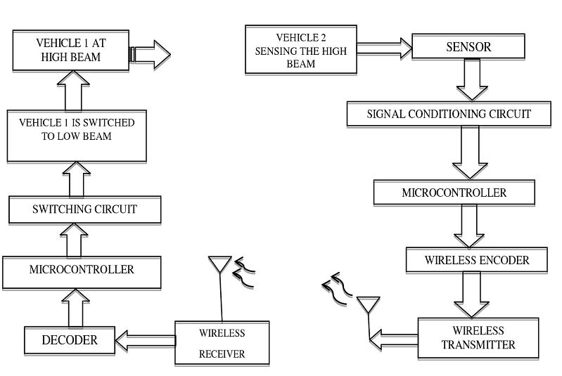

**Fig 1: Proposed System**

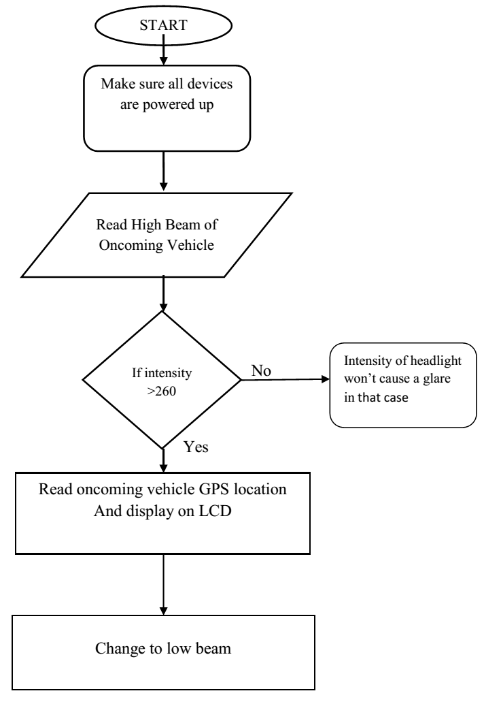

**Fig 2: Flowchart of a proposed system**

Fig 2: Flowchart of a proposed system

The above flowchart shown in fig 2 has the overall functioning of the implemented system. The flow of the implemented system can be explained as: Initially make sure that all the connections are correct, the power supply is given to the circuit board.

• In the Second step, check whether all the devices are powered are not.

• Then the intensity of the oncoming vehicle is read and compared with the threshold intensity i.e.,260.

• If the oncoming vehicle intensity is less than 260 then there is no glare effect to the opposite vehicle, then there is no change the headlight beam, hence the road is clear to the opposite vehicle.

• If the oncoming vehicle intensity is greater than 260 then read the GPS location of the vehicle is displayed on the LCD display of the opposite vehicle and then the headlight intensity is changed to low beam.

• In this case, location of oncoming vehicle is gathered and displayed on the LCD.

• These location serve as intermediate between two vehicles to get the information about their location.

• GPS module used to find the location of the car and RF module used to transmit it other vehicle.

• Every module should be carefully designed or else no communication between devices are going to perform then the result will high beam only,

• This working happened in both the vehicles, vehicle 1 and vehicle 2 respectively. The sensor modules continuously read the intensities of the headlights. So that it can read the intensities very fast and small variations can also be easily observed. The proposed system can communicate only with the headlight intensity but not with the external light source so a line of communication is possible with the proposed system.

An experiment was carried out during night times and detected that due to the absence of the GPS signal, the GPS module is not transmitting any signal. The absence of GPS signal can be identified by a red light on the GPS module. When power supply is given to the circuit board, immediately the LCD display shows the normal condition of the circuit on its display board as shown in Fig.3 this is due to the absence of the GPS location in that area. The GPS module takes some time to get it power on, then to display the position of the vehicle also it takes little bit of time. The different types of Offline locations from RINEX file or GPS simulator generated IF samples can be given as a testing input to the GPS receiver to find the location [8].

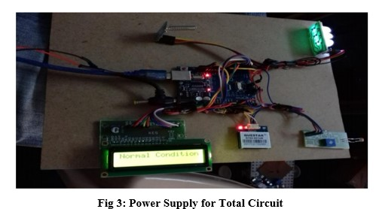

Until then the LCD display shows the normal condition as shown in Fig 3. When GPS signal is available a green light will blinks on the GPS module. Then the headlight intensity of the opposite vehicle is sensed and is displayed on the LCD displayed on the LCD as either

low intensity or high intensity

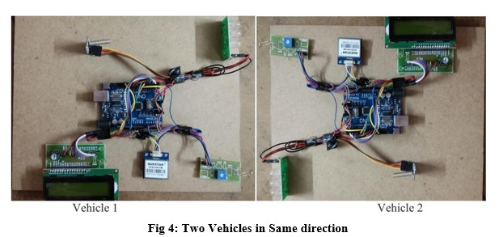

There is no need to change their intensities and vehicles can move with the same intensity until there is no vehicle present in the opposite direction.

The two vehicles, vehicle 1 and vehicle 2 has been setup with the above shown circuits in Fig 4 ,in their headlight systems and since the power supply is not given to the Arduino, the circuit is not still switched on. From the above Fig 4, it is clear that both the vehicles should have same modules to carry out the process and to communicate two vehicles with each other, since vehicle 1 and vehicle 2 having similar setup, it is convenient that only two vehicles can communicate with each other and not with other external light sources or any other.

The working model can be analyzed in two ways:

1. By moving vehicles in same direction.

2. By moving two vehicles in opposite direction.

3.1 Moving the vehicles in same direction

An experiment has been conducted during night time assuming that both vehicles are moving in same direction and assuming that there are no vehicles coming in the opposite direction, there is no need to change their intensities and vehicles can move with the same intensity until there is no vehicle present in the opposite direction.

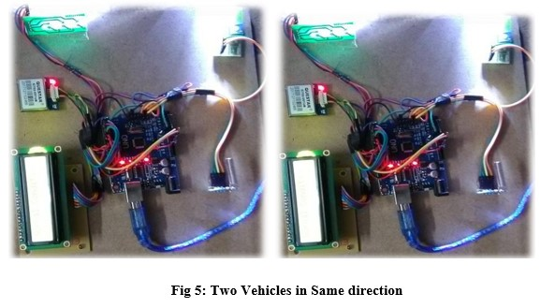

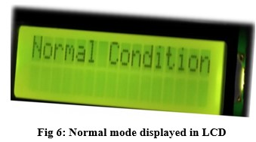

When two vehicles are moving in same direction means the vehicle 1 and vehicle 2 headlights are not facing each other, as shown in Fig 5, the vehicles need not change their intensity levels and since there is no glare effect for the opposite vehicle the LCD display shows the Normal Condition state as shown in fig. 6.

**3.2 Moving Vehicles in opposite direction**

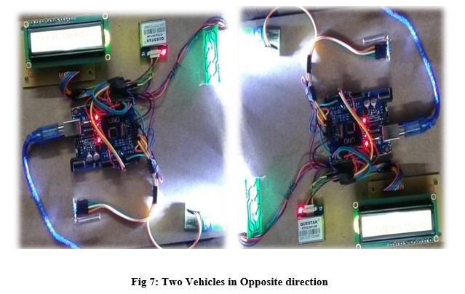

Similar to moving vehicles in same direction and experiment has been conducted during night time now assuming that both vehicles are moving oppositely means both vehicles are facing each other. Since in the Fig 7, the headlights are facing each other. Then depending on the intensity of the headlights there is a need to change the intensity of the headlight of the opposite vehicles.

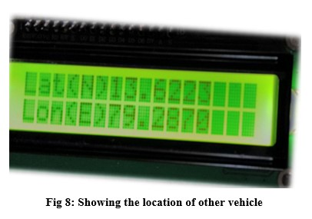

The intensity of the oncoming vehicles is greater than the threshold value ie., 260 then the intensity of the opposite vehicle is made low. When intensity is greater than 260 and when GPS gets the signal the Questar GPS Module tracks the position of the opposite vehicle. The longitude and latitude coordinates displayed on the LCD as shown in fig 8, we calculate the distance and tracking of the vehicle. The GPS module can only read the its position only when opposite vehicle has more intensity compared to the threshold. From this it is clear that the system is an efficient one and follows line of sight communication for reliable operation.

# 4. Results and Discussions

An experiment has been conducted during night times when any vehicle coming in opposite direction, the another opposite vehicle has to change its intensity level but on observation it is found from the below Fig 9 that the both vehicles have the same intensity of light.

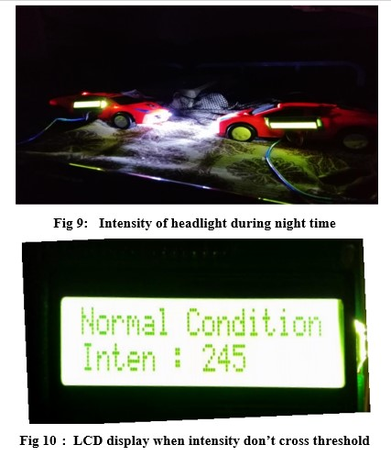

Because both the vehicles have intensities less than threshold value i.e., 260, so the LCD display shows normal condition and intensity is 245 as shown in Fig 10. When intensity cross threshold level: Another trial experiment has been conducted by moving the vehicles in opposite direction as shown in Fig 11, during this trial it is seen the intensities of the vehicles are made to low intensities to remove the glare effect. This intensity is made to change automatically.

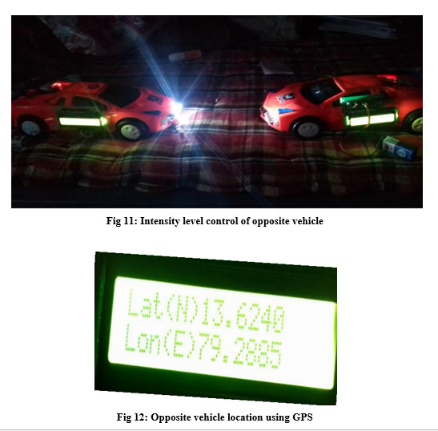

when the intensity of headlights repeatedly checked and when the system observes that the intensity is greater than the threshold i.e., 260, the GPS module tracks the position of the opposite vehicle and makes the intensity low automatically as soon as it gets the GPS location as it is shown in Fig 12, after few seconds of time only when two vehicles crosses each other their intensity is made high. This is also done automatically without any driver’s actions to control the intensity.

**4.1 Calculation of distance between Two Vehicles**

If the latitude and longitude values are given, one can calculate the distance between two vehicles by using this formula as given by [6]

a=〖sin〗^2 (∆φ/2)+cosφ_1 cosφ_2 〖sin〗^2 (∆σ/2)

c=2atan2(√(a,) √(1-a))

d = R ⋅ c

φ is latitude, σ is longitude, R is earth’s radius (mean radius = 6,371km)

The measured distance is communicated through RF module (Si4463- HC -12 RF) from one vehicle to another vehicle. Based on the distance calculated by the above equation, the beam of the light is controlled. In the microcontroller, it has been programmed, as the opposite vehicle comes at a distance of 5 meters ahead then automatically the intensity of the car is dimmed till the car is moved .The interference and noise distorted the GPS receiver, in that case, some sort of de-noising algorithms such as SSA based pre filtering [7], wavelet de-noising [9], longer duration GPS data [10] may be used to combat the noise.

The distance can be increased by using external lights like high beam focusing lights so that even the low intensity can travel long distances.

In these the speed of two vehicles are fixed at a point and two vehicles headlight gets a high beam and there are to be in same direction then the distance it covers are 5– 10 meter in range.

In second case, the two vehicles are in opposite direction and they are in fixed place then the result is no longer changing of intensity form the vehicle.

In third case where the one vehicle is with high beam and other is with low beam and direction of vehicle is noted whether it’s in oncoming or in same direction of our vehicle.

In this case, two ways of operation can be done whether low beam of one vehicle won’t make a glare to other vehicle. Other way it may be in same direction so if won’t affect the other vehicle.

The vehicle distance can be calculated for the location want we got in these we can determine the distance between that two vehicle

When the module in both vehicle present in that case these module going to work else it won’t change to low beam manually driver need to take care of it.

**5. Conclusion and Future Scope**

The proposed microcontroller system strives to remove the temporary blindness caused to the drivers during the night vision travel. The universal embedded module automatically switches the high beam into low beam and returns backs to high beam based on road conditions, thus reducing the sudden glare effect. The interconnected modules connected wirelessly at every vehicle independently control the headlight by evaluating parameters like current GPS location headlight intensity.

In future, the adaptive headlight system can be made more efficient by controlling the climatic light from the environment and street lights using an advanced sensor. The beam can be made to diverge when the vehicle is travelling at high speeds and can be made to converge when the speed is low. Also automatic low beam high beam adjuster can be incorporated to reduce accidents due to dazzling of lights. We can also improve range and time which takes to convert high beam to low beam.

**6.References**

[1] Amiya Kumar Tripathy , Deepali Kayande , Joel George, Jerome John , Bejoy Jose , “Wi Lights -A Wireless Solution to Control Headlight Intensity”, 2015 International Conference on Technologies for Sustainable Development (ICTSD-2015), Feb. 04–06, 2015, Mumbai, India.

[2] Pushkar Sevekar, S.B.Dhonde“Night-Time Vehicle Detection For Automatic Headlight Beam Control”, International Journal of Computer Applications (0975 – 8887) Volume 157 – No 7, January 2017.

[3] Okrah. S.K, Williams. E.A,Kumassah. F“Design And Implementation Of Automatic Headlight Dimmer For Vehicles Using Light Dependent Resistor (Ldr) Sensor”, International Journal of Emerging Technology and Innovative Engineering Volume 2, Issue 4, April 2016.

[4] Amiya Kumar Tripathy, Deepali Kayande , Joel George , Jerome John Bejoy Jose “Wi Lights -A Wireless Solution To Control Headlight Intensity”, 2015 International Conference on Technologies for Sustainable Development (ICTSD-2015), Feb. 04–06, 2015, Mumbai, India.

[5] Jyotiraman De“Universal adaptive Headlight System”, 2014 IEEE International Conference on Vehicular Electronics and Safety (ICVES) December 16-17, 2014. Hyderabad, India.

[6] ShubhalaxmiKher, Victor Nutt"Headlight Intensity Controller Design using Wireless Sensors (HIC-WSN)", Special Issue of International Journal of Computer Applications On Issues and Challenges in Networking, Intelligence and Computing Technologies, November 2012.

[7] G. Arul Elango, G.F. Sudha, Bastin Francis, Weak signal acquisition enhancement in software GPS receivers – Pre-filtering combined post-correlation detection approach, Applied Computing and Informatics, Volume 13, Issue 1, 2017, Pages 66-78, ISSN 2210-8327.

[8] G. Arul Elango, G.F Sudha, Design of complete software GPS signal simulator with low complexity and precise multipath channel model, Journal of Electrical Systems and Information Technology, Volume 3, Issue 2, 2016, Pages 161-180, ISSN 2314-7172.

[9] Lei, Nana, Zhu, Hao, Cui, Jianyong, Wavelet-based method for weak satellite signal acquisition, International Conference on Transportation, Mechanical, and Electrical Engineering (TMEE), 2011, December, 2011, pp. 2487- 2490.

[10] Arul Elango, G.F. Sudha, Weak GPS acquisition via compressed differential detection using structured measurement matrix, International Journal on Smart Sensing and Intelligent Systems. Volume 9, Issue 4, ISSN (Online) 1178-5608, DOI: 10.21307/ijssis-2017-944, December 2016.