**A Novel Approach in Online Food Ordering System**

**Dr.S. Mohan kumar**,

New Horizon College of Engineering, Research Centre,Bangalore,India.

# Introduction

“Online Food Ordering System” is a restaurant search program that provides information and reviews on a list of restaurants and allows the user to order from one or more restaurants. This program is designed to help a particular restaurant to carry out operations in a smooth and error free manner. Every restaurant faces challenges to overcome and manage information like item category, food, order and delivery address. These problems are taken care of by using an automated program which keeps track of all the user’s orders and details to generate the final bill.

The program uses the concept of classes and array of objects. The list of restaurants along with their details and their respective menus are stored in files. The user gets to choose from a list of restaurants and the menu of the chosen restaurant is displayed. The user is then allowed to choose from a variety of dishes and place his order. The total for the chosen restaurant is then calculated. The program also gives the user an option of selecting from multiple restaurants. Once the user has entered all the details, the final bill and total including delivery charge and tax is calculated and printed.

The main goal is to maintain the restaurant’s function in an effective and accurate manner and also reducing the use of manual entries. The program displays error messages when the user enters invalid data, thus making it user friendly and error free.

**1.1Motivation of the project.**

❖ The main motivation of the project “Online Food Ordering System” is to manage details of food, item category, item and order where customer satisfaction is of utmost importance.

❖ It handles all the information about food, order and delivery address

❖ It tracks and manages all the information entered by the user. The program increases efficiency and improves service provided to the customer.

❖ It also eliminates paper work and increases speed of service, sales volume and customer satisfaction.

**1.2 Problem Statement.**

“To design and implement a System which takes the information about a list of restaurants and provides the facility for the user to order from one or more restaurants and also generating the bill to be paid to those restaurants.”

**1.2Methodology**

❖ Displays the list of restaurants and the user selects the corresponding menu of that restaurant.

❖ The user is asked to select the dish and its price is calculated.

❖ The total is displayed with an option for the user to repeat the food ordering process for another restaurant if need be.

❖ Once the order is taken the user has an option of home delivery or take away, if home delivery the address is entered and if take away the final bill is calculated.

❖ The final bill is calculated by adding the total of all restaurants, mode of payment is to be mentioned by the user.

**2.System Requirement And Language Used**

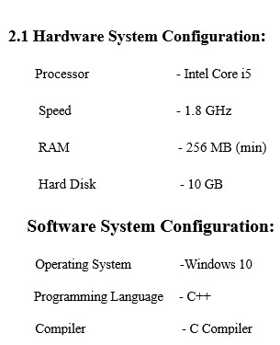

**2.2Language Used:**

C++ is a general-purpose programming language. It has imperative, object oriented and generic programming features, while also providing facilities for low-level memory manipulation.

**3.System Design**

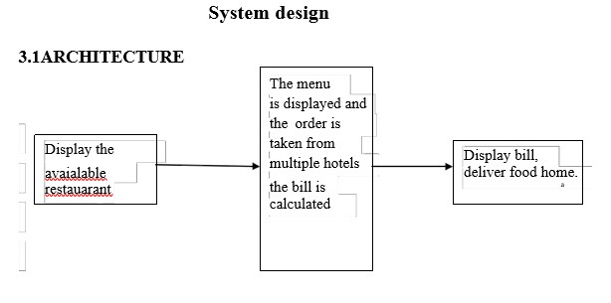

Fig 3.1:Control Flow

**3.1 ALGORITHM USED**

Step 1: Start

Step 2: Display the list and details of restaurants stored

in a file “RestaurantList”.

Step 3: Read the restaurant details as a

two-dimensional matrix.

Step 4: Input the user’s choice of restaurant.

Step 5: Get the corresponding details of the

chosen restaurant from the file and store it in

an object of class restaurant

Step 6: Display the menu of the chosen restaurant.

Step 7: Input the user’s order of dishes along with quantity.

Step 8: Obtain the price of each chosen dish and

calculate the total from the current restaurant.

Total=Price*Quantity

Step 9: Display the total from the chosen restaurant.

Step 10: Ask the user if he wants to order from

another restaurant.

If yes, repeat steps 2 to 8.

Step 11: Once the user has order from as many

restaurants as he wants, input the mode of delivery.

If chosen mode is home delivery, input the user’s delivery address and phone number and calculate the delivery charge.

If the chosen mode is take away, calculate the final bill.

Step 12: Calculate the final bill by adding the totals from all the restaurants and display.

Step 13: Input the method of payment and calculate the tax accordingly and add it to the total.

Step 14: Display the final total.

Step 15: Stop

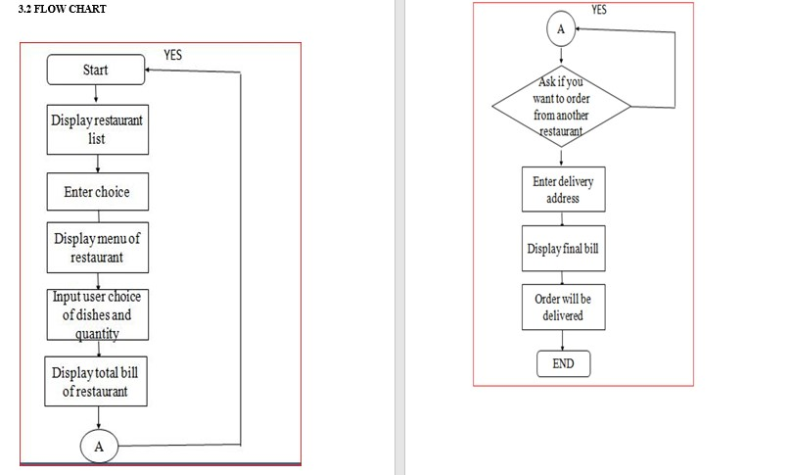

Fig 3.2:Flow chart for online food processing system

**4.RESULTS AND DISCUSSION**

**4.1 Summary of result obtained**

Many of the OOPS concepts are used to implement this project. Classes, objects, data abstraction, encapsulation, inheritance and friend function are used in the coding

**Significance of result**

❖ This project reduces the manual work of typing the order calculating, the bill and reordering from a different restaurant and following the same procedure.

❖ This project will also tell us about the feedback on the restaurant and an efficient way of calculating the bill .

❖ This project saves time of the user and the restaurant.

**5.Conclusion**

The proposed system is an attempt to remove the existing flaws in the manual method of ordering and billing food. It is different from existing food ordering systems as this provides the additional feature of ordering from many restaurants and getting one final bill on all the orders.

Generating the bill online is another significant way of making the user aware beforehand of how much to be paid. Since online payments are used widely by the people this method of ordering and delivering becomes helpful.

resource-constrained applications, including desktop applications, servers (e.g. e-commerce,Web searchorSQLservers), and performance-critical applications (e.g.telephone switchesorspace probes). C++ is a compiled language, with implementations of it available on many platforms.

**6.References**

The following links and paper were very helpful during the completion of project:

❖http://www.academia.edu/4935972/ONLINE_ORDERING_SYSTEM_PROJE CT_PROPOSAL

❖ https://www.slideshare.net/armanreza161/food-ordering-system-75284735,

❖ https://www.scribd.com/document/343606727/Synopsis-of-Online-Food-Ordering-System