**A Novel Approach to CAPTCHA Generator**

**Dr.S.Mohan kumar**,

New Horizon College of Engineering, Research Centre,Bangalore,India.

# 1.Introduction

Presently, living has changed the dimension with the introduction of the Internet to mankind, ways people connect to each other, advertising, shopping, education, etc. Consequently, system security has become the most important issue for any websites since there are many methods used to intrude the system over the internet. People have developed techniques, systems, programs and software systems that can replace a normal human being to do a job; such kinds of jobs include entering of data into systems, generate data automatically, handling events that occur on or within a system. As a matter of fact, web sites must ensure that the services are supplied to legitimate human users rather than bots to prevent service abuse. To thwart automated attacks, services often ask users to solve a puzzle before being given access to a service. Human Interactive Proofs (HIPs), focus on automation tests that virtually all humans can pass but current computer programs fail. Completely Automated Public Turing test to tell Computers and Humans Apart (CAPTCHA) was an acronym that was coined in 2000. It is a type of challenge-response test that only a human completes successfully.

CAPTCHAs are designed to be simple problems that can be quickly solved by humans, but are difficult for computers to solve. Using Captchas, services can distinguish legitimate users from computer bots while requiring minimal effort by the human user . In the procedure, a computer or a program creates a test for its user, who is expected to be a human. The test is meant for the humans, that is, it is to be solvable only by humans and not any other machine, system or program. The user is required to provide a correct response to the test and then the user is permitted to access the work. When a correct response is received, it is presumed that the response arrived because of a human user.

**1.1 Purpose of study**

Internet has become a vital part of everyone’s day to day life. The facilities offered by internet are vast. As a downside of it, many robots are used for misusing the web and to steal details. To block spammers and robots that try to automatically harvest email addresses or try to automatically sign up for websites, blogs or forum, a simple text-based CAPTCHA is designed and implemented so as to verify whether the user is human or not.

* The below mentioned are some of the problems caused by bots. To find a solution to these problems we are implementing this project.Registration for web forms: many websites on internet give a facility for free registration to access their services. But they are vulnerable to web robots. It can be used to register hundreds of email accounts, thereby wasting the space on internet.
* Polling sites: These sites take user’s feedback in the form of questions. To make sure that only human’s response is considered they make use of CAPTCHA.
* To prevent web crawling: If any site doesn’t want to be indexed by a search engine, they can make use of CAPTCHA.
* E-Ticketing.
* Preventing Dictionary Attacks
* E-mail spam.

The purpose of CAPTCHA is to build up good security, which is very useful for blocking these robots from misusing the web. The CAPTCHA works mainly because the humans and computers process strings of characters differently.

**1.2 Problem Statement**

To prevent the bots from misusing the internet and stealing the details of other users, we implement CAPTCHA so as to differentiate computers and humans.

**1.3 Motivation of project**

The development of the internet is a boon to the human society in large. It has given us plenty of opportunity to invent, create, develop, learn and write new things from the internet. The services that a website provides is uncountable. Blogs are a medium of expressing one’s thoughts or providing useful information. But most of the web sites are not safe and secure because of the following reasons.

* Some robots, computer programs are created to steal the data from webpages.
* Robots are used to make fraudulent transactions. Some websites offer registrations to access their services.
* These bots are used to register for such websites many numbers of times and avail their services.
* Spammers create hundreds of email accounts and they make use of bots to send unsolicited mails to other users of email service.

**1.4 Methodology**

CAPTCHA is a test to tell computers and humans apart. In this proposed schema, a simple text-based captcha is generated which will be easy to solve by humans and difficult to solve by computers as the response for strings is different by bots and humans. The user is asked to enter the captcha that is generated. Then the captcha is matched with user input. If both are same then the user is taken to the next page. If not same, a message is displayed on the screen saying “Please re-check your captcha”. If the user did not understand the captcha, the user can refresh the captcha any number of times. This project is developed using HTML, CSS, JAVASCRIPT. It’s a simple web-based project.

# 2. System Requirements

**2.1 Software/Hardware Used**

**Hardware System Configuration:**

Processor - Intel Core i5

Speed - 1.8 GHz

RAM - 256 MB (min)

Hard Disk - 10 GB

**Software System Configuration:**

Operating System - Windows 10

Programming Language - HTML, CSS.JAVASCRIPT.

**2.2 About the language**

HTML:

1. Hypertext Markup Language (HTML) is the standard markup language for creating web pages and web applications. With Cascading Style Sheets (CSS) and JavaScript, it forms a triad of cornerstone technologies for the World Wide Web.

2. Web browsers receive HTML documents from a web server or from local storage and render the documents into multimedia web pages. HTML describes the structure of a web page semantically and originally included cues for the appearance of the document.

3. HTML elements are the building blocks of HTML pages. With HTML constructs, images and other objects such as interactive forms may be embedded into the rendered page. HTML provides a means to create structured documents by denoting structural semantics for text such as headings, paragraphs, lists, links, quotes and other items.

4. HTML elements are delineated by tags, written using angle brackets. Tags such as <img /> and <input /> directly introduce content into the page. Other tags such as <p> surround and provide information about document text and may include other tags as sub-elements. Browsers do not display the HTML tags, but use them to interpret the content of the page.

5. HTML can embed programs written in a scripting language such as JavaScript, which affects the behavior and content of web pages. Inclusion of CSS defines the look and layout of content.

Features of HTML:

* Easy and simple language.
* Mark-up language provides a flexible way to design.
* Facilitates to add link on web pages.
* It is platform independent.
* Facilitates to add graphics, videos and sounds

CSS:

1. Cascading Style Sheets (CSS) is a style sheet language used for describing the presentation of a document written in a markup language like HTML. CSS is a cornerstone technology of the World Wide Web, alongside HTML and JavaScript.

2. CSS is designed to enable the separation of presentation and content, including layout, colors, and fonts. This separation can improve content accessibility, provide more flexibility and control in the specification of presentation characteristics, enable multiple web pages to share formatting by specifying the relevant CSS in a separate .css file, and reduce complexity and repetition in the structural content.

3. The name cascading comes from the specified priority scheme to determine which style rule applies if more than one rule matches a particular element. This cascading priority scheme is predictable.

4. HTML sorts out the page structure while CSS defines how HTML elements are displayed.

5. CSS allows to apply specific styles for specific html elements.

6. The main benefit of CSS is that it provisions to separate style from content.

7. All formatting can be removed from the html document and stored in a separate CSS file.

8. It reduces complexity in the structured content.

9. Inline CSS: using an inline style is one of the ways to insert a style sheet. With an inline CSS, a unique style can be applied to a single element.

10. Embedded/ internal CSS: Internal styles are defined within the <style> element, inside the head section of an HTML page.

11. External CSS: With this method, all styling rules are contained in a single text file, which is saved with the .css extension.

JAVASCRIPT:

1. JavaScript often abbreviated as JS, is a high-level, interpreted programming language. It is a language which is also characterized as dynamic, weakly typed, prototype-based and multi-paradigm.

2. Alongside HTML and CSS, JavaScript is one of the three core technologies of the World Wide Web. JavaScript enables interactive web pages and thus is an essential part of web applications. The vast majority of websites use it, and all major web browsers have a dedicated JavaScript engine to execute it.

3. As a multi-paradigm language, JavaScript supports event-driven, functional, and imperative (including object-oriented and prototype-based) programming styles. It has an API for working with text, arrays, dates, regular expressions, and basic manipulation of the DOM, but the language itself does not include any I/O, such as networking, storage, or graphics facilities, relying for these upon the host environment in which it is embedded.

4. It is an object-based scripting language.

5. It is characterized as dynamic, prototype-based and multi-paradigm.

6. It is a light weight programming language.

7. It has small memory foot prints.

8. Easy implementation.

9. Less syntax and features.

10. It is a cross platform programming language.

11. it is a language that can run on multiple platform and is compatible with different operating system.

12. It is used to understand the behavior of web pages.

13. It is used to create interactive website.

14. Used to display clock.

15. Used in displaying date and time.

16. Used to create dynamic drop-down menus.

17. Displaying popup windows and dialogue boxes.

18. The script tag specifies that we are using JavaScript

**3.System Design**

**3.1 Architecture**

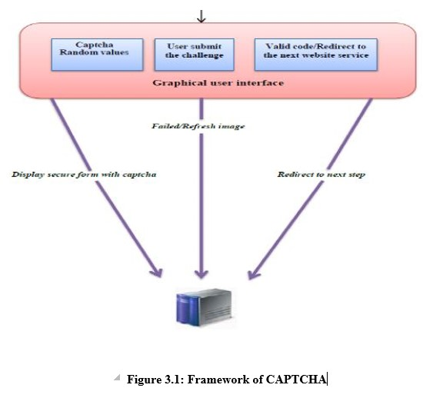

3.2Algorithm

Step 1: Start

Step 2: Generate random variable(CAPTCHA).

Step 3: Store and display that random variable.

Step 4: Take input from user.

Step 5: If user presses refresh button on web browser, go back to step 1. Else go to step 6.

Step 6: Compare the generated variable with the user entered input.

Step 7: If they are same, go to the next web page.

Step 8: If they are not same, print as “please re-check the captcha” and go back to step 1.

Step 9: Exit.

**3.3 Flow chart**

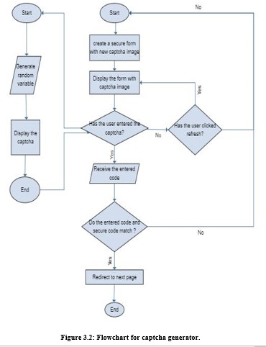**4.Results and discussion**

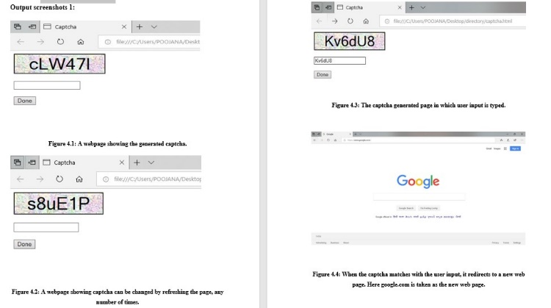

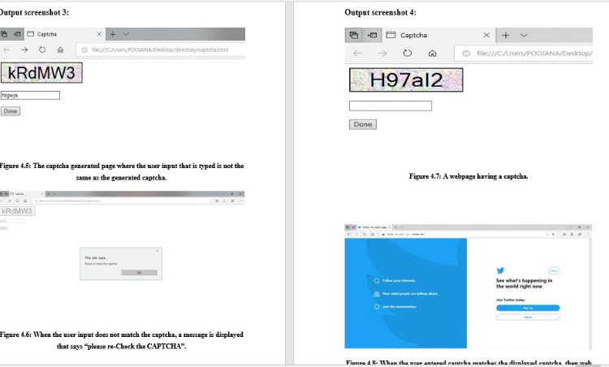

Fig 4.1 Results

**5.Conclusion**

CAPTCHA plays important role in World Wide Web security where it prevents Bot programs and Hackers from abusing online services. As a contribution toward improving the web security in the field of an automated challenge and response against attacks issued by automated programs, we proposed a simple text based CAPTCHA. The proposed project is successfully implemented and verified with different inputs. It helps us in differentiating bots from humans. We can reduce internet spams and provide safe browsing facility to the users.

**6.References**

BOOKS:

1. HTML & CSS: Design and Build Web Sites Book by Jon Duckett.

2. Learning Web Design Book by Jennifer Niederst Robbins.

3. JavaScript and jQuery: Interactive Front-End Web Development by Jon Duckett.

**CITATIONS:**

1. https://ijcsmc.com/docs/papers/April2015/V4I4201599a30.pdf

2. https://www.slideshare.net/kunalkiit/seminar-report-on-captcha

3. https://stackoverflow.com/questions/891701/captcha-algorithm

4. http://citeseerx.ist.psu.edu/viewdoc/download?doi=10.1.1.444.8759&rep=rep1&type=pdf

5. https://www.geeksforgeeks.org/program-generate-captcha-verify-user/

6. http://www.ijera.com/papers/Vol2_issue3/NN2322582262.pdf

7. https://www.snaphost.com/captcha/

**RESEARCH PAPERS:**

1. Wei-Bin Lee, Che-Wei Fan ,Kevin Ho, Chyi-Ren Dow , and "A CAPTCHA with Tips Related to Alphabets Upper or Lower Case," in Seventh International Conference on Broadband, Communication, Wireless Computing and Applications, 2012.

2. Baljit Singh Saini and Anju Bala "A Review of Bot Protection using CAPTCHA for Web Security," IOSR Journal of Computer Engineering, 2013

3. Xiao Ling-Zi and ZHANG Yi-Chun "A Case Study of Text-Based CAPTCHA Attacks," in International Conference on Cyber-Enabled Distributed Computing and Knowledge Discover, 2012.

4. Rich Gossweiler, Maryam Kamvar and Shumeet Baluja “What’s Up CAPTCHA?A CAPTCHA Based on Image Orientation” WWW 2009 MADRID!, pp. 841-850, 2009

5. S. Benson Edwin Raj, Deepa Devassy and Jiji Jagannivas "A New Architecture for the Generation of Picture Based CAPTCHA," IEEE, pp. 67-71, 2011.

6. Aditya Raj, Ashish Jain, Tushar Pahwa and Abhimanyu Jain "Picture CAPTCH As With Sequencing: Their Types and Analysis," International Journal of Digital Society, vol. 1, no. 3, pp. 208-220, 2010.

7. ElieBursztein, Steven Bethard, John C. Mitchell, DanJurafsky, and Celine Fabry. How good are humans at solving captchas? a large scale evaluation. In Security and Privacy,2010