**A Novel Approach to Ultrasonic Motion Sensor**

**Samitha.K** 1,, **Dr.S.Mohan kumar**2

New Horizon College of Engineering, Research Centre,Bangalore,India1.

New Horizon College of Engineering, Research Centre, Bangalore, India2.

# Introduction

The ultrasonic motion detector is a project that uses an ultrasonic sensor as its base to detect movement or moving object in small places. It is design to be a low-cost ultrasonic motion detector. A motion detector is a kind of security system that uses sensing ability in the form of sensors to detect movement and this usually triggers an alarm, or sometimes activate another circuit. However, motion detectors are normally used to protect indoor areas, in this, conditions can then be controlled more closely. Detectors for use in homes for security purpose usually detect movement in a closed space area of little feet-by-feet. Detectors for large range warehouses can protect areas with dimensions as large as 24mx37m (80ft by120ft).

The motion detector is normally useful in places like museums where important assets are located. As such, motion detectors can detect break-in at vulnerable points. Such points include walls, doors windows and other openings. Special motion detectors can protect the inside of exhibit cases where items such as diamonds arc placed. Others can be focused on a narrow area of coverage, somewhat like a curtain, that projected in front of a painting to detect even the slightest touch.Human, animal or anything can produce sound. This sound is creating by the physical movement whether the movement is fast or slow depends on the medium that create the sound. Eventually these movements can be detected by using an ultrasound sensor. Ultrasonic sound waves are sound waves that are above the range of human hearing and, thus, have a frequency above about 20,000 hertz. Any frequency above 20,000 hertz may be considered ultrasonic.

An ultrasonic sensor typically comprises at least one ultrasonic transducer which transforms electrical energy into sound and, in reverse, sound into electrical energy, a housing enclosing the ultrasonic transducer or transducers, an electrical connection and, optionally, an electronic circuit for signal processing also enclosed in the housing.

**1.1 Purpose of Study**

Putting lights on a motion sensor is a very simple and effective – not to mention inexpensive way to secure your property. You can place flood lights, garden lights, your front entrance light, and other outdoor lighting on motion sensors. Many indoor/outdoor motion sensor lights can be easily installed on your own (DIY).

Motion-sensing lights provide several benefits:

• Reduce Crime: Statistics show that well-lit communities have lower crime rates than neighborhoods with poor lighting.

• No Place to Hide: When the exterior of your home is well lit, would-be burglars have no place to lurk or hide.

• Warning Signs: If your flood lights suddenly go on, it’ll give you the chance to investigate or call the police.

**1.2 Problem Statement**

• Cannot work in a vacuum

Because ultrasonic sensors operate using sound, they are completely non-functional in a vacuum as there is no air for the sound to travel through.

• Not designed for underwater use

Our sensors have not been properly tested in this environment, so underwater use voids our warranty. This being said, we do supply documentation for customers who would still like to test our sensors underwater. If you are interested in underwater applications with ultrasonic, check out our articles on Water Depth Sensing with Ultrasonic and Underwater Ranging for more information.

• Sensing accuracy affected by soft materials

Objects covered in a very soft fabric absorb more sound waves making it hard for the sensor to see the target.

• Have a limited detection range

At the moment, our longest-range sensors have a maximum range of 10 meters. While this is a disadvantage in certain applications, our sensors have great mid-range capabilities and are still suited for many applications.

**1.1 Motivation**

Ultrasonic sensor works on a principle similar to radar or sonar which evaluate attributes of a target by interrupting the echoes from radio or sound waves respectively. Ultrasonic sensors generate high frequency sound waves and evaluate the echo which is received back by the sensor. Sensors calculate the time interval between sending the signal and receiving the echo to determine the distance to an object.

**1.2 Methodology**

ON state: When an object passes within the set range the ultrasonic sensor gets detected and the LED glows.

OFF state: When an object passes after the set range the ultrasonic sensor doesn’t gets detected and LED does not glow.

**2.System requirements**

**2.1 Hardware and Software configuration**

**Hardware System Configuration:**

Arduino UNO -R3 CH340G

Ultrasonic sensor - HC-SR04

Led bulb

**Software System Configuration:**

Operating System- windows

Programming Language- C

Software- Arduino 1.0.x.

**2.2 About the language**

C is an imperative procedural language. It was designed to be compiled using a relatively straightforward compiler, to provide level access to memory, to provide language constructs that map efficiently to machine instructions, and to require minimal run-time support. Despite its low-level capabilities, the language was designed to encourage cross-platform programming. A standards-compliant C program that is written with portability in mind can be compiled for a very wide variety of computer platforms and operating systems with few changes to its source code. The language has become available on a very wide range of platforms, from embedded microcontrollers to supercomputers.

To make a good understandable program we need to follow:

• Reliability: This enables a code to handle its own generated errors while running.

• Solidity: This provides a frame to anticipate problems on the user side(wrong inputs).

• Ergonomics: This helps to intuitively be able to use it with ease.

• Portability: This is the designing of a program for a wide range of platforms.

• Maintainability: This is the ease of modifying it even if you didn't code it yourself.

• Efficiency: This indicates that a program runs very smoothly without consuming a lot of resources.

**3.System Design**

**3.1 Architecture**

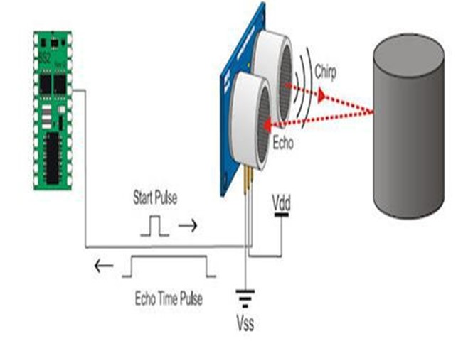

**3.2 Algorithm**

Step1: Start

Step2:Take choice as input

Step3:Check range of the object

if distance<=given range

turn digital wire high

else

if distance>given range

turn digital wire low

break

Step4:End

**3.3 Flow Diagram**

The process flow begins with detecting a ultrasonic sensor range, then if the object is within 10cm LED glows else if it is after 10cm it doesn’t glow as it is shown in the below flow diagram 3.3.1

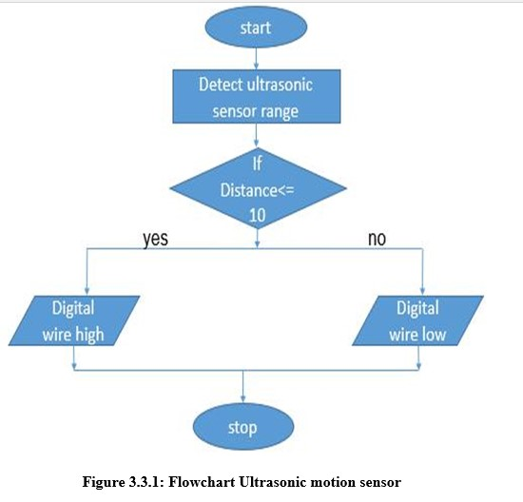

3.4 CODE AND IMPLEMENTATION

int trigPin = 9;

int echoPin = 10;

int led = 7;

void setup() {

Serial.begin(9600);

pinMode(led, OUTPUT);

pinMode(trigPin, OUTPUT);

pinMode(echoPin, INPUT);

// put your setup code here, to run once:

}

void loop() {

long duration, distance;

digitalWrite(trigPin,HIGH);

delayMicroseconds(1000);

digitalWrite(trigPin, LOW);

duration=pulseIn(echoPin, HIGH);

distance =(duration/2)/29.1;

Serial.print(distance); Serial.println("CM");

**4.Results and Discussions**

**4.1 Summary of result obtained**

The result of this project is as if any object passes or comes within the range of 10cm the ultrasonic sensor gets detected and the LED glows. If the object does not passes within the range of10cm the LED doesn’t glow.

**4.2 SNAP SHOTS**

The components used in the mini project is displayed in the below snapshot.

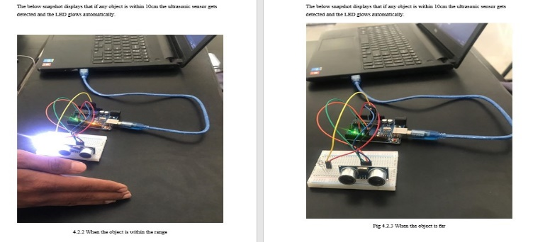

**5.Conclusion**

It could be deduced from the foregoing design analysis that the design of ultrasonic motion detector like any other electronic need careful planning and implementation. This work is mainly a design and construction of a system that has the ability to sense motion through movement of humans or any target, to design a low cost and portable motion detector system, and the design of a system that can be used to trigger another circuit which can trigger ON or OFF the circuit depending on the circuit attached to it. Generally, the design is made to detect movement or moving object in an enclosed area. In this work, a transmitter transducer generates a signal at a frequency of 40khz, and when the signal is blocked by any moving object, the receiver will be notified and the led glows

**6.References**

The following websites and books were helpful during the development of the project:

✓ M. N. N. A. Asghar, M.H., “Principle application and vision in internet of things (iot),” in Communication Technologies (GCCT), 2015 Global Conference on, may 2015.

✓ B. R. Pavithra, D., “Iot based monitoring and control system for home automation,” pp. 169 – 173, April 2015.

✓ Bass, H.E., & Bolen, L.N. (1985), “Ultrasonic background noise in industrial environments,” Journal of Acoustical Society of America, 78(6), pp. 2013-2016.

✓ Theraja, B. L., &Theraja, B.K (2002), “A textbook of Electrical Technology”, S.Chand and Company Ltd. New Delhi, India 2002

http://electronicsviaweb.blogspot.com/2012/07/ultrasonic-motion-detector.html

✓https://www.researchgate.net/publication/319356469_Obstacle_Detection_Using_ the_Concept_of_Ultrasound