**Teaching English Grammar using Bloom’s Revised Taxonomy**

**Dr.N.Asokan1 W.Robert2**

Principal, Mount Zion College of Engineering and Technology, Pudukottai, Tamilnadu- 622 507**1**.

Email : ntvasokan@gmail.com Mobile: 9965520311

Sr. Lecturer, Dept. of English, Mount Zion College of Engineering and Technology, Pudukottai.**2**

***Abstract*** *-* This paper shows how the use of Bloom's revised taxonomy as a pedagogical framework, can help teachers to address the issues and concerns pertaining to teaching English grammar.This study was carried out and delimited to 60 students of first year undergraduate Electronics and Communication Engineering programme during 2009 – 2010 for Technical English subject at Mount Zion College of Engineering and Technology, Pudukkottai, Tamil Nadu, India. The teaching methodology includes Planning that is “objective –driven” begins with specifying instructional objectives from University syllabus (affiliated system) in terms of the classification of the Taxonomy table followed by “activity –driven”, which gives initial emphasis to the instructional activities and then, operating from a “test-driven” perspective starts with concerns for assessment finally mapping of all the above in the taxonomy table.A Learning activity consist of a verb that relates to an activity at one of the levels of the cognitive domain, and a noun providing additional insight into the relationship of the specific learning objective to a category of knowledge.Staff members expressed their satisfaction regarding “the way they allocate the time in the class room and by the emphasis they convey to their students about what is really important”, satisfying the teachers systematically plan a way of effectively facilitating student’s learning.Learning taxonomies help us to "understand about understanding"

.***Keywords*: Taxonomy, Specific Instructional Objectives, Knowledge Dimension, Cognitive Dimension, Teaching Learning and Assessing, Mapping**

# Introduction

The reasoned aspect of teaching relates to what objectives teachers select for their students. The intentional aspect of teaching concerns how teachers help students achieve the teachers’ objectives, that is, learning environments the teachers create and the activities and experiences they provide. The learning environments, activities, and experiences should be aligned with, or be consistent with, the selected objectives.

When teachers are confronted with exceedingly large number of vague objectives, we need to organize and to make the objectives more precise. In a nutshell, then teachers need an organizing framework that increases precision and, most important, promotes understanding.

This paper shows how the use of Bloom's revised taxonomy (Anderson et al. 2001) , as a pedagogical framework, can help teachers to address the issues and concerns pertaining to education. The teaching methodology includes Planning that is “objective –driven” begins with specifying instructional objectives from University syllabus (affiliated system) in terms of the classification of the Taxonomy table followed by “activity –driven”, which gives initial emphasis to the instructional activities and then, operating from a “test-driven” perspective starts with concerns for assessment finally mapping of all the above in the taxonomy table.

In order to ensure successful learning amongst all students, it is extremely important to fully understand the educational needs of individual students.

Learning taxonomies help us to "understand about understanding".

**2.Bloom’s Taxonomy**

It is the author’s belief that the use of Bloom's taxonomy could improve the understanding of the pedagogical, or learning, objectives that should be considered in any educational program, amongst teachers. The rest of this paper will briefly examine this taxonomy, before discussing its possible use in technical education. Bloom's taxonomy of the cognitive domain Bloom's taxonomy is possibly one of the best known and most widely used models of human cognitive processes. Bloom's model was originally developed in the 1950's and remained in use more or less unchanged until fairly recently (Van Niekerk ,2008, p. 249). A revised version of the taxonomy was published in 2001. This revised taxonomy has become accepted as more appropriate in terms of current educational thinking (Van Niekerk ,2008, pp. 249-260). Both versions of Bloom's taxonomy consist of six levels which increase in complexity as the learner moves up through these levels.

There are two main differences between the original and the revised versions of the taxonomy. Firstly, the revised version uses descriptive verbs for each level that more accurately describes the intended meaning of each level. Secondly, the revised version has swapped the last two levels of the original version around. This was done because recent studies have suggested that generating, planning, and producing an original "product" demands more complex thinking than making judgments based on accepted criteria. The hierarchy of complexity in the revised taxonomy is also less rigid than in the original in that it recognizes that an individual may move among the levels during extended cognitive processes. This paper will focus on the revised version of the taxonomy.Wherever this paper mentions Bloom's taxonomy, it should be assumed that the revised version is intended, unless otherwise stated. The following is a brief explanation of each of the six levels of this revised taxonomy.

Activities at these six levels of the cognitive domain are usually combined with the one or more of the four types of knowledge in a collection of statements outlining the learning objectives of an educational program. Usually a learning objective statement will be used to create a set of learning activities. Learning activities are activities which help learners to attain the learning objectives.

A Learning activity consist of a verb that relates to an activity at one of the levels of the cognitive domain, and a noun providing additional insight into the relationship of the specific learning objective to a category of knowledge (Anderson et al. 2001, pp. 93-109). The uses of taxonomy often assist educators in gaining better understanding of learning objectives, and activities. However, it is not always clear how this increased understanding can help the educators.

**3. TEACHING LEARNING AND ASSESSING PROCESS**

Teachers often attempt to address needs of students without adequately studying and understanding the underlying factors that contribute to those needs (Fuller et al 2007, pp. 27-36). It has been argued before that educational material should ideally be tailored to the learning needs and learning styles of individual learners (Roper, 2005, p. 19).

The reference point for any educational program should be a set of clearly articulated "performance objectives" that have been developed based on an assessment of the target audience's needs and requirements (Fuller et al 2007, p. 96). Correct usage of an educational taxonomy not only helps to articulate such performance objectives but, more importantly, helps the educator to correctly gauge the needs and requirements of the audience.

The following is the methodology of teaching, learning and assessing followed at Mount Zion College of Engineering & Technology.

a. Identifying the pre-requisite knowledge for a particular subject.

b. Mapping of five units of subject content for that subject

c. Mapping of that subject with other subjects of a progrmme

d. Delivering the knowledge content of pre-requisite knowledge at the beginning of the semester.

e. Preparing the specific instructional objectives from the syllabus in accordance with Bloom’s revised taxonomy

f. Preparing the lesson plan

g. Teaching learning process in accordance with Bloom’s revised taxonomy

h. Continual evaluation during the semester and at the end of the semester in accordance with Bloom’s revised taxonomy

i. Mapping of objectives, teaching learning process and assessment in the Bloom’s revised taxonomy table.

**4.METHODOLOGY**

The teaching, learning and assessing methodology is illustrated for 60 students of first year (first semester) undergraduate Electronics and Communication Engineering programme during 2009 – 2010 for Technical English I subject at Mount Zion College of Engineering and Technology, Pudukkottai, Tamil Nadu, India.

Planning that is “objective –driven” begins with specifying instructional objectives from University syllabus (affiliated system) in terms of the classification of the Taxonomy table followed by “activity –driven”, which gives initial emphasis to the instructional activities and finally, operating from a “test-driven” perspective starts with concerns for assessment.

Objectives exist in many forms, ranging from highly specific to global and from explicit to implicit. The most commonly used model of educational objectives is based on the work of Ralph Tyler (1949). Tyler suggested that “the most useful form for stating objectives is to express them in terms which identify both the kind of behavior to be developed in the student and the content.

Parts of speech have been identified as pre- requisite knowledge and delivered the same to the students at the beginning of the semester.

There are five units in the syllabus. First unit deals with vocabulary, second unit deals with grammar, third unit deals with reading, fourth unit deals with writing and firth unit deals with listening and speaking. Mapping of these five units is illustrated after the pre-requisite knowledge delivered before the actual content delivered as per the lesson plan.

4.1.Example

Illustration of One sample objective is given below

Subject content given in the II unit of syllabus: Tense.

Objective: To speak and write using correct tense

To speak and write using correct tense – Conceptual knowledge domain and “Apply” cognitive process domain.

Activities:

To define tense – Factual Knowledge domain and Remember Cognitive Process Domain

To list the 12 types of tense - Factual Knowledge domain and Remember Cognitive Process Domain

To explain 12 types of tenses – Conceptual knowledge Domain and Understand Cognitive Process Domain

To explain format of each 12 tenses - Conceptual knowledge Domain and Understand Cognitive Process Domain

To apply the tense in framing sentences - Procedural knowledge domain and “Apply” cognitive process domain

Activities: Defined what is tense, listed out the 12 types of tenses, explained the same, explained the format of each 12 tenses and, given exercises on the use of tense and concord (suitable forms of verbs).

Assessment: Exercises have been given to assess (“To speak and write using correct tense” – Conceptual knowledge domain and “Apply” cognitive process domain objective) the students understanding of tense and the ability to apply suitable tense in the sentences.

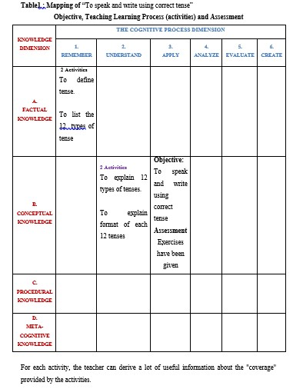

The teacher could choose to focus on the learning objective itself, and thus, only use assessment methods that require the learner to apply procedural knowledge. Or the assessor might decide to focus on one or more learning activities and thus have a wider range of assessment coverage. By noting assessment activities on the same taxonomy table, the teacher can ensure that the chosen assessments correspond directly to what he/she intends to assess.

In the given example, a clear "disconnect" between the learning objective, activities and disconnect between activities and assessment and the alignment between objective and assessment is observed.

Instead of focusing on the application, or use of tense , the activities focus on factual and conceptual knowledge. If the teacher directly focuses on application, then this factual and conceptual knowledge have become pre-requisite knowledge for that objective. Similarly, other "miss-alignments" can be identified with the help of this taxonomy table.

Forty six learning objectives were established for Technical English –I subject in accordance with Bloom’s revised taxonomy. Forty six learning activities are delivered to the students over the period of 49 hours as per the lesson plan prepared before beginning of the semester.

The following table illustrates unit wise the number of objectives classified in accordance with Bloom’s revised taxonomy and the representative sample of learning objectives is selected as questions to evaluate the students’ achievements of learning objectives.

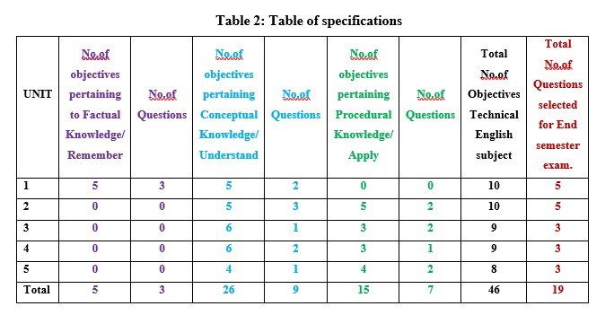

**5. Findings and discussions**

Linda.V et al., (2009) considered what has traditionally been the focus of engineering curricula: mastery of the core competencies. Empirical data show that a greater degree of engagement or active learning results in higher mastery.

There are 5 objectives pertaining to Factual Knowledge, of which 3 objectives are used for evaluation of students at the end of the semester. 15 out of 60 students (remembered) i.e. 25% of students correctly answered all the 5 objectives, and 21 out of 60 students (remembered) i.e.,35% of students correctly answered 50 % of the objectives.

There are 26objectives pertaining to Conceptual l Knowledge, of which 9 objectives are used for evaluation of students at the end of the semester. 26 of 60 students (understood) i.e.,43% of students correctly answered these objectives and 24 out of 60 students (understood) i.e.,40 % of students correctly answered 50 % of the objectives.

There are 15 objectives pertaining to Procedural Knowledge, out which 7 objectives are used for evaluation of students at the end of the semester. 30 out of 60 students (able to apply the factual and conceptual knowledge in a given situation) i.e., 50% of students correctly answered these objectives, and 19 out of 60 students (able to apply the factual and conceptual knowledge in a given situation) i.e.,31% of students correctly answered 50 % of the objectives.

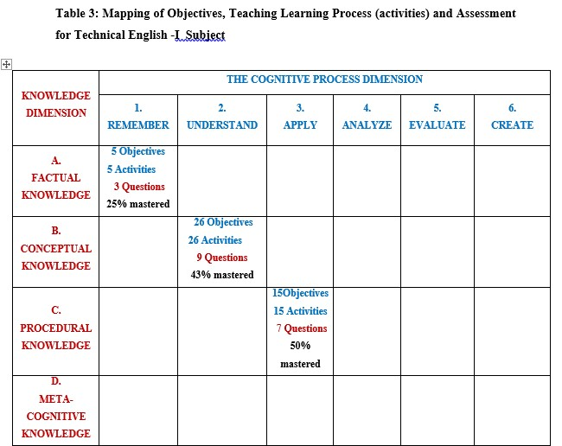

These learning activities "are most important activities receiving the larger share of the available resources". In order to design activities that will result in maximum learning, one can look for activities that involve more than just one type of knowledge.

**6. Conclusion**

An example of how Bloom's revised taxonomy might be applied to learning objectives, activities and assessment in Technical English-I subject has been provided. The paper used this brief example, to show how a taxonomy table based on this example, could assist educators to address the issues and concerns pertaining to education as best methodology.

If all the objectives, activities and assessment are placed in the taxonomy table, then it helps us to "understand about understanding". By examining the taxonomy table the teacher can easily identify areas of knowledge, or levels of the cognitive domain, that has not been covered by the learning activities. Similarly, areas where multiple activities cover the same levels of cognition and categories of knowledge can be identified. Through the use of such taxonomy certain common weaknesses in educational programs might be addressed. The "miss-alignments" can be identified with the help of this taxonomy table

This paper suggested that technical educational programs would be more effective if they adhered to pedagogical principles.

Curriculum developers should use a taxonomy, like Bloom's taxonomy, before compiling the content category of the educational programme. The use of such a taxonomy could help to understand the learning needs of the target audience better.

**7.References**

Anderson, L., Krathwohl, D., Airasian, P., Cruikshank, K., Mayer, R., Pintrich, P., Raths, J., Wittrock, M.: A Taxonomy for Learning, Teaching, and Assessing: A Revision of Bloom's Taxonomy of Educational Objectives, Complete Edition. Longman (2001)

Bloom, B.S. (Ed.), Engelhart, M.D., Furst, E.j., Hill, W.H., & Krathwohl, D.R. Taxonomy of educational objectives : Handbook I : Congintive domain. New York : David Mckay, 1956.

Linda.V, Jonathan .S, Roberta J.H. The Four-Domain Development Diagram: A Guide for Holistic Design of Effective Learning Experiences For the Twenty-first Century Engineer. Journal of Engineering Education January 2009, Vol.98 No.1:67-78.

Roper, C., Grau, J., Fischer, L.: Security Education, Awareness and Training: From Theory to Practice. Elsevier Butterworth Heinemann (2005).

Tyler, R.W. Basic principles of curriculum and instruction. Chicago: University of Chicago press, 1949.

Van Niekerk, J., Von Solms, R.: Bloom's taxonomy for information security education. Information Security South Africa (ISSA), Johannesburg, South Africa (2008).

/