**Smart Farm using Wireless Sensor Network**

**Prof. Govindaraj M1, Gudgunti VV,Srikanth T2**

New Horizon College of Engineering, Research Centre,Bangalore,India1.

New Horizon College of Engineering, Research Centre, Bangalore, India2.

***Abstract*** *-* Wireless Sensor Networks due to their vast area of application being used in current research areas. In agricultural field like Greenhouses, various Climatic Condition Parameters are essential to monitored for regulation of crop production. We are going to make the automation system to trace down the local climatic condition parameters (like CO2, Temperature, and Humidity) at different locations. Wireless Sensor Networks (WSN) does this job to automate and analyze the corresponding parameters. We are going to develop the Web Application, Smartphone Application and Sensor Network using Zigbee Devices, Beagle Bone Controller and various Sensors.

***Keywords*: Automation, Wireless Sensor Network, Zigbee, XBee, BeagleBone, Router, Access Point, Solar Plates, Android, Database, Server, Temperature, CO2, Humidity, Remote, Wireless, Sensor, Agriculture, Green House, Controller, Sink, Sensing Node, Node, Gateway, Monitor.**

# Introduction

Sensor networks are compact wireless networks of small and low cost sensors, which gather and distribute environmental data. Wireless sensor networks empower monitoring and controlling of corresponding physical environments from remote area with better efficiency and accuracy [1]. They have applications in a range of fields such as environmental monitoring, climate control, surveillance and many more. Sensor nodes have various energy and computational restrictions because of their reasonable nature and ad-hoc method of implementation.

In this paper we have proposed the Wireless sensor network to design the smart environment to monitor and control various climatic parameters. We are going to deploy the wireless sensor network in the greenhouses, where this network is connected to Beagle Bone Controller. Beagle Bone Controller is a device which will collect all the climatic parameters and dump into webserver’s database by regular time interval. Web application and Smartphone application will analyze the climatic parameter values and predict the preventive measures for the corresponding environmental conditions. System will be powered by solar and storagebatteries.

**2. RELEATEDWORK**

2.1 Agriculture Field Monitoring

Instead of observing the productivity and quality of faming all the time, this paper proposes the design to monitor the same attributes using wireless sensor network. For the growth, quality and productivity of crops in agriculture temperature, humidity and carbon dioxide levels are the most important climatic parameters. Moreover, when a critical change in one of the measurements occurs, then the farmer will be acknowledged viaSMS and e-mail by an agriculture expert. [2]

2.2 Environment MonitoringSystem

There are various problems in the traditional agriculture like weak real-time data acquisition, limitations in monitoring area, excessive manpower etc., The system collects various climatic parameters like temperature, humidity, illumination, voltage etc. from greenhouse and from there it transmits the data to nearest server via GPRS. The system includes a web application which is using Google Maps to show the greenhouse status and provide regular voice and SMS alarm service. Since, it requires lots of power so it is powered by solar and storage batteries. This results that low power system has better scalability and can provide better service.[3]

2.3 Extending Automation to theFarm

Automation can be used to reduce amount of manual labor and make farming precise also leading to more agricultural growth. Number of operations of farm can be automated like irrigation system, temperature controlled system for livestock and farm product.[4]In this work they implemented automatic lighting system, automatic sprinkler system, house temperature control and security in farm houses. System is energy efficient because temperature and motion sensitive devices will work only when required. Energy efficient system is important factor for agro-based economy.[5]

2.4 Development of Precision Agriculture System

In this system temperature and moisture sensors are deployed at suitable location to monitor the crop. Sensing system uses feedback control mechanism with control unit which controls flow of water depending on temperature and moisture value. Control unit collects data from sensor analyze it and take action. [6]

**2.5 Integrated Wireless Sensor Network For Smart SesameFarming**

Various parts of the ranch are mechanized, which incorporate auto-watering system cycles and secure temperature controlled walled in areas for domesticated animals and homestea d items. In our paper, we actualize programmed lighting framework, auto-sprinkler framework, in-house temperature control and security for ranch houses. As temperature and movement touchy gadgets will just work when needed, such a framework rations vitality successfully. The paper likewise shows elements to improve the security of the homestead. Vitality effective ranch automation is the need of great importance in an agro-based economy.[7]

2.6 Irrigation Control by usingWSN

Paper elaborates the application of WSN for Wireless Controlled and monitoring irrigation solution. The implemented irrigation method removes the somewhat need of farmer for flooding irrigation. In agricultural cropping system the efficient water management important factor.[8]

2.7 Remote Wireless Automation and Monitoring of LargeFarm

Application describes Designing and programming the controller to monitor and control the network using LabView Software. It shows changes in values of farm as well as real values required for controlling sensing sectors. RF link is built to connect farmer’s house and the sensing and control unit. Controller sends signal to farmer’s house from 10 KM. [9].

2.8 WSN for precisionhorticulture

By using the precision agricultural instruments of SDI-12 standard which is used in precision horticulture by the design of new Wireless Sensor node (GAIA SoilMote). Using the IEEE 802.15.4 standard wireless communication can be achieved with a transceiver complaint. The Software which is used for GAIA Soil Mote is TinyOS based. There are two methodologies was devised to validate the sensor node design. The phase one consists of laboratory validation of the hardware and software which proposed for the system and also including a study of power consumption and autonomy. Thetypeofapplicationwhichischosenhasalargepotential

in market for farming sector and especially the development of PA(Precision Agriculture) applications. [10]

2.9 Wireless Application of Drip Irrigation Automation

The crucial problem which is faced in agricultural areas is the irrigation by fresh water resources. The high demand of freshwater is highly increased, the optimal use of water resources has been provided by automation technology at a greater extent and its apparatus such as solar power sensors, remote control and drip irrigation. There a difficulties on measuring & control systems over large geographical areas. The traditional instrumentations are based on discrete and connected network solution. The system was applied for drip irrigation of dwarf cherry trees on an area of 8 acres in the venue which is located in Central Anatolia. [11]

2.10 Drip Irrigation System & Monitoring Of SoilWirelessly

In past some years the agricultural technology has immediate growth. The utilization of proper method for irrigation by drip is very proficient and reasonable. The approach reviews various monitoring system and also proposes an automatic monitoring system model which is using Wireless Sensor Network (WSN) which is useful for the farmers to improve the growth of crops. In this method the test of soil for chemical constituents, salinity, fertilizer & water contents and all these data is collected wireless nodes and further processed for the improvement in drip irrigation plan. [12]

3. HOW WSNWORKS?

We are going to implement the Wireless Sensor Network or Zigbee Network with the help of XBee devices. There are 3 main parts in Zigbee network. Please refer the Fig. 1 for more details. Sensing nodes or End devices are embedded with the various sensors like CO2, Temperature and Humidity. Sensor Nodes will percept the environment values and forward to routers. Routers will collect values from various sensing nodes and forward to co-coordinator. Finally coordinator will collect values from all routers by regular interval. Coordinator is connected to a device which will be Internet enabled. All the collected values from various sensing nodes will be dumped in to database forprocessing.

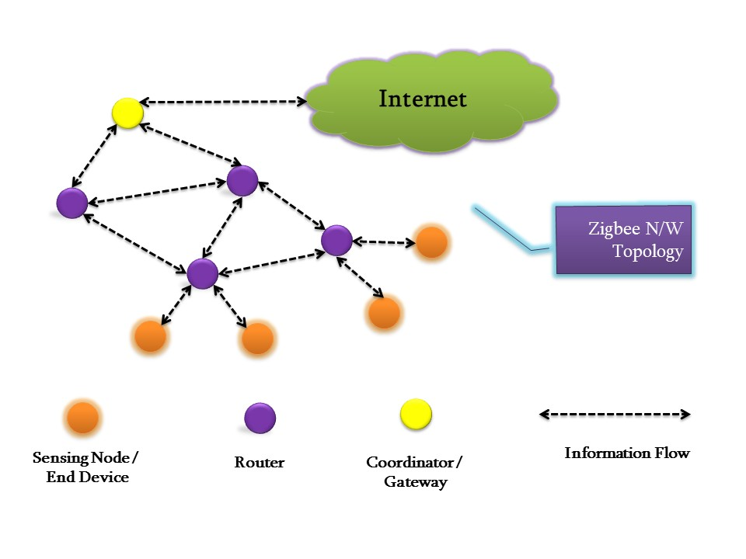

Fig 1: Zigbee Network Topology (WSN)

**4. SYSTEMARCHITECTURE**

Proposed system architecture is shown in Fig. 2 from which we can completely define a proposed system. Architecture description is given below.

4.1 GreenHouse

Green house is the field position where we are going to deploy and test for various climatic parameters by proposed system.

4.2 SensingNode

Various sensors like CO2, Temperature and Humidity are attached to sensing node. Sensing node will read the values by regular interval and forward it to routers. Sensing Nodes are XBee Devices which are configurable for various sensors. XBee devices are capable of working on Solar Power as well as storage batteries. These devices are remotely configurable.

4.3 Routers

Routers are the XBee devices which work independently, accept the various reading from sensor nodes and forward the values to coordinator. This is also capable to operate on solar power and storage batteries. Even though routers are optional part in the network because sensing node can directly send the values to coordinator / gateway.

4.4 Coordinator(Gateway)

Coordinator is XBee device which accept values from various routers and sensing nodes. Coordinator is connected to BeagleBone which is connected to internet. All the accepted values will be sent to BeagleBone for processing by serial interface.

4.5 BeagleBone (BB)

BeagleBone is the small device powered by Debain Operating System. We can perform all operations which we can perform using any computer device. BB will communicate with gateway/coordinator by serial interface. The python API will regularly check for frames or values on serial port because coordinator will be sending all the values on serial port of BeagleBone. As BB is computer device we can connect internet to it via Ethernet port or Wi-Fi/ Wireless LAN. BB will access the API from webserver and dump all the readings into database.

4.6 AccessPoint

Access point is simple router which will provide internet connectivity to BeagleBone Board. Even if we are using local webserver we can provide connectivity via router to BB.

4.7 Web Server

Webserver will have a database and specific API from where the BB can connect and store values in database remotely. API and all will be developed by using MVC Framework in PHP and Some Python Scripts. Webserver analyzes all the incoming values from the BB and analyze them, if any instant change is observed the farmer will be acknowledge by SMS, Email and Notification on MobileApplication.

4.8 Computer/WebApplication

Web Application can be accessed from any Internet enabled device from which we can continuously monitor the greenhouse. Graphs, Charts and History are used for effectiveness. Even web application will be in multi-language support because of which any farmer can effectively use it. Web application will be hosted on webserver. From web application we can remotely configure any XBee device such as switching ON OFF at any time. Web application will periodically analyze the values and predict some actions depending on the conditions.

4.9 SmartphoneApplication

Smartphone app designed in Android will be connected to Internet i.e. specifically to webserver. As webserver will be connected to webserver same this application will be working. From Smartphone we can monitor the environment continually without manual monitoring. Even all the remote devices are capable to configure remotely fromapplication.

**5. ACKNOWLEDGMENT**

Thanks to Authors B. BalajiBhanu, K. RaghavaRao, J.V.N. Ramesh, Mohammed Ali hussain for their research work in this domain.

Special thanks to our guide Prof. Govindaraj Mfor their precious guidance and their support for this research paper.

**6. CONCLUSION**

In farming Temperature, Humidity and CO2 are the most essential parameters. The growth of crops is mainly depending on these three parameters. Currently farmers don't have any system which will show real-time levels of these parameters. Even farmer don't know when humidity is increased or CO2 level increased in his green house, because of it crop production gets affected. The proposed system is going to monitor these changes periodically and take an action automatically or pretend the required action to the farmer. Systemwill have a provision to visualize the graphical representation of all the streaming data from the green house. Later on farmer can operate the devices from remote location by using its smart phone.

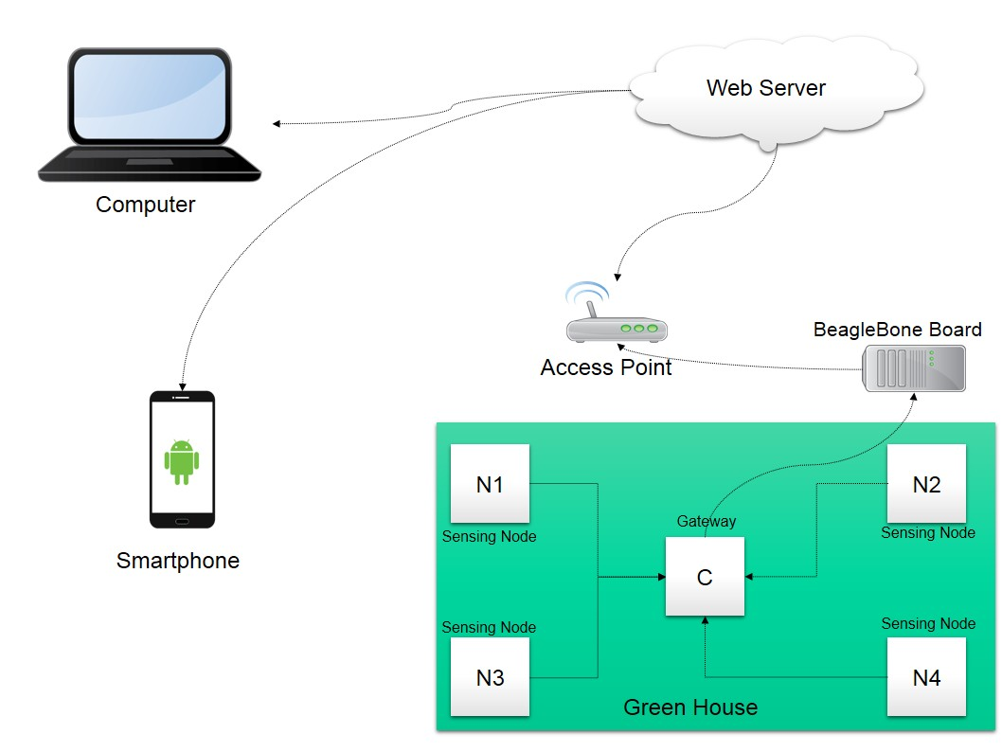

Fig 2: Proposed System Architecture

7. REFERENCES

[1] A. Willig and H. Karl, Protocols and the Architectures for Wireless Sensor Networks, John Wiley and Sons Ltd, The Atrium, Southern Gate, Chichester, West Sussex, England, 2005.

[2] B. BalajiBhanu, K. RaghavRao, J. V. N. Ramesh, Mohammed Ali Hussain, Agriculture Field Monitoring and Analysis using Wireless Sensor Networks for improving Crop Production", IEEE,2014.

[3] Jianfa Xia, Zhenzhou Tang, Xiaoqiu Shi, Lei Fan, Huaizhong Li ,"An environment monitoring for precise agriculture, based on wireless sensors network", IEEE,2011.

[4] Shining Li, Jin Cui, ZhigangLi,"Wireless Sensors Network forPrecise Agriculture Monitoring", 2011, China.

[5] DrishtiKanjilal, Divyata Singh, Rakhi Reddy, Prof Jimmy Mathew,"Smart Farm: Extending Automation to the Farm ", IJSTR,2014.

[6] S. R. Nandurkar, V. R. Thool, R. C. Thool, "Design and Development of Precision Agriculture System Using Wireless Sensor Network", IEEE,2014.

[7] Rekha P, Lekshmi G.S and ManeeshaV.Ramesh, "Inegrated Wireless Sensor Network for Smart Sesame Farming in India", Elsevier,2012.

[8] V.Ilango, et al., “A Five Step Procedure for Outlier Analysis in Data Mining-Survey”, European Journal of

[11] Lopez RJA, Sotoa F, Suardiaza F, Sancheza P, Iborraa A, Verab JA, “Wireless Sensor Networks for precision horticulture in Southern Spain”, Computer Electronics Agriculture, 68:25-35.

[12] V.Ilango, et al., “Cluster Analysis Research Design Models, Problems, Issues, Challenges, Trends And Tools”, International journal on Computer Science and Engineering, Vol.3(8).August 2011, P. 3064-3070, ISSN: 0975–3397.

[13] MahirDursun and SemihOzden, “A wireless application of drip irrigation automation supported by soil moisture sensors”, Scientific Research and Essays Vol. 6(7), AcademicJournals,2011.

[14] Aniket Hade, Dr. M.K. Sengupta, "Automatic Control of Drip Irrigation System & Monitoring Of Soil by Wireless", IOSR-JAVS, 2014

Figure 3: The knowledge cycle implemented with AI methods and tools