**Roles Of Retriveing The Data Using Various Technoques By Robotics In Education**

**Prof Krishna Chandra M1, PRIYANKA M2**

New Horizon College of Engineering, Research Centre,Bangalore,India**1**.

New Horizon College of Engineering, Research Centre, Bangalore, India**2**.

***Abstract*** *-* In the current decades robots play an vital role in all the industries namely Maintenance, Manufacturing, Education and Health etc…among which Robots are an integral component of our society and are potentially being used as an Educational technology. To have a better understanding of robotics, we present a review in the field of robots in education .To improve the Education system ,how a robot and advanced technology to take up the Initiatives towards the various modes of delivering concepts through the teacher ,tool or peer to peer in the learning activity. So this system proposes advanced teaching and learning mechanism to the society using robots.

***Keywords*: Educational robotics, Humanoid interaction, Social robotics, pedagogy.**

# 1.Introduction

Robots are enormously growing in today's life in one or the other way and this review paper is focused on the education basis for the primary students. In this paper we are talking about the primarily uses to improve students language skills, science or technology and the robot would take the role of a teacher, tool or peer in the learning activity. We admin in educational institutes who wish to understand the wider implications of adopting robots in education .The main role that Educational robots play in the young lives of children is by playing an important role to teach them in a easy way, make them understand better and with this the advent that student can achieve is based on their learning with this tool. As we know that robots are an entertaining platform to learn about computers and languages. It has been said that students are not showing interest towards language learning subjects through books and so we came up with a solution i.e that introducing robots would help and students started showing interest towards the language learning subjects and performed better.

**2. Literature Survey**

The review had many ways that would classify the use of robots in the field of education that would help the students to understand the subject better and make it use in their daily life of their student career and may be also in the future and should have a strong base in their primary education. We came up with the problem faced by students of primary school students in learning the language skills, science and technology and we came up with some solutions to their problem and will be identified in the later stage and will be given some examples based on the solution and the students participation, when robots where teaching the students. The robot can take a number of roles in teaching the students and the robots involvement also is very much important because students grasping power may be different from one to one student. Robots are not only treated as teaching tool but on the other hand also acts as learning tool. Robots play an Important and different roles where the roles would include the following: As a teacher, A mentor ,A companion and many more.

A systematic approach was followed to teach students and the outcome was noticed at each stages and also was reviewed .We could notice the changes of the student before robots teaching was introduced to them and after the robots started teaching them and their level of understanding and exploring with the building of words and start thinking different. For example:

• Technical subjects: Computer subject was the technical subject that was learnt, as it was electronic device and it was about touch, look and feel, they showed interest in learning in this subject and they were thought just the basics on how to use it.

• Non Technical Subjects: One of the main subject was language learning skills ,as it plays an important role and as we need it as a strong foundation because it will be used throughout our life.

**3. Related Work**

Robots where not just playing one role in intra-curricular activities ,but also in extra -curricular activities for teaching students. We wanted to check how students will participate in extra-curricular activities. The location was also the important as a part of learning activity. We had to differentiate the type of robots that would help for the teaching tool and also needed to teach robots how to explain things for student that would help students to understand and understand the concepts and concentrate in the class.The mechanism that we have used is webcrawler mechanism that how robots fetch the information from various sites and teach the students. WebCrawler:

A Web crawler, sometimes called a spider, is an Internet bot that systematically browses the World Wide Web, typically for the purpose of Web indexing.

A current report in view of a substantial scale investigation of robots.txt documents demonstrated that specific web crawlers were favored over others, with Googlebot

Architecture of a Web crawler

being the most favored web crawler There are various "visual web scrubber/crawler" items accessible on the web which will slither pages and structure information into sections and lines in light of the client prerequisites. One of the principle distinction between a work of art and a visual crawler is the level of programming capacity required to set up a crawler. The most recent age of "visual scrapers"like Diffbot, outmaneuver center point andimport.io evacuate most of the programming aptitude should have been ready to program and begin a slither to rub web data.The visual scratching/creeping approach depends on the client "educating" a bit of crawler innovation, which at that point takes after examples in semi-organized information sources. The predominant technique for instructing a visual crawler is by featuring information in a program and preparing segments and lines. While the innovation isn't new, for instance it was the premise of Needlebase which has been purchased by Google (as a feature of a bigger securing of ITA Labs), there is proceeded with development and interest around there by financial specialists and end-clients.

**4.Problem Identification**

Students in primary school may face different problem and it also depends on the student mental and physical problem that they are facing. Some students will grasp the concept easily and fast, on the other way round some students need to be explained about the concepts more than once and some students may need some explanation with examples. It is also said by teachers that every student who walk into my cabin is not facing the same problem ,some are facing problem in language skills ,some other students in mathematics ,some in computers and many more. There are cases where the students are not able to concentrate in the class due to their mental presence and their absence mind.

The problem which we have identified in this review is that the primary students facing problem in learning the language skills and technology in today's world is growing wider and it's better that we start teaching the basics of the use of computer for primary school children. Some students are failing to understand the problem in mathematics and some student's are not clear about the language skills that are required and some are not able to use the computers for just switching on and off of the system. There must be some co-operation with the parents to put their children in some camps where they learn and play. It's both the teachers and parents responsibility to take care of their children and yes ,not to pressurize the student to always learn. The student when he/she is pressurized will start hating to go to to school or may not show interest towards their learning .It may also cause their physical and mental behavior. For the above problems that students are facing will be solved with some examples below in the problem solving and the methods that are used to make student be perfect in their leaning.

There were many solutions for the students to explore themselves and to prove what was learnt is complete and they had given some word building activities at the class and were encouraged to memorize what was learnt. For all the achievement of the students ,teachers had to sit and think of each student capability and had to teach the robot so that robot would teach according to that. Either way teachers had to put their effort and today they made each student as the beast in one or the other way or even in some field where student will have a strong basis and would explore in the future in their a heading life.

Robots are teachers for the students ,they are programmed for their jobs on teaching and they will obey, they are the solution for education and they also teach technological skills. There are robots where when the students are asked to repeat and the robot will in return answer them telling well done and this will also motivate the students to participate in the activities that are done in the class.

It's not that our education and teachers are replacing with robots ,it's just that we need to make our students understand and be perfect in what they are taught and they need to understand better .

In many countries robots education has become popular and students are introduced with robotic teaching. Efforts is more important aspect and that is made by the teachers in teaching the students. But it's sure that robots or the technology cannot replace teachers. It is the past followed education system that Teachers are the best one to make education system to work so well ,it's just that robots have introduced to make students to be attentive as robots are new feel and touch. The solution that was proved is that with the help of teachers teaching to the robots and robots following the teachers instructions and teaching students and making them understand and students following the instructions is the effect that we would follow. It's not just that robots are acting as a tool rather it is also suggested that robot creation is also done by students who are studying UG and PG and is also a part of their projects .So we taught students this new technique and robots also act as a bridge in enabling students to understand humans.

**5.Methodology and solution**

The methods and solution we came across that would help students is as follows:

We did some case studies and experimented that on the primary school children's ,where how students were interested before the robots were introduced in schools for teaching. Robots were introduced to the students to help the students to have a bright future because it's students who will have to explore and get a strong foundation in their school life.

As we all have heard about the concept of working together in groups will be more effective than individual working .When we work in groups we exchange knowledge and learn deeper about the subject that we are learning, whereas when we start doing it individually we end up with many dought's and questions in our mind and towards the subject and may also happen this way round, where we start feeling difficult towards the subject and also hate the particular subject.

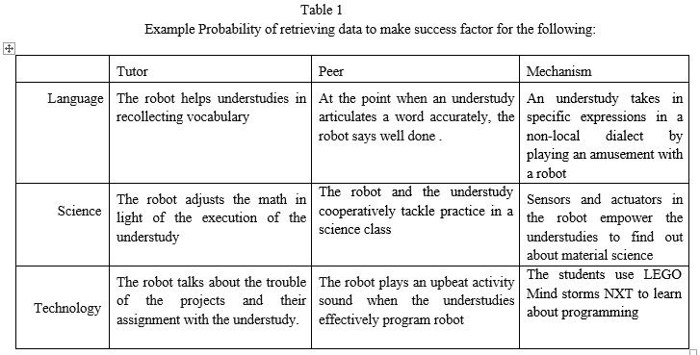

**6. Implementation**

In today's world as education plays an important role in our society and every individual is keen to have a higher level of education and it's very important to be educated as every country is having their own education culture and achieving in different areas. One of the main implementation was robots in education had many roles and one of the main role which we took it and reviewed was robots acting as a role of teacher, tutor and peer. We taught the students technological skills and language skills.

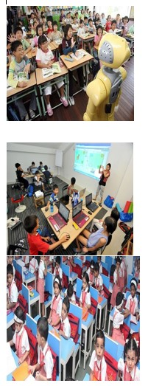

**7. Conclusion**

This audit paper has displayed a synopsis of important and late works in the region of robots in training. We trust that are robots based on cutting edge innovation as well as give an unmistakable and physical portrayal of learning results: a profitable part of utilizing them in instruction. A result of the survey is to urge instructive specialists to additionally comprehend the pragmatic parts of the usage of robots in education. We have made an effort not to dig excessively into academic hypothetical angles and have endeavored to concentrate more on issues identified with Student Robot Collaboration, not at all like earlier surveys in the field [4]. Also, since there is a vast volume of research in the region we may have ignored certain works, for example, reports from instructive establishments, which are not promptly and generally accessible. To finish up, our message is that we don't mean that robots supplant human educators yet feature the additional esteem that robots can convey to the classroom as an empowering, drawing in and educational instructing help.

**8. REFERENCES**

[1] A. Eguchi, ―What is educational robotics? Theories behind it and practical implementation,‖ in Proc. Society for Information Technology & Teacher Education International Conference.

[2] R. Balogh, ―Basic activities with the Boe-Bot mobile robot,‖ in Proc. Conference DidInfo, FPV UMB, Banská Bystrica, Slovakia, 2008.

[3] A. Eguchi and J. Reyes, ―Engage and motivate non-computer science major undergraduates using educational robotics,‖ in Proc. Society for Information Technology and Teacher Education International Conference, pp. 2572–2576, 2008

[4] O. Miglino, H. H. Lund, and M. Cardaci, ―Robotics as an educational tool,‖ Journal of Interactive Learning Research, vol. 10, no. 1, pp. 25-47, 1999.

[5] E. Sklar, S. Parsons, M. Q. Azhar, and V. Andrewlevich, ―Educational robotics in Brooklyn (short version),‖ in Proc. the AAAI Mobile Robot Workshop, 2006

[6] H. H. Lund and L. Pagliarini, ―Edutainment robotics: Applying modern AI techniques,‖ in Proc. International Conference on International Journal of Information and Education Technology, Vol. 7, No. 6, June 2017 Autonomous Minirobots for Research and Edutainment, AMIRE, 2001

[7] E. Bilotta, L. Gabriele, R. Servidio, and A. Tavernise, ―Edutainment robotics as learning tool,‖ Transactions on Edutainment III, vol. 2, no. 2, Springer Berlin: Hei-delberg, pp. 25–35, 2009.

[8] V.Ilango, et al., “Cluster Analysis Research Design Models, Problems, Issues, Challenges, Trends And Tools”, International journal on Computer Science and Engineering, Vol.3(8).August 2011, P. 3064-3070, ISSN: 0975–3397

algorithm, clusters are detected and adjusted according to the intra-relationship within clusters and the inter-relationship between clusters and outliers, and vice versa. The rest of the paper is organized as follows. Section 2 reviews related work in outlier detection. Section 3 describes the proposed method to detect missing values and outlier. Experimental results and their analysis are presented in Section 4 and finally, Section 5 concludes the paper.