BudgetAnalyzer.Api

Transaction.cs
Here's what each field is and why it's there:
- Id — the primary key. EF Core automatically treats a property named Id as the auto-incrementing primary key.
- Date — when the transaction happened.
- Description — the raw merchant text ("Tesco Stores", "Uber Eats"). = string.Empty avoids null-warning noise.
- Amount — decimal, not double. This is the money-correctness point I flagged earlier — decimals don't drift by pennies. Negative = spending, positive = income (or we can flip that later; your call once we see your real data).
- Category — "Groceries", "Transport", etc. Defaults to "Uncategorized" so nothing is ever null.
- SourceBank — "Monzo" or "HSBC". Lets you filter by account.
- StatementMonth — like "2026-06". Makes monthly grouping trivial.
- Fingerprint — the dedup hash I mentioned. We'll populate this later; having the column now means we won't need a migration to add it.

Transaction Controller
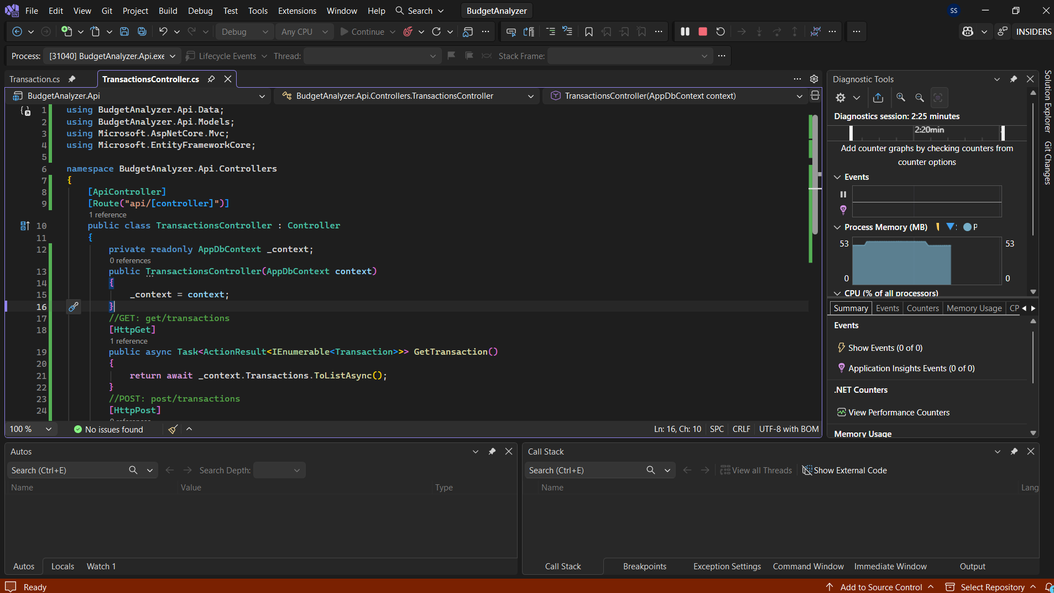
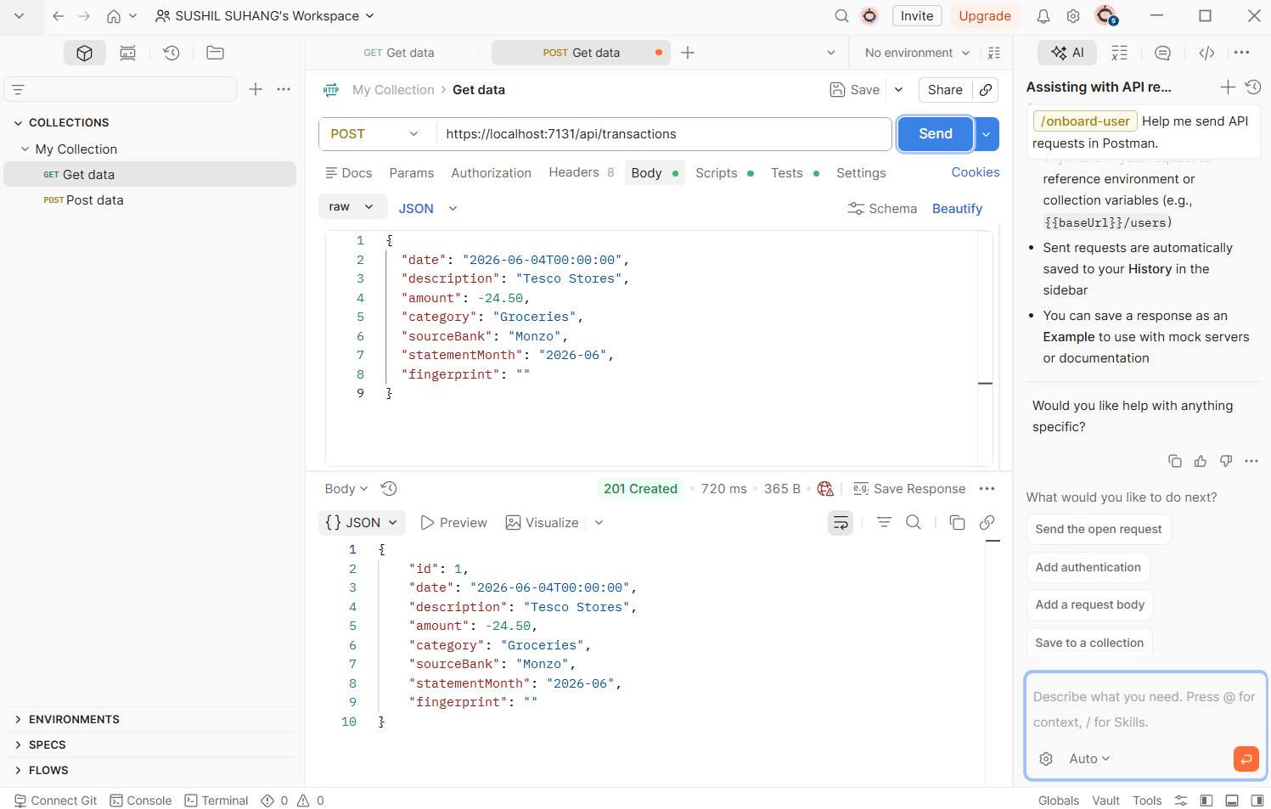

Transaction Api Endpoint working well

