About beautiful city Indore:-

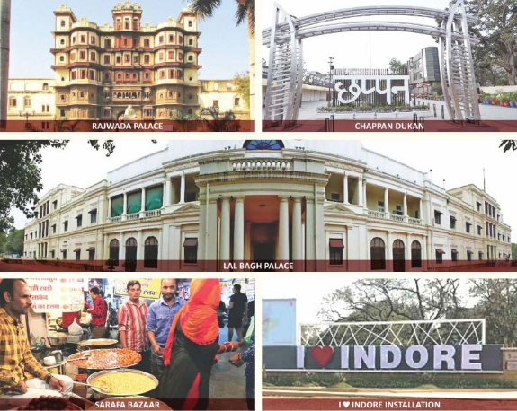
Indore, the crown jewel of Madhya Pradesh, is a city where history, culture, and modernity blend seamlessly to create an enchanting urban paradise. Known as India’s cleanest city for seven consecutive years, Indore stands as a shining example of sustainable urban development. The city’s majestic Rajwada Palace and Lal Bagh Palace whisper tales of royal grandeur, while the awe-inspiring Kanch Mandir reflects unmatched architectural brilliance.
Indore is a food lover’s utopia, where the aroma of poha-jalebi, sabudana khichdi, and garadu fills the air, and the bustling Sarafa Bazaar comes alive at night, offering a feast for the senses. As an educational powerhouse, it is home to prestigious institutions like IIM Indore and IIT Indore, shaping the nation’s future leaders.
Beyond its academic and culinary fame, Indore is a hub of commerce, industry, and innovation, driving economic growth in Central India. The spiritual essence of the city is reflected in the revered Khajrana Ganesh Temple, where thousands seek blessings. Festivals like Rangpanchami turn the streets into a vibrant canvas of colors. With warm-hearted people, an ever-evolving skyline, and an unshakable spirit, Indore is not just a city—it’s an experience, a legacy, and a dream woven into reality.
Customs Indore: Guardians of Economic Integrity & National Security
Customs Indore stands as a pillar of excellence, safeguarding India’s economic frontiers with unwavering commitment and efficiency. Covering the vast jurisdictions of Madhya Pradesh and Chhattisgarh, it plays a pivotal role in trade facilitation, anti-smuggling operations, and enforcement of laws that protect national interests. With cutting-edge technology and a highly skilled workforce, Customs Indore ensures seamless import-export procedures, boosting India’s global trade competitiveness.
The department is not just about taxation—it is a sentinel of national security, preventing the inflow of contraband, narcotics, and illegal goods. Its proactive vigilance and intelligence-driven operations have consistently upheld the integrity of our borders. Customs Indore also promotes the Ease of Doing Business by streamlining procedures, enhancing transparency, and supporting businesses in compliance with international standards.
Beyond enforcement, Customs Indore actively participates in community outreach, environmental sustainability, and public awareness programs, reflecting its commitment to national development. As the custodian of trade across Madhya Pradesh and Chhattisgarh, it ensures lawful commerce, economic growth, and national security. With its progressive vision and steadfast duty, Customs Indore stands as a beacon of excellence, making every Indian proud of its unparalleled contribution to the nation’s prosperity.
Message from the Principal Commissioner, Customs Indore
Welcome to the official website of Customs Indore, a crucial step towards transparency, efficiency, and seamless trade facilitation. As part of the Central Board of Indirect Taxes and Customs (CBIC), Ministry of Finance, we are committed to revenue collection, trade facilitation, and law enforcement with integrity and excellence. Covering the vast jurisdictions of Madhya Pradesh and Chhattisgarh, we oversee Inland Container Depots (ICDs), Air Cargo complexes, and Devi Ahilyabai Holkar International Airport, Indore, ensuring the smooth flow of trade while vigilantly preventing smuggling and illicit activities.
This website serves as a digital gateway to our services, offering easy access to policies, procedures, and real-time updates. With digital initiatives like ICEGATE, we are driving a paperless, efficient customs system aligned with the Ease of Doing Business vision. Our dedicated team is committed to fostering a secure, trade-friendly, and technology-driven ecosystem that strengthens India’s economic growth.
I encourage all stakeholders to explore and utilize this platform, reinforcing our collective mission of efficiency, compliance, and national security. Together, let us build a progressive and robust customs framework that upholds the spirit of a self-reliant and prosperous India.
Jai Hind!

