|  |
| --- |
| **About beautiful city Indore:-** |

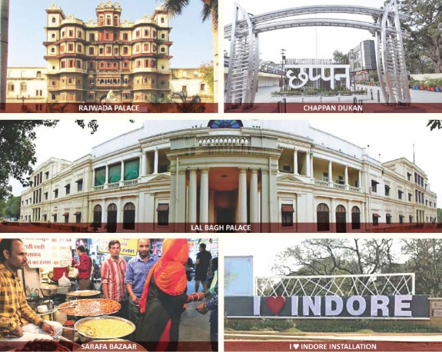Indore, the crown jewel of Madhya Pradesh, is a city where history, culture, and modernity blend seamlessly to create an enchanting urban paradise. Known as **India’s cleanest city for seven consecutive years**, Indore stands as a shining example of sustainable urban development. The city’s majestic **Rajwada Palace** and **Lal Bagh Palace** whisper tales of royal grandeur, while the awe-inspiring **Kanch Mandir** reflects unmatched architectural brilliance.

Indore is a **food lover’s utopia**, where the aroma of **poha-jalebi, sabudana khichdi, and garadu** fills the air, and the bustling **Sarafa Bazaar** comes alive at night, offering a feast for the senses. As an **educational powerhouse**, it is home to prestigious institutions like **IIM Indore and IIT Indore**, shaping the nation’s future leaders.

Beyond its academic and culinary fame, Indore is a hub of commerce, industry, and innovation, driving economic growth in Central India. The spiritual essence of the city is reflected in the revered **Khajrana Ganesh Temple**, where thousands seek blessings. Festivals like **Rangpanchami** turn the streets into a vibrant canvas of colors. With warm-hearted people, an ever-evolving skyline, and an unshakable spirit, Indore is not just a city—it’s an experience, a legacy, and a dream woven into reality.

**Customs Indore: Guardians of Economic Integrity & National Security**

Customs Indore stands as a pillar of excellence, safeguarding India’s economic frontiers with unwavering commitment and efficiency. Covering the vast jurisdictions of **Madhya Pradesh and Chhattisgarh**, it plays a pivotal role in **trade facilitation, anti-smuggling operations, and enforcement of laws** that protect national interests. With cutting-edge technology and a highly skilled workforce, Customs Indore ensures seamless import-export procedures, boosting India’s global trade competitiveness.

The department is not just about taxation—it is a **sentinel of national security**, preventing the inflow of contraband, narcotics, and illegal goods. Its proactive vigilance and intelligence-driven operations have consistently upheld the integrity of our borders. Customs Indore also promotes the **Ease of Doing Business** by streamlining procedures, enhancing transparency, and supporting businesses in compliance with international standards.

Beyond enforcement, Customs Indore actively participates in **community outreach, environmental sustainability, and public awareness programs**, reflecting its commitment to national development. As the **custodian of trade across Madhya Pradesh and Chhattisgarh**, it ensures lawful commerce, economic growth, and national security. With its progressive vision and steadfast duty, Customs Indore stands as a beacon of excellence, making every Indian proud of its unparalleled contribution to the nation’s prosperity.

**Message from the Principal Commissioner, Customs Indore**

Welcome to the official website of **Customs Indore**, a crucial step towards **transparency, efficiency, and seamless trade facilitation**. As part of the **Central Board of Indirect Taxes and Customs (CBIC), Ministry of Finance**, we are committed to **revenue collection, trade facilitation, and law enforcement** with integrity and excellence. Covering the vast jurisdictions of **Madhya Pradesh and Chhattisgarh**, we oversee **Inland Container Depots (ICDs), Air Cargo complexes, and Devi Ahilyabai Holkar International Airport, Indore**, ensuring the smooth flow of trade while vigilantly preventing smuggling and illicit activities.

This website serves as a **digital gateway** to our services, offering easy access to policies, procedures, and real-time updates. With digital initiatives like **ICEGATE**, we are driving a paperless, efficient customs system aligned with the **Ease of Doing Business** vision. Our dedicated team is committed to fostering a **secure, trade-friendly, and technology-driven ecosystem** that strengthens India’s economic growth.

I encourage all stakeholders to explore and utilize this platform, reinforcing our collective mission of **efficiency, compliance, and national security**. Together, let us build a **progressive and robust customs framework** that upholds the spirit of a self-reliant and prosperous India.

**Jai Hind!**