Made in Heaven S2 — Visual Insights

Sentiment Distribution (Donut)
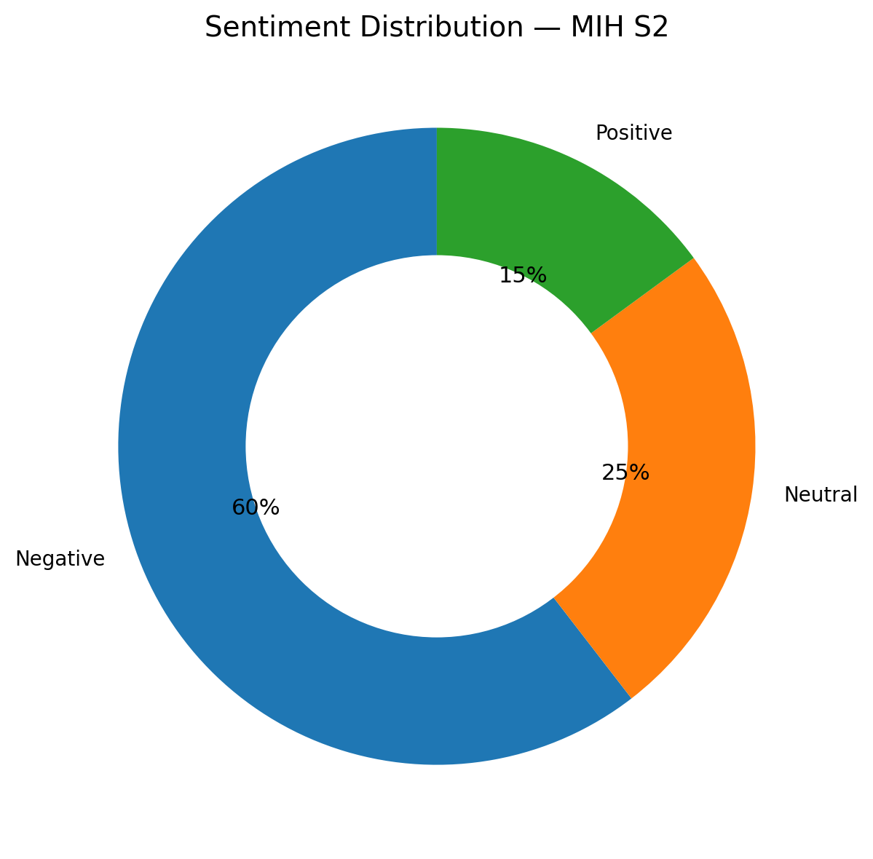

Attitudes Toward Traditional Gender Norms
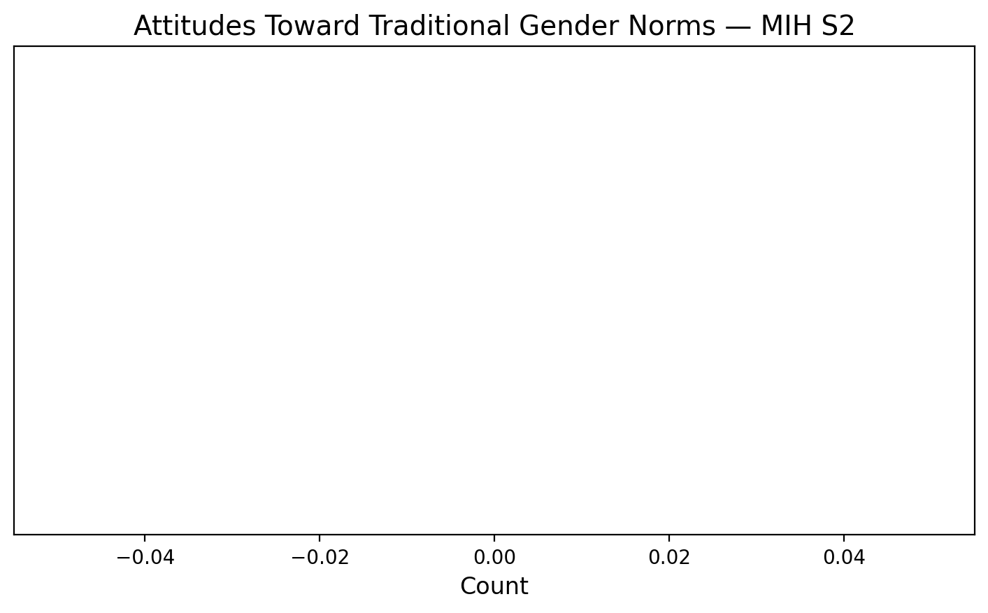

Top Themes Frequency (Lollipop Chart)
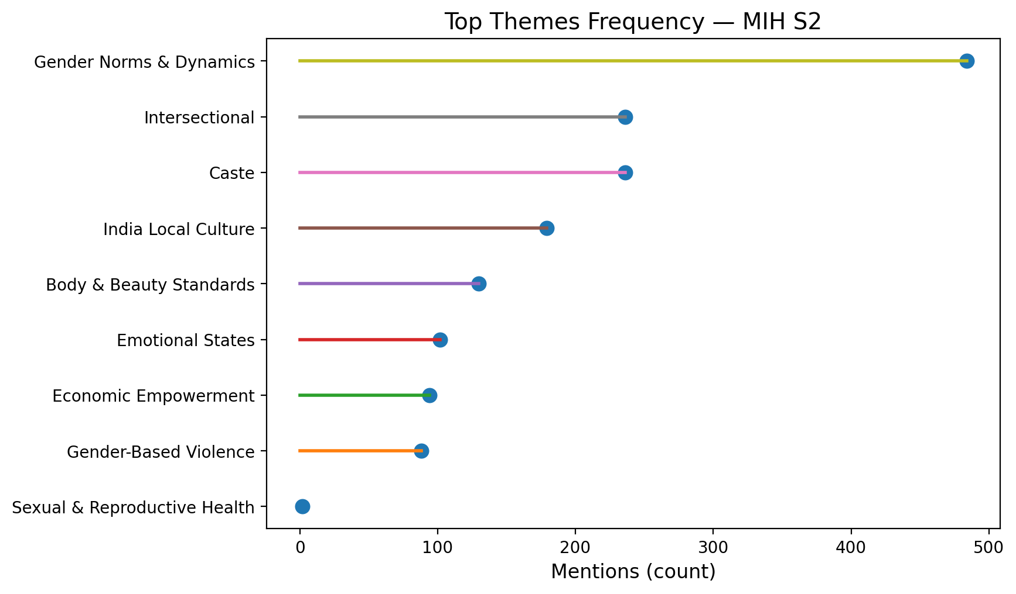

Themes × Sentiment (Heatmap)
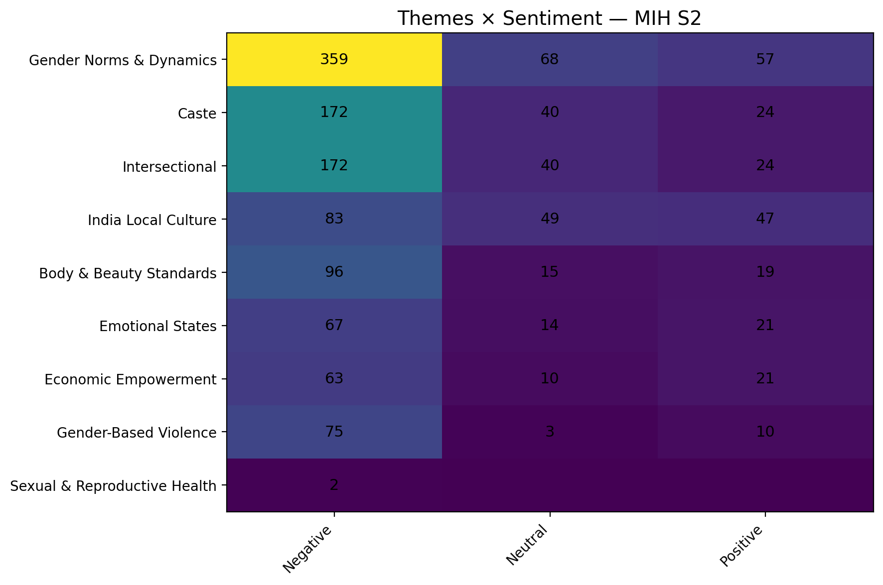

Norm Stance × Sentiment (Stacked Bar)
