Problem Statement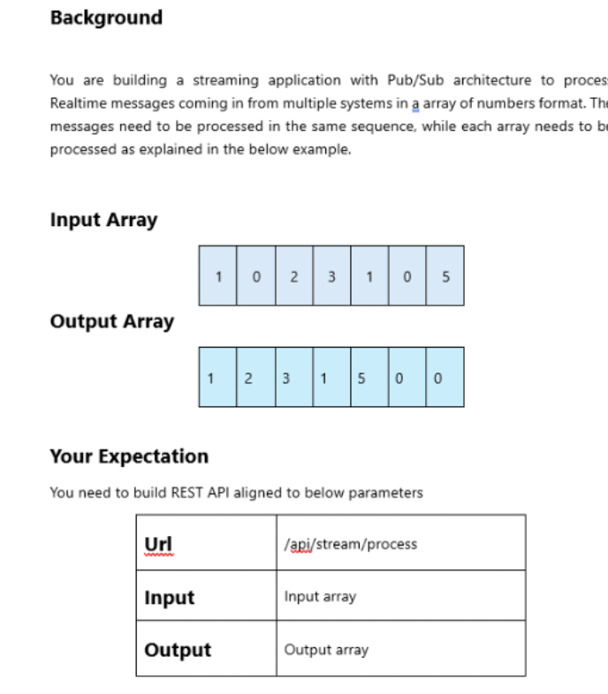
Understanding of the problem statement
- Input will come via REST API
- As request comes in stream need to take the request as process it background
- Once Complete user can see the result
- For Data processing, move all 0s to the end while maintaining order of non-zero elements

Details of the approach
Client => API Gateway => Producer API (Create RequestId + Save "Pending") =>
RabbitMQ (Event) => Processor Service => Process Data => Update DB
array manipulation approch
- Move all 0s to the end while maintaining order of non-zero elements.
- Mreate a new array with zero value same length
- Loop[ on original array and check the value is non zero then replace in new array

HLD
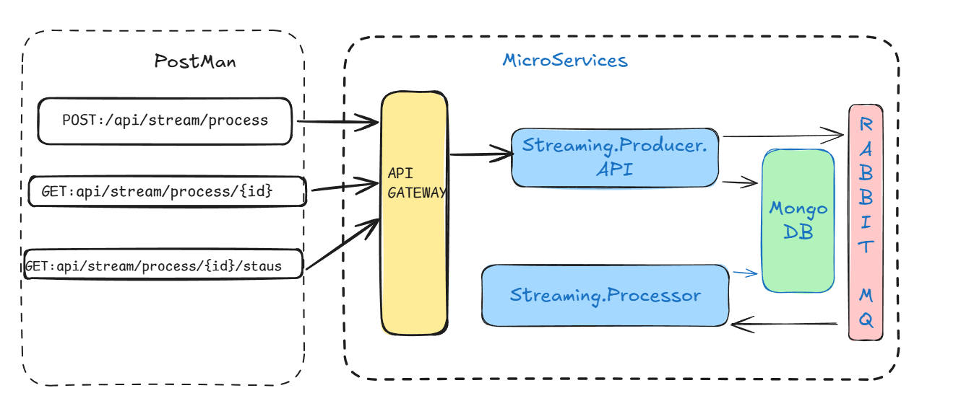

Streaming.Producer.API
This API have the end point to get the stream on input from client Via REST API the it take the request save in NoSql db and publish the message in RabbitMq for asyn process . It return processId with status as Pending.
POST: api/stream/process
BODY: {
"data":[1,0,2,3,1,0,5,6]
}
Response: {
"processId": "a8b704a3-8da0-435f-872a-ff1845b41c8c",
"processStatus": "Pending"
}
Now client can check the status for processId via GET request OR may implement Webhook, CallBack endpoint, SignalR etc as not polling required.
GET: api/stream/process/{processId }/status
Response: {
"processId": "a8b704a3-8da0-435f-872a-ff1845b41c8c",
"processStatus": "Completed" }

Once Completed will get the Output of processId via GET request.
GET: api/stream/process//{processId }
Response{
"processId": "a8b704a3-8da0-435f-872a-ff1845b41c8c",
"data": [1, 0, 2, 3, 1, 0, 5, 6],
"outputData": [1, 2, 3, 1, 5, 6,0,0 ],
"processStatus": "Completed"
}

Streaming.Processor
This is the worker process and process the request via RabbitMq queue handler and update the result in NoSql db with status as Completed.
Logic : Move all 0s to the end while maintaining order of non-zero elements.
Create a new array with zero value same length
- Loop[ on original array and check the value is non zero then replace in new array

LLD
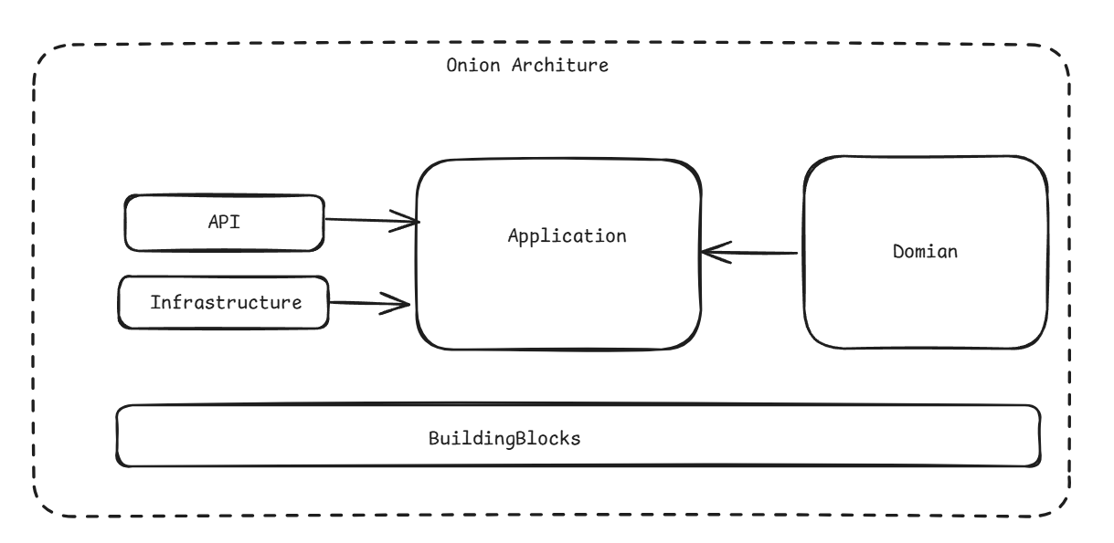

Technologies Used:
- .Net 10
- Rest API
- MongoDB.Driver
- MassTransit
- Generic Repository Pattern
- docker

Run the code:
docker-compose build
docker-compose down
docker-compose up -d

