

### Tribhuvan University

### Faculty of Humanities and Social Sciences

### Pet Adoption System

### A PROJECT PROPOSAL

### Submitted to Department of Computer Application

### DAV College

#### In partial fulfillment of the requirements for the Bachelors in Computer Application

Submitted by Sushil Nemkul

[TU Reg No: 6-2-469-20-2022]

Shrawan, 2081

Table of Contents

1. INTRODUCTION 1
2. PROBLEM STATEMENT 2
3. OBJECTIVE 3
4. METHODOLOGY 3
   1. Requirement Identification 3
   2. Feasibility Study 5
   3. High Level System Design 6
5. GANTT CHART 9
6. EXPECTED OUTCOME 9
7. REFERENCES 9

List of Figure

Figure 1 level 0 DFD 6

Figure 2 level 1 DFD 6

Figure 3 ERD of Online Bike Rental System 7

Figure 4 waterfall model 8

Figure 5 gantt chart 9

# INTRODUCTION

Animal adoption refers to the process in which an individual takes responsibility for an animal, commonly a cat or a dog, that has been lost or abandoned. These animals are often picked up by animal control and placed in animal shelters. Unfortunately, animals that remain in shelters for extended periods of time are often euthanized to manage the overpopulation of unwanted animals. To address this issue, a web-based adoption portal has been developed to raise awareness of the animals waiting to be adopted. The website enables users and administrators to register and browse through the list of available animals, along with their details such as estimated age, gender, and description. The administrators hold the highest authority in the system and are responsible for adding, modifying, updating, and removing information as required.

# PROBLEM STATEMENT

People don't have a common digital platform for pet adoption. Either they're going to animal shelters or they depend upon social media which isn't reliable enough. Most of the apps available on play store are available for the USA region and have bugs in application. The purpose of this app is to facilitate the adoption of stray animals. The application provides a user-friendly interface to help automate the process Of serving pets' welfare.

.

# OBJECTIVE

* To develop a system that shows data of the pet and help people find right pet by

viewing the data.

1. METHODOLOGY

## Requirement Identification

* + 1. Study of Existing System

We have surfed through some of the pet adoption websites and compared the features with the system purposed based on our observation. One of them is petfinder[1].

This system provides two portals i.e. Client-side Portal:

The client-side portal has following features:

* + - * User Management

It includes user account creation and user login.

* + - * Rental Management

Sends the vehicle booking request to admin portal with customers information booking details.

* + - * Enquiry

Transmits the customer's inquiry to the administrative site.

* + - * Show vehicle list

Clients can view the list of vehicles while booking or renting the vehicle.

* + - * Integrated chat bot

Customers can send messages to the admin and automatic reply is generated.

* + - * Total bookings

Customers can view total number of their bookings in their dashboard.

* + - * Show booking details

shows the renting date, renting location and status of the request.

Admin Portal:

The admin portal has following features:

* + - * Show the booking request

Shows the client’s renting request with their booking details.

* + - * Add vehicles to the list

The administrator has the facility to update and add new rental vehicles list.

* + - * Add other admin users

Can create other admin users with their different user roles.

* + - * Show enquiries

The enquiries that are sent from the client side can be seen and reply can also be sent to the users.

* + - * Show users list

Shows all the users list that have been using the system for renting purpose.

* + - * Show messages in the chat

The messages that are sent by the users in the chat box and the reply that are given by the integrated chat bot can be seen and other replies can also be sent.

* + 1. Requirement Collection

1. Function Requirements:
   * User Registration and Login
   * Bike Listing and Details
   * Customer Dashboard
   * Admin Dashboard
   * Rental Management
2. Non-Functional Requirements
   * User friendly UI
   * Security

## Feasibility Study

* + 1. Technical Feasibility:

This project will make use of HTML, CSS, and JavaScript for its front end. MySQL isgoing to be used for the database, and PHP will be the language used for server-side programming. These are well-known technologies that are used in web application development. For this project, a desktop or laptop that is easily available in the market is needed. It can be concluded that this project is technically feasible.

* + 1. Operational Feasibility:

The online bike rental system fits in well with our existing operational workflows whenit comes to the adoption process. Checking the availability of the required resources and making sure it is prepared for the changeover. It evaluates the system's compatibility with our current databases and procedures, giving security and legal compliance the greatest importance. So, this project can be said operationally feasible.

* + 1. Economic Feasibility:

This economic feasibility analysis aims to provide a clear understanding of the financial implications and benefits associated with the implementation of the Online Bike Rental System. The organization seeks to make well-informed decisions to ensure the project's success and alignment with its overarching financial goals. Market trends, revenue streams, and competitive pricing strategies align favorably with the project. So, this system can be said economically feasible.

## High Level System Design

* + 1. Data Flow Diagram

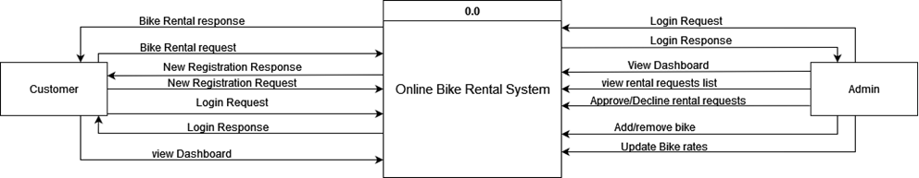

Figure 1 level 0 DFD

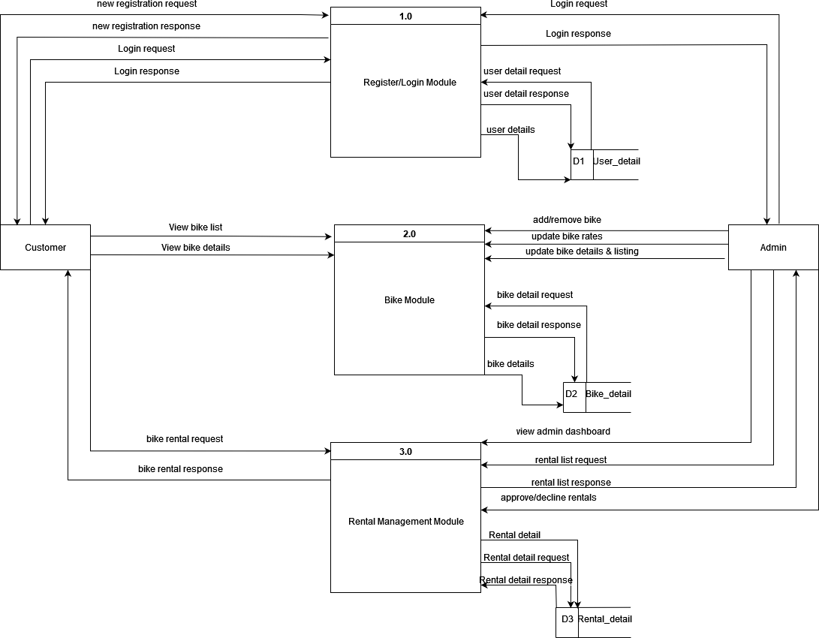

Figure 2 level 1 DFD

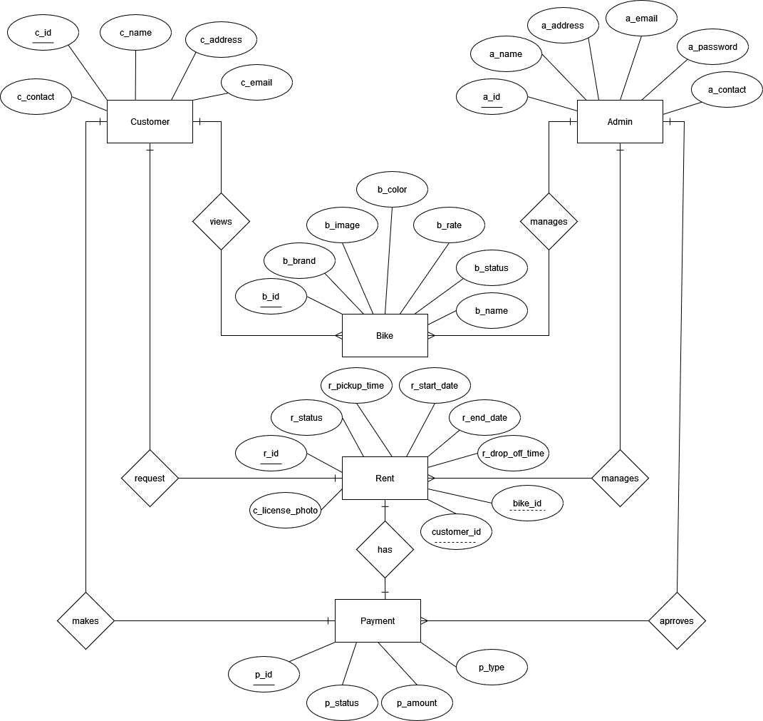

Figure 3 ERD of Online Bike Rental System

* + 1. Methodology

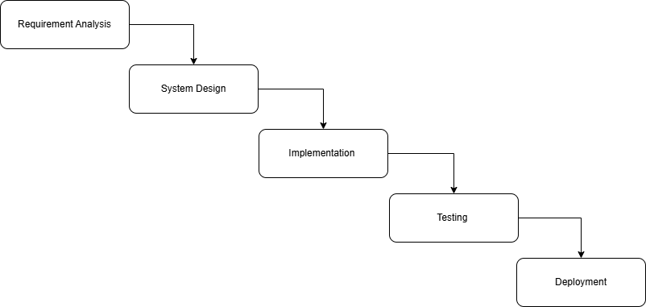

Figure 4 waterfall model

The waterfall model is ideal for developing this project because all the requirements are known and there is not much time left for development. The requirements analysis, system design, implementation, testing, and deployment phases make up the project's five stages.

# GANTT CHART

Figure 5 gantt chart

# EXPECTED OUTCOME

* A web-based system that will help you adopt pets online.

# REFERENCES

|  |  |
| --- | --- |
| [1] | "selfdrivenepal," [Online]. Available: https://selfdrivenepal.com/. [Accessed 26 12 2023]. |