User Manual
Of
Centralized SMS gateway
for
System Admin



Submitted Date: 2080/01/08

Submitted by | Submitted to
Service Towards Technology Nepal Pvt. Ltd.  New Baneshwor, Kathmandu, Nepal | Department of Information Technology  Tinkune, Kathmandu, Nepal

Table of Contents
1. Login and Dashboard: 3
2. Office Management: 4
3. Sender Assignment: 6
4. Add Client: 8
5. API Integration: 9

Login and Dashboard:
- Open Preferred Browser and type: https://newsms.doit.gov.np/
- Login page is seen on the screen.
- Please Enter the provided username and password by Department of Information Technology.

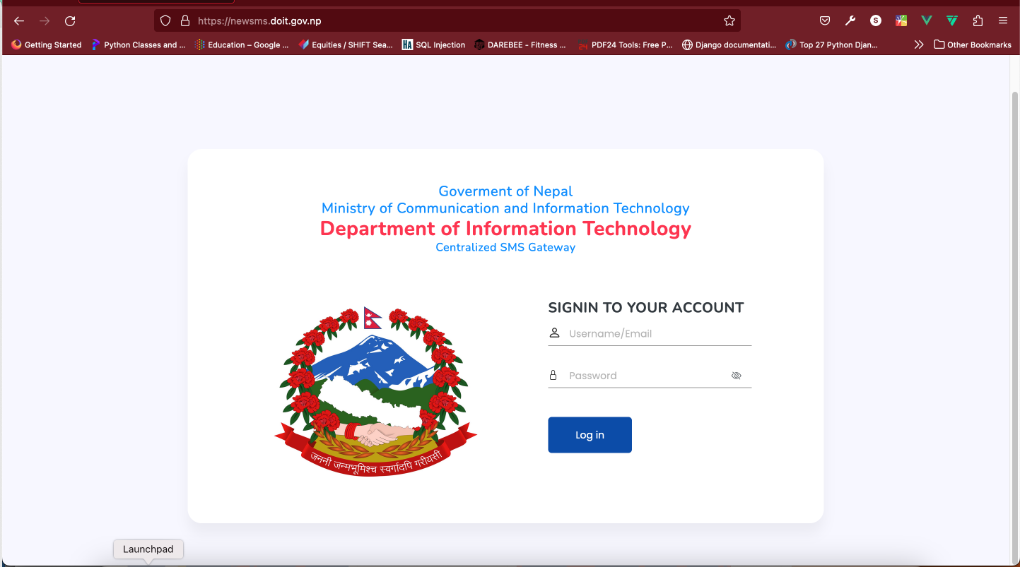
- Use correct Username and Password; if not “Invalid Username and Password:” will appear on top right corner of the screen.
- If the user is authenticated with valid username and password user will be redirected to Dashboard page
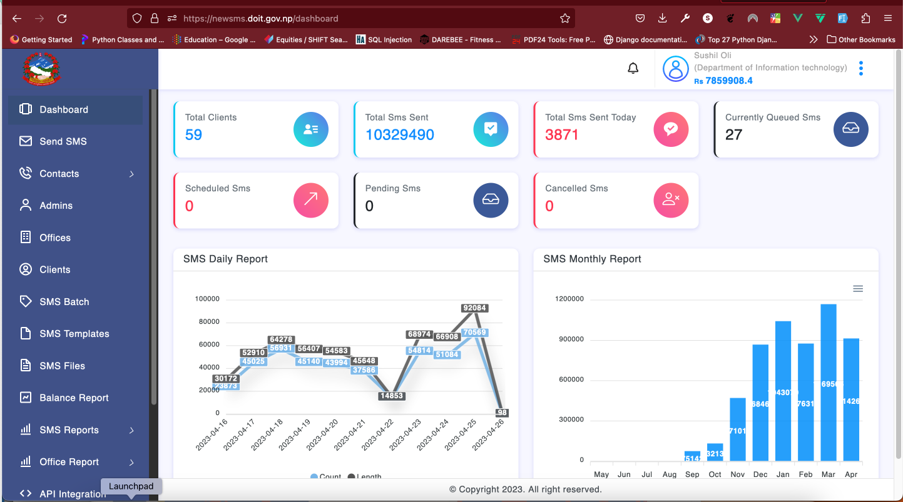

- Dashboard page shows Total number, Total SMS sent till date, Total number of SMS Queued, Scheduled SMS, Pending SMS and Cancelled SMS,
- Just Below count section line Graph and bar graph is seen:
  - Line Graph indicates date wise daily SMS report.
  - Bar graph shows the monthly SMS count.

Office Management:
- After login, on the left sidebar on the screen, Menu with name Offices is seen on the screen, Click on Offices and offices table with Menu will appear on the screen.
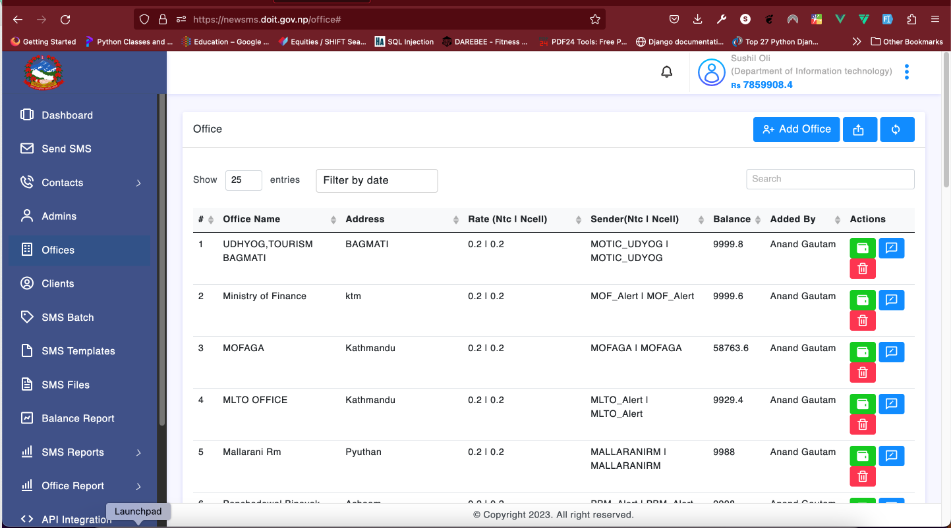
- Click on Add office () button which is located on third button on top right corner of the screen. Add office pop up will appear on the screen.
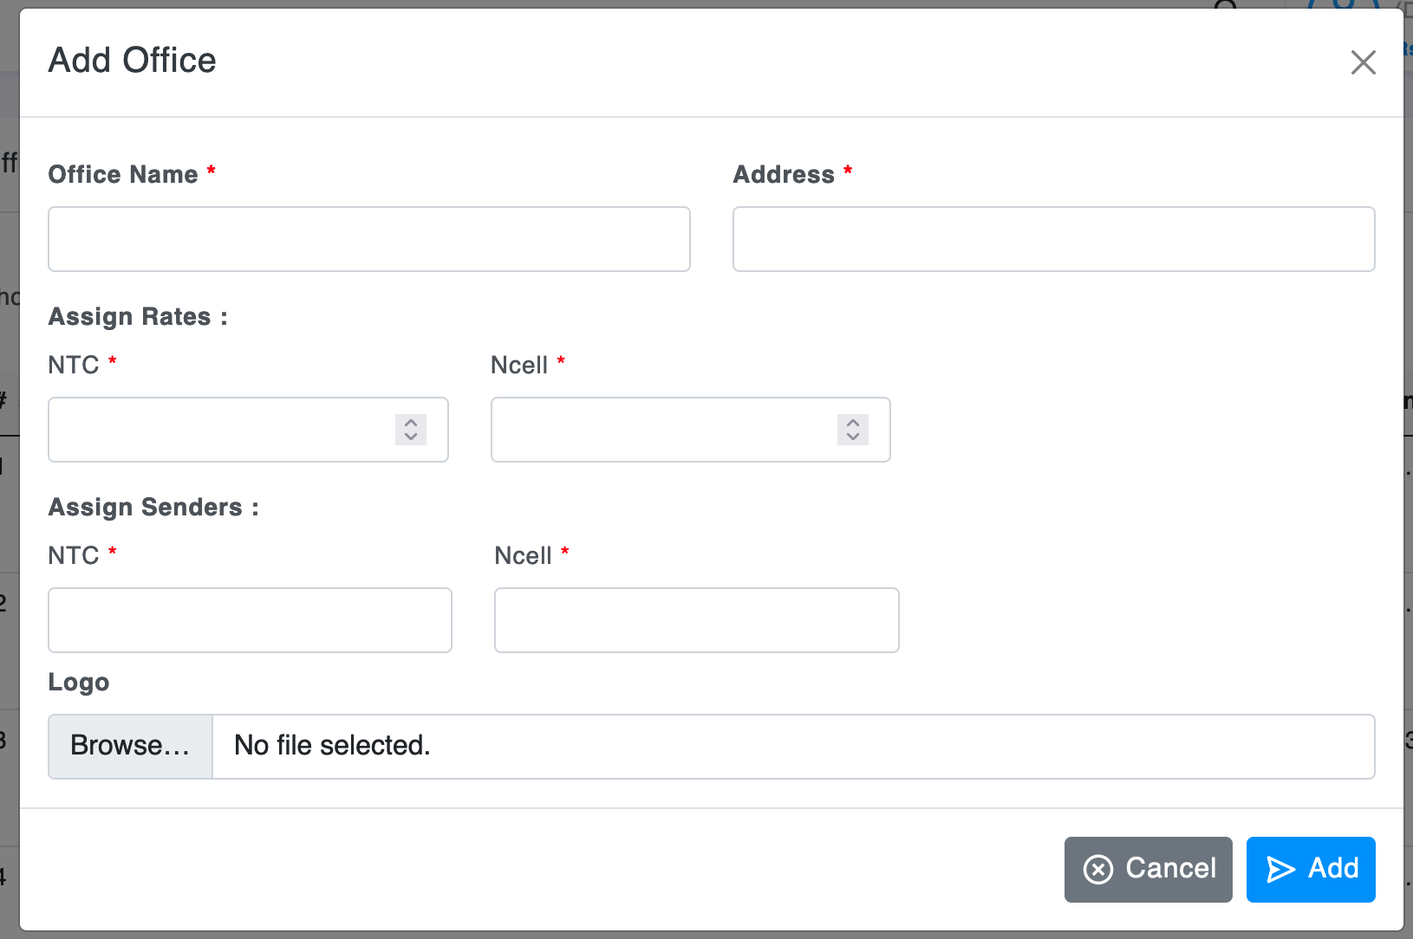

- Type the office name that you want to enter, office address Assign the NTC ana NCELL rates. Assign Sender for NCELL and NTC.
- Upload the logo of that office if the office has a logo.
- Click on the Add button on bottom of popup.
- Office has been added successfully will appear on the screen.
[Note: Use the same Sender name provided by Service Providers i.e. NTC and Ncell.]

Sender Assignment:
- After login, on the left sidebar on the screen, Menu with Clients is seen click on it and table with client name sender office table will appear on the screen.
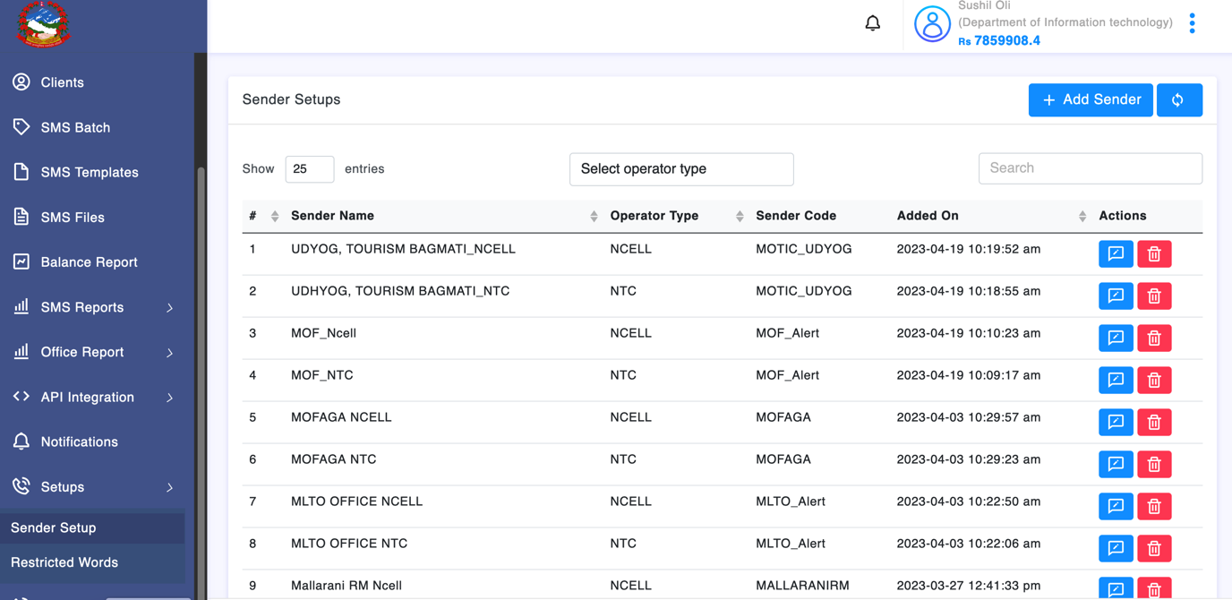
- Click on Add sender in Top right corner of the screen; Add Sender Popup will display on the screen.
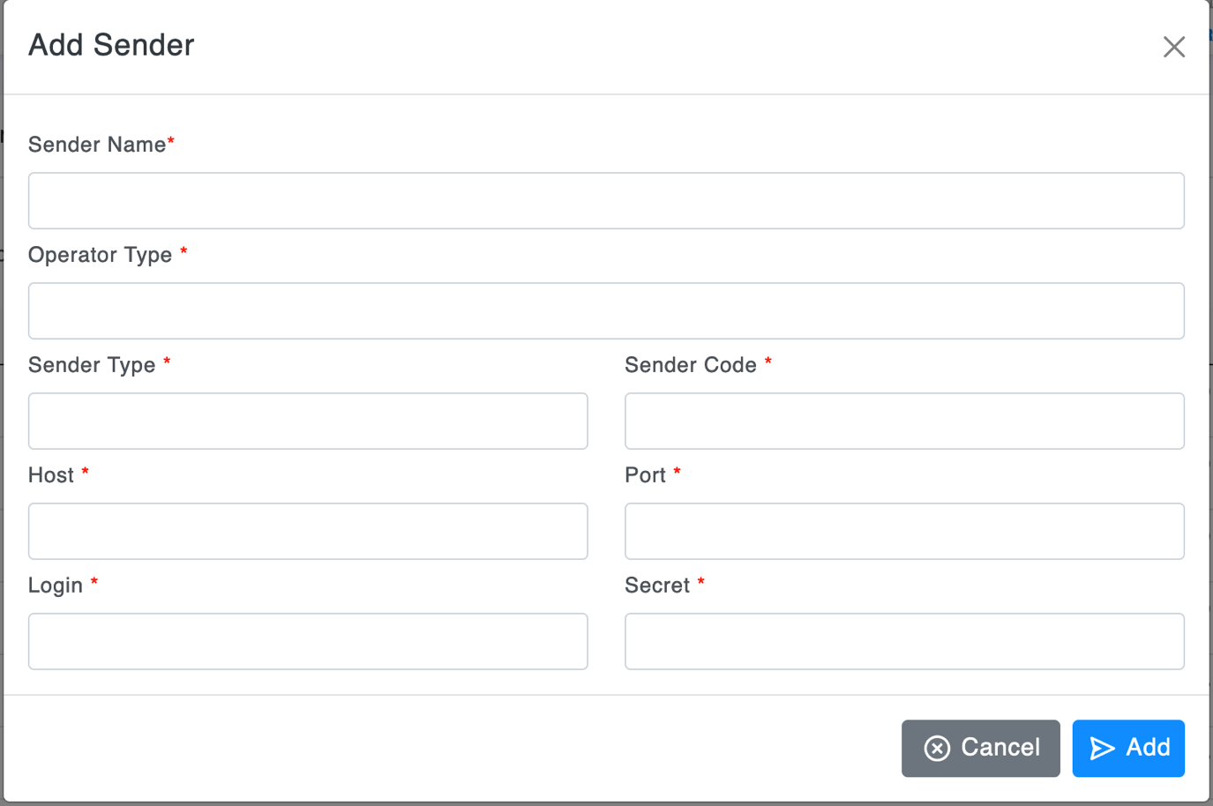
- All the parameters should be entered as provided by Telecommunication Operators.
- In Sender Name use the name for further Recognition like DOIT_NTC, in Operator type select NTC or NCELL, Select sender type like Alert or Short code. Use host name port login and secret provided by Operator.
- And hit the add button from the bottom right corner.
- Sender added successfully will appear on the screen.

Add Client:
- After login, on the left sidebar on the screen, Menu with name Setup, click on it and sender setup is seen on the screen, click on sender setup and Client list in table will appear on the screen.
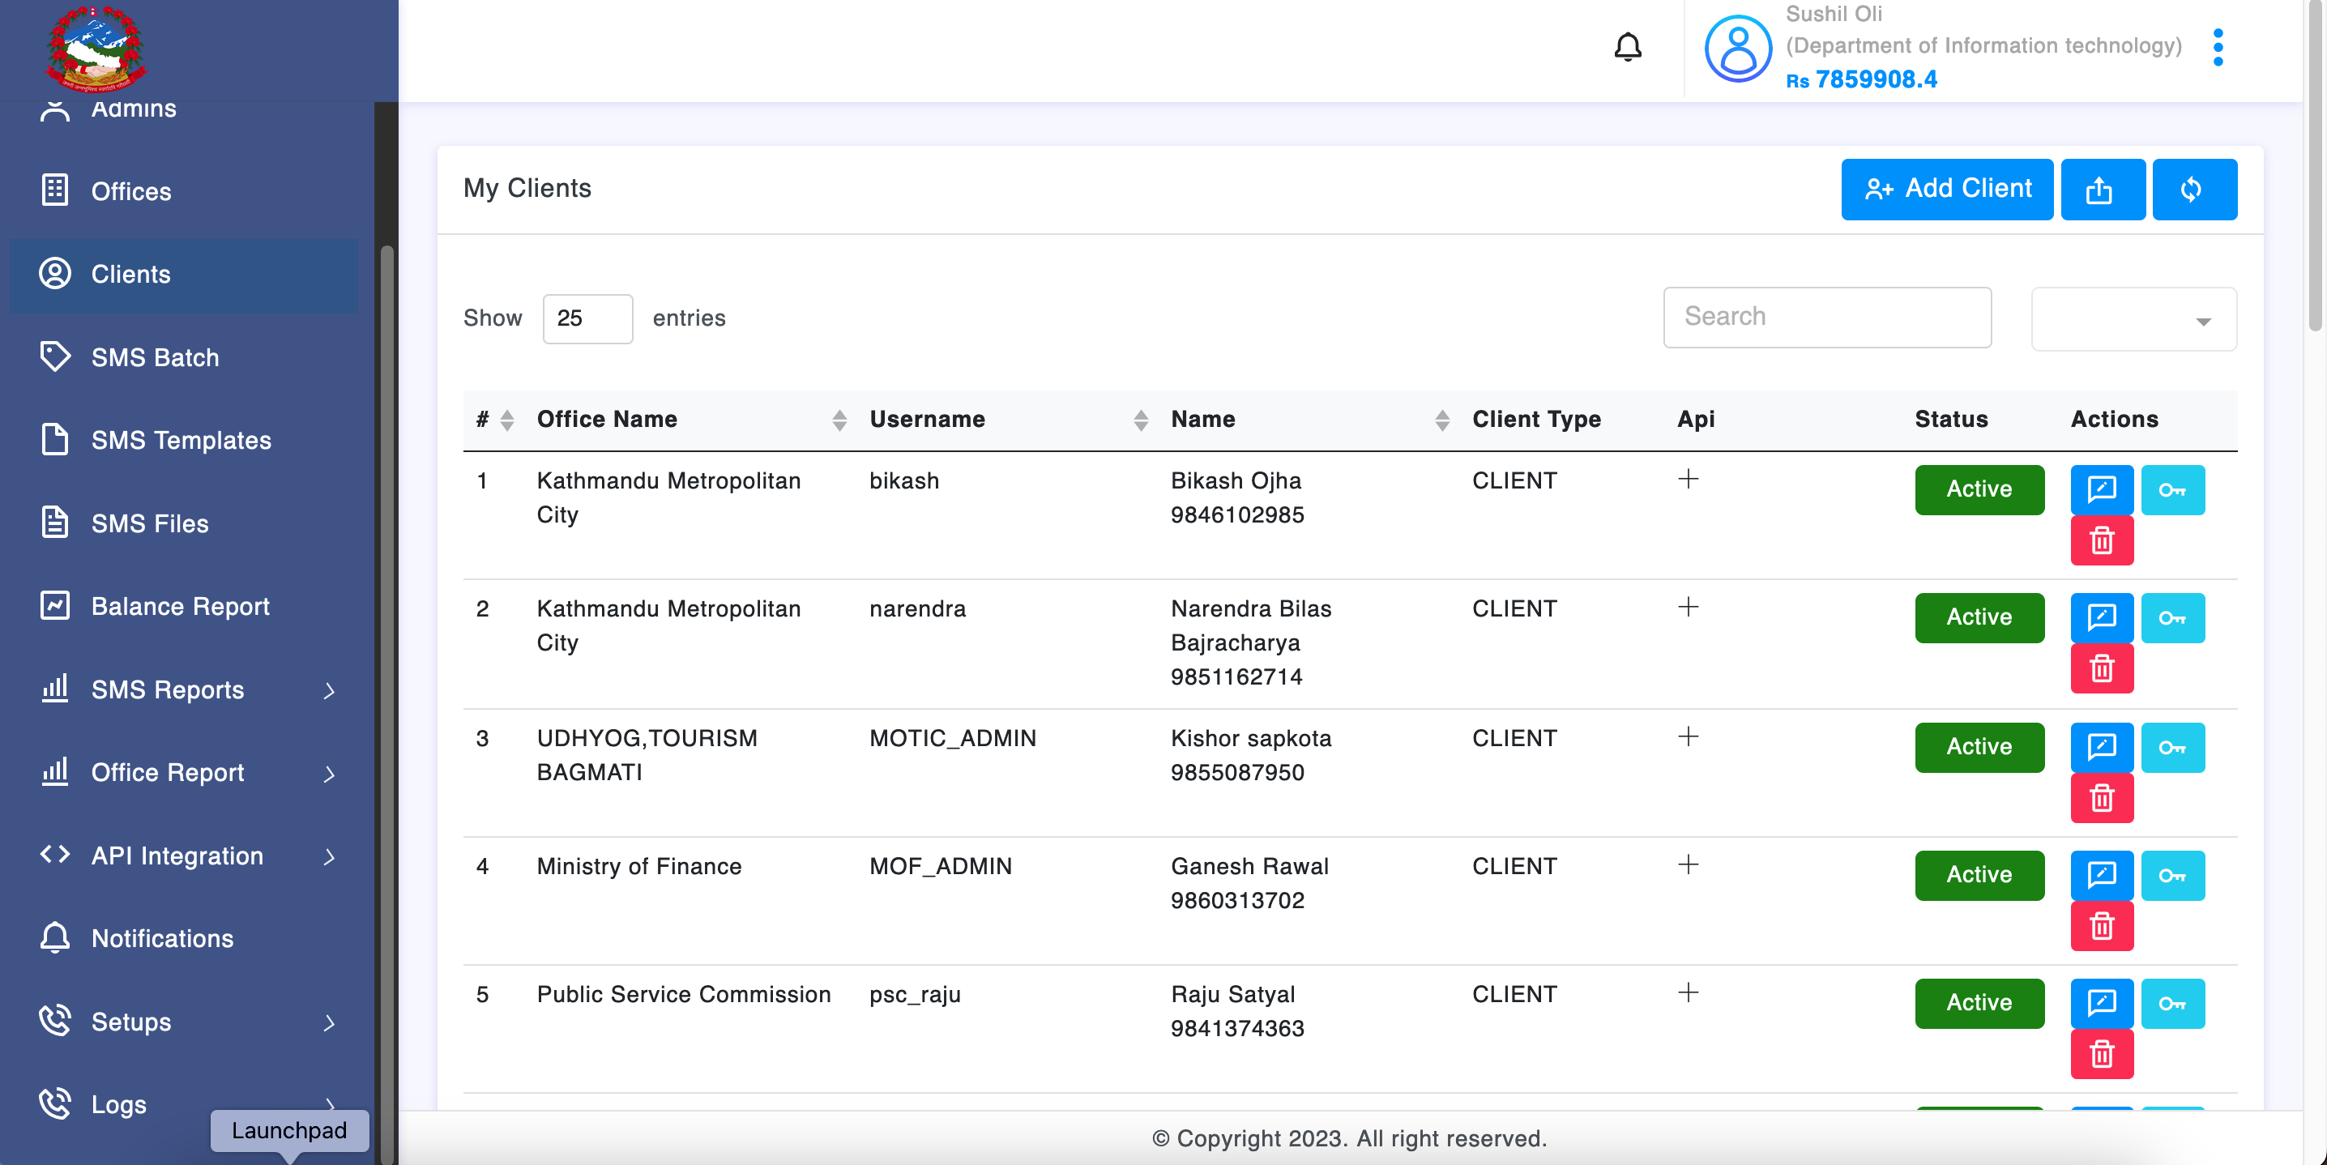
- On the top right corner of the screen, Client on Add Client ().
- Popups with added clients will appear on the screen.
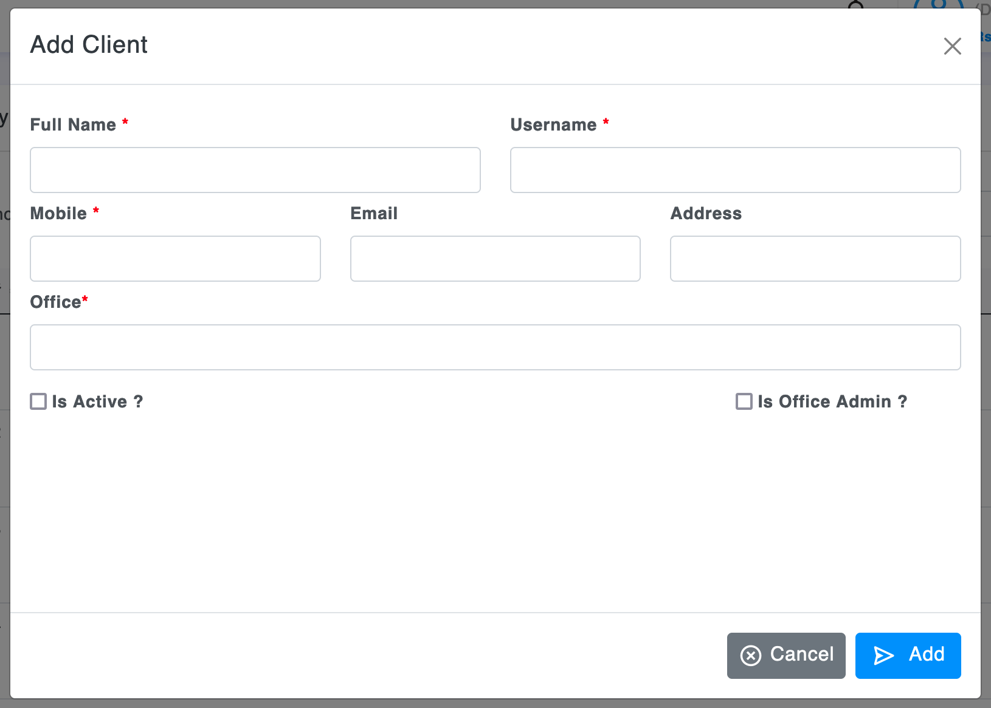

- Type full name of the Client, type username, mobile of related client, email, if necessary, address etc.
- Select office from the list and add the client check mark on is active to let user login tick on is office admin if office admin is created.
[Note: From this user of that office is created and if office admin is selected then the office admin can create users of that office as well.]

API Integration:

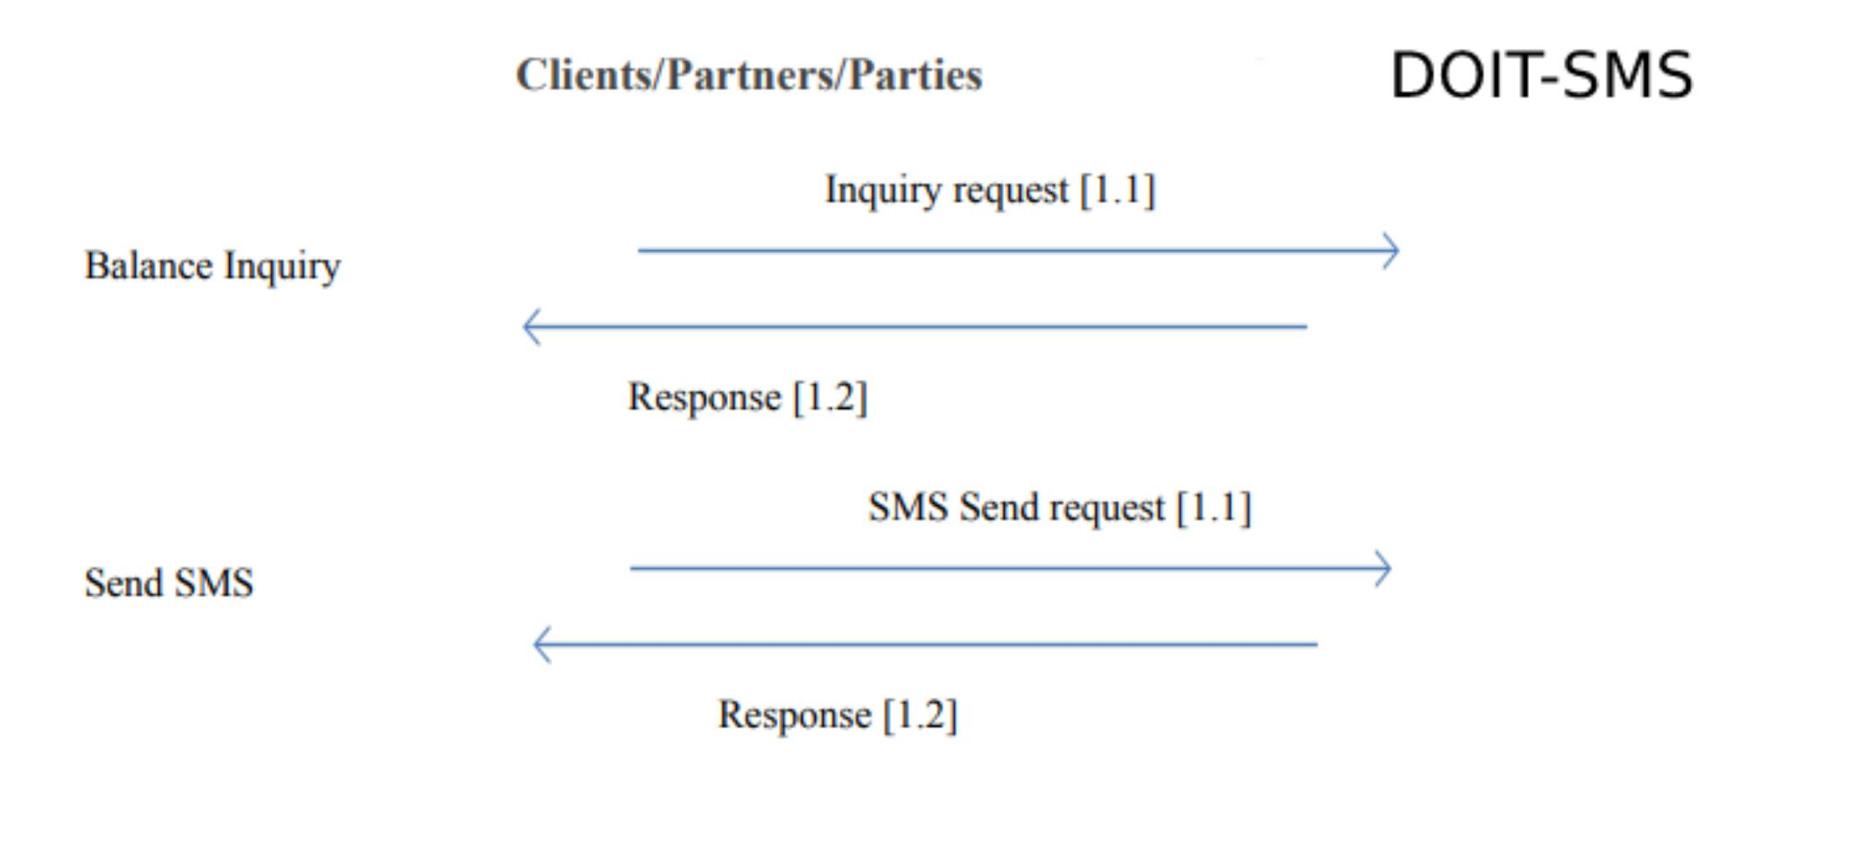
For API Integration a detail website developed with markdown has been hosted in same server with link: https://sms.doit.gov.np/developer-guide/
- User can generate API bearer token and use API token and following the guide user can.
- After login, on the left sidebar on the screen, Menu with name API Integration is seen, click on it and API Token is seen on the screen, click on API Token.
- Click on (+) icon and your API will see on the screen. Copy the API Token follow the link above to and follow the instructions.
- [Note: While Applying the API token; if unauthenticated message appears on the screen., that denotes that the API token do not match in that case Please check API token and verify it.]

