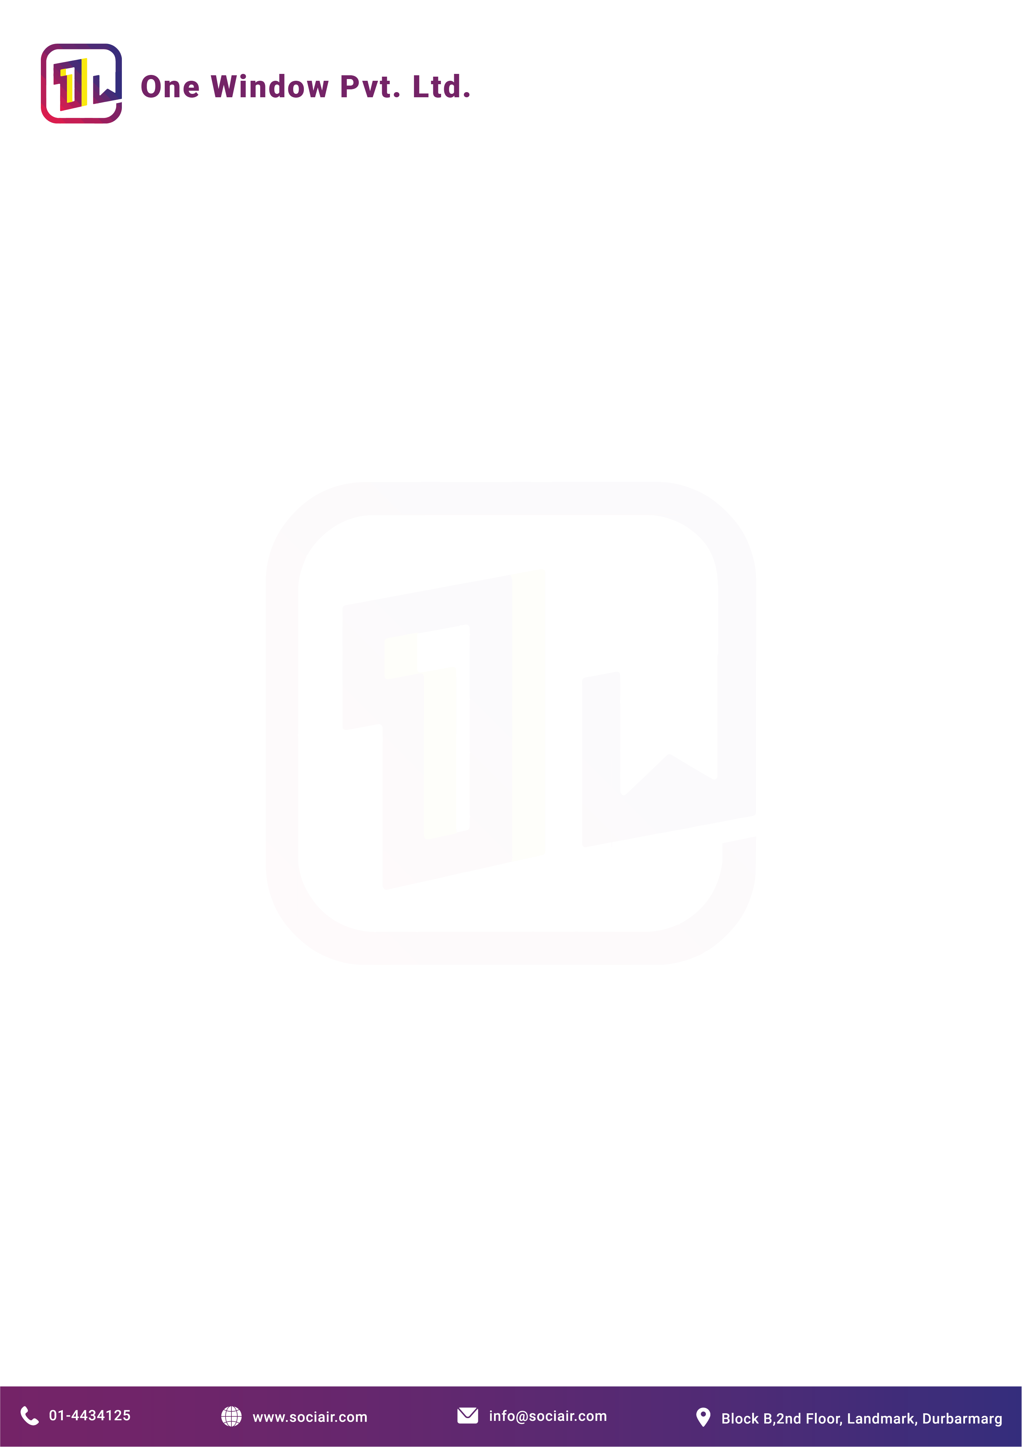

Date: 2080/03/05

To,
Aamachhodingmo Rural Municipality,
Rasuwa, Nepal

Subject: Request for Payment for SMS Service
Dear Sir/Madam,
We would like to notify you that we have been providing the SMS service to Aamachhodingmo Rural Municipality. Notifying that, we would like to request to release the payment of NPR 16,950/- (Sixteen Thousand Nine Hundred Fifty rupees) which is inclusive of VAT. The VAT bill is also attached to this document.
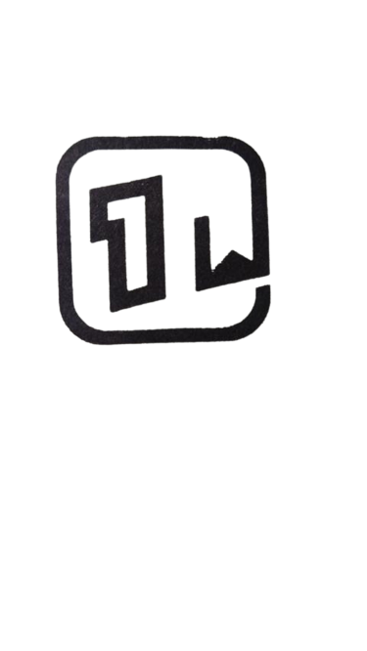

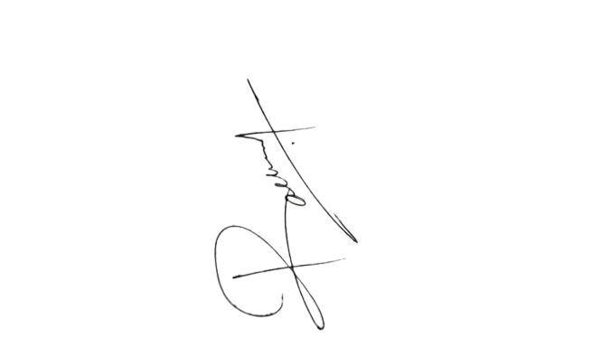
Sincerely Yours,

………………………
Mr. Rachel Giri
One Window Pvt. Ltd.
Business Development Officer

