Jenkins.

What is Jenkins?
-> Jenkins is a free open source Continuous Integration tool and automation server to monitor continuous integration and delivery. It is written in Java.t is known as an automated Continuous Delivery tool that helps to build and test the software system with easy integration of changes to the system.

What are the features of Jenkins?
->
Free open source.
- Easy installation on various operating systems.
- Build Pipeline Support.
- Workflow Plugin.
- Test harness built around JUnit.
- Easy upgrades.
- Rapid release cycle.
- Easy configuration setup.
- Extensible with the use of third-party plugins.
What are the advantages of Jenkins? Why we use Jenkins?
-> Jenkins is used to continuously monitor the large code base in real time. It enables developers to find bugs in their code and fix. Email notifications are made to the developers regarding their check-ins as a post-build action.
- Build failures are cached during the integration stage.
- Notifies the developers about build report status using LDAP (Lightweight Directory Access Protocol) mail server.
- Maven release project is automated with simple steps.
- Easy bug tracking.
- Automatic changes get updated in the build report with notification.
- Supports Continuous Integration in agile development and test-driven development.

Mention some of the important plugins in Jenkins?
->
Gits
- Maven 2 Project
- HTML Publisher
- Copy Artcraft
- Join
- Green Balls
- Amazon EC2

What is Continuous Integration in Jenkins?
-> Continuous integration is the process of continuously checking-in the developer’s code into a version control system and triggering the build to check and identify bugs in the written code.

- Development and Compilation
- Database Integration
- Unit Testing
- Production Deployment
- Code Labeling
- Functional Testing
- Generating and Analyzing Reports
What is Groovy in Jenkins?
->
Currently Apache Groovy is the dynamic object-oriented programming language that is used as a scripting language for the Java platform. Apache Groovy comes with some useful features such as Java Compatibility and Development Support.
Which Command is used to start Jenkins?
-> Open Command Prompt
- From the Command Prompt browse the directory where Jenkins. war resides
- Run the command given below:
D:\>Java –jar Jenkins.war

What is Jenkinsfile?
-> The text file where all the definitions of pipelines are defined is called Jenkinsfile. It is
being checked in the source control repository.

What is the difference between Continuous Integration, Continuous Delivery, and Continuous Deployment?
-> Involves keeping the latest copy of the source code at a commonly shared hub where all the
developers can check to fetch out the latest change in order to avoid conflic

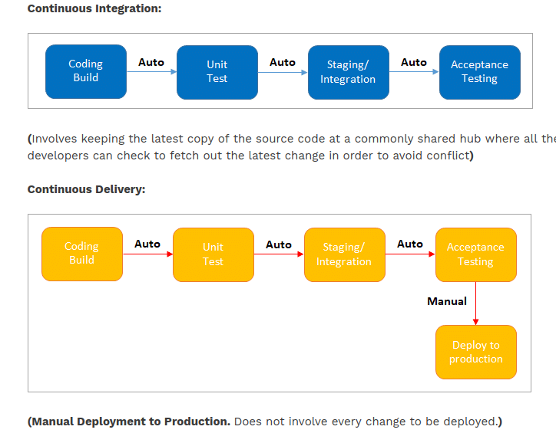
What is Jenkins pipeline? What is a CI CD pipeline?
-> Continuous integration or continuous delivery pipeline consists of build, deploy, test, release pipeline. The pipeline feature saves a lot of time and error in maintaining the builds. Basically, a pipeline is a group of build jobs that are chained and integrated in sequence.

What are Scripted Pipelines in Jenkins?
-> Node {
}
the node is a part of the Jenkins distributed mode architecture, where there
are two types of node Master which handle all the tasks in the development environment and
the Agent is being used to handle multiple tasks individually.
Q. What are Declarative Pipelines in Jenkins?
-> Declarative Pipelines are the newest additions to Jenkins that simplify the groovy syntax of Jenkins pipelines (top-level pipeline) with some exceptions.
No semicolon to be used as a statement separator. The top-level pipeline should be enclosed within block.
The common syntax is:
pipeline {
/* Declarative Pipeline */
}

pipeline {
agent any
stages {
stage(‘Build’) {
steps {
// Statements…
}
}
stage (‘Test’) {
steps {
// Statements…
}
}
}
}

- Pipeline: The block of script contents.
- Agent: Defines where the pipeline will start running from.
- Stage: The pipelines contain several steps enclosed in the block called Stage.
Q. What is SCM? Which SCM tools are supported in Jenkins?
->
- SCM stands for Source Control Management.
- SCM module specifies source code location.
- The entry point to SCM is being specified as jenkins_jobs.scm.
- The job specified with ‘scm’ attribute accepts multiple numbers of SCM definitions.
- Jenkins supported SCM tools include:
- CVS
- Git
- Perforce
- AccuRev
- Subversion
- Clearcase
- RTC
- Mercurial
Q. Which CI Tools are used in Jenkin?
-> Jenkins supported CI tools are:
- Jenkins
- GitLab CI
- Travis CI
- CircleCI
- Codeship
- Go CD
- TeamCity
- Bamboo

Q. Which commands can be used to start Jenkins manually?
- -> (Jenkins_url)/restart: To force restart without waiting for build completion.
- (Jenkin_url)/safeRestart: Waits until all the build gets completed before restarting.
Q. Which Environmental Directives are used in Jenkins?
-> Environmental Directives is the sequence which specifies pairs of the key-values called
Environmental Variables for the steps in the pipeline.

Q. What are Triggers?
-> Trigger in Jenkins defines the way in which the pipeline should be executed
frequently. PollSCM, Cron, etc are the currently available Triggers.
Q. What is Agent Directive in Jenkins?
-> The Agent is the section that specifies the execution point for the entire pipeline or any
specific stage in the pipeline. This section is being specified at the top-level inside the
pipeline block.

Q. How to make sure that your project build does not break in Jenkins?
- Clean and successful installation of Jenkins on your local machine with all unit tests.
- All code changes are reflected successfully.
- Checking for repository synchronization to make sure that all the differences and changes related to config and other settings are saved in the repository.
Q. What is the difference between Maven, Ant, and Jenkins?
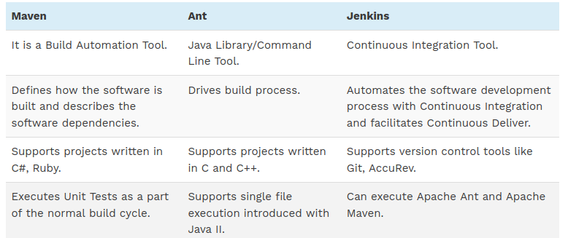
Q. How you can set up a Jenkins job?
->
Step 1: Go to the Jenkins Dashboard and Login with your registered login credentials.
Step 2: Click on the New Item that is shown in the left panel of the page.
Step 3: Click on the Freestyle Project from the given list on the upcoming page and specify
the item name in the text box.
Step 4: Add the URL to Git Repository.

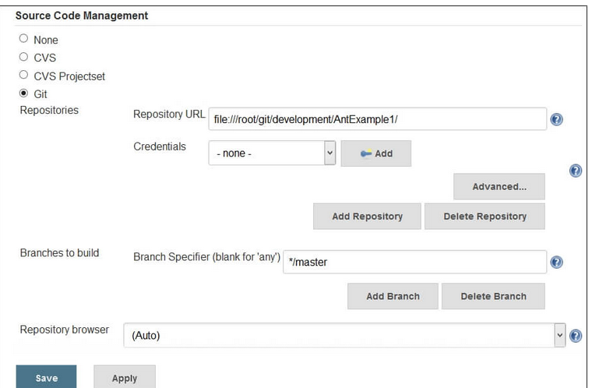
Step 5: Go to the Build section and click on the Add build step => Execute Windows batch
command.
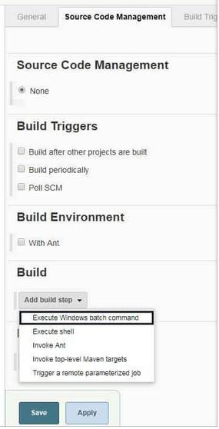

Step 6: Enter the command in the command window as shown below.
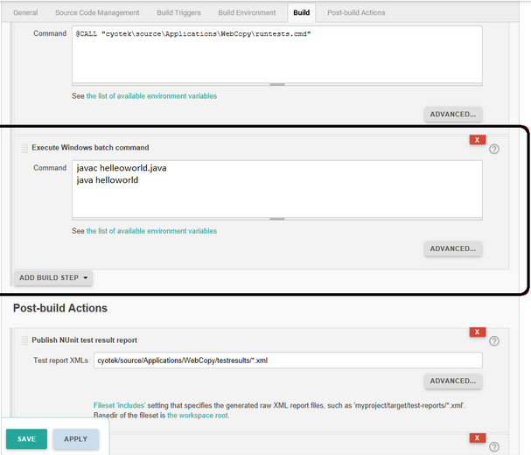
Step 7: After saving all the settings and changes click on Build Now.
Step 8: To see the status of the build click on Console Output.

Q. What are the two components (pre-requisites) that Jenkins is mainly integrated with?
-> 1. Build tools/ Build working script like Maven script.
2. Version control system/Accessible source code repository like Git repository.
Q. How can You Clone a Git Repository via Jenkins?
-> i) Access Control which includes authenticating users and giving them an appropriate set of permissions, which can be done in 2 ways.
- Security Realm determines a user or a group of users with their passwords.
- Authorization Strategy defines what should be accessible to which user. In this case, there might be different types of security based on the permissions granted to the user such as Quick and simple security with easy setup, Standard security setup, Apache front-end security etc.
(ii) Protecting Jenkins users from outside threats.

Q. How to create a backup and copy files in Jenkins?
-> n Jenkins, all the settings, build logs and configurations are stored in the JENKINS_HOME
directory. Whenever you want to create a backup of your Jenkins you can back up JENKINS_HOME directory frequently.

Q. What is the use of Backup Plugin in Jenkins? How to use it?
-> Jenkins Backup Plugin is used to back up the critical configurations and settings in order to use them in the future in case of any failure or as per the need of time.

The following steps are followed for backing up your settings by using the Backup Plugin.

Step 1: Go to the Jenkins Dashboard and click on Manage Jenkins.
Step 2: Click on Manage Plugins that appears on the next page.
Step 3: Go to Available Tab in the next page and search for ThinBackup.
Step 4: Once you choose the available option, it will start installing.
Step 5: Once it is installed the following screen will appear, from there choose Settings.
Step 6: Enter the necessary details like backup directory along with other options as shown on the below screen and save the settings. The backup will be saved to the specified Backup Directory.
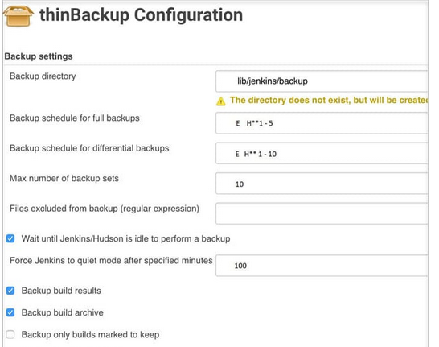
Step 7: Go to the previous page to test whether the backup is happening or not by clicking on Backup Now as shown in the below image.
Step 8: At last you can check the Backup Directory specified in the ThinBackup Settings.

Q. What is Flow Control in Jenkins?
-> In Jenkins, flow control follows the pipeline structure (scripted pipeline) that are being
executed from the top to bottom of the Jenkins file.

Q. What is the solution if you find a broken build for your project?
-> (i) Open console output for the build and check if any file change has missed.
OR
(ii) Clean and update your local workspace to replicate the problem on the local system and try to resolve it (In case you couldn’t find out the issue in the console output).
Q. How can you define a Continuous Delivery Workflow?
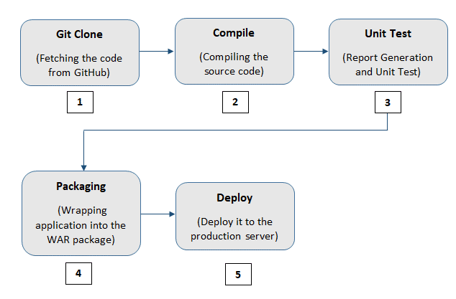
Q. What are the various ways in which the build can be scheduled in Jenkins?
-> The build can be triggered in the following ways:
- After the completion of other builds.
- By source code management (modifications) commit.
- At a specific time.
- By requesting manual builds.
Q. Why is Jenkins called a Continuous Delivery Tool?
->
1. Developers work on their local environment for making changes in the source code and push it into the code repository.
- When a change is detected, Jenkins performs several tests and code standards to check whether the changes are good to deploy or not.
- Upon a successful build, it is being viewed by the developers.
- Then the change is deployed manually on a staging environment where the client can have a look at it.
- When all the changes get approved by the developers, testers, and clients, the final outcome is saved manually on the production server to be used by the end users of the product.
Q. Give any simple example of Jenkins script.
-> This is a Jenkins declarative pipeline code for Java:
pipeline {
agent
stages {
stage('Building your first asset') {
agent
steps {
echo 'Build asset'
}
}
stage('Test') {
agent
steps {
echo 'Building project 1'
}
}
}
}

Q. What are the types of jobs or projects in Jenkins?
-> These are the types of jobs/projects in Jenkins –
- Freestyle project
- Maven project
- Pipeline
- Multibranch pipeline
- External Job
- Multi-configuration project
- Github organization
Q. What is blue ocean in Jenkins?
-> While this project is in the alpha stage of development, the intent is that Jenkins users can install Blue Ocean side-by-side with the Jenkins Classic UI via a plugin.

Q.

