GLACO

S. R. S. Report – I

16th Sept , 2017

Sushil Singh

Shubham Kumar

**Table of Contents**

**1. INTRODUCTION 3**

1.1 Purpose 3

1.2 Scope 3

1.3 Definitions, Acronyms, and Abbreviations 3

1.4 References 4

1.5 Overview 4

**2. GENERAL DESCRIPTION 2**

2.1 Product Perspective 2

2.2 Product Functions 2

2.3 User Characteristics 2

2.4 General Constraints 2

2.5 Assumptions and Dependencies 2

**3. SPECIFIC REQUIREMENTS 2**

3.1 External Interface Requirements 3

*3.1.1 User Interfaces 3*

*3.1.2 Hardware Interfaces 3*

*3.1.3 Software Interfaces 3*

*3.1.4 Communications Interfaces 3*

3.2 Functional Requirements 3

*3.2.1 Food Order via App*

*3.2.2 Take order*

*3.2.3 Delivered order*

*3.2.4 Payment*

*3.2.5 Customer order*

*3.2.6 Customer Review 3*

3.3 Use Cases 3

*3.3.1 User use case 3*

*3.3.2 Canteen Employee use case 3*

3.4 Classes / Objects 3

3.5 Non-Functional Requirements 4

*3.5.1 Performance 4*

*3.5.2 Reliability 4*

*3.5.3 Availability 4*

*3.5.4 Security 4*

*3.5.5 Maintainability 4*

*3.5.6 Portability 4*

3.6 Inverse Requirements 4

3.7 Design Constraints 4

3.8 Logical Database Requirements 4

3.9 Other Requirements 4

**4. ANALYSIS MODELS 4**

4.1 Sequence Diagrams 5

4. 2 Data Flow Diagrams (DFD) 5

4.3 ENTITY RELATIONSHIP DIAGRAM 5

**A. APPENDICES 5**

A.1 Appendix 1 5

A.2 Appendix 2 5

**Introduction**

Online ordering system that we are proposing here, greatly simplifies the ordering process for both the students and the faculties of GLA University. System presents an interactive and up-to-date menu with all available options in an easy to use manner. Users can choose one or more items to place an order which will land in the Cart. Users can view all the order details in the cart before checking out. At the end, Users gets order confirmation details. Once the order is placed it is entered in the database and retrieved in pretty much real time. This allows Canteen Employees to quickly go through the orders as they are received and process all orders efficiently and effectively with minimal delays and confusion.

## 1.1 Purpose

This document presents a detailed explanation of the objectives, features, user interface and application of GLA Canteen Management System in real life. It will also describe how the system will perform and under which it must operate. In this document it will be also shown user interface. Both the consumers and the developers of the system can benefit from this document.

## 1.2 Scope

This system will help to manage and run the restaurant business systematically. In this management system, we will provide an app that can be used by the users to order food. Users can also give feedback through this app. So that owner of the canteen can evaluate the whole system. Users can also make payment through Paytm wallet or GLA wallet which will be integrated with the management software. All the information about daily expenses and profit will be saved in the system. Also the required information’s about orders items will be saved in the system which can be only accessed by the system admin.

## 1.3 Definitions, Acronyms, and Abbreviations

|  |  |
| --- | --- |
| **Term** | **Description** |
| Item | Single serving food |
| Order | Comprises one or more items |
| Users | Canteen patron that orders/pays for a item |
| Canteen Employee | Staff employee whose primary job is to manage canteen operations |
| Menu | Surface computer representation of the available items and other options |
| Paytm Wallet | A digital payments platform that allows you to transfer cash into the integrated wallet via online banking, debit cards, and credit cards, or even by depositing cash via select banks and partners |
| GLACO Wallet | A virtual wallet that allows you to pay for your items in virtual points |
| Payment | Comprises the total cost of zero or more meals and zero or more tips |
| Account | Comprises all the items from a order |
| Server | Backend computer that hosts the canteen menu and ordering system |

**Table 1.3.1 System Terminology**

|  |  |
| --- | --- |
| **Acronym** | **Description** |
| GLACO | GLA Canteen Online system |
| SRS | Software Requirement Specification |
| DBMS | Database Management System |
| LAN | Local Area Network |
| IP | Internet Protocol |
| IEEE 802.11 | Wireless Local Area Network Standard |

**Table 1.3.2 System Acronyms**

## 1.4 References

[www.google.com](http://www.google.com) - the world's information.

[www.wikipedia.com](http://www.wikipedia.com) - free online encyclopedia.

[www.slideshare.net](http://www.slideshare.net) - the world's largest professional content sharing community.

[www.youtube.com](http://www.youtube.com) - the world’s video database.

IEEE. IEEE Std 830-1998 IEEE Recommended Practice for Software Requirements Specifications. IEEE Computer Society, 1998.

## 1.5 Overview

The GLACO is a management system to facilitate ordering within GLA Canteen. The user is able to view the menu, place orders. Employees are able to confirm orders, send orders to users The food staff, with their touch-display interfaces to the system, are able to view orders sent to the kitchen by waiters. During preparation, they are able to let the waiter know the status of each item, and can send notifications when items are completed, again through the touch-display. The system contains full accountability and logging systems, and supports supervisor actions to account for exceptional circumstances, such as a meal being refunded or walked out on. Customers are presented with an attractive and easy-to-use surface computer GUI with a drag-and-drop ‘object’ metaphor in their menus. Waiters are able to perform all actions that the table system normally handles via their tablet PCs, so in the event of a customer being unable to operate the surface computer, the waiter can handle orders traditionally while using retaining the accountability and logging functions of the system, and retaining the same channel of communication with food staff.

# 2. General Description

Our Project is based on automation of GLA Canteen which allows users to pay canteen bills using online wallet and request for delivery of available canteen items in the menu.

The project consists of android app and a web services .The android app will be used by the students and faculties of university whereas the web service will be used by the canteen management.

## 2.1 Product Perspective

The GLACO System helps the canteen employees to manage the canteen more effectively and efficiently by computerizing food ordering, payments and inventory control.

The system processes transaction and stores the resulting data. The whole GLACO system is designed for a general Computerized Digital Canteen. So that any canteen owner can get it and can start automated process to his canteen.

## 2.2 Product Functions

* Create an account.
* Manage their account.
* Log in to the system.
* Navigate the restaurant’s menu.
* Select an item from the menu.
* Add an item to their current order.
* Review their current order.
* Remove an item/remove all items from their current order.
* Provide payment details.
* Place an order.
* Receive confirmation in the form of an order number.
* View order placed.
* Customer Information.
* Customer Review.
* Order Details.

## 2.3 User Characteristics

The GLACO System has five active actors and one cooperating SRS for GLACO system. The user can access the system through wifi connection and order food. The canteen employees can see the order and accordingly can accept or reject order. The delivery-boy will deliver the order to the provided address. The employees can access the system and receive the payment from customers. The Admin can edit the price, menu and users.

## 2.4 General Constraints

The system shall use the current corporate standard MySQL and Firebase database engine. All HTML code shall conform to the HTML 4.0 standard. All scripts shall be written in JavaScripts and jQuery. The android app will be coded in Java and XML using Android Studio.

## 2.5 Assumptions and Dependencies

* The android app is used for ordering items and payments.
* The operation of the GLACO depends on changes being made in the menu to accept payment requests for items ordered with the GLACO app.

# 3. Specific Requirements

## 3.1 External Interface Requirements

There are many types of interfaces as such supported by this software system namely; User Interface, Software Interface, Communication Interface and Hardware Interface.

### 3.1.1 User Interfaces

The user interface will be implemented using any android smartphone app browser. This interface will be user friendly. So that every kind of users can place the food order easily. Users can also give feedback through it easily with some demo comment or if they are keen to write their review by own they can do it.

### 3.1.2 Hardware Interfaces

No hardware interfaces have been identified.

### 3.1.3 Software Interfaces

The system shall communicate with the Configurator to identify all the available components to configure the product. The system shall communicate with the content manager to get the product specifications.

### 3.1.4 Communications Interfaces

The GLACO System shall send an e-mail message to the User to verify his/her email to activate his account.

## 3.2 Functional Requirements

**3.2.1 Food Order via App**  
User can order food with the app but it needs internet connection.

**3.2.2 Take Order**  
The employees will take the order and if it is available to make then he will confirm the  
order and start to prepare food.

**3.2.3 Deliver Food**  
When the food is ready to be served then the employees will hand over the order to the delivery-boy. After delivering the food the employee will insure the order as delivered.

**3.2.4 Payment**  
The payment is done by Paytm wallet or the GLA wallet for the items purchased.

**3.2.5 Customer Information**The user will be get registered and the payment details and order details will be saved in the database for the processing of order and for the future reference.

.  
**3.2.6 Customer Review**  
User can give overall review about the food and services.

## 3.3 Use Cases

The use cases for each of the actors are described in this section.

### 3.3.1 User Use Case

**Use case:** Order Food

**Description**

The User can order food and see their items in the cart and pay for the items. User will also verify the delivery status.

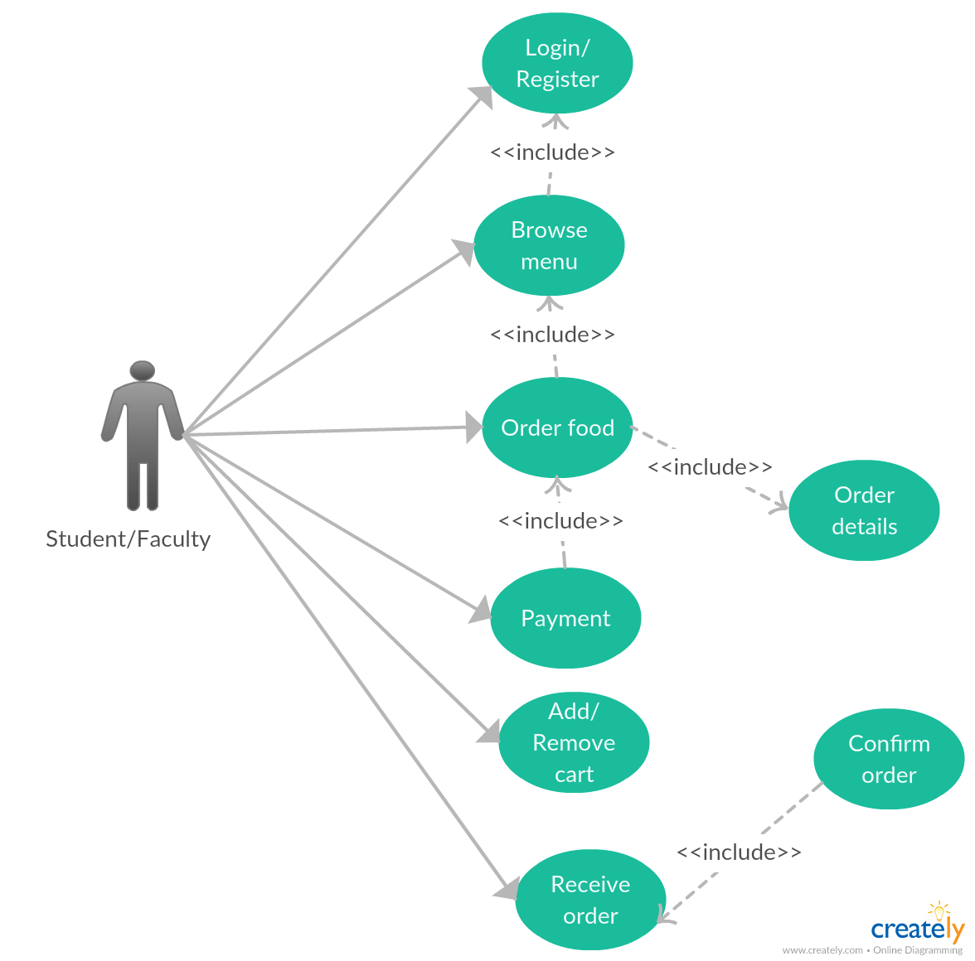

### 3.3.2 Canteen Employee Use Case

**Use case:** Deliver Food

**Description**

The Canteen employees can see the food orders and accept/reject the orders. After accepting the order the items will be delivered to the users. The canteen management can also manage the students details, order details, menu items.

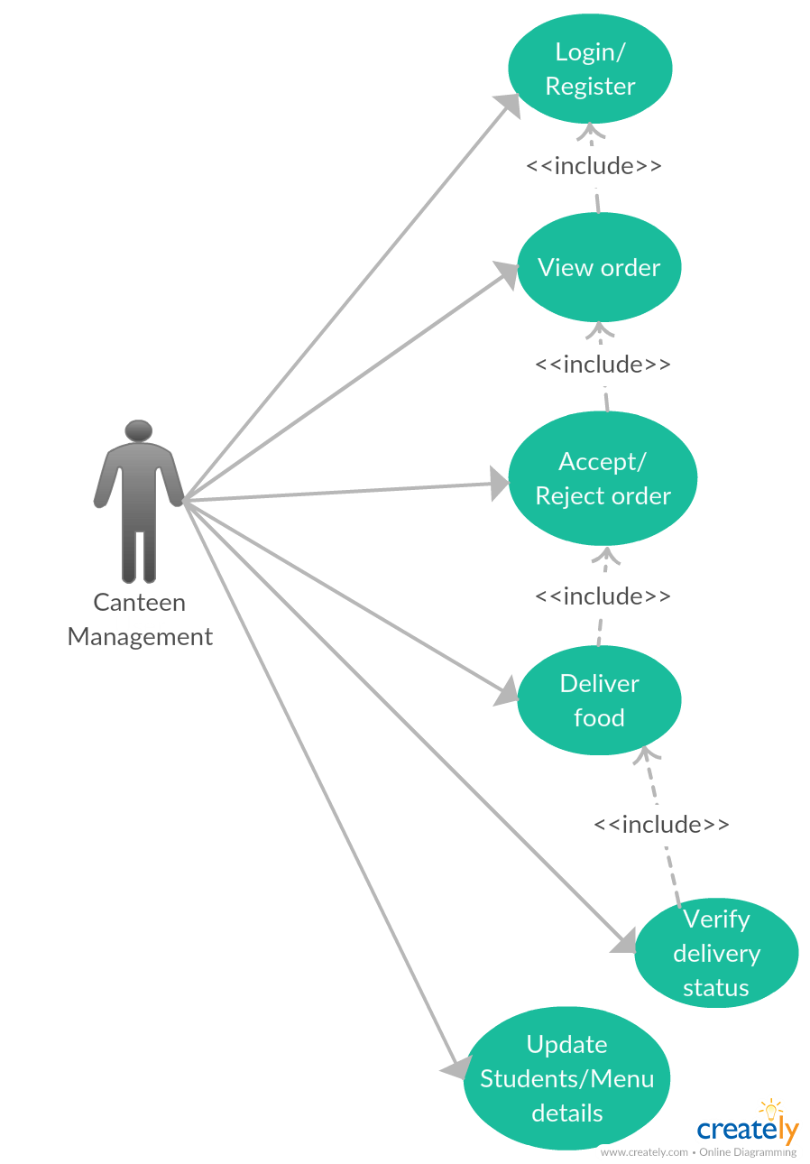

## 3.4 Classes / Objects

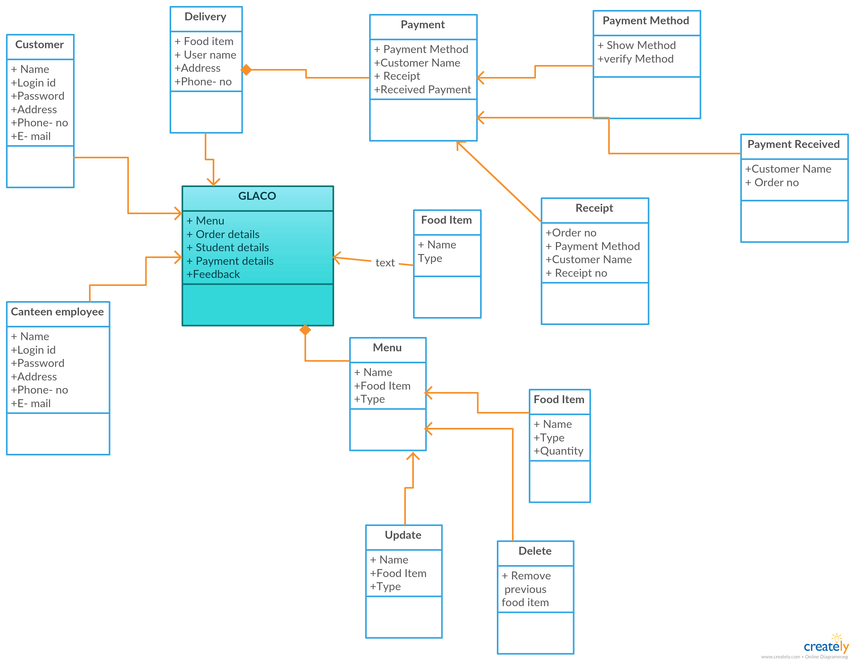

**Attributes**

1. Customer
2. Canteen employee
3. Menu
4. Delivery
5. Update
6. Delete
7. Food item
8. Payment method
9. Payment received
10. Receipt
11. Payment
12. Delivery

## 3.5 Non-Functional Requirements

### 3.5.1 Performance

* The product will be based on local server.
* The product will take initial load time.
* The performance will depend upon hardware components.
* Different database for employee.

### 3.5.2 Reliability

The website portal and android app will work smoothly but internet connection should be smooth.

### 3.5.3 Availability

The system shall provide for replication of databases to off-site storage locations.

### 3.5.4 Security

* The source code developed for this system shall be maintained in configuration management tool.
* The whole system is secured. Only Admin can access all the data.
* This system will use HTTPS. Because of this protocol this is more secure.

### 3.5.5 Maintainability

The GLACO system modules will be maintained on regular intervals so as to provide better functionality and reliability.

### 

### 3.5.6 Portability

Due to android app the GLACO system is easy to carry with proper functioning internet connection.

## 3.6 Inverse Requirements

No inverse requirements detected.

## 3.7 Design Constraints

There are some constraints which costs more for the system. If those constraints can

overcome then this whole system will perform best. They are-

1. Android App and Website Portal.

2. Information flow or data flow can be controlled and more effective.

3. Faster server system such as LINUX server.

4. English language is used in app and portal for communication.

## 3.8 Logical Database Requirements

MySQL and Firebase database is used for the proper data storage of the GLACO system. Both databases will be easy to integrate and have high data storage capabilities. The data formats will be assigned according to the tuple values.

## 3.9 Other Requirements

**3.9.1 Licensing Requirements**

Not Applicable

**3.9.2 Legal, Copyright, and Other Notices**

All right reserved by our team.

**3.9.3 Applicable Standards**

It should be as per the industry standard.

# 4. Analysis Models

## 4.1 Sequence Diagrams

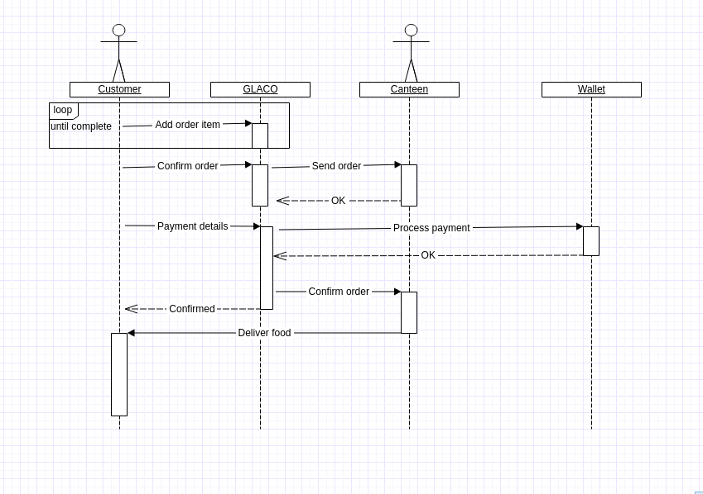

## 4.2 Data Flow Diagrams (DFD)xOnline,P20Food,P20Ordering,P20System,P20Zero,P20Level.jpeg.pagespeed.ic.wceElWQx2M.jpgOnline Billing System First Level_0.jpeg

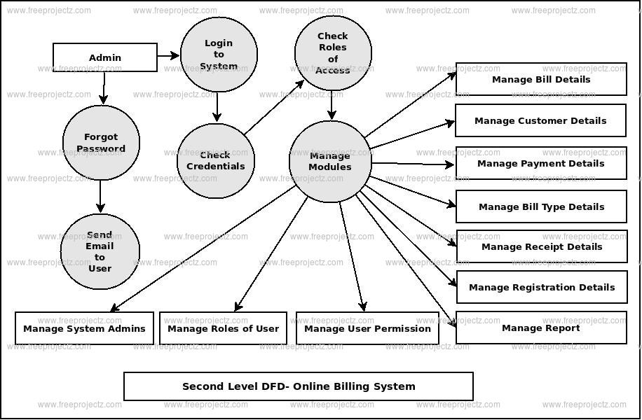

## 4.3 Entity Relationship Diagrams (ERD)

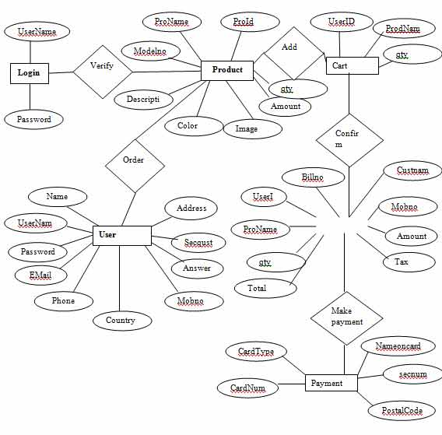

# A. Appendices

*Appendices may be used to provide additional (and hopefully helpful) information. If present, the SRS should explicitly state whether the information contained within an appendix is to be considered as a part of the SRS’s overall set of requirements.*

*Example Appendices could include (initial) conceptual documents for the software project, marketing materials, minutes of meetings with the customer(s), etc.*

## A.1 Appendix 1

## A.2 Appendix 2