**JSS MAHAVIDYAPEETHA**

**JSS SCIENCE AND TECHNOLOGY UNIVERSITY**

JSS Technical Institutions Campus, Mysuru – 570006



**WEB TECHNOLOGY ASSIGNMENT**

**ADOBE FLASH APPLICATION**

**BACHELOR OF ENGINEERING**

**IN**

**COMPUTER SCIENCE AND ENGINEERING**

*by*

**DIVYA R MADHYAN GAURAV GOBIND SINGH**

**(01JST16CS030) (01JST16CS034)**

**SUSHIL KUMAR**

**(01JST16CS110)**

*Under the Guidance of*

**PROF. NANDEESH H D**

Assistant Professor,

Dept.of CS & E,

JSS STU, MYSURU - 570006

**DEPARTMENT OF COMPUTER SCIENCE AND ENGINEERING**

**2019-2020**

|  |  |  |
| --- | --- | --- |
|  |  |  |

**JSS MAHAVIDYAPEETHA**

**JSS SCIENCE AND TECHNOLOGY UNIVERSITY**

JSS Technical Institutions Campus, Mysuru – 570006

**WHAT IS ADOBE FLASH ?**

The Flash CS4 Professional Software from Adobe is a development suite that is used to create Flash animations, videos, and applications. Flash is the industry-standard file format for multimedia web and mobile content delivery. The software features full integration with the other applications in the Adobe Creative Suite, including Photoshop, Illustrator, After Effects, and Premiere Pro. Flash is an essential tool for multimedia web development.

Flash Professional has many creative tools to help you create better animations and effects. These include the FlashType font rendering engine, filters, blend modes, custom easing control, ActionScript 3.0, and an object-based animation mode. One can convert an animation path into ActionScript 3.0 so that it can be reused in other projects. One can also copy animation paths to the clipboard, allowing to quickly drop it into another project. Flash is fully complaint with the Adobe AIR runtime.

End-users can view Flash content via [Flash Player](https://en.wikipedia.org/wiki/Adobe_Flash_Player) (for web browsers), [AIR](https://en.wikipedia.org/wiki/Adobe_AIR) (for desktop or [mobile apps](https://en.wikipedia.org/wiki/Mobile_app)) or third-party players such as [Scaleform](https://en.wikipedia.org/wiki/Scaleform) (for video games). Adobe Flash Player (supported on [Microsoft Windows](https://en.wikipedia.org/wiki/Microsoft_Windows), [macOS](https://en.wikipedia.org/wiki/MacOS) and [Linux](https://en.wikipedia.org/wiki/Linux)) enables end-users to view Flash content using [web browsers](https://en.wikipedia.org/wiki/Web_browser). [Adobe Flash Lite](https://en.wikipedia.org/wiki/Adobe_Flash_Lite) enabled viewing Flash content on older [smartphones](https://en.wikipedia.org/wiki/Smartphone), but has been discontinued and superseded by [Adobe AIR](https://en.wikipedia.org/wiki/Adobe_AIR).

Adobe Flash Player (labeled Shockwave Flash in [Internet Explorer](https://en.wikipedia.org/wiki/Internet_Explorer) and [Firefox](https://en.wikipedia.org/wiki/Firefox))[[5]](https://en.wikipedia.org/wiki/Adobe_Flash_Player#cite_note-5) is [computer software](https://en.wikipedia.org/wiki/Software) for using content created on the [Adobe Flash](https://en.wikipedia.org/wiki/Adobe_Flash) platform, including viewing [multimedia](https://en.wikipedia.org/wiki/Multimedia) contents, executing [rich Internet applications](https://en.wikipedia.org/wiki/Rich_Internet_application), and [streaming audio and video](https://en.wikipedia.org/wiki/Streaming_media). Flash Player can run from a [web browser](https://en.wikipedia.org/wiki/Web_browser) as a browser [plug-in](https://en.wikipedia.org/wiki/Plug-in_(computing)) or on supported mobile devices. Flash Player was created by [Macromedia](https://en.wikipedia.org/wiki/Macromedia) and has been developed and distributed by [Adobe Systems](https://en.wikipedia.org/wiki/Adobe_Systems) since Adobe acquired Macromedia in 2005. Flash Player is distributed as [freeware](https://en.wikipedia.org/wiki/Freeware).

Data formats[[edit](https://en.wikipedia.org/w/index.php?title=Adobe_Flash_Player&action=edit&section=2)]

Flash Player includes native support for many [data formats](https://en.wikipedia.org/wiki/File_format), some of which can only be accessed through the [ActionScript](https://en.wikipedia.org/wiki/ActionScript) scripting interface.

* XML: Flash Player has included native support for [XML](https://en.wikipedia.org/wiki/XML) parsing and generation since version 8. XML data is held in memory as an XML [Document Object Model](https://en.wikipedia.org/wiki/Document_Object_Model), and can be manipulated using ActionScript. ActionScript 3 also supports [ECMAScript for XML](https://en.wikipedia.org/wiki/ECMAScript_for_XML) (E4X), which allows XML data to be manipulated more easily.
* JSON: Flash Player 11 includes native support for importing and exporting data in the [JavaScript Object Notation](https://en.wikipedia.org/wiki/JavaScript_Object_Notation) (JSON) format, which allows interoperability with [web services](https://en.wikipedia.org/wiki/Web_service) and [JavaScript](https://en.wikipedia.org/wiki/JavaScript) programs.
* AMF: Flash Player allows application data to be stored on users computers, in the form of [Local Shared Objects](https://en.wikipedia.org/wiki/Local_Shared_Object), the Flash equivalent to [browser cookies](https://en.wikipedia.org/wiki/HTTP_cookie).[[25]](https://en.wikipedia.org/wiki/Adobe_Flash_Player#cite_note-adobe-lso-25) Flash Player can also [natively](https://en.wikipedia.org/wiki/Native_(computing)) read and write files in the [Action Message Format](https://en.wikipedia.org/wiki/Action_Message_Format), the default data format for Local Shared Objects. Since the AMF format specification is published, data can be transferred to and from Flash applications using AMF datasets instead of [JSON](https://en.wikipedia.org/wiki/JSON) or [XML](https://en.wikipedia.org/wiki/XML), reducing the need for [parsing](https://en.wikipedia.org/wiki/Parsing) and [validating](https://en.wikipedia.org/wiki/Data_validation) such data.
* SWF: The specification for the [SWF](https://en.wikipedia.org/wiki/SWF) file format was published by Adobe, enabling the development of the SWX Format project, which used the SWF file format and AMF as a means for Flash applications to exchange data with server side applications.[[26]](https://en.wikipedia.org/wiki/Adobe_Flash_Player#cite_note-26)[[27]](https://en.wikipedia.org/wiki/Adobe_Flash_Player#cite_note-27) The SWX system stores data as standard SWF bytecode which is automatically interpreted by Flash Player.[[28]](https://en.wikipedia.org/wiki/Adobe_Flash_Player#cite_note-28) Another [open-source](https://en.wikipedia.org/wiki/Open-source_software) project, SWXml allows Flash applications to load XML files as native ActionScript objects without any client-side XML parsing, by converting XML files to SWF/AMF on the server.

As part of this assignment, we created a student portal, where there will be a home page, displaying institution details

It includes several buttons, each of which represents a particular student.

Whenever a button is clicked, it displays the details of that particular student, namely, the name, the USN, the roll number and the institution name, along with a photograph of the particular student.

This application can be further enhanced to include several more features and functionalities, to serve as a helpful tool in all educational institutions, to save and store the data of all students, in an effective manner.

The entire aim of the project was to describe a simple application which can be built using adobe flash CS4 and can be run using the Flash Player Plugin.

Further Enhancements will leave this application very helpful and useful for not only this field of application, but with slight change in implementation functionalities, it can be tailored to cater to the requirements of several other stakeholders, as and when needed.

The major advantage is that it is very interactive and its cross browser compatibility and it is independent of different browsers.

Also, it allows image replacement for special fonts.

Flash is vector based and hence a lightweight option for animation with smaller file size as opposed to real movie files that are raster based with much larger file size.

Flash supports audio, animation, and advanced video handling and interactivity.

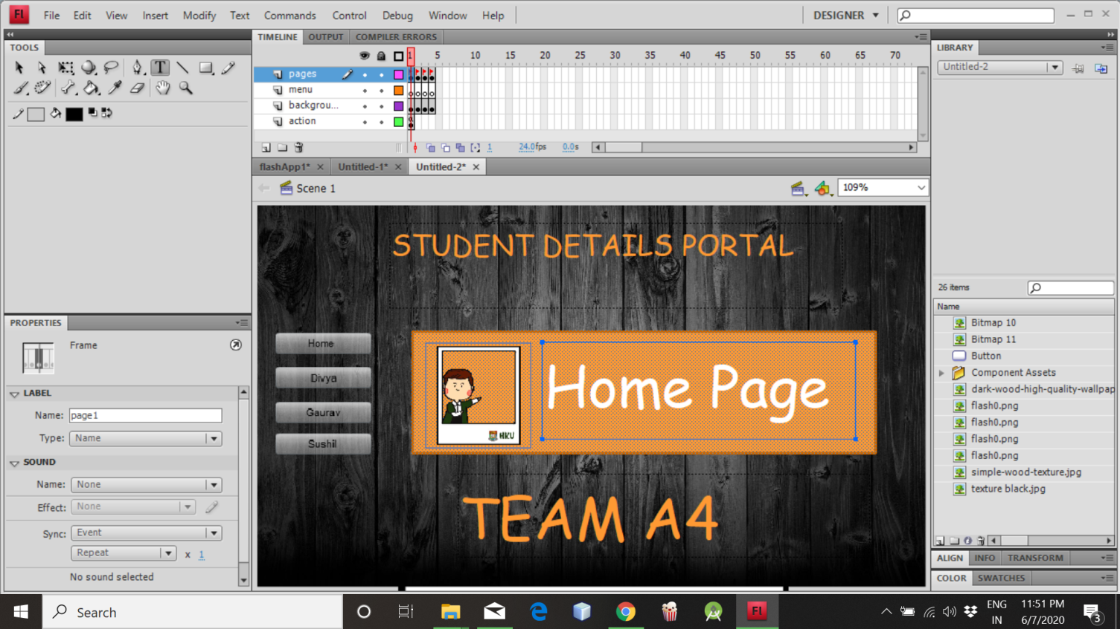

This is the design for the home page. It consists of buttons, which will redirect to individual pages.

On running the above design on flash player, this is how the output appears.

The above screenshot shows the individual page. Similarly, it opens for each of the other users, once the data is fed.

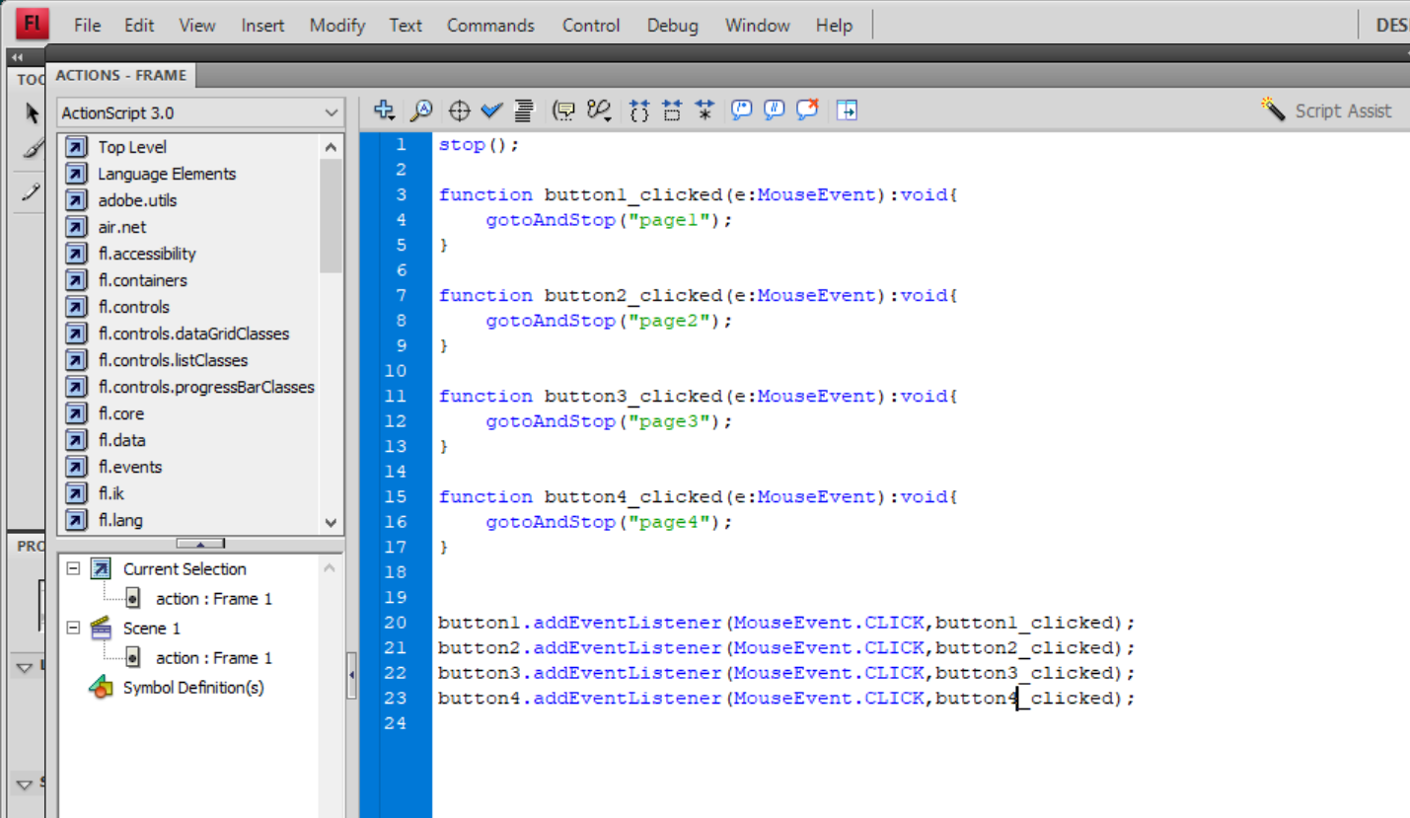

This is the code part for the individual pages.