Edureka (www.edureka.co)

Data Science Certification Training

Report of Certification Project

By: Sushil Kumar Verma

sushilverma208016@gmail.com

About Data:

It is a company’s human resource data where data of employee’s salary, bonus, promotion etc. and his stay in company is given. The task is to create a predicting model for VP of company to predict stay rate of current employees.

Size: 14999 rows and 10 columns

Columns:

• Employee satisfaction level (satisfaction_level : numeric)

• Last evaluation (last_evaluation : numeric)

• Number of projects (numer_project : numeric)

• Average monthly hours (average_monthly_hours : numeric)

• Time spent at the company (time_spend_company : numric)

• Whether they have had a work accident (work_accident : numeric)

• Whether the employee has left (left : categorical)

• Whether they have had a promotion in the last 5 years (promotion_last_5years : numeric)

• Department (department : categorical)

• Salary (salary : categorical)

Target column is left which is 7th column of dataset.

Data Wrangling:

* Factorized categorical columns: left, department and salary.
* Scaled remaining numeric columns.
* As all columns are potential, so dimensionality reduction must not do.
* In each classifier, ratio of training and test data is taken as 80:20

Correlation among variables:

Used ‘corrr’, ‘Hmisc’ and ‘corrplot’ to find and plot correlation among numeric variables. The result is below:

last_evaluation number_project average_montly time_spend_company Work_accident promotion_last_5years

satisfaction_level 1.00000000 0.105021214 -0.142969586 -0.020048113 -0.100866073 0.058697241 0.025605186

last_evaluation 0.10502121 1.000000000 0.349332589 0.339741800 0.131590722 -0.007104289 -0.008683768

number_project -0.14296959 0.349332589 1.000000000 0.417210634 0.196785891 -0.004740548 -0.006063958

average_montly -0.02004811 0.339741800 0.417210634 1.000000000 0.127754910 -0.010142888 -0.003544414

time_spend_company -0.10086607 0.131590722 0.196785891 0.127754910 1.000000000 0.002120418 0.067432925

Work_accident 0.05869724 -0.007104289 -0.004740548 -0.010142888 0.002120418 1.000000000 0.039245435

promotion_last_5years 0.02560519 -0.008683768 -0.006063958 -0.003544414 0.067432925 0.039245435 1.000000000

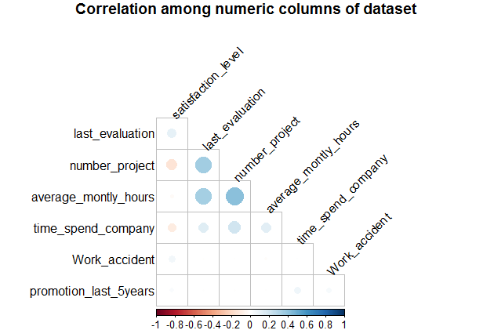

Decision Tree Classifier:

* Used package ‘rpart’ for decision tree
* Average accuracy of 5-fold cross validation: 90.89%
* The plot between accuracy of decision tree and its accuracy parameter is below:

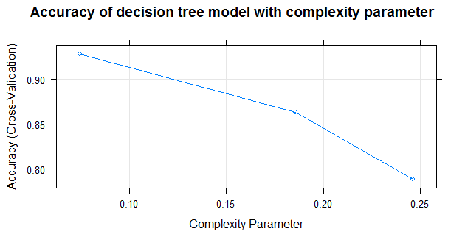

Confusion Matrix

0 1

0 11217 1156

1 211 2415

Random Forest Classifier:

* Used library ‘randomForest’ for random forest classifier
* With number of trees (ntree)=300, achieved 98.23% accuracy

Confusion Matrix

0 1

0 2283 3

1 50 664

* With 10-fold cross validation achieved on average 99.16% accuracy.

Accuracies of these ten iteration are:

99.20000 99.13333 99.20000 99.13333 99.13333 99.13333 99.20000 99.13333 99.20000 99.13333

* The plot between error in random forest classifier and number of tree is:

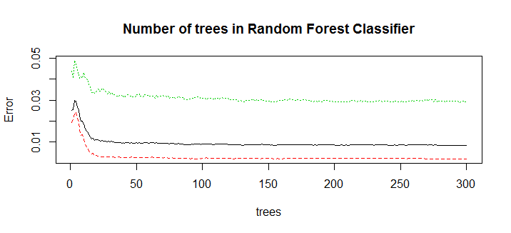

Support Vector Machine (SVM):

* Used library ‘e1071’ to build SVM model
* Achieved 77.37% accuracy with linear kernel SVM

Confusion Matrix

0 1

0 2147 139

1 540 174

* Polynomial kernel SVM of degree four gave 93.83% accuracy

Confusion Matrix

0 1

0 2222 64

1 121 593

* Sigmoid kernel SVM gave 57.87% accuracy

Confusion Matrix

0 1

0 1677 609

1 655 59

k-Nearest Neighbor (k-NN) Classifier:

* Library ‘class’ is used for k-NN classifier
* Achieved accuracy of 94.97% from k-NN algorithm using k=5

Confusion Matrix

0 1

0 2187 99

1 52 662

* Varied value of k from 1 to 10 and below are accuracies for each k:

# Value of K: 1 Accuracy: 0.97

# Value of K: 2 Accuracy: 0.952

# Value of K: 3 Accuracy: 0.954666666666667

# Value of K: 4 Accuracy: 0.952666666666667

# Value of K: 5 Accuracy: 0.949666666666667

# Value of K: 6 Accuracy: 0.949666666666667

# Value of K: 7 Accuracy: 0.952

# Value of K: 8 Accuracy: 0.947666666666667

# Value of K: 9 Accuracy: 0.948333333333333

# Value of K: 10 Accuracy: 0.947666666666667

Logistic Regression Classifier:

* Used function ‘glm’ to create a logistic regression classifier.
* Achieved accuracy of 79.1% with ‘binomial’ family and probability threshold of 0.5

Confusion Matrix

0 1

0 2117 169

1 458 256

* Tried different family of function with logistic regression and their accuracies are:

# Family : binomial Accuracy: 0.793333333333333

# Family : gaussian Accuracy: 0.793333333333333

# Family : Gamma Accuracy: 0.793333333333333

# Family : inverse.gaussian Accuracy: 0.793333333333333

# Family : poisson Accuracy: 0.793333333333333

# Family : quasi Accuracy: 0.793333333333333

# Family : quasibinomial Accuracy: 0.793333333333333

# Family : quasipoisson Accuracy: 0.793333333333333

Naïve Bayes Classifier:

* Used library ‘e1071’ to implement naïve Bayes classifier
* Simple naïve Bayes classifier gave 78.67% accuracy

Confusion Matrix

0 1

0 1854 432

1 208 506

* Naïve Bayes classifier with ‘laplace’ value=2000, ‘eps’=0.1 and ‘threshold’=0.5 gave 79.67% accuracy

Confusion Matrix

0 1

0 1899 387

1 223 491

Neural Network:

* Library ‘h2o’ is used for neural network
* Obtained asccuracy of 94.53% with ‘Rectifier’ activation function, 5 hidden layers and 100 epochs

Confusion Matrix

0 1

1. 2215 71

1 93 621

* Obtained accuracy of 96.43% with ‘Rectifier’ activation function, 100 hidden layers and 100 epochs

Confusion Matrix

1. 1

0 2231 55

1 52 662

* Obtained accuracy of 97% with ‘tanh’ activation function, 50 hidden layers and 1000 epochs

Confusion Matrix

0 1

0 2245 41

1 49 665

* Obtained accuracy of 97.33% with ‘tanh’ activation function, 50 hidden layers and 150 epochs

Confusion Matrix

0 1

0 2247 39

1 41 673

* Training Scoring History of neural network classifier is given in the below plot:

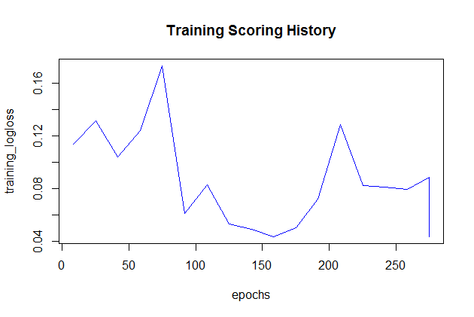

Summary of accuracies of different classifiers:

* Decision Tree: 90.89%
* Random Forest: 99.20%
* SVM: 93.83%
* K-NN: 97%
* Logistic Regression: 79.33%
* Naive Bayes Classifier: 79.67%
* Neural Network: 97.33%