Coding Problem Set – 2 (Hotel-Search)

By: Sushil Verma ([sushilverma208016@gmail.com](mailto:sushilverma208016@gmail.com))

Tools needed to run:

Browser: chrome

Environment: JRE+JAVA

Technology Used:

Backend: Spring Boot

Build: Gradle

Editor: Intellije Idea, Swagger

Steps to Run:

1. Download project and unzip it
2. Open terminal in project directory and do “cd Hotel-Search” to go inside project folder
3. Do “gradlew clean build” to build the project
4. Do “java -jar build/libs/Hotel-Search-0.1.0.jar ----spring.config.location=/build/resources/main/application.properties” to run project in localhost
5. Go to <http://localhost:9000/> in browser to see welcome message

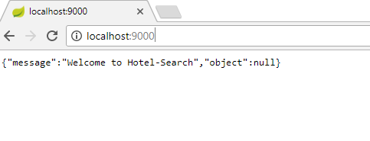

Other APIs and Features:

1. Get hotel by Id: type following in browser to see a hotel by its Id <http://localhost:9000/hotel/CL8ZWELDOBFMP3PDF5IS/3>

Note: “CL8ZWELDOBFMP3PDF5IS” is API key and “3” is hotel Id.

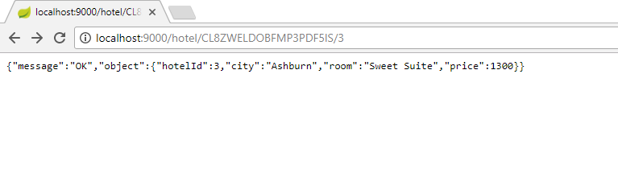

If hotel with given Id does not exist then following response can be seen.

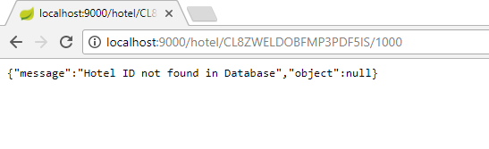

1. Search hotels by City Id: as City Id is given in the csv file, I am considering City Name for filtering. Type following in browser to see the list of hotels in the given city

<http://localhost:9000/all-hotels/CL8ZWELDOBFMP3PDF5IS/Ashburn>

Note: here “CL8ZWELDOBFMP3PDF5IS” is API key and “Ashburn” is given city.

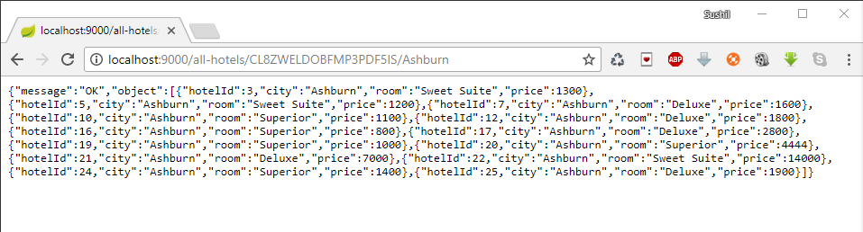

To see this same list in sorted in ascending order based on price, add query parameter “sort=ASC” or “sort=asc” in URL making:

<http://localhost:9000/all-hotels/CL8ZWELDOBFMP3PDF5IS/Ashburn?sort=ASC>

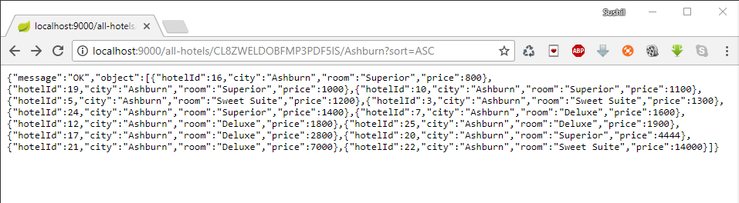

To see this list in sorted in descending order based on price, add query parameter “sort=DESC” or “sort=desc” in URL making:

<http://localhost:9000/all-hotels/CL8ZWELDOBFMP3PDF5IS/Ashburn?sort=DESC>

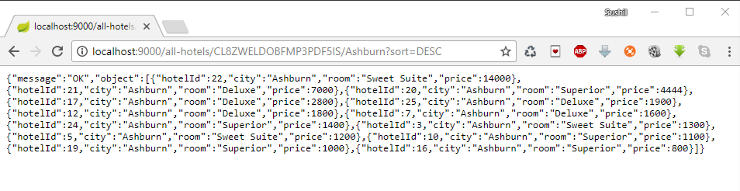

1. Also made API to create API Key generated from a random string of length 20.

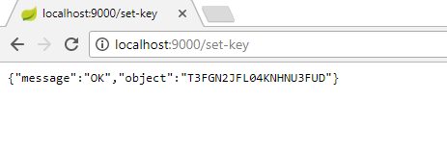

1. Implemented the limited rate to call first and second APIs. Maximum time for requesting API “max-count”=10 and time for suspension “suspension-time”= 5 min= 300000 milliseconds is set in “application.properties” file.

For other details, please see code.

Thankyou,

Sushil Verma