# [配置WCF同时支持WSDL和REST，swaggerwcf生成文档](http://www.cnblogs.com/ddrsql/p/5920562.html)

**一：VS创建一个WCF工程，通过NuGet添加SwaggerWcf**

创建完成后通过 程序包管理控制台

pm>Install-Package SwaggerWcf

也可在 工具 -> NuGet包管理器 -> 管理解决方案的NuGet程序包 安装。

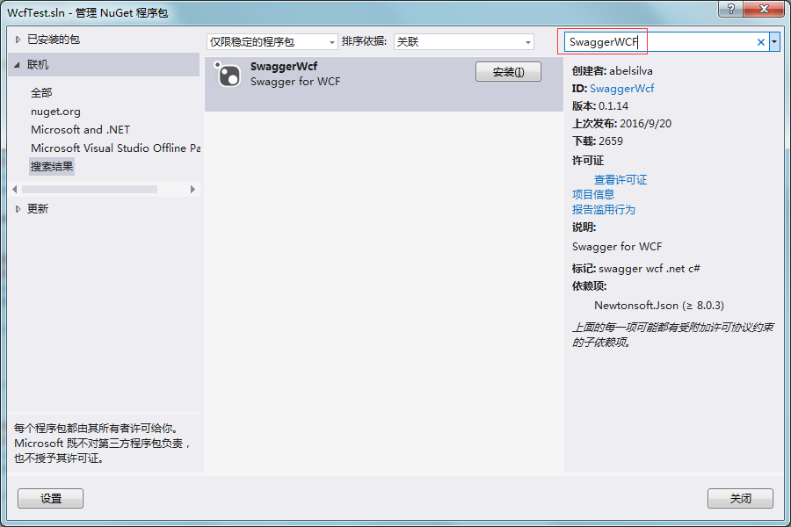

**二：配置**

1. 在项目中添加Global.asax文件，并对Global.asax改动如下：

protected void Application_Start(object sender, EventArgs e)

{

RouteTable.Routes.Add(new ServiceRoute("Service1", new WebServiceHostFactory(), typeof(Service1)));

RouteTable.Routes.Add(new ServiceRoute("api-docs", new WebServiceHostFactory(), typeof(SwaggerWcfEndpoint)));

}

2. Web.config配置文件改动如下

在<configuration>**节点下**添加

<configSections>

<section name="swaggerwcf" type="SwaggerWcf.Configuration.SwaggerWcfSection, SwaggerWcf" />

</configSections>

<swaggerwcf>

<tags>

<tag name="LowPerformance" visible="false" />

</tags>

<settings>

<setting name="InfoDescription" value="地址：http://192.168.3.162:8089/api-docs" />

<setting name="InfoVersion" value="0.0.1" />

<setting name="InfoTitle" value="站点容器组织架构接口" />

<setting name="InfoContactName" value="谢永平（QQ:175415051）" />

**<setting name="BasePath" value="/UserService"/>**

</settings>

</swaggerwcf>

如图：

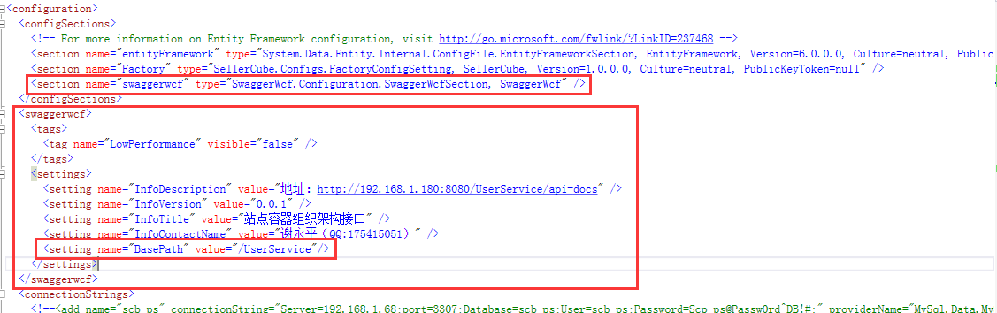

**\*BasePath的设置相当重要，如果有站点名称，必须加上，且格式需带”/”**

1. 在<serviceHostingEnvironment>**节点后**添加

<standardEndpoints>

<webHttpEndpoint>

<standardEndpoint name="" helpEnabled="true" automaticFormatSelectionEnabled="true" crossDomainScriptAccessEnabled="true"/>

</webHttpEndpoint>

</standardEndpoints>

如图：

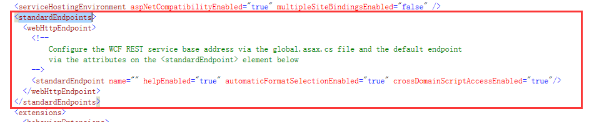

1. 运行后，webconfig.xml中会自动增加以下节点。

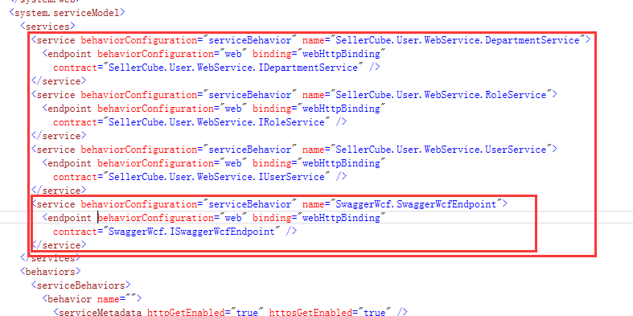

本地测试或者测试服务器测试，由于是Http访问，没有任何问题。

**针对在线上发布**，由于是https访问，这样的配置会导致无法访问swagger doc的问题。需要**在红内框节点上加上 bindingConfiguration="TransportSecurity"**



1. 改动接口文件，IRoleService文件中改动如下：入参、返回有多个时BodyStyle = WebMessageBodyStyle.Wrapped

Get方法：

[OperationContract]

[Description("功能：获取某个角色下的用户；参数1：角色名；参数2：排序字段，默认为UserName")]

[SwaggerWcfPath("获取某个角色下的用户", "获取某个角色下的用户")]

[WebInvoke(Method = "GET", UriTemplate = "GetUsersByRoleName?roleName={roleName}&orderField={orderField}",

BodyStyle = WebMessageBodyStyle.Bare,

RequestFormat = WebMessageFormat.Json, ResponseFormat = WebMessageFormat.Json)]

List<UserEntity> GetUsersByRoleName(string roleName, string orderField = "userName");

Post方法：

[OperationContract]

[Description("功能：根据角色名获取用户；参数1：角色名数组；参数2：默认参数；返回：TextValue[userName,UserId]")]

[SwaggerWcfPath("根据角色名获取用户", "根据角色名获取用户")]

[WebInvoke(BodyStyle = WebMessageBodyStyle.WrappedRequest, Method = "POST", UriTemplate = "GetUserListByRoleNameEx",

RequestFormat = WebMessageFormat.Json, ResponseFormat = WebMessageFormat.Json)]

List<TextValue> GetUserListByRoleNameEx(string[] roleName, string defaults);

如：

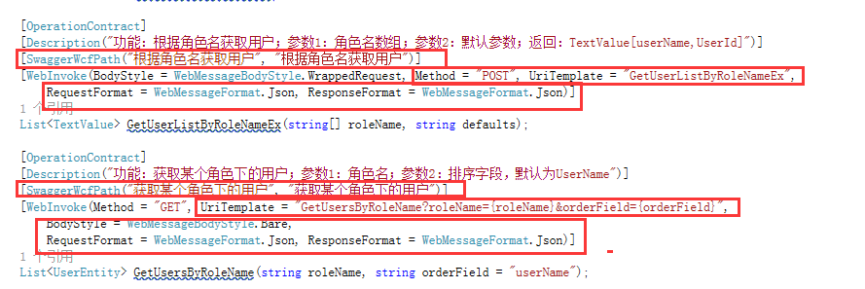

注意：Get时多个参数地址的写法。

1. 改动接口实现文件，RoleService.svc.cs文件中改动如下：

[ServiceBehavior(InstanceContextMode = InstanceContextMode.PerSession)]

[AspNetCompatibilityRequirements(RequirementsMode = AspNetCompatibilityRequirementsMode.Allowed)]

[SwaggerWcf("/RoleService")]

public class RoleService : ServiceBase, IRoleService

{

[SwaggerWcfTag("RoleService:角色接口")]

[SwaggerWcfResponse(HttpStatusCode.Created, "Book created, value in the response body with id updated")]

[SwaggerWcfResponse(HttpStatusCode.BadRequest, "Bad request", true)]

[SwaggerWcfResponse(HttpStatusCode.InternalServerError, "Internal error (can be forced using ERROR_500 as book title)", true)]

public List<RoleEntity> GetAllRoleList()

{

var roleQuery = DataRepository.GetQueryable<RoleEntity>();

var result = roleQuery.Distinct().ToList();

return result;

}

[SwaggerWcfTag("RoleService:角色接口")]

[SwaggerWcfResponse(HttpStatusCode.Created, "Book created, value in the response body with id updated")]

[SwaggerWcfResponse(HttpStatusCode.BadRequest, "Bad request", true)]

[SwaggerWcfResponse(HttpStatusCode.InternalServerError, "Internal error (can be forced using ERROR_500 as book title)", true)]

public List<Dictionary<string, List<RoleEntity>>> GetRoleByUserId(string[] userId)

{

var result = new List<Dictionary<string, List<RoleEntity>>>();

if (userId == null || userId.Length == 0) return result;

var list = (from role in DataRepository.GetQueryable<RoleEntity>()

join userInRole in DataRepository.GetQueryable<UserRoleEntity>()

on role.RoleId equals userInRole.RoleId

where userId.Contains(userInRole.UserId)

select new

{

UserId = userInRole.UserId,

RoleId = role.RoleId,

RoleName = role.RoleName,

IsSystem = role.IsSystem,

RoleCategoryId = role.RoleCategoryId,

Description = role.Description

}).ToList();

if (list == null || list.Count == 0) return result;

var userIds = list.Select(o => o.UserId).Distinct().ToArray();

foreach (var id in userIds)

{

var inRole = new List<RoleEntity>();

foreach (var item in list)

{

inRole.Add(new RoleEntity()

{

RoleId = item.RoleId,

RoleName = item.RoleName,

IsSystem = item.IsSystem,

RoleCategoryId = item.RoleCategoryId,

Description = item.Description

});

}

result.Add(new Dictionary<string, List<RoleEntity>> { {id, inRole} });

}

return result;

}

/// <summary>

/// 通过角色ID获取角色

/// </summary>

/// <param name="roleId">角色ID</param>

/// <returns></returns>

[SwaggerWcfTag("RoleService:角色接口")]

[SwaggerWcfResponse(HttpStatusCode.Created, "Book created, value in the response body with id updated")]

[SwaggerWcfResponse(HttpStatusCode.BadRequest, "Bad request", true)]

[SwaggerWcfResponse(HttpStatusCode.InternalServerError, "Internal error (can be forced using ERROR_500 as book title)", true)]

public List<RoleEntity> GetRoleById(string[] roleId)

{

if (roleId == null) return null;

var roleQuery = DataRepository.GetQueryable<RoleEntity>(); //为空的时候查询所有

if (roleId.Length > 0)

roleQuery = roleQuery.Where(role => roleId.Contains(role.RoleId));

var result = roleQuery.ToList();

return result;

}

}

如图：

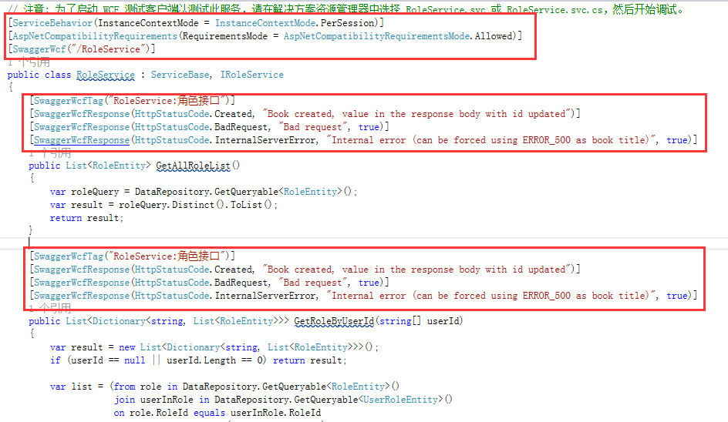

**三：生成接口文档**

wcf自带的rest文档（本地测试）：http://localhost:23368/RoleService.svc/help

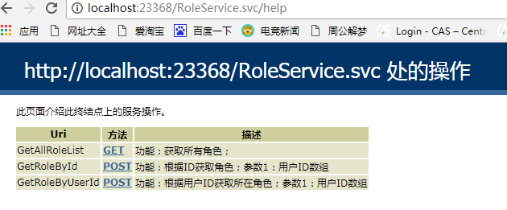

swaggerwcf生成的文档（线上测试）：

[https://erpapi.banggood.cn/UserService/api-docs/index.html?url=/UserService/api-docs/swagger.json#/](https://erpapi.banggood.cn/UserServiceTest/api-docs/index.html?url=/UserServiceTest/api-docs/swagger.json#/)

简写其实访问：<https://erpapi.banggood.cn/UserService/api-docs即可>

**红色部分为站点名称，有则加上，无则去掉**

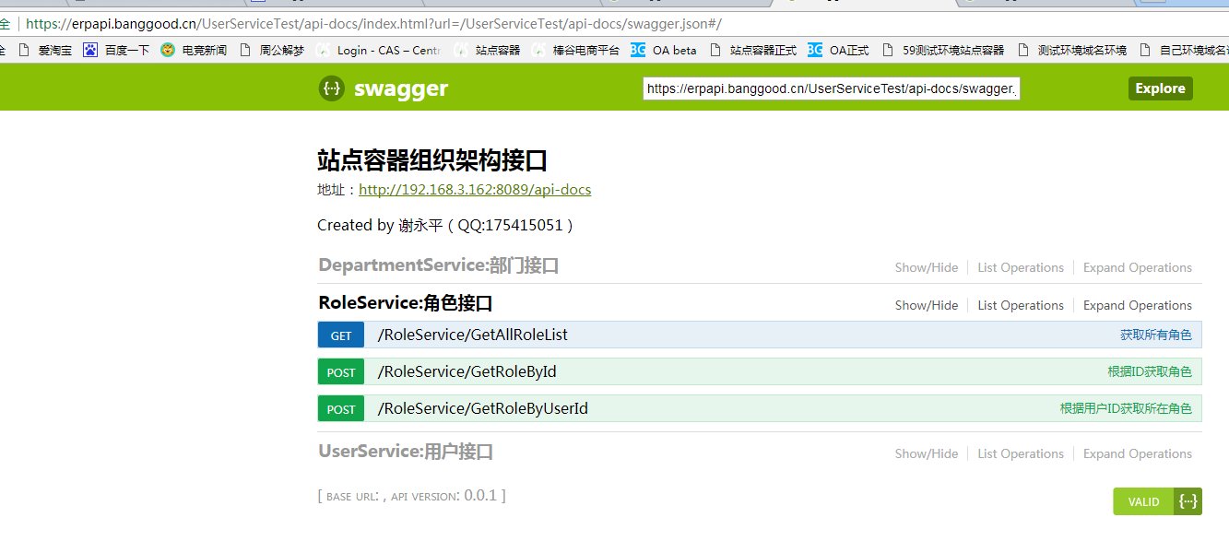

[https://erpapi.banggood.cn/UserService/UserService/GetAllCompanys](https://erpapi.banggood.cn/UserService/GetAllCompanys)

http://192.168.3.162:8089/RoleService/GetAllRoleList