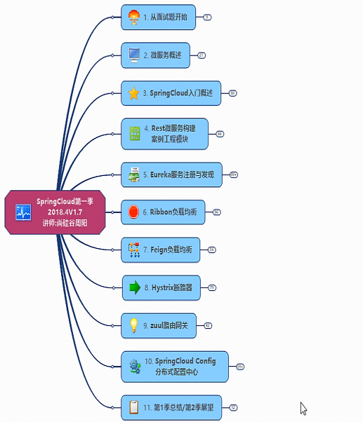

# 从面试题开始

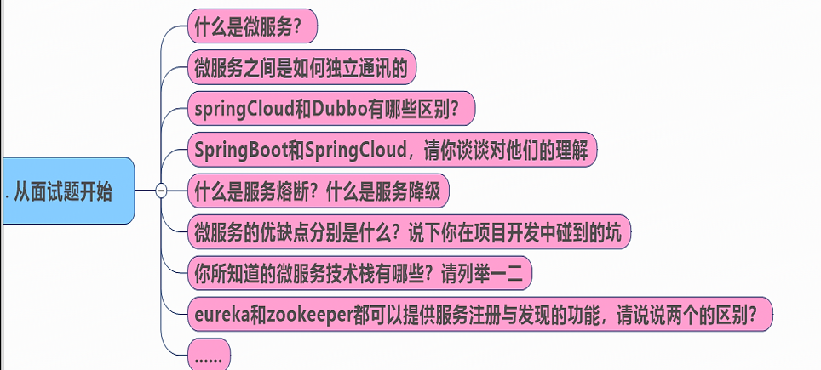

# 微服务概述

|  |
| --- |
|  |

# 微服务技术栈

|  |
| --- |
|  |

# 服务架构

|  |
| --- |
|  |

