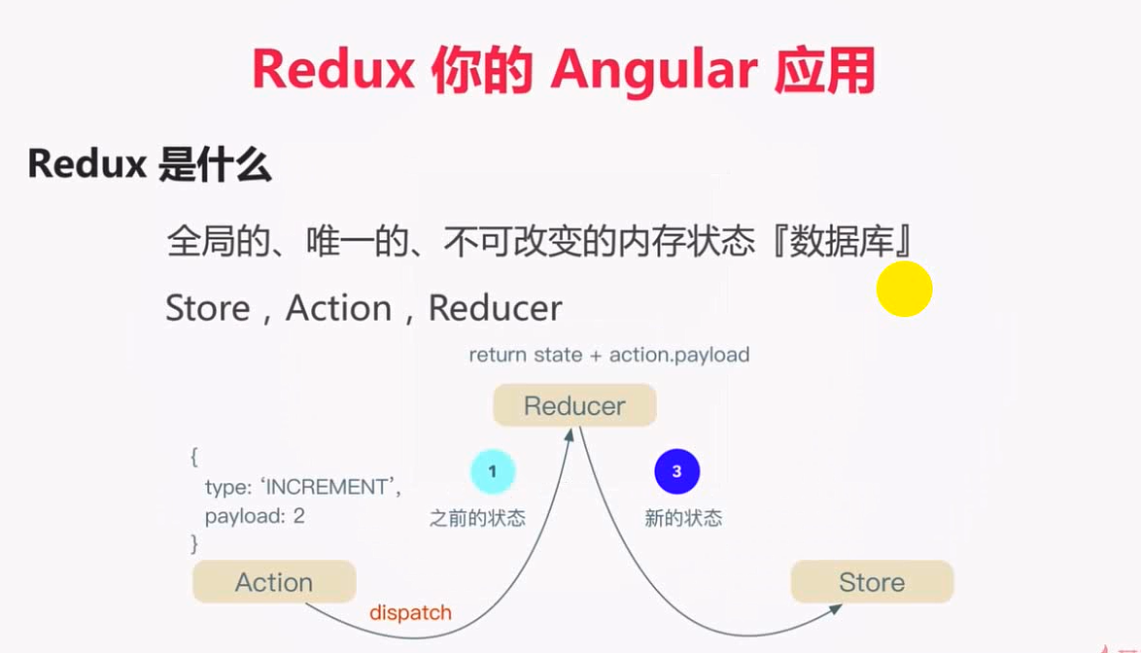

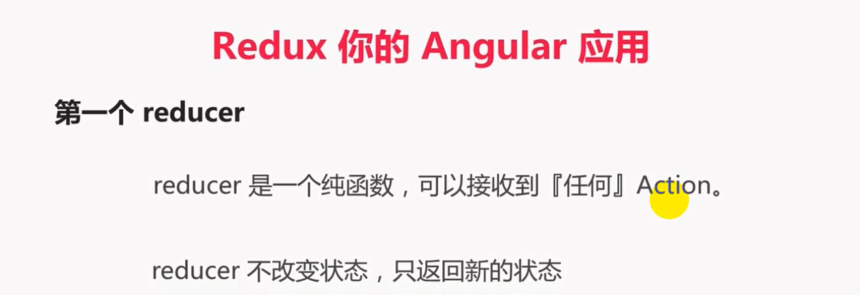

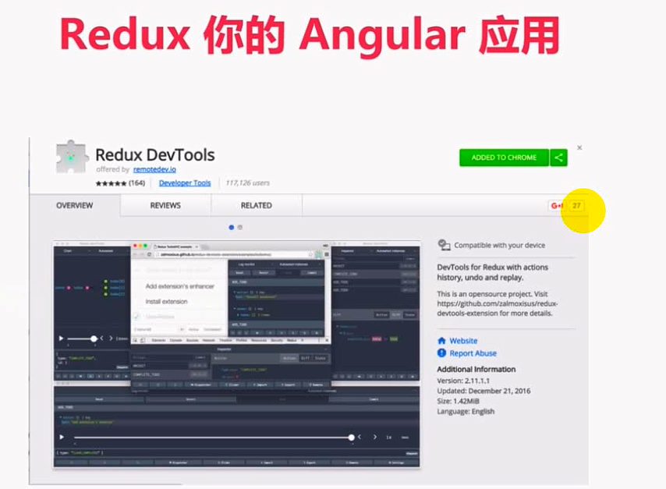



yarn add @ngrx/core@1.2.0 @ngrx/store@

2.2.3 @ngrx/router-store@1.2.6 @ngrx/effects@2.0.4 @ngrx/store-devtools@3.2.4 -S

