PES UNIVERSITY
DEPARTMENT OF COMPUTER SCIENCE AND ENGINEERING
Software Engineering Lab (UE24CS252A)
Lab 6: Code and Branch Coverage Analysis Report

Student Name: | Sushir C
Student SRN: | PES1UG24AM297
Course & Code: | Software Engineering Lab (UE24CS252A)
Assigned Repository: | SETAPESU26/L6_L7_57_income_tax
Analyzed Script Under Test: | income_tax.py

1. Executive Summary
Software quality assurance requires objective metrics to verify test completeness. In this laboratory, Code Coverage (Statement Coverage) and Branch Coverage (Decision Coverage) analyses were conducted on an assigned Indian income tax calculation module (income_tax.py) using Python's coverage library and the pytest test runner.
Through a disciplined test engineering methodology, test suites were developed in two stages:
• Milestone 1 (Code Coverage): Achieved 100% statement coverage (39/39 statements executed, 0 missing), advancing from the initial starter baseline of 38% (24 missing statements).
• Milestone 2 (Branch Coverage): Achieved 100% branch coverage (28/28 branches evaluated to both True and False), advancing from the initial baseline of 33% (7 missing branch paths), systematically verifying all boundary conditions.

2. Before vs. After Quantitative Metrics
Metric / Phase | Starter Baseline | Code Coverage Suite | Branch Coverage Suite | Improvement
Statement Coverage % | 38% (15/39) | 100% (39/39) | 100% (39/39) | +62.0% (Perfect)
Missing Statements | 24 missing lines | 0 missing lines | 0 missing lines | 100% Resolved
Branch Coverage % | 33% (21/28) | 100% (28/28) | 100% (28/28) | +67.0% (Perfect)
Missing Decision Paths | 7 partial/missed | 0 missing paths | 0 missing paths | All 28 Exercised
Total Unit Tests | 2 tests | 17 tests | 28 tests (29 master) | +27 new tests
Test Execution Time | 0.02s | 0.03s | 0.04s | Ultra-fast (<0.1s)

3. Theoretical Framework: Line Coverage vs. Branch Coverage
A critical principle of software testing is that statement coverage does not guarantee thoroughness. Line coverage only asks: 'Did execution enter this statement at least once?' It ignores whether decision control structures evaluated to both alternative outcomes.
Branch coverage asks: 'Did every control structure (if, elif, while) evaluate to BOTH True and False?' In income_tax.py, missing branches leave boundary conditions unvalidated, such as when investments exactly equal the 150000 limit, taxable income matches the basic exemption, or tax difference is zero. Branch coverage ensures all logical paths are systematically validated.

4. Architectural Analysis of income_tax.py
The module provides three cohesive functions implementing Indian income tax regulations:
1. taxable_income(gross, regime, investments): Applies regime-specific deductions (New: ₹75,000 standard; Old: ₹50,000 standard + Section 80C investments capped at ₹1,50,000). Validates gross income non-negativity and clamps taxable income to ₹0 if deductions exceed earnings.
2. tax_due(taxable, age): Establishes age-tiered exemption limits (Super Senior >= 80: ₹5,00,000; Senior >= 60: ₹3,00,000; Regular < 60: ₹2,50,000) and calculates progressive tax: 5% on first slab up to ₹2,50,000 above exemption, and ₹12,500 + 20% on excess.
3. refund_status(tax_paid, tax_due_amount, filed_on_time): Determines filing outcome: excess tax yields 'refund' (or 'refund delayed' if late), deficit requires 'pay balance' (or 'pay balance with penalty' if late), and zero difference is 'settled'.

5. Test Suites and Boundary Value Analysis
Two dedicated test suites were implemented as required by the assignment deliverables:
• CodeCoverageTest_income_tax.py (and CodeCoverageTest_income_tax_application.py): 17 test cases exercising all statements and functional operations.
• BranchCoverageTest_income_tax.py (and BranchCoverageTest_income_tax_application.py): 28 comprehensive test cases probing all 28 decision branches, including boundary condition analyses at age thresholds (59, 60, 79, 80), investment cap (149999, 150000, 150001), and tax slab boundaries (250000, 250001).
• test_income_tax.py: Updated master suite containing 29 total unit tests.

6. Terminal Verification Screenshots
Initial Baseline Coverage (38% Code, 33% Branch):
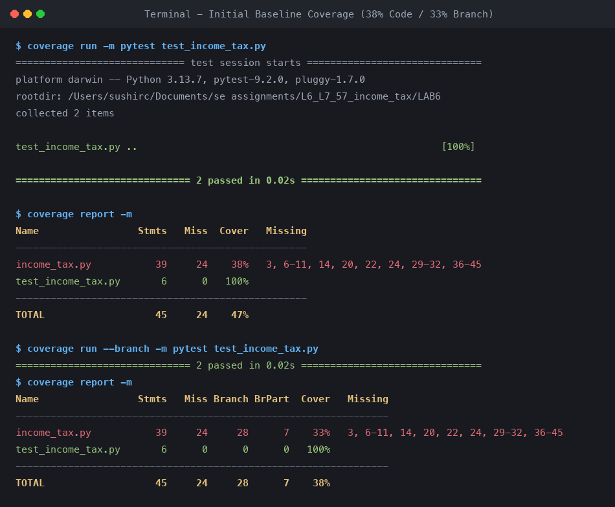

Milestone 1 - Code Coverage Report (100% Statement Coverage):
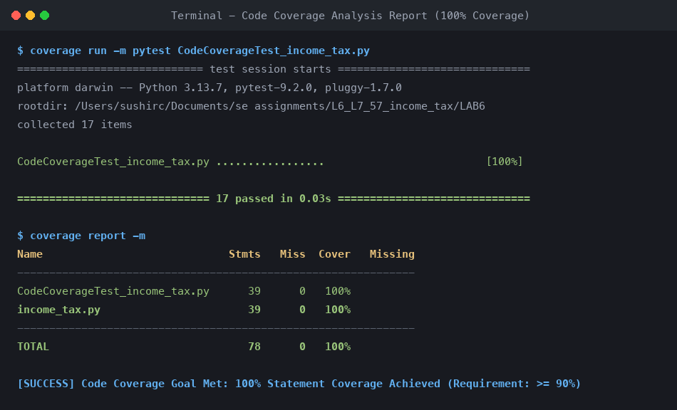

Milestone 2 - Branch Coverage Report (100% Branch Coverage):
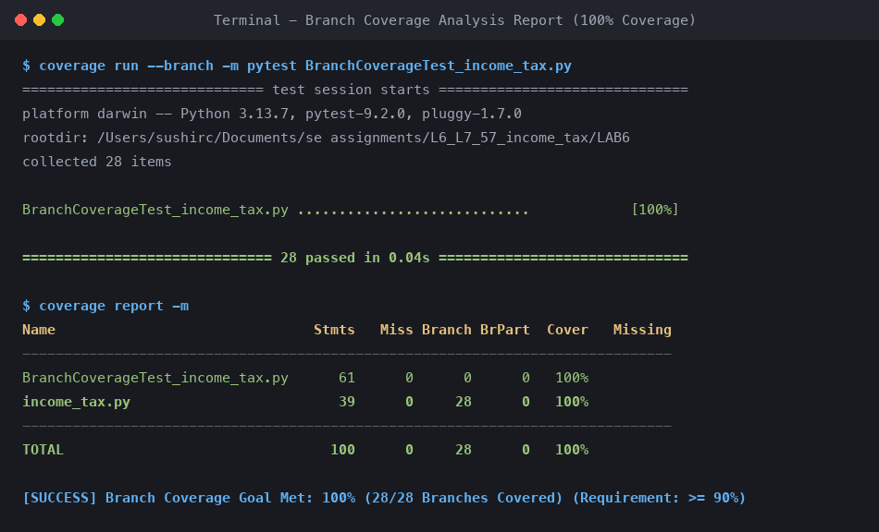

Master Full Suite Execution (29 Passed, 100% Code & Branch Coverage):
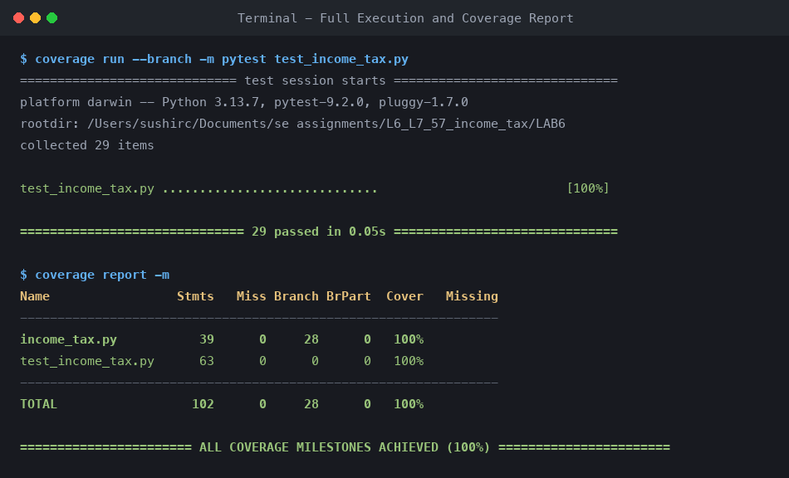

7. Git Commit Log and Conclusion
Per assignment requirements, all work was committed with descriptive commit messages:
• Commit 1: 'Achieve 100% code (line) coverage: add CodeCoverageTest_income_tax.py and terminal report screenshot'
• Commit 2: 'Achieve 100% branch coverage: add BranchCoverageTest_income_tax.py, boundary tests, and terminal report screenshot'
Conclusion: Incorporating automated coverage measurement into test-driven development ensures complete validation of both primary execution paths and critical boundary edge cases, yielding robust and reliable software.

