Engineering Report
Turbine Telemetry Anomaly Analysis | 24-Hour Snapshot
To: Chief Technology Officer, AeroGrid | 17 June 2026

1. Findings
AeroGrid’s legacy single-server monitoring system failed to trigger timely alerts on 15 April 2026. Analysis of 5,000 sensor readings across 10 turbines over the same 24-hour period identified two units requiring urgent maintenance:
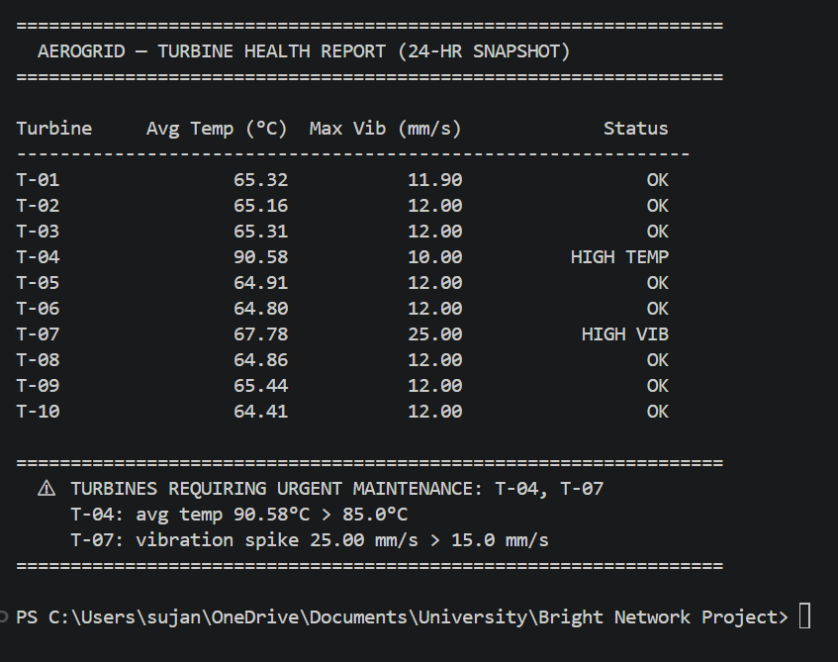
- T-04: Average temperature of 90.58°C exceeds the 85.0°C threshold. Consistent with cooling system failure or blocked heat exchanger.
- T-07: Peak vibration of 25.0 mm/s which is 67% above the 15.0 mm/s limit. Consistent with blade imbalance or bearing degradation.

2. Architecture Justification
The proposed pipeline replaces AeroGrid's single legacy server with seven decoupled components, each with a distinct responsibility. This eliminates the single point of failure that caused the missed alerts.

Data originates at the 10 turbine sensors, which emit continuous telemetry (temperature, RPM, and vibration) over MQTT. Rather than sending this directly to a database, the sensors publish to AWS Kinesis Data Streams, a managed pub-sub message queue. Kinesis acts as a waiting room, absorbing data spikes and holding readings safely until downstream components are ready to consume them. If the database crashes, no data is lost.
AWS Lambda connects to the Kinesis stream and applies the anomaly detection rules in real time as each reading flows through. Because Lambda is serverless, it scales automatically across all 10 turbines with no idle server costs, which is the exact bottleneck that overwhelmed the legacy system.
From Lambda, data splits into two storage paths. Recent readings go to InfluxDB, a time-series database optimised for high-frequency sensor data, which serves as the hot data store for live dashboards. Historical data is archived to AWS S3, a cheap object store functioning as a cold data lake for long-term analysis, keeping query performance high without inflating storage costs.
Grafana sits on the frontend, querying InfluxDB to give engineers a live view of turbine health. When Lambda detects an anomaly, it triggers AWS CloudWatch, which handles alerting and pages the on-call team immediately. This is the early-warning capability AeroGrid currently lacks.
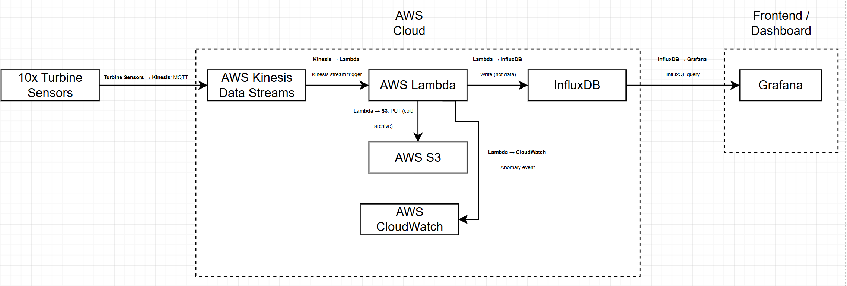
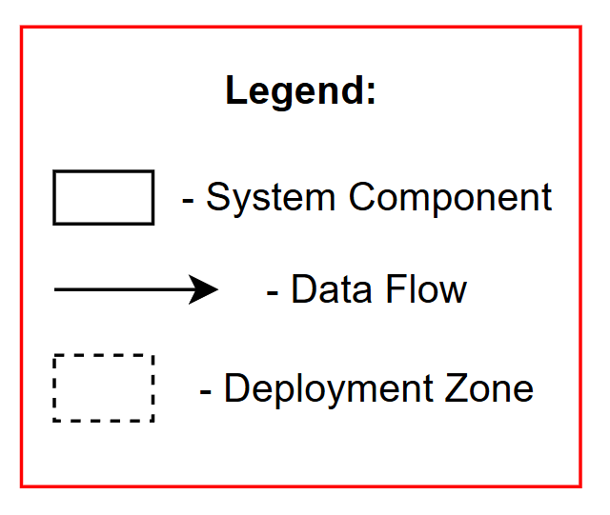

3. Cost Optimisation
Enable S3 Intelligent-Tiering on the cold data bucket. This automatically moves objects that have not been accessed for 30 days to a lower-cost storage tier, and further to archive tiers at 90 and 180 days. Given that turbine telemetry data is rarely queried after the first month, this single policy change can reduce storage costs by 40–70% on historical data with no performance impact on active workloads.

AeroGrid Engineering | IEUK 2026 Sector Skills Project

