**INTRODUCTION**

Amazon S3 is object storage service, which differs from block and file cloud storage. Each object is stored as a file with its metadata included and given an ID number. Applications use this ID number to access an object. Unlike file and block cloud storage, a developer can access an object via a rest API. [4]

The S3 cloud storage service gives a subscriber access to the same systems that Amazon uses to run its own websites. S3 enables a customer to upload, store and download practically any file or object that is up to five [gigabytes](http://searchstorage.techtarget.com/definition/gigabyte) (5 GB) in size.

Amazon S3 comes in two storage classes: S3 Standard and S3 Infrequent Access. S3 Standard is suitable for frequently accessed data that needs to be delivered with low latency and high throughput.S3 Standard targets applications, dynamic websites, content distribution and big data workloads. S3 Infrequent Access offers a lower storage price for backups and long-term data storage.

### Working with buckets

A bucket is a logical unit of storage in Amazon Web Services ([AWS](http://whatis.techtarget.com/definition/Amazon-Web-Services-AWS)) [object storage](http://searchstorage.techtarget.com/definition/object-storage) service, Simple Storage Solution [S3](http://searchaws.techtarget.com/definition/Amazon-Simple-Storage-Service-Amazon-S3). Buckets are used to store objects, which consist of [data](http://searchdatamanagement.techtarget.com/definition/data) and [metadata](http://whatis.techtarget.com/definition/metadata) that describes the data.

An S3 customer must create a bucket before he can store data in Amazon's [public cloud](http://searchcloudcomputing.techtarget.com/definition/public-cloud) and specify access [privileges](http://searchexchange.techtarget.com/definition/privilege) for the bucket by using the AWS Policy Generator. Although customers are not charged for creating buckets, they are charged for storing objects in a bucket and for transferring objects in and out of buckets. AWS account can only have 100 buckets at one time; however, it may be increased through payment of some extra charges.

An Amazon S3 bucket exists within a particular region of the cloud. An AWS customer uses an Amazon S3 API to upload objects to a particular bucket. Customers configure and manage [S3 buckets](http://searchaws.techtarget.com/definition/AWS-bucket). This is the basis in which our project works on.

A subscriber can choose to keep data private or make it publicly accessible. A user can also encrypt data prior to storage. Rights may be specified for individual users. When a subscriber stores data on S3, Amazon tracks usage for billing purposes but does not otherwise access the data unless required to do so by law. [2]

# AWS SDK for PHP 3.x

# The language that we implemented for the system is PHP, as all of the necessary APIs, libraries, documentation and dependencies are provided by Amazon frugally. AWS SDK is thus the basic building block of any system targeted to leverage the power and facilities provided by S3.

The API documentation for the AWS SDK for PHP contains documentation for every namespace, class, and method in the SDK and its required dependencies. More importantly, it describes each of the services' APIs, including the parameter and result structures for each operation, so that we can see how to use the operations in our PHP code. To view the API documentation for a particular service, a reference to table is given inside the document. To view API documentation for various classes in the SDK, the namespace and class trees are used. [1]

**SCREENSHOTS**

Fig 1. User login page

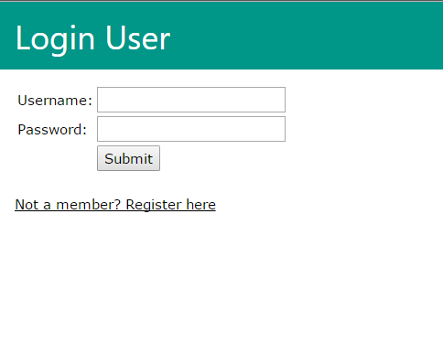  
Fig 2. Home page

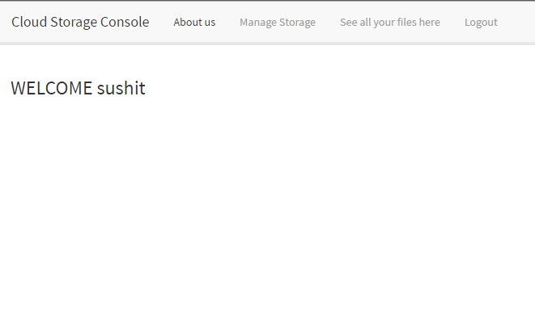

Fig 3. File upload page

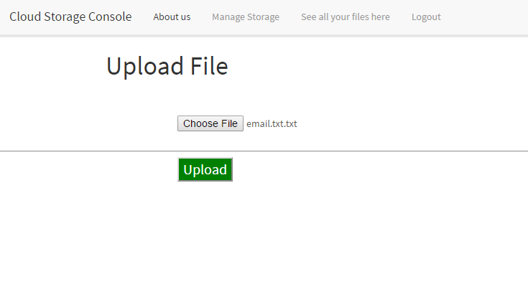

Fig 4. File list page

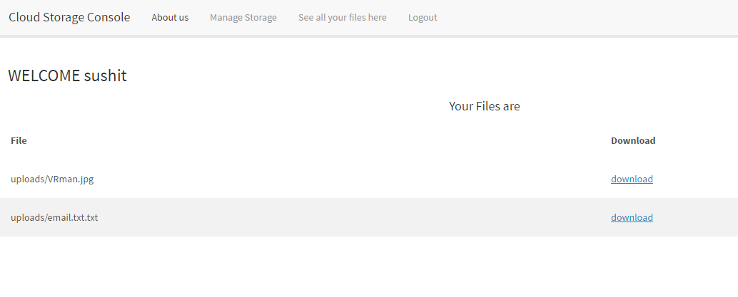

**CONCLUSION**

Cloud Storage is a service where data is remotely maintained, managed, and backed up. The service allows the users to store files online, so that they can access them from any location via the Internet.It not only increases the overall usability of files, but also helps in improving the bandwidth efficiency, as **we** avoid emailing files to individuals and instead send a web link to recipients through our email. Also, overall accessibility is focused upon, as files can be accessed from anywhere via Internet connection. Businesses and organizations can often reduce annual operating costs by using cloud storage; cloud storage (Amazon S3) costs about 3 cents per gigabyte to store data internally. Users can see additional cost savings because it does not require internal power to store information remotely.

Cloud computing is one of the most promising technologies of this era, and doing a project in this area gives us immense platform to boost our knowledge and uplift our technical skills. Our system might have some robustness issues. However, focusing on the bigger picture, the opportunity is what matters the most.

**REFERENCES AND BIBLIOGRAPHY**

[1] http://docs.aws.amazon.com/aws-sdk-php/v3/api/api-s3-2006-03-01.html

[2] http://searchaws.techtarget.com/definition/AWS-bucket

[3] http://www.webopedia.com/TERM/C/cloud_storage.html

[4] http://www.auxis.com/auxis-journal/how-to-use-amazon-s3-and-the-benefits-it-provides