Tribhuvan University
Faculty of Humanities and Social Sciences
[Insert Tribhuvan University logo here]
A PROJECT REPORT ON
"STAYEASE: ONLINE HOTEL BOOKING AND MANAGEMENT SYSTEM"
Submitted to
Department of Computer Application
[COLLEGE NAME]
In partial fulfillment of the requirements for the Bachelors in Computer Application
Submitted by
[YOUR FULL NAME] ([TU Roll No.])
[Month Year]
Under the Supervision of
[Supervisor Name]

Tribhuvan University
Faculty of Humanities and Social Sciences
A PROJECT REPORT ON
"STAYEASE: ONLINE HOTEL BOOKING AND MANAGEMENT SYSTEM"
Submitted to
Department of Computer Application
[COLLEGE NAME]
In partial fulfillment of the requirements for the Bachelors in Computer Application
Submitted by
[YOUR FULL NAME] ([TU Roll No.])
[Month Year]
Under the Supervision of
[Supervisor Name]

Tribhuvan University
Faculty of Humanities and Social Sciences
[COLLEGE NAME]

SUPERVISOR'S RECOMMENDATION
I hereby recommend that this project prepared under my supervision by [YOUR FULL NAME] entitled "STAYEASE: ONLINE HOTEL BOOKING AND MANAGEMENT SYSTEM" in partial fulfillment of the requirements for the degree of Bachelor of Computer Application is recommended for the final evaluation.

....................................
SIGNATURE
[Supervisor Name]
SUPERVISOR
[Academic Designation]
Department of Computer Application
[COLLEGE NAME], [Full Address]

Tribhuvan University
Faculty of Humanities and Social Sciences
[COLLEGE NAME]

LETTER OF APPROVAL
This is to certify that this project prepared by [YOUR FULL NAME] entitled "STAYEASE: ONLINE HOTEL BOOKING AND MANAGEMENT SYSTEM" in partial fulfillment of the requirements for the degree of Bachelor in Computer Application has been evaluated. In our opinion it is satisfactory in the scope and quality as a project for the required degree.

..............................  [Supervisor Name]  Supervisor  [Academic Designation]  Department of Computer Application  [COLLEGE NAME] | ..............................  [Coordinator / HOD Name]  Coordinator / HOD  [Academic Designation]  Department of Computer Application  [COLLEGE NAME]
..............................  [Internal Examiner Name]  Internal Examiner  Department of Computer Application  [COLLEGE NAME] | ..............................  [External Examiner Name]  External Examiner  Tribhuvan University  Department of Computer Application  [COLLEGE NAME]

ABSTRACT
StayEase is a web-based hotel room booking and management system developed to replace the manual, register-based reservation process still used by many small and medium hotels in Nepal. In such hotels, bookings are taken by phone or at the front desk and recorded on paper or in spreadsheets, which leads to double-booked rooms, lost reservations, slow response to guests, and no reliable picture of occupancy or revenue.
The system gives customers a single online portal where they can register, search rooms by check-in date, check-out date, number of guests, price and room type, view room details and photos, place a booking, pay through a demo payment step, and view or cancel their own bookings. Every booking receives a unique booking code and its total cost is calculated automatically from the nightly price and the number of nights. Administrators use a separate panel to manage room types and individual rooms with images and amenities, change room status for maintenance, confirm bookings, record check-in and check-out, update payment status, view customers, and follow key figures such as total bookings, occupancy and revenue on a dashboard.
The central problem the system solves is double booking. Before a booking is saved, the system checks for any active booking whose dates overlap the requested stay, and it repeats this check inside a database transaction that locks the room row, so two customers cannot reserve the same room for the same night even when they submit at the same moment. Security is handled through bcrypt password hashing, role-based access control, CSRF tokens, prepared statements against SQL injection, output escaping against cross-site scripting, login rate limiting and validated file uploads.
The system is built with HTML5, CSS3 and JavaScript on the front end, PHP 8 on the server, and a MySQL (MariaDB) database, and it runs on the XAMPP stack. It was developed using an iterative Agile approach and verified with unit and system test cases.
Keywords: Hotel Booking System, Room Reservation, Availability Checking, Double-Booking Prevention, Role-Based Access Control, Web Application, PHP, MySQL, XAMPP

ACKNOWLEDGEMENT
The successful completion of this project, "StayEase: Online Hotel Booking and Management System", was possible because of the guidance, support and encouragement of many people, and I would like to express my sincere gratitude to all of them.
I am deeply grateful to my project supervisor, [Supervisor Name], for continuous guidance, constructive feedback and encouragement at every stage of this project. The suggestions received during the proposal, mid-term and final phases shaped both the design and the quality of this work.
I would also like to thank [Coordinator / HOD Name], Coordinator of the Department of Computer Application, and all faculty members of [COLLEGE NAME] for their academic support, valuable advice, and for providing the laboratory facilities and environment needed to carry out this project.
I am thankful to Tribhuvan University, Faculty of Humanities and Social Sciences, for including Project I (CACS256) in the BCA curriculum, which gave me the opportunity to apply classroom knowledge to a real-world problem.
Finally, I am thankful to my family and friends for their constant support, motivation and patience throughout the development of this project.

[YOUR FULL NAME]
[TU Roll No.]

TABLE OF CONTENTS
SUPERVISOR'S RECOMMENDATION i
LETTER OF APPROVAL ii
ABSTRACT iii
ACKNOWLEDGEMENT iv
LIST OF ABBREVIATIONS vii
LIST OF FIGURES viii
LIST OF TABLES ix
CHAPTER 1: INTRODUCTION 1
1.1 Introduction 1
1.2 Problem Statement 1
1.3 Objectives 2
1.4 Scope and Limitation 2
1.4.1 Scope 2
1.4.2 Limitations 3
1.5 Report Organization 3
CHAPTER 2: BACKGROUND STUDY AND LITERATURE REVIEW 5
2.1 Background Study 5
2.2 Literature Review 6
CHAPTER 3: SYSTEM ANALYSIS AND DESIGN 8
3.1 System Analysis 8
3.1.1 Requirement Analysis 8
3.1.2 Feasibility Analysis 10
3.1.3 Methodology Used 11
3.1.4 Data Modelling (ER Diagram) 13
3.1.5 Process Modelling (DFD) 14
3.2 System Design 16
3.2.1 Architectural Design 16
3.2.2 Database Schema Design 17
3.2.3 Interface Design 19
3.2.4 Physical DFD 21
CHAPTER 4: IMPLEMENTATION AND TESTING 23
4.1 Implementation 23
4.1.1 Tools Used 23
4.1.2 Implementation Details of Modules 24
4.2 Testing 26
4.2.1 Test Cases for Unit Testing 26
4.2.2 Test Cases for System Testing 27
CHAPTER 5: CONCLUSION AND FUTURE RECOMMENDATIONS 29
5.1 Lesson Learnt / Outcome 29
5.2 Conclusion 29
5.3 Future Recommendations 30
REFERENCES 31
APPENDICES 32
Appendix A: Screenshots 32
Appendix B: Source Code Excerpt 36
Appendix C: Supervisor Visit Log Sheet 37

LIST OF ABBREVIATIONS
AJAX | Asynchronous JavaScript and XML
API | Application Programming Interface
CASE | Computer Aided Software Engineering
CRUD | Create, Read, Update, Delete
CSP | Content Security Policy
CSRF | Cross-Site Request Forgery
CSS | Cascading Style Sheets
DBMS | Database Management System
DFD | Data Flow Diagram
ER | Entity Relationship
HTML | HyperText Markup Language
HTTP | HyperText Transfer Protocol
IDOR | Insecure Direct Object Reference
JSON | JavaScript Object Notation
NPR | Nepalese Rupee
OTA | Online Travel Agency
PDO | PHP Data Objects
PHP | PHP: Hypertext Preprocessor
PMS | Property Management System
RBAC | Role-Based Access Control
SQL | Structured Query Language
UI | User Interface
VS Code | Visual Studio Code
XAMPP | Cross-platform, Apache, MariaDB, PHP and Perl
XSS | Cross-Site Scripting

LIST OF FIGURES
Figure 3.1: Use Case Diagram of StayEase 9
Figure 3.2: Gantt Chart 11
Figure 3.3: Agile Development Cycle 12
Figure 3.4: ER Diagram of StayEase 13
Figure 3.5: Context Diagram (Level 0 DFD) 14
Figure 3.6: Level 1 DFD 15
Figure 3.7: Level 2 DFD of Process 3.0 (Book Room) 16
Figure 3.8: Three-Tier Architecture of StayEase 17
Figure 3.9: Database Schema 18
Figure 3.10: Home Page with Room Search 19
Figure 3.11: Room Details and Booking Form 20
Figure 3.12: Admin Dashboard 20
Figure 3.13: Admin Booking Management 21
Figure 3.14: Physical DFD 22

LIST OF TABLES
Table 3.1: Project Schedule 10
Table 3.2: Structure of the bookings Table 18
Table 4.1: Unit Test Cases for Registration 26
Table 4.2: Unit Test Cases for Login 26
Table 4.3: Unit Test Cases for Room Search and Booking 26
Table 4.4: Unit Test Cases for Payment and Cancellation 27
Table 4.5: Unit Test Cases for Admin Room Management 27
Table 4.6: System Test Case for the Complete Booking Journey 27
Table C.1: Supervisor Visit Log Sheet 37

CHAPTER 1: INTRODUCTION

1.1 Introduction
StayEase is a web-based Online Hotel Booking and Management System that allows hotel guests to find and reserve rooms over the internet and allows hotel staff to manage rooms, bookings and payments from a single administrative panel. The system is designed around two roles. Customers can register, search for rooms that are free for their chosen dates, see each room's price, capacity, amenities and photos, book a room, pay, and follow the status of their bookings. Administrators can create room categories such as Deluxe or Suite, add individual rooms with room numbers and nightly prices, upload photos, place rooms under maintenance, confirm or cancel bookings, record check-in and check-out, update payment status, and view a dashboard of rooms, bookings, customers, occupancy and revenue.
The core of the system is its availability engine. A room is shown as available only when it is in the "available" state and has no active booking (pending, confirmed or checked-in) whose dates overlap the requested stay. The same rule is enforced again inside a database transaction at the moment of booking, with the room row locked, so that two guests who submit at the same time cannot both reserve the same room. Each booking receives a unique booking code, and the total amount is calculated automatically as the nightly price multiplied by the number of nights.
The application is built with HTML5, CSS3 and JavaScript for the interface, PHP 8 for server-side logic and MySQL (MariaDB) as the database, and it runs on the XAMPP stack. Prices are shown in Nepalese Rupees (NPR), and the payment step is implemented in demo mode so that it can later be connected to local gateways such as eSewa or Khalti.

1.2 Problem Statement
Many small and medium hotels, guest houses and resorts still take reservations by telephone, walk-in or social media messages and record them in a paper register or a spreadsheet. This way of working causes several problems:
• Double booking: Two staff members, or a phone booking and a walk-in, can assign the same room for overlapping nights because there is no single, real-time record of availability.
• No self-service for guests: Guests cannot see which rooms are free, their prices or their facilities without contacting the hotel, and they cannot book outside office hours.
• Slow and error-prone calculations: The number of nights and the total bill are calculated by hand, which leads to mistakes and disputes.
• Poor record keeping: Paper records are easily lost or damaged, are hard to search, and do not show the history of a guest's bookings or payments.
• No management overview: The owner has no quick way to see occupancy, pending bookings, today's check-ins or total revenue.
There is therefore a need for a simple, secure and affordable web application that keeps one authoritative record of rooms and bookings, lets guests book online, and gives the hotel a clear view of its operations.

1.3 Objectives
The main objective of this project is to develop a secure web-based hotel booking and management system. The specific objectives are:
• To allow customers to search available rooms by dates, guests, price and room type, and to book and pay for a room online.
• To prevent double booking through date-overlap checking and transaction-level locking of rooms.
• To provide an administrative panel for managing room types, rooms, bookings, payments and customers, with a statistics dashboard.

1.4 Scope and Limitation

1.4.1 Scope
• Customers can register, log in, search rooms, view room details, book a room, pay through the demo payment step, view their booking history and cancel eligible bookings.
• Administrators can manage room types and rooms, including images, gallery photos, amenities, prices and status (available, unavailable, maintenance).
• Administrators can view and filter all bookings, update booking status through its full life cycle (pending, confirmed, checked-in, checked-out, cancelled) and update payment status.
• The dashboard shows total rooms, bookings, customers, revenue, occupancy rate, pending bookings and today's check-ins.
• A JSON availability endpoint returns the free rooms for given dates and guests, which can be reused by other clients in the future.
• The system is suitable for a single small or medium hotel and runs in any modern web browser.

1.4.2 Limitations
• Online payment works in demo mode only; no real money is transferred and no live payment gateway such as eSewa or Khalti is integrated yet.
• The system does not send email or SMS notifications for booking confirmation or cancellation.
• It supports a single hotel property; multiple branches or hotel chains are not supported.
• There is no separate role for front-desk staff, housekeeping or accounts; all staff functions are performed through the admin role.
• Guest reviews, ratings, discount coupons, seasonal pricing and refunds are not implemented.
• The system has been tested on a local XAMPP server with a small data set and has not been load-tested for heavy traffic.

1.5 Report Organization
This report is organized into five chapters:
Chapter 1: Introduction introduces the project, the problem it addresses, its objectives, and its scope and limitations.
Chapter 2: Background Study and Literature Review explains the concepts behind online hotel reservation and reviews existing systems and related studies.
Chapter 3: System Analysis and Design presents the functional and non-functional requirements, the feasibility analysis, the development methodology, the ER diagram, the data flow diagrams, and the architectural, database and interface design.
Chapter 4: Implementation and Testing describes the tools used, the implementation of each module, and the unit and system test cases.
Chapter 5: Conclusion and Future Recommendations summarizes the lessons learnt, the outcome of the project and possible future enhancements.

CHAPTER 2: BACKGROUND STUDY AND LITERATURE REVIEW

2.1 Background Study
Hotel reservation is the process of holding a specific room, or a room of a given category, for a guest for a given range of nights. The key rule that any reservation system must enforce is that a single room cannot be occupied by two guests on the same night. In StayEase a booking is described by a room, a check-in date and a check-out date, where the check-out date is exclusive: a guest who checks out on the 5th frees the room for a new guest arriving on the 5th. Two bookings for the same room therefore conflict only when the existing check-in is earlier than the new check-out and the existing check-out is later than the new check-in. This half-open interval test is the basis of the availability engine described in Chapter 3.
The hospitality industry was among the earliest adopters of information technology. Large chains have long used central reservation systems and property management systems (PMS), and the growth of the internet moved booking directly to the guest through hotel websites and online travel agencies (OTAs) such as Booking.com and Agoda [1], [2]. Buhalis and Law observed that the internet changed how travellers search for and buy accommodation and that hotels which do not offer online booking lose visibility and business [1]. For small and medium hotels, however, commercial PMS and OTA commissions are often costly, which leaves a gap for simple, low-cost direct booking systems.
A web-based booking system follows a client-server model. The guest uses a browser (the client) to send HTTP requests to a web server, server-side code processes the request and talks to a relational database, and an HTML page is returned [3]. Because many guests may try to book the same room at once, the database must guarantee consistency. Relational databases such as MySQL provide transactions with the ACID properties (atomicity, consistency, isolation and durability) and row-level locks such as SELECT ... FOR UPDATE, which make it possible to check availability and insert a booking as one indivisible step [4], [5].
Because a booking system stores personal data and accepts payments, security is a central concern. The OWASP Top 10 lists injection, broken access control, cryptographic failures and security misconfiguration among the most critical web application risks [6]. Standard countermeasures include parameterized queries, strong password hashing, anti-CSRF tokens, output encoding and role-based access control (RBAC), where each user can reach only the functions allowed for their role [6]-[8]. StayEase applies each of these measures.

2.2 Literature Review
Large OTAs such as Booking.com and Agoda offer room search by date and guests, photos, reviews, instant confirmation and online payment. They serve as the reference model for the customer side of StayEase, particularly the search-then-book flow and the unique booking reference. Their main drawback for small hotels is commission on every booking and limited control over the guest relationship, which is why many hotels also want a direct booking channel [2].
O'Connor and Frew studied hotel electronic distribution and found that direct channels such as the hotel's own website were expected to grow in importance because they reduce distribution costs and give hotels more control over pricing and inventory [2]. This supports the idea of a lightweight system that a single hotel can host itself.
Commercial PMS products, such as eZee Absolute which is widely used by hotels in Nepal, combine front-desk operations, room status, billing and channel management. They show the importance of a clear booking life cycle (reserved, confirmed, checked-in, checked-out, cancelled) and of room status for maintenance. StayEase adopts the same life cycle and room status model in a simplified form suitable for an academic project.
Many student and academic hotel reservation projects built with PHP and MySQL implement registration, room listing and booking, but they commonly check availability with a single SELECT before an INSERT and do not handle two users booking at the same moment, which can still result in double bookings. Sommerville and Pressman both emphasize that such non-functional requirements, including reliability, security and concurrency, must be designed in rather than added later [3], [9]. StayEase addresses this gap by re-checking availability inside a transaction with a locked room row and by rejecting duplicate submissions made within five minutes.
From this review, the features selected for StayEase are online search by dates and guests, clear pricing with automatic total calculation, a unique booking code, a full booking status life cycle, room maintenance status, an administrative dashboard, and strong protection against double booking and common web attacks.

CHAPTER 3: SYSTEM ANALYSIS AND DESIGN

3.1 System Analysis
System analysis was carried out by identifying requirements, studying feasibility, choosing a development methodology, and modelling data and processes, as described below.

3.1.1 Requirement Analysis
i. Functional Requirements
The functional requirements of StayEase are:
• User registration and login: Customers register with name, email, 10-digit phone number and a strong password, then log in and log out. Administrators log in to a separate panel.
• Room search: Anyone can list room types and rooms and filter them by check-in date, check-out date, guests, maximum price and room type. Only rooms free for the whole stay are shown.
• Room details: Logged-in customers see a room's photos, gallery, amenities, capacity, nightly price and the calculated total for the selected nights.
• Booking: Customers book a room with contact details and an optional special request. The system validates input, checks availability, generates a booking code and saves the booking as pending.
• Payment: Customers pay for a pending booking through the demo payment page, after which the booking becomes confirmed.
• My bookings and cancellation: Customers view their bookings and cancel a booking while it is pending or confirmed.
• Room type and room management: Administrators add, edit, enable, disable and delete room types and rooms, upload images and set room status.
• Booking management: Administrators view and filter all bookings and update booking status and payment status.
• Customer list and dashboard: Administrators view registered customers and a dashboard of key statistics and recent bookings.
The use case diagram in Figure 3.1 shows these functions and the actors who use them.
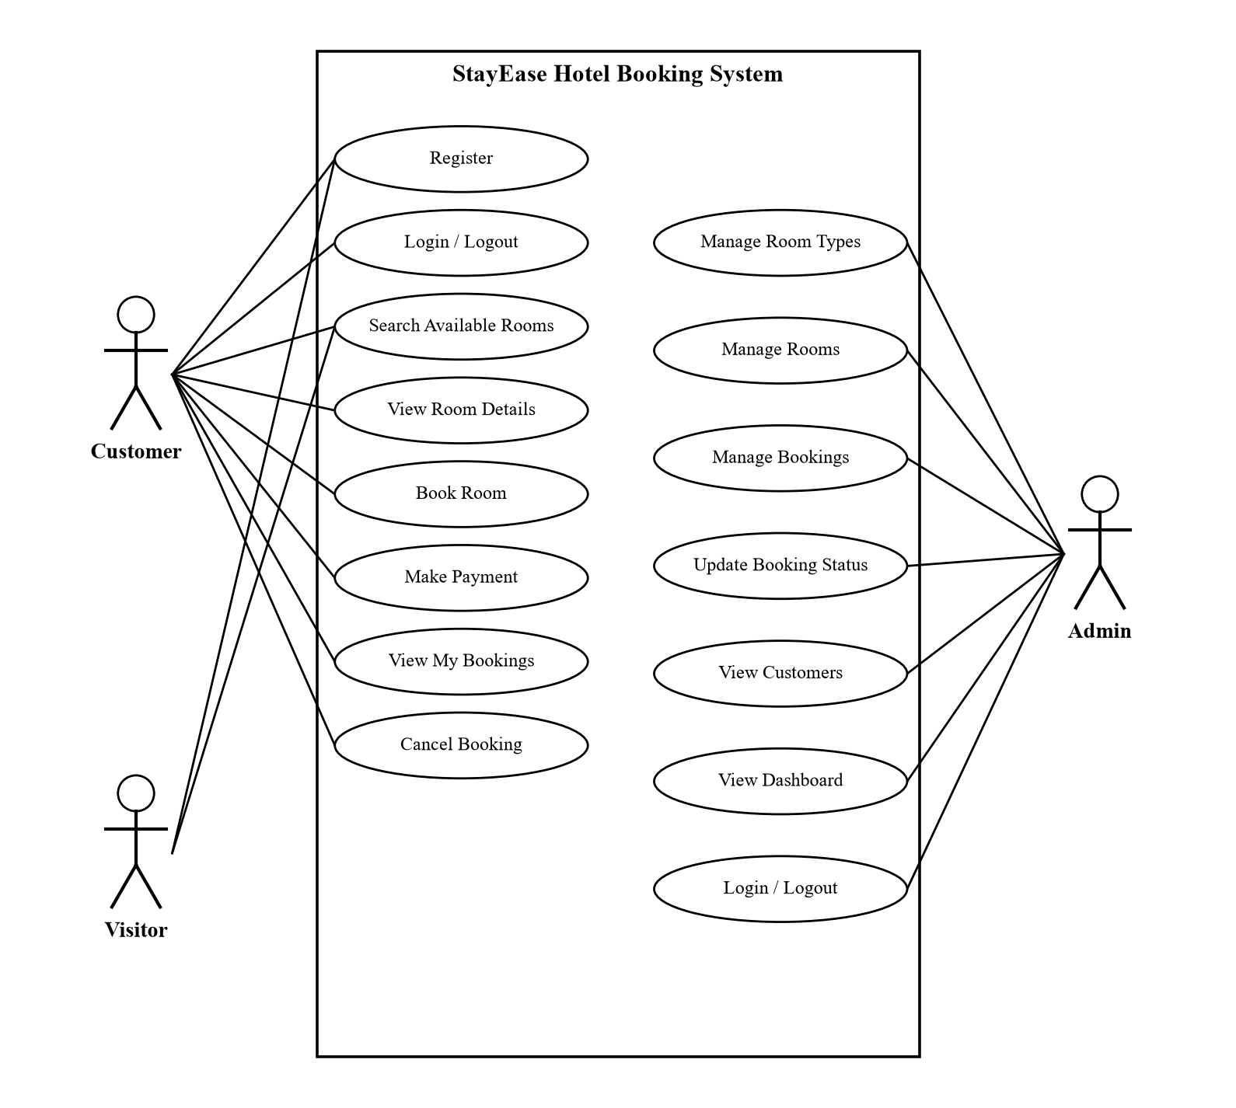
Figure 3.1: Use Case Diagram of StayEase
ii. Non-Functional Requirements
• Security: Passwords are hashed with bcrypt, all queries use prepared statements, every form carries a CSRF token, output is escaped, login is limited to five attempts per 15 minutes, and admin pages require the admin role.
• Reliability and consistency: A room can never be booked twice for overlapping nights, even under concurrent requests, because the final check and insert run in one transaction with a row lock.
• Usability: The interface is clean, responsive and works on desktop, tablet and mobile browsers, with clear validation messages and toast notifications.
• Performance: Pages load quickly on a local server, and the bookings table is indexed on room and dates to keep availability queries fast.
• Availability and portability: The system runs on any machine with Apache, PHP 8 and MySQL and is accessed from any modern browser.
• Maintainability: Common functions such as database access, escaping, CSRF and availability checking are kept in one configuration file and reused across pages.

3.1.2 Feasibility Analysis
A feasibility study was carried out before development to confirm that the system could be built and used within the available time and resources.
i. Technical Feasibility
StayEase uses mature, widely available and free technologies: HTML5, CSS3, JavaScript, PHP 8 and MySQL, all packaged in XAMPP. These technologies were studied during the BCA course, run on an ordinary laptop, and are supported by almost every web hosting provider. No special hardware is required. The project is therefore technically feasible.
ii. Operational Feasibility
The system follows the same steps that guests already know from popular booking websites: choose dates, pick a room, book and pay. The admin panel uses simple forms, tables, filters and status buttons that hotel staff can learn quickly. Because it removes manual calculation and register keeping, staff have a clear reason to adopt it. The system is operationally feasible.
iii. Economic Feasibility
All development tools and runtime software are free and open source, so there is no licensing cost. The only costs of real deployment would be a domain name and shared hosting, which are low compared with OTA commissions or commercial PMS subscriptions. The system is economically feasible.
iv. Schedule Feasibility
The project was planned over the fourth semester and divided into phases as shown in Table 3.1 and the Gantt chart in Figure 3.2. The planned work fitted within the semester, so the project is feasible in terms of schedule.
Table 3.1: Project Schedule
Week | Task | Description
1-2 | Requirement Analysis | Study of manual booking, existing systems, and collection of requirements.
3-4 | System Design | Use case, ER diagram, DFDs, database schema and interface design.
4-6 | Frontend Development | Home, rooms, room details, login, register and my bookings pages.
5-8 | Backend Development | Authentication, availability logic, booking, payment and cancellation.
7-9 | Admin Panel | Dashboard, room types, rooms, bookings and customers modules.
9-10 | Testing | Unit and system testing, bug fixing and security hardening.
10-12 | Documentation | Preparation of the project report and final review.

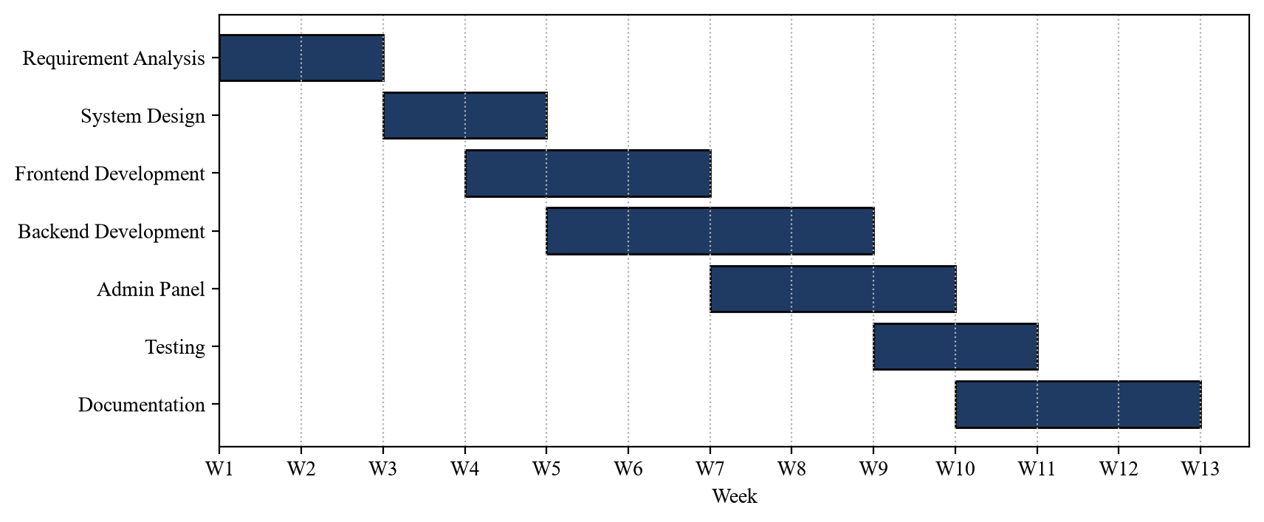
Figure 3.2: Gantt Chart

3.1.3 Methodology Used
The Agile methodology was used to develop StayEase. The system was built in short iterations, and each iteration delivered a working part of the system that was tested and reviewed before the next iteration began. This suited the project because the requirements became clearer as the system was used; for example, the need for room maintenance status, duplicate booking protection and payment status updates by the admin was identified during reviews and added in later iterations.
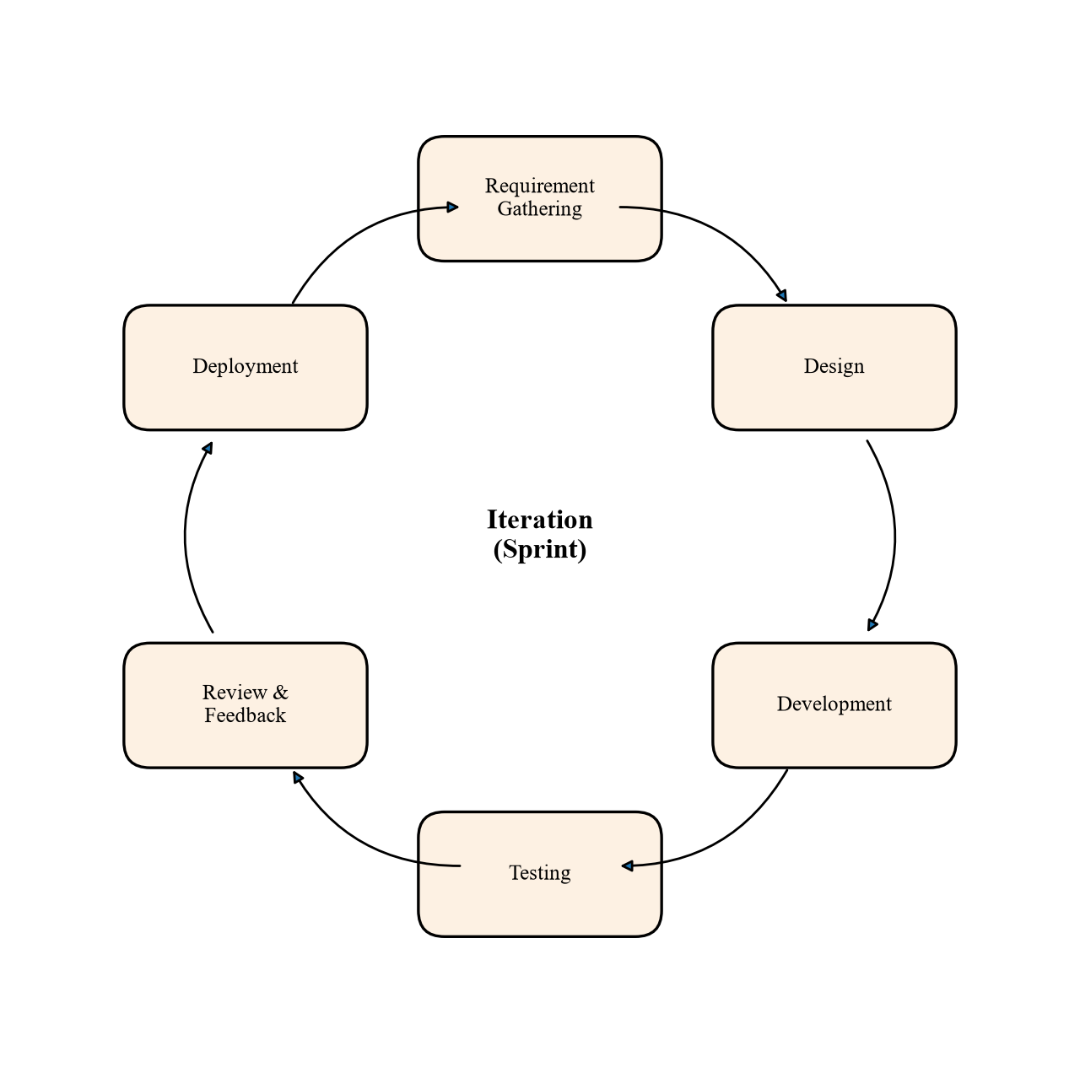
Figure 3.3: Agile Development Cycle
The Agile phases were applied to StayEase as follows:
• Requirement Gathering: Features were listed from the study of manual hotel booking and existing booking websites, and then prioritized.
• Design: For each iteration, the related tables, pages and data flows were designed.
• Development: Iteration 1 built authentication and the database; iteration 2 built room listing, search and availability; iteration 3 built booking, payment and cancellation; iteration 4 built the admin panel; iteration 5 added security hardening and UI improvements.
• Testing: Each feature was tested with valid and invalid input before being accepted.
• Review and Feedback: Working features were reviewed with the supervisor, and the feedback was added to the next iteration.
• Deployment: Each completed iteration was deployed on the local XAMPP server.

3.1.4 Data Modelling (ER Diagram)
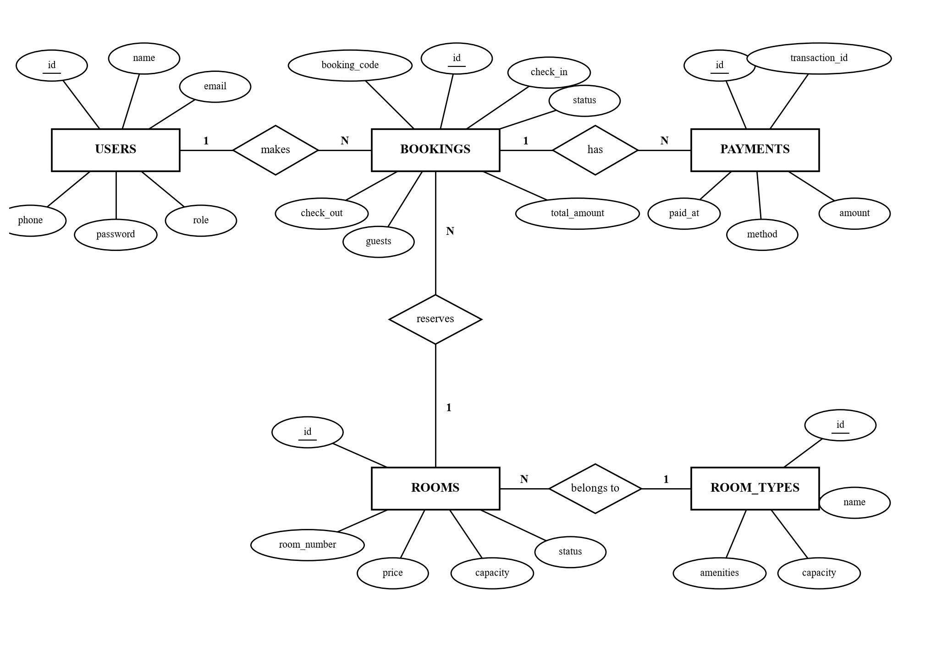
Figure 3.4: ER Diagram of StayEase
The ER diagram in Figure 3.4 contains five entities. USERS stores both customers and administrators, distinguished by the role attribute. A user makes many BOOKINGS, and each booking belongs to exactly one user (1:N). Each booking reserves exactly one room, while one ROOM can appear in many bookings over time (N:1). Each room belongs to one ROOM_TYPE, and a room type groups many rooms (N:1). A booking has zero or more PAYMENTS, for example a demo online payment or a cash payment recorded by the admin (1:N). Booking status and payment status are stored as enumerated attributes so that the booking life cycle can be tracked.

3.1.5 Process Modelling (DFD)
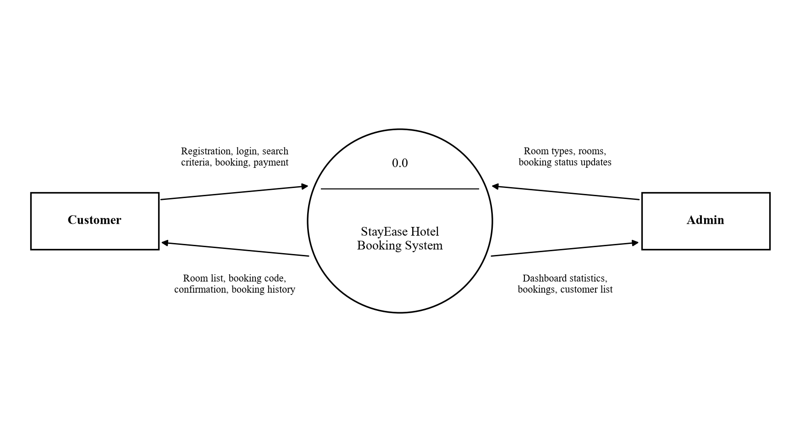
Figure 3.5: Context Diagram (Level 0 DFD)
The context diagram in Figure 3.5 shows StayEase as a single process with two external entities. The customer sends registration and login details, search criteria, booking requests and payment, and receives room lists, booking codes, confirmations and booking history. The admin sends room type and room data and booking status updates, and receives dashboard statistics, booking lists and customer lists.
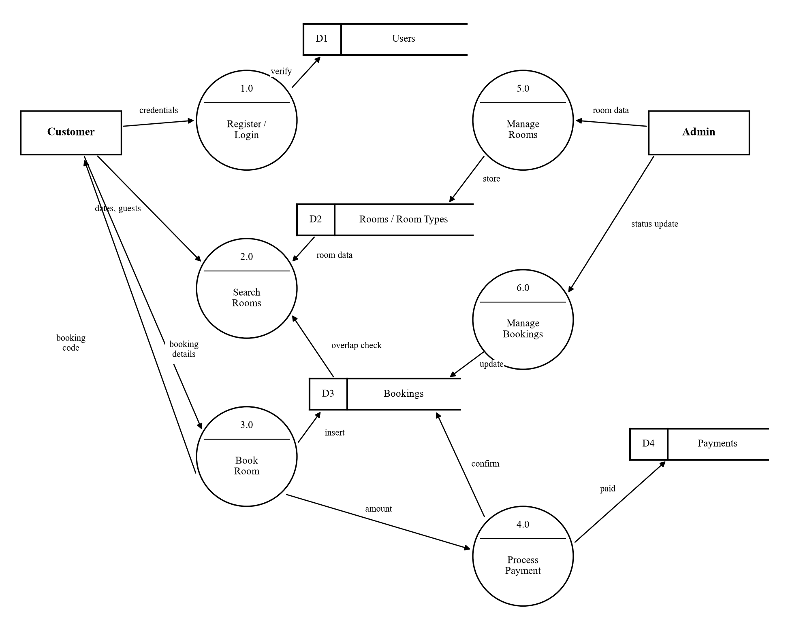
Figure 3.6: Level 1 DFD
The Level 1 DFD in Figure 3.6 breaks the system into six processes. Register/Login (1.0) verifies credentials against the Users store (D1). Search Rooms (2.0) reads the Rooms and Room Types store (D2) and checks the Bookings store (D3) for overlapping stays. Book Room (3.0) saves a new booking in D3 and returns the booking code. Process Payment (4.0) records the payment in D4 and confirms the booking in D3. On the admin side, Manage Rooms (5.0) writes to D2 and Manage Bookings (6.0) updates booking and payment status.
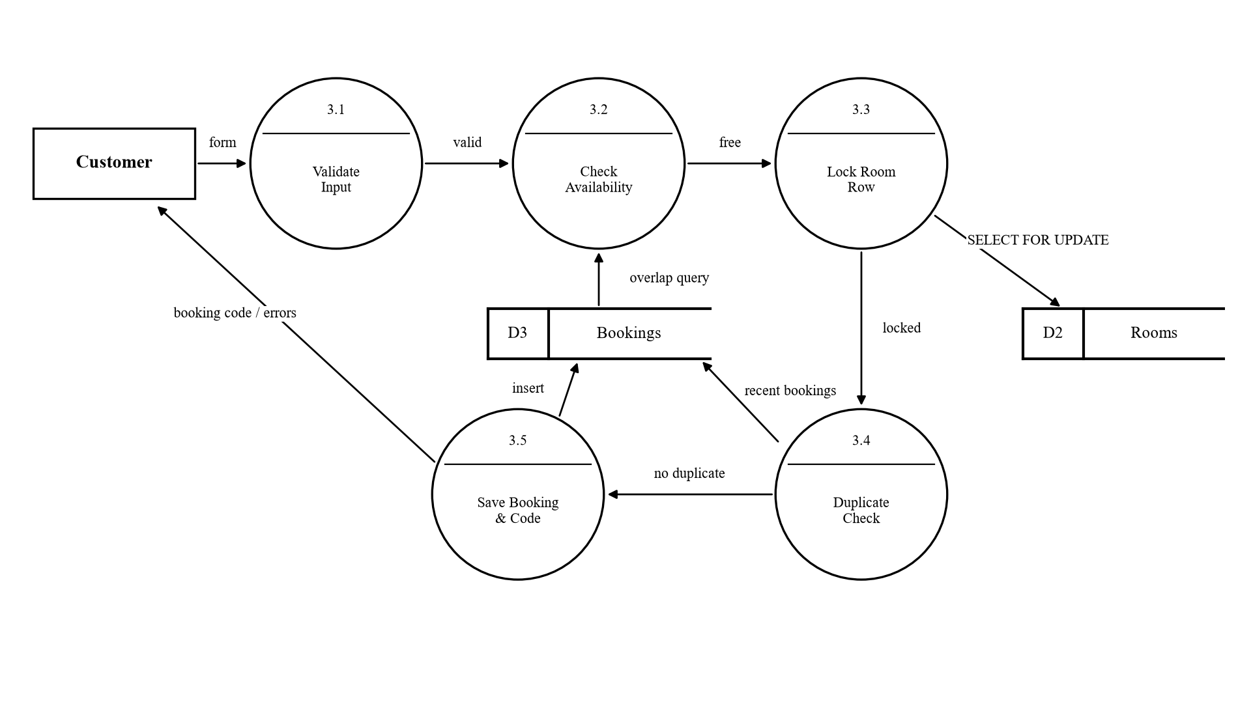
Figure 3.7: Level 2 DFD of Process 3.0 (Book Room)
Figure 3.7 expands the Book Room process, which is the most critical part of the system. The booking form is first validated (3.1): dates must not be in the past, the stay must be between 1 and 30 nights, guests must not exceed room capacity, and contact details must be valid. Availability is then checked against active bookings (3.2). Inside a transaction, the room row is locked with SELECT ... FOR UPDATE and availability is checked again (3.3). A duplicate check (3.4) rejects the same booking made by the same user within the last five minutes, which prevents double clicks. Finally, the booking is saved with a unique code and a calculated total (3.5), and the code or an error message is returned to the customer.

3.2 System Design
The system design of StayEase consists of the architectural design, database schema design, interface design and physical DFD.

3.2.1 Architectural Design
StayEase follows a three-tier client-server architecture, shown in Figure 3.8.
• Presentation tier: HTML5 pages styled with CSS3, with JavaScript for date validation, price preview, image galleries, modals and toast notifications. It includes public pages, customer pages and the admin panel.
• Application tier: PHP 8 scripts running on Apache. They handle sessions, authentication, CSRF protection, rate limiting, validation, availability checking, booking transactions, payments and file uploads. A small JSON API returns available rooms.
• Data tier: A MySQL (MariaDB) database named hotel_booking holding the users, room_types, rooms, bookings and payments tables, accessed only through PDO prepared statements.
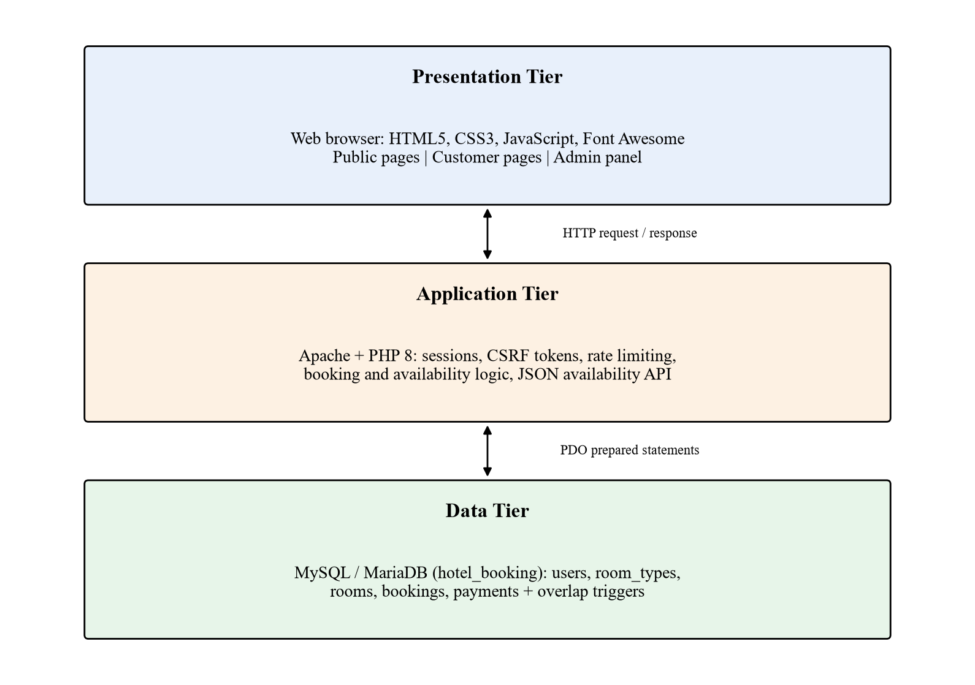
Figure 3.8: Three-Tier Architecture of StayEase

3.2.2 Database Schema Design
The ER diagram was converted into five relational tables, shown in Figure 3.9. Primary keys are auto-increment integers. Foreign keys link bookings to users and rooms, rooms to room types, and payments to bookings. Email addresses, room numbers and booking codes are unique. A check constraint ensures that the check-out date is after the check-in date, and composite indexes on room and dates speed up availability queries. The database script also defines triggers that reject overlapping bookings at the database level as an extra safeguard.
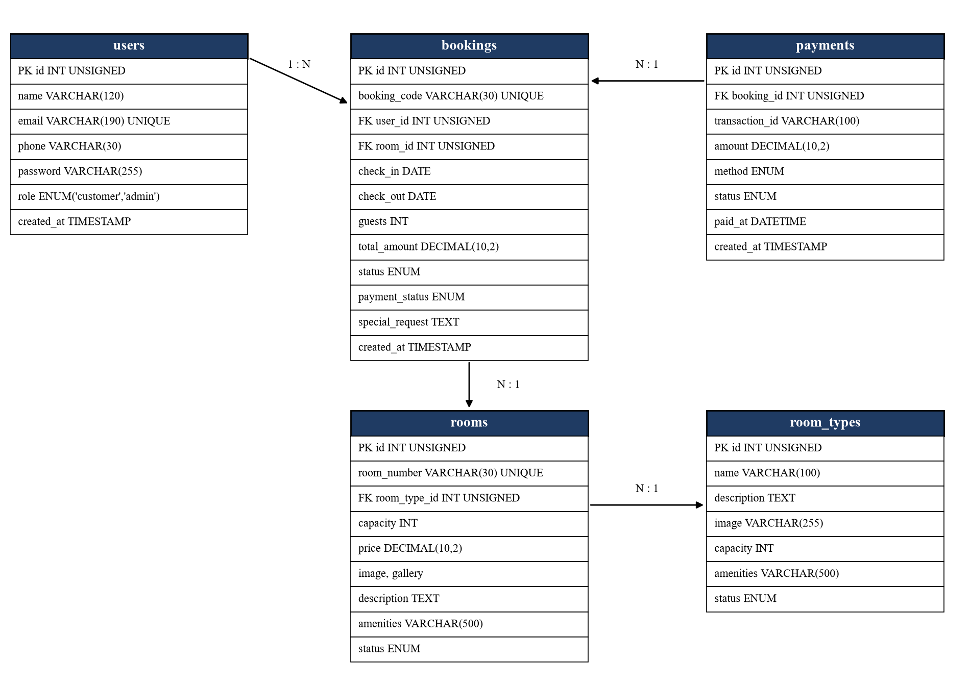
Figure 3.9: Database Schema
Table 3.2: Structure of the bookings Table
Field | Data Type | Constraint | Description
id | INT UNSIGNED | PK, auto increment | Unique booking identifier
booking_code | VARCHAR(30) | UNIQUE, NOT NULL | Code shown to the guest, e.g. BK260930A1B2C3
user_id | INT UNSIGNED | FK to users.id | Customer who made the booking
room_id | INT UNSIGNED | FK to rooms.id | Room that is reserved
check_in | DATE | NOT NULL | Arrival date
check_out | DATE | NOT NULL, > check_in | Departure date (exclusive)
guests | INT UNSIGNED | NOT NULL | Number of guests
total_amount | DECIMAL(10,2) | NOT NULL | Nights multiplied by nightly price
status | ENUM | default pending | pending, confirmed, cancelled, checked_in, checked_out
payment_status | ENUM | default pending | pending, paid, failed, refunded
special_request | TEXT | NULL | Contact details and guest request
created_at | TIMESTAMP | default now | Time the booking was made

3.2.3 Interface Design
The interface was designed to be simple and consistent. Public and customer pages share a top navigation bar with the StayEase logo and links to Home, Rooms, My Bookings and Login or Logout. The admin panel uses a dark sidebar with Dashboard, Bookings, Rooms, Room Types, Customers and Home links, and a content area with cards, tables and filters. Orange is used for primary actions and colour-coded badges show booking and payment status. Figures 3.10 to 3.13 show the main screens; more screens are included in the Appendix.
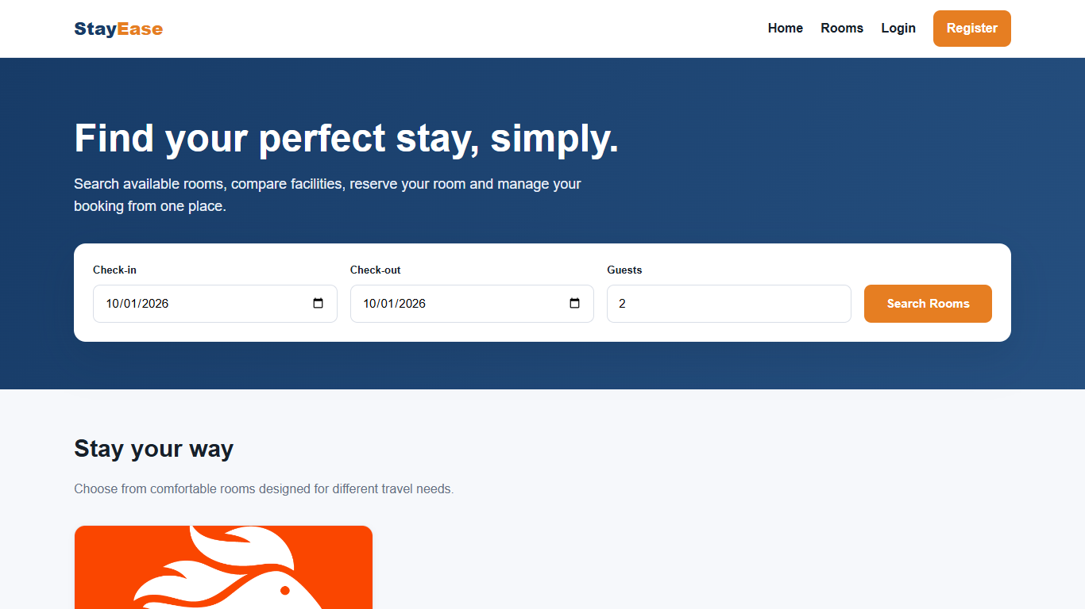
Figure 3.10: Home Page with Room Search
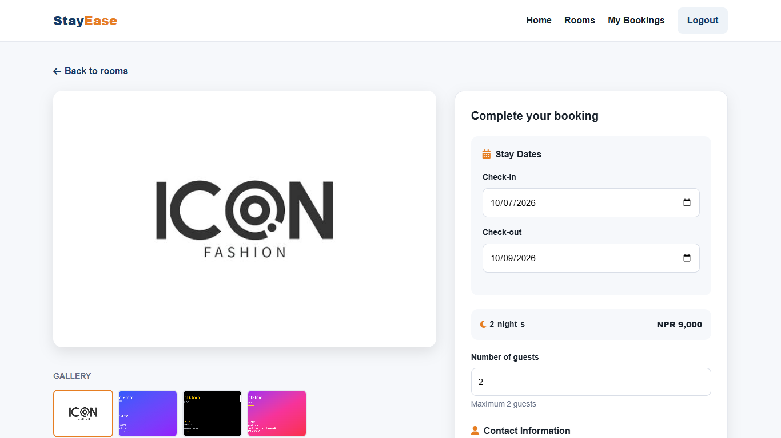
Figure 3.11: Room Details and Booking Form
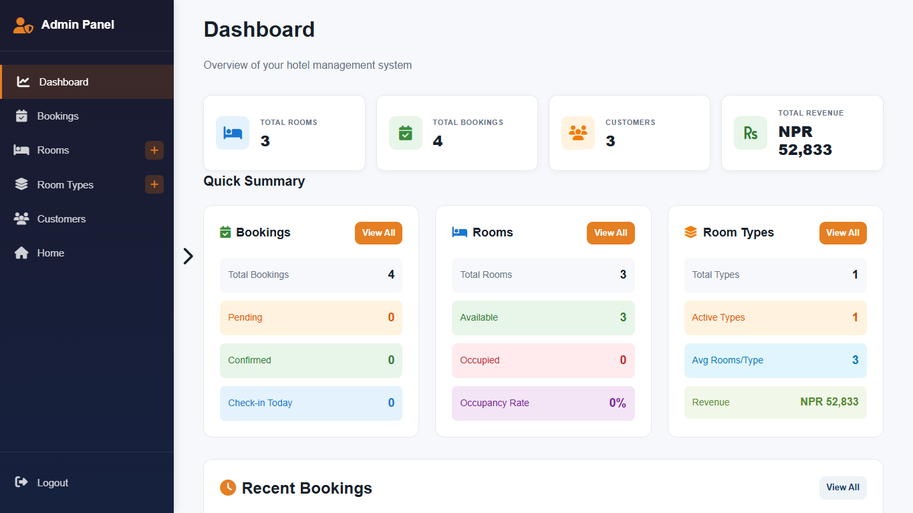
Figure 3.12: Admin Dashboard
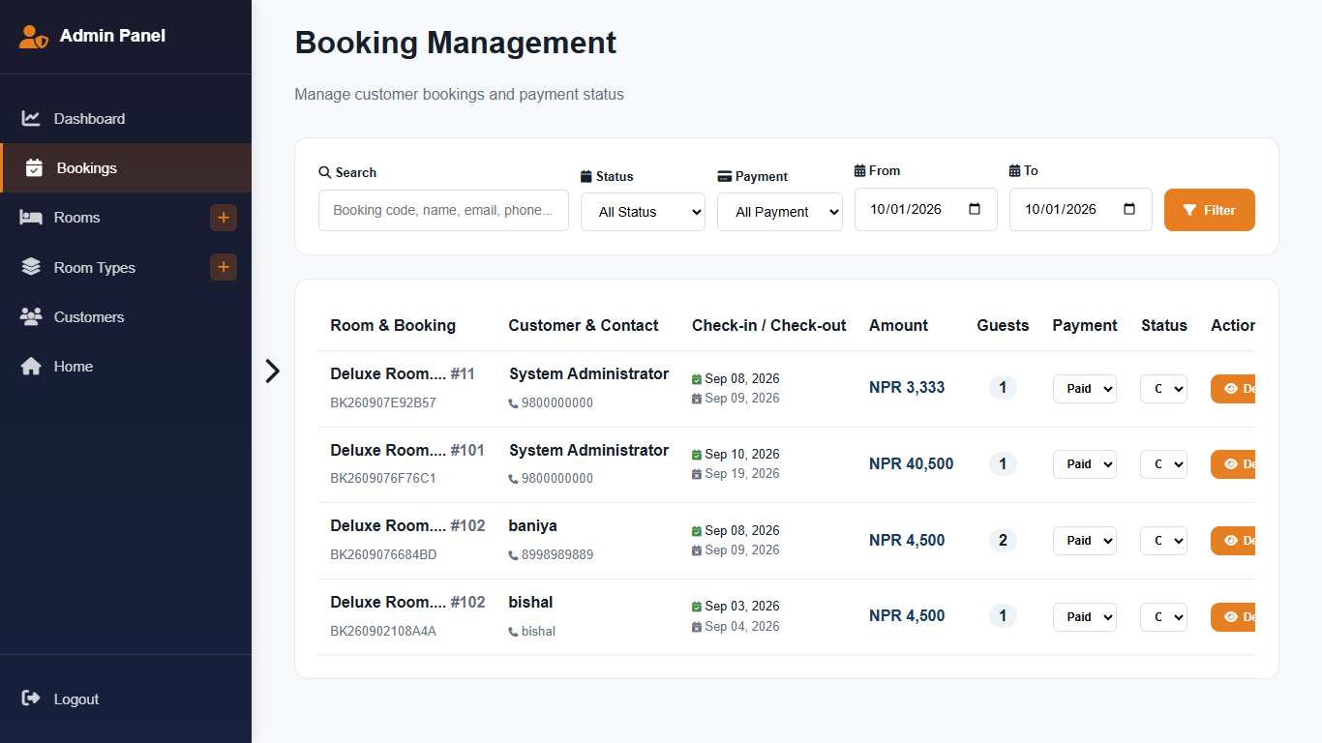
Figure 3.13: Admin Booking Management

3.2.4 Physical DFD
The physical DFD in Figure 3.14 shows how data actually moves through the implemented system. The user interacts with a web browser, which sends HTTP requests to the Apache server in XAMPP. Apache runs the relevant PHP script, such as book.php, payment.php or the admin pages, which reads and writes the MySQL database through PDO. Uploaded room images are stored in the uploads folder, and errors are written to a log file instead of being shown to the user. The generated HTML is returned to the browser.
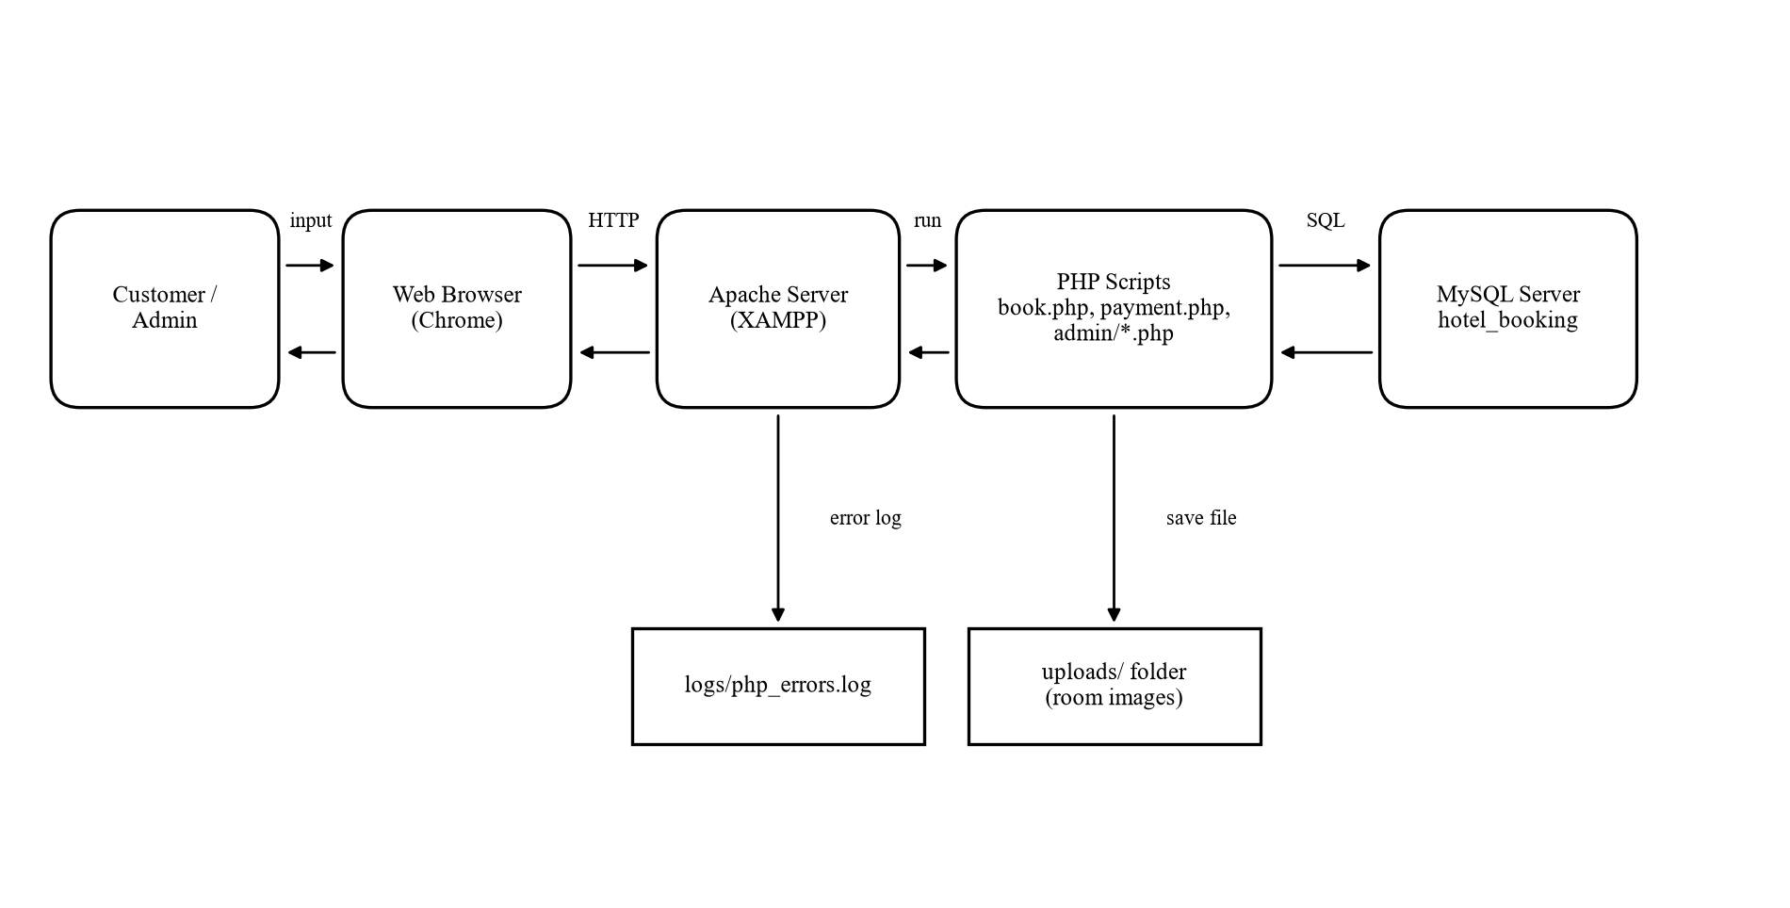
Figure 3.14: Physical DFD

CHAPTER 4: IMPLEMENTATION AND TESTING

4.1 Implementation
StayEase was implemented as a PHP web application following the design in Chapter 3. Shared functions for database connection, escaping, redirects, flash messages, CSRF tokens, authentication, rate limiting and availability checking are kept in config/config.php and included by every page. Customer pages are in the project root, administrator pages are in the admin folder, and the availability API is in the api folder.

4.1.1 Tools Used
Programming Languages and Frameworks
• HTML5: Structure of all pages, forms and tables, including date inputs for check-in and check-out.
• CSS3: Styling with custom properties (CSS variables), flexbox and grid layouts, and responsive design for mobile screens.
• JavaScript: Client-side validation, live price and night calculation, image gallery, confirmation modals and toast notifications.
• PHP 8: Server-side logic, sessions, authentication, validation, booking transactions, payments and file uploads, using PDO for database access.
• MySQL / MariaDB: Relational database for users, room types, rooms, bookings and payments, with foreign keys, constraints, indexes and triggers.
• Font Awesome 6.5: Icon library used across the interface.
Tools and Software (CASE Tools)
• XAMPP: Local Apache web server, PHP runtime and MariaDB database server.
• Visual Studio Code: Code editor used for writing and organizing all source files.
• phpMyAdmin: Creating, importing and inspecting the hotel_booking database.
• Google Chrome: Running and testing the application, with developer tools for debugging.
• Git and GitHub: Version control of the source code.
• draw.io / Python (Matplotlib): Drawing the use case diagram, ER diagram, DFDs and architecture diagrams.
• Microsoft Word: Preparing the project report.

4.1.2 Implementation Details of Modules
• Authentication Module (register.php, login.php, logout.php)
Registration validates name length, email format, a 10-digit phone number and a password of at least six characters with an uppercase letter, a lowercase letter and a digit, then stores the password with password_hash() (bcrypt). Login verifies the password with password_verify(), regenerates the session ID, and stores the user in the session. The function check_rate_limit() blocks an IP and email pair after five failed attempts in 15 minutes. The functions require_login() and require_admin() protect customer and admin pages.
• Room Search Module (index.php, rooms.php, api/availability.php)
The home page lists active room types. The rooms page lists rooms with their type, capacity and price and filters them by dates, guests, maximum price and room type. When dates are given, each room is passed through is_room_available(), which returns true only if the room status is "available" and no pending, confirmed or checked-in booking satisfies check_in < requested check-out and check_out > requested check-in. The availability API returns the same result in JSON format.
• Booking Module (room.php, book.php)
The room page shows photos, amenities and a booking form with live calculation of nights and total price. On submission, book.php verifies the CSRF token and validates dates (not in the past, 1 to 30 nights), guests (within room capacity) and contact details. It then starts a transaction, locks the room row with SELECT ... FOR UPDATE, re-checks the room status and overlapping bookings, and rejects an identical booking made in the last five minutes. It generates a booking code in the form BK + date + six random hexadecimal characters, calculates the total as nights() multiplied by the nightly price, inserts the booking as pending, and commits. Any failure rolls back the transaction.
• Payment Module (payment.php)
The payment page shows the booking summary and total in NPR. On confirmation it checks that the booking belongs to the logged-in user and is still pending, generates a demo transaction ID, and in one transaction marks the payment as paid and the booking as confirmed. The module is designed so that a real gateway such as eSewa or Khalti can replace the demo step.
• My Bookings and Cancellation Module (my_bookings.php, cancel.php)
Customers see all their bookings with code, room, dates, total, booking status and payment status. A booking can be cancelled only by its owner and only while it is pending or confirmed; the update query includes the user ID, which prevents one user from cancelling another user's booking.
• Admin Dashboard Module (admin/index.php)
The dashboard counts total rooms, bookings, customers, room types, pending and confirmed bookings, today's check-ins and available rooms, calculates occupied rooms and the occupancy rate, sums revenue from paid payments, and lists recent bookings.
• Room Type and Room Management Module (admin/room_types.php, admin/rooms.php, admin/add_room.php)
Administrators create, edit, enable, disable and delete room types and rooms. Room images and gallery photos are uploaded with checks on file size (maximum 5 MB) and real MIME type using finfo, and are saved with generated file names in the uploads folder. Rooms can be set to available, unavailable or maintenance; rooms that are not available are hidden from search and cannot be booked.
• Booking Management Module (admin/bookings.php, admin/customers.php)
Administrators view all bookings with customer and room details, filter them by status, update booking status to confirmed, checked-in, checked-out or cancelled, and update payment status. When a cash payment is marked as paid and no payment row exists, a new payment record is created. The customers page lists registered customers and their details.
• Security Module (config/config.php)
This module sets secure session cookies (HttpOnly, SameSite Strict), regenerates the session ID every 30 minutes, sends security headers including Content-Security-Policy and X-Frame-Options, logs errors to a file instead of displaying them, escapes all output with e(), and provides csrf_token() and verify_csrf() for every form.

4.2 Testing
StayEase was tested to make sure that each module works correctly on its own and that the modules work correctly together. Unit testing checked individual functions and pages with valid and invalid input, and system testing checked complete user journeys from registration to checkout.

4.2.1 Test Cases for Unit Testing
Table 4.1: Unit Test Cases for Registration
S.N. | Test Case | Input | Expected Result | Actual Result | Status
1 | Register with valid data | Name, valid email, 10-digit phone, Demo@12345 | Account created, redirect to login | Account created | Pass
2 | Register with existing email | Email already in the database | Error: email already registered | Error shown | Pass
3 | Weak password | Password "demo12" | Error: needs an uppercase letter | Error shown | Pass
4 | Invalid phone number | Phone "98123" | Error: phone must be 10 digits | Error shown | Pass

Table 4.2: Unit Test Cases for Login
S.N. | Test Case | Input | Expected Result | Actual Result | Status
1 | Login with valid admin credentials | admin@stayease.test / password | Redirect to admin dashboard | Dashboard displayed | Pass
2 | Login with wrong password | Valid email / wrong password | Error: invalid credentials | Error shown | Pass
3 | Invalid email format | "admin@" | Error: invalid email format | Error shown | Pass
4 | Repeated failed login | 6 wrong attempts in 15 minutes | Login temporarily blocked | Blocked with wait message | Pass
5 | Customer opens admin page | Customer session, /admin/index.php | Access denied (403 Forbidden) | 403 Forbidden shown | Pass

Table 4.3: Unit Test Cases for Room Search and Booking
S.N. | Test Case | Input | Expected Result | Actual Result | Status
1 | Search available rooms | Future dates, 2 guests | Only free rooms with capacity >= 2 shown | Correct rooms listed | Pass
2 | Check-out before check-in | Check-in 10th, check-out 8th | Error: check-out must be after check-in | Error shown | Pass
3 | Past check-in date | Yesterday's date | Error: check-in cannot be in the past | Error shown | Pass
4 | Guests exceed capacity | 5 guests for a 2-person room | Error: guests exceed room capacity | Error shown | Pass
5 | Book an already booked room | Dates overlapping an active booking | Error: room no longer available | Booking rejected | Pass
6 | Back-to-back booking | Check-in on the day another guest checks out | Booking accepted | Booking saved | Pass
7 | Double click on Book | Same booking submitted twice | Second request rejected as duplicate | Duplicate message shown | Pass

Table 4.4: Unit Test Cases for Payment and Cancellation
S.N. | Test Case | Input | Expected Result | Actual Result | Status
1 | Pay a pending booking | Click Pay & Confirm | Payment paid, booking confirmed | Status confirmed | Pass
2 | Pay an already confirmed booking | Reopen payment page and submit | Error: already processed | Error shown | Pass
3 | Cancel own pending booking | Click Cancel | Booking cancelled | Status cancelled | Pass
4 | Cancel another user's booking | cancel.php?id=<other user's booking> | Error: cannot be cancelled | Error shown | Pass

Table 4.5: Unit Test Cases for Admin Room Management
S.N. | Test Case | Input | Expected Result | Actual Result | Status
1 | Add room type | Name, description, image | Room type added and listed | Added | Pass
2 | Add room with duplicate number | Existing room number | Error: room number exists | Error shown | Pass
3 | Upload non-image file | file.pdf renamed as .jpg | Error: invalid file type | Upload rejected | Pass
4 | Set room to maintenance | Status = maintenance | Room hidden from search and cannot be booked | Room hidden | Pass

4.2.2 Test Cases for System Testing
Table 4.6: System Test Case for the Complete Booking Journey
S.N. | Test Step | Expected Result | Actual Result | Status
1 | Open home page and search rooms for future dates | Available rooms listed with price | Rooms listed | Pass
2 | Register a new customer and log in | Customer logged in, navigation shows My Bookings | Logged in | Pass
3 | Open a room, enter details and book | Booking saved as pending with a booking code | Booking code shown | Pass
4 | Pay for the booking | Booking confirmed, payment paid | Confirmed | Pass
5 | Admin logs in and opens Bookings | New booking appears with status confirmed | Booking visible | Pass
6 | Admin marks booking as checked-in, then checked-out | Status updated at each step | Status updated | Pass
7 | Admin dashboard is refreshed | Booking count and revenue updated | Updated | Pass
8 | Second customer searches the same dates | Booked room no longer offered for those dates | Room not listed | Pass
9 | Customer logs out | Session ended, redirect to home page | Logged out | Pass

CHAPTER 5: CONCLUSION AND FUTURE RECOMMENDATIONS

5.1 Lesson Learnt / Outcome
Developing StayEase gave practical experience of the complete software development life cycle, from requirement collection and feasibility study through design, coding, testing and documentation. The most important technical lesson was that a feature which looks simple, such as checking whether a room is free, becomes difficult when several users act at the same time. Solving it required an understanding of date-range overlap, database transactions and row-level locking. The project also showed the value of designing the database carefully first, because clear tables, keys and constraints made every later module easier to build.
Security was another major lesson. Implementing password hashing, prepared statements, CSRF tokens, output escaping, rate limiting, secure file uploads and ownership checks showed how common attacks work and how they are prevented. Working in iterations with regular supervisor feedback improved planning, time management, debugging and report writing skills.
The outcomes of the project are:
• Customers can register, log in, search available rooms, view details, book, pay (demo), view and cancel bookings.
• Administrators can manage room types, rooms, images, room status, bookings, payment status and customers.
• The system prevents double booking, including under simultaneous requests.
• The dashboard gives the hotel a real-time view of bookings, occupancy and revenue.
• The system is protected against the most common web application attacks.

5.2 Conclusion
The StayEase Online Hotel Booking and Management System meets the objectives set at the start of the project. It replaces manual, register-based reservation with a single online system in which guests can find and book rooms at any time and hotel staff can manage rooms, bookings and payments from one panel. Automatic night and price calculation, unique booking codes and a clear booking life cycle reduce errors and disputes, while the availability engine with transaction-level locking ensures that a room is never booked twice for the same night. Although it is an academic project with a demo payment step and a single-hotel scope, StayEase is a working and secure base that a small hotel could extend and deploy.

5.3 Future Recommendations
• Integrate real payment gateways used in Nepal, such as eSewa, Khalti and Fonepay, with refund handling.
• Send booking confirmation, reminder and cancellation messages by email and SMS.
• Add separate roles for receptionist, housekeeping and accountant with their own permissions.
• Add seasonal and weekend pricing, discount coupons and loyalty points.
• Allow guests to rate and review rooms after checkout.
• Generate downloadable invoices and monthly occupancy and revenue reports with charts.
• Support multiple hotel branches and synchronize availability with OTAs through a channel manager.
• Develop a mobile application using the existing availability API.

REFERENCES
[1] D. Buhalis and R. Law, "Progress in information technology and tourism management: 20 years on and 10 years after the Internet - The state of eTourism research," Tourism Management, vol. 29, no. 4, pp. 609-623, 2008.
[2] P. O'Connor and A. J. Frew, "The future of hotel electronic distribution: Expert and industry perspectives," Cornell Hotel and Restaurant Administration Quarterly, vol. 43, no. 3, pp. 33-45, 2002.
[3] I. Sommerville, Software Engineering, 10th ed. Boston, MA, USA: Pearson, 2016.
[4] R. Elmasri and S. B. Navathe, Fundamentals of Database Systems, 7th ed. Hoboken, NJ, USA: Pearson, 2016.
[5] Oracle Corporation, "MySQL 8.0 Reference Manual: InnoDB Locking Reads," [Online]. Available: https://dev.mysql.com/doc/refman/8.0/en/innodb-locking-reads.html
[6] OWASP Foundation, "OWASP Top 10:2021," [Online]. Available: https://owasp.org/Top10/
[7] OWASP Foundation, "Cross-Site Request Forgery Prevention Cheat Sheet," [Online]. Available: https://cheatsheetseries.owasp.org/cheatsheets/Cross-Site_Request_Forgery_Prevention_Cheat_Sheet.html
[8] OWASP Foundation, "Password Storage Cheat Sheet," [Online]. Available: https://cheatsheetseries.owasp.org/cheatsheets/Password_Storage_Cheat_Sheet.html
[9] R. S. Pressman and B. R. Maxim, Software Engineering: A Practitioner's Approach, 8th ed. New York, NY, USA: McGraw-Hill Education, 2015.
[10] The PHP Group, "PHP Manual: PHP Data Objects," [Online]. Available: https://www.php.net/manual/en/book.pdo.php
[11] K. Beck et al., "Manifesto for Agile Software Development," 2001. [Online]. Available: https://agilemanifesto.org/

APPENDICES

Appendix A: Screenshots
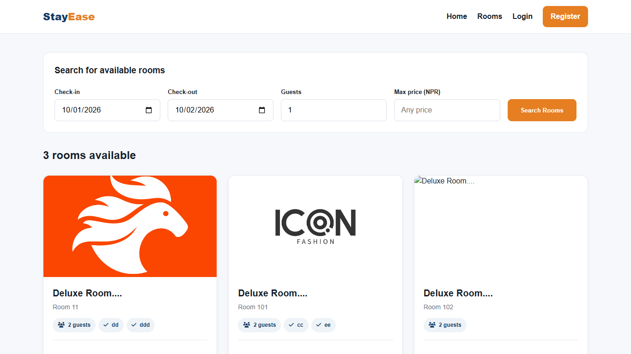
Screenshot: Room Listing Page
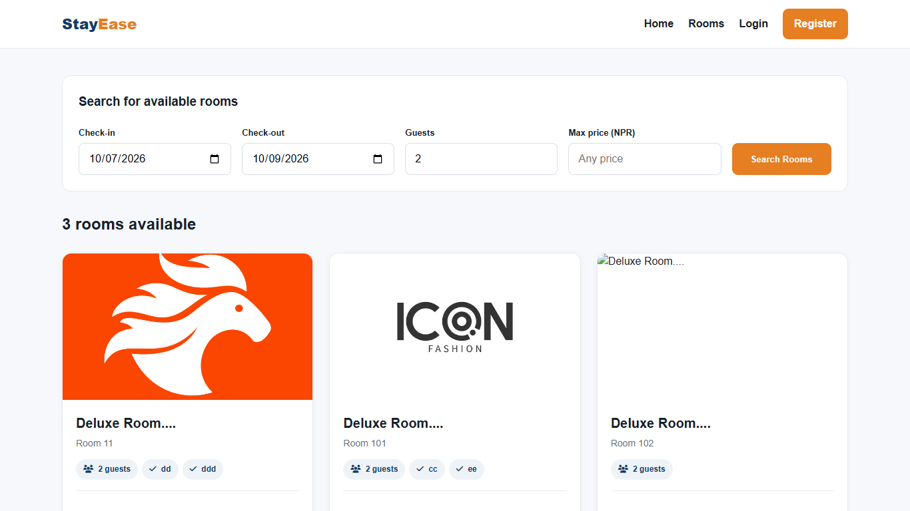
Screenshot: Room Search Results by Date and Guests
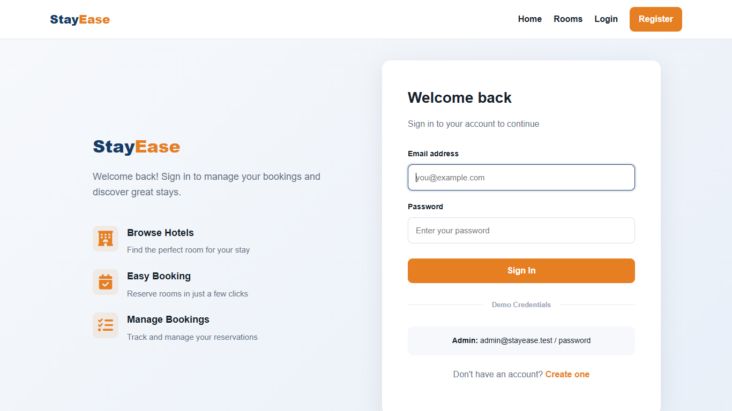
Screenshot: Login Page
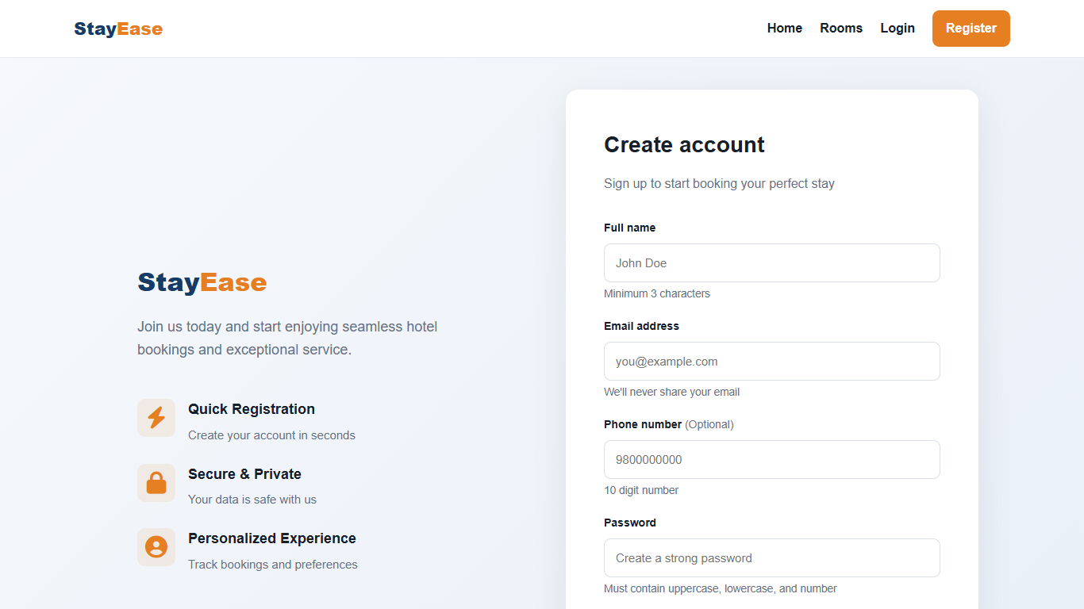
Screenshot: Customer Registration Page
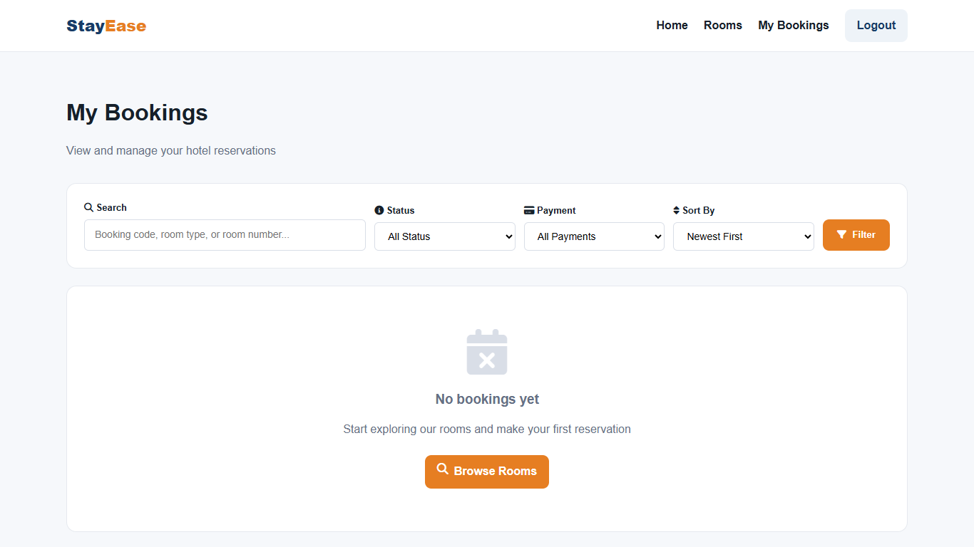
Screenshot: My Bookings Page
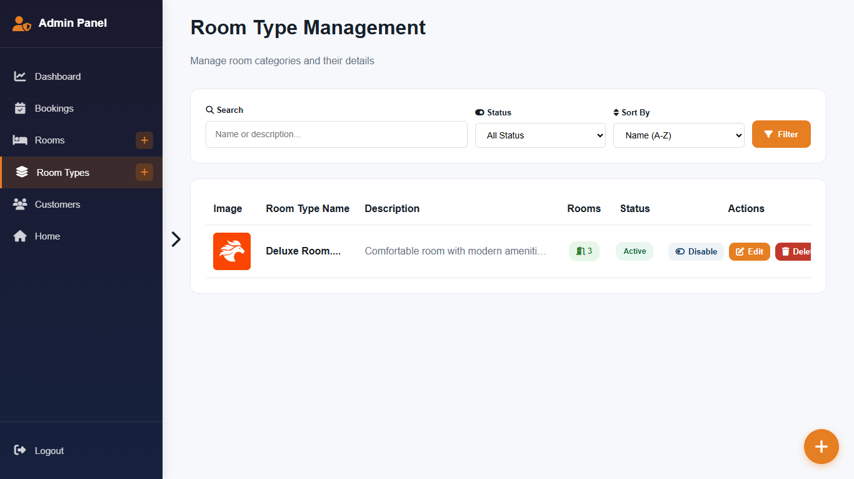
Screenshot: Admin Room Type Management
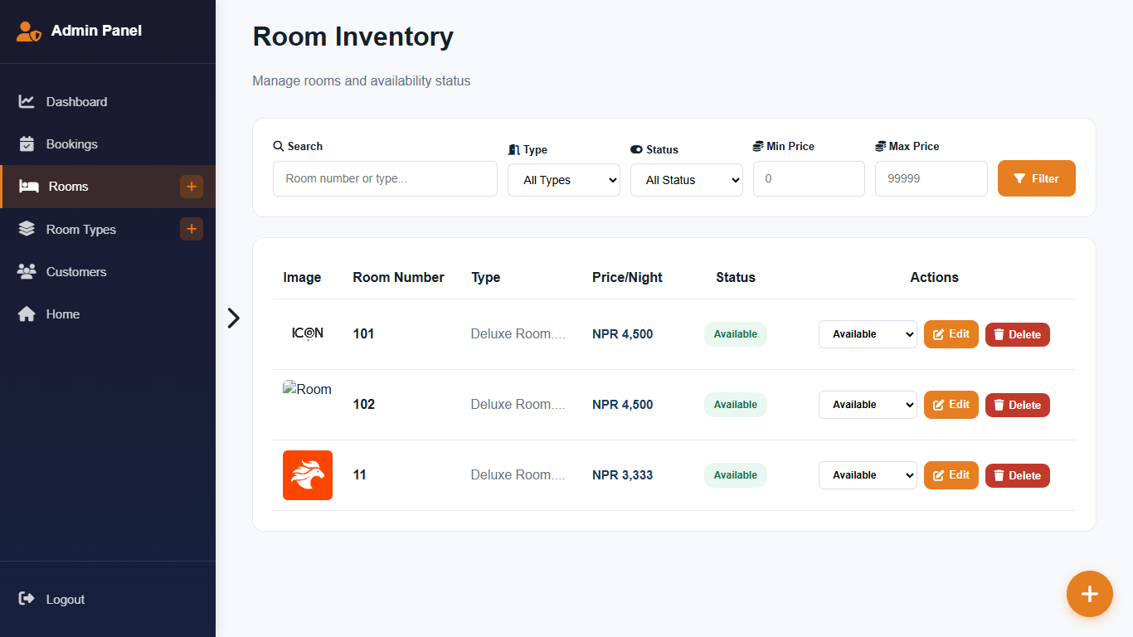
Screenshot: Admin Room Management
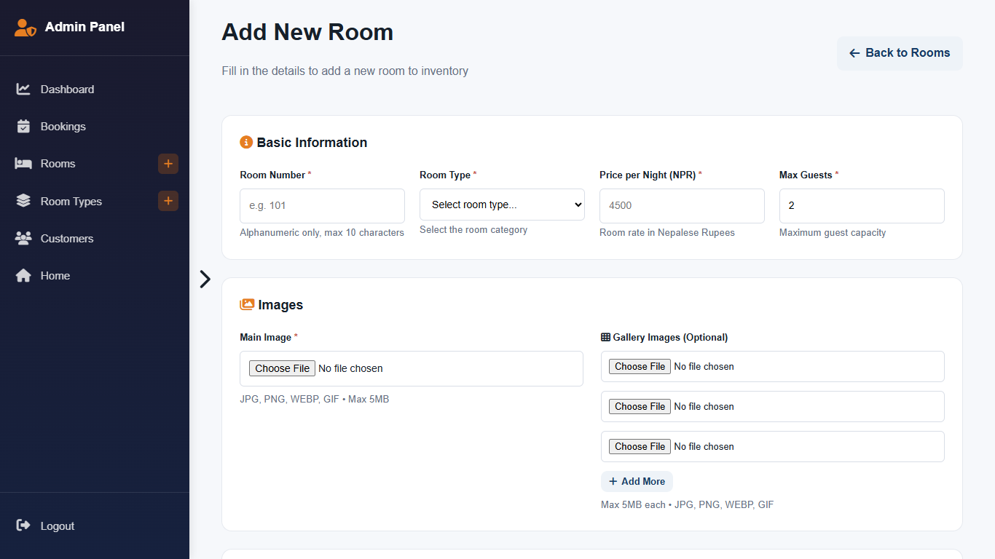
Screenshot: Admin Add Room Form
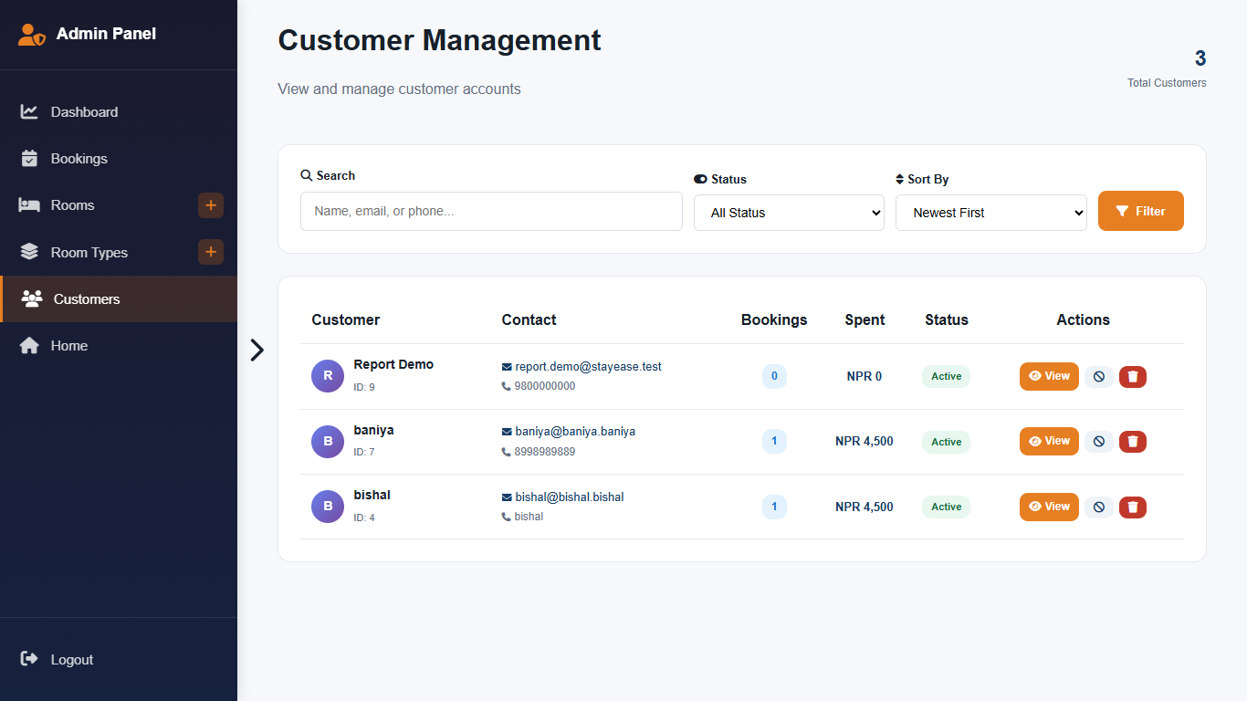
Screenshot: Admin Customer List

Appendix B: Source Code Excerpt
The function below, from config/config.php, decides whether a room is free for a given stay.
function is_room_available(int $roomId, string $checkin, string $checkout, ?int $ignoreBookingId = null): bool {
// First check if room itself is available (not unavailable or in maintenance)
$roomCheck = db()->prepare("SELECT status FROM rooms WHERE id = ?");
$roomCheck->execute([$roomId]);
$roomStatus = $roomCheck->fetchColumn();

if($roomStatus !== 'available') {
return false;
}

// Then check for booking conflicts
$sql = "SELECT COUNT(*) FROM bookings
WHERE room_id = ?
AND status IN ('pending','confirmed','checked_in')
AND check_in < ?
AND check_out > ?";
$params = [$roomId, $checkout, $checkin];
if ($ignoreBookingId) {
$sql .= " AND id <> ?";
$params[] = $ignoreBookingId;
}
$stmt = db()->prepare($sql);
$stmt->execute($params);
return (int)$stmt->fetchColumn() === 0;
}

Appendix C: Supervisor Visit Log Sheet
Table C.1: Supervisor Visit Log Sheet
S.N. | Date | Work Reviewed / Discussion | Supervisor Remarks | Signature
1
2
3
4
5
6
7
8
9
10

