1. Create one jenkins job using the below code and create three stages.

stage1: Git clone to download the source code.

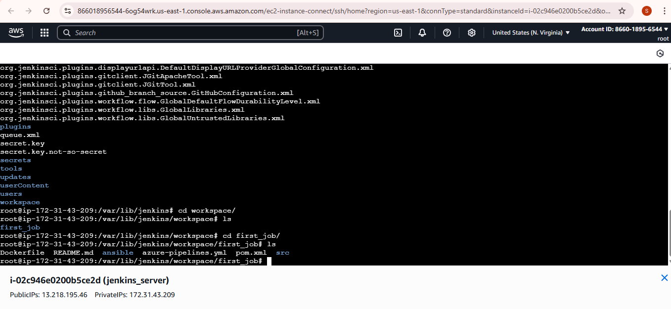

stage2: Sonarqube Integration to check the quality of code.

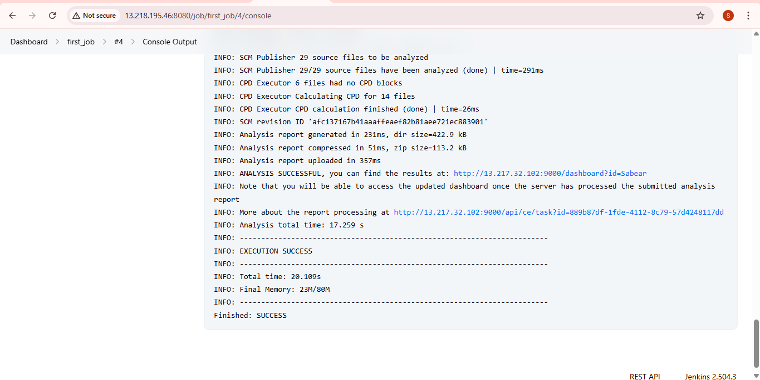

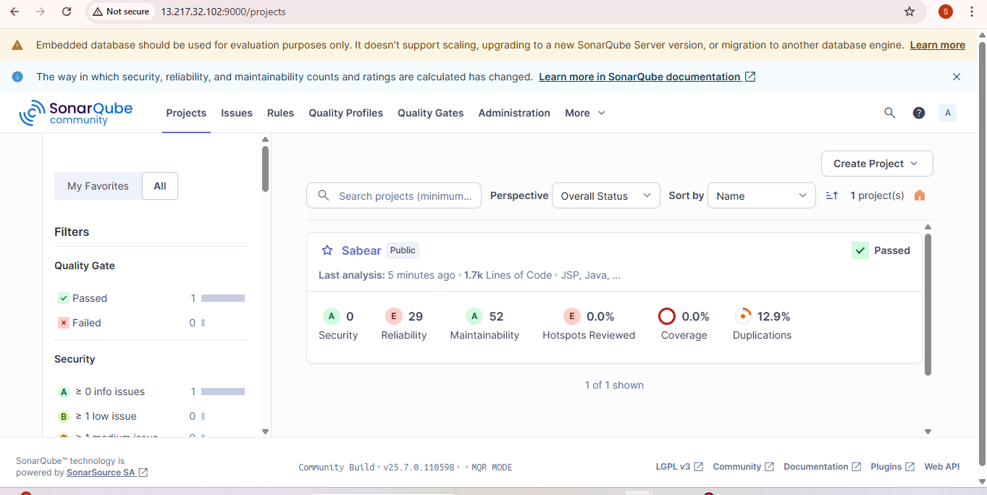

stage3: Slack Integration to send the alerts to slack.

Url: <https://techiehorizon.slack.com/archives/C08SJ5DJ3GF/p1751273101372289>

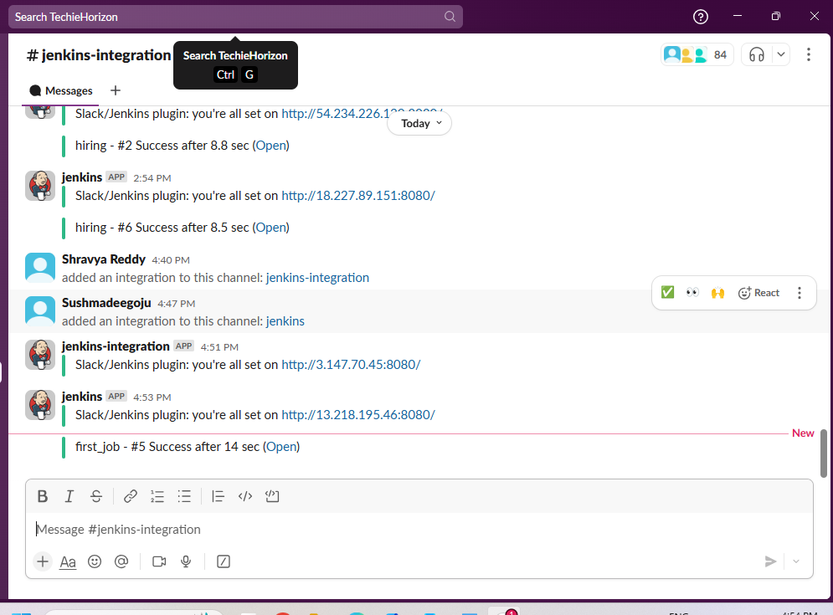

1. Create one jenkins job using the below code and create three stages.

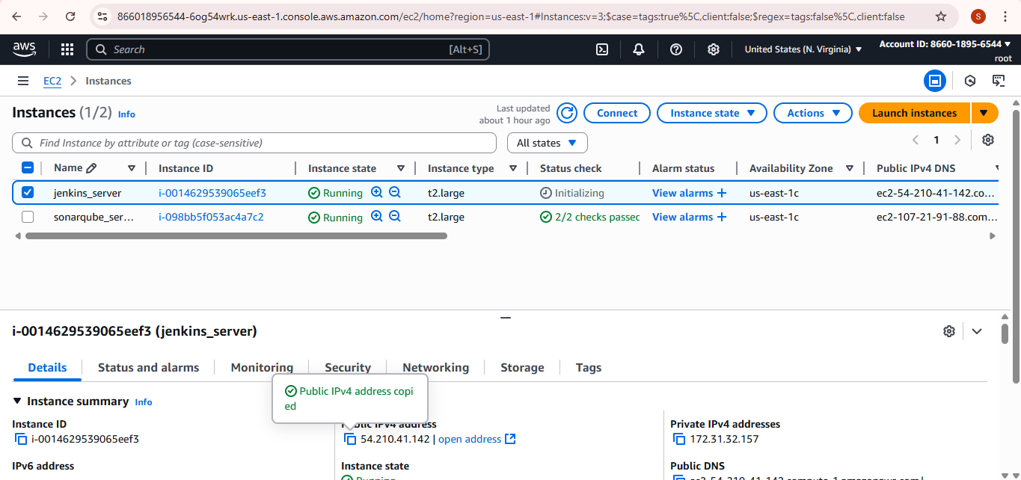

stage1: Git clone to download the source code.

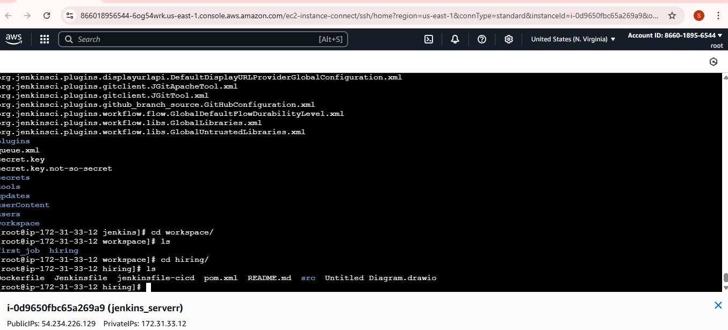

stage2: Sonarqube Integration to check the quality of code

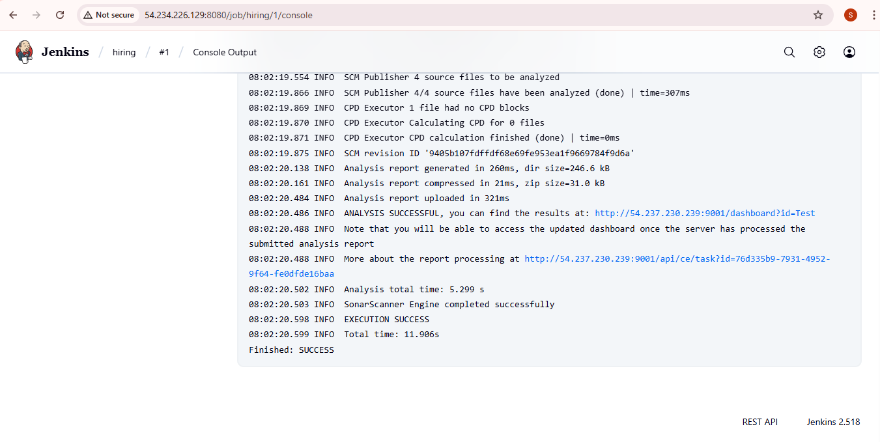

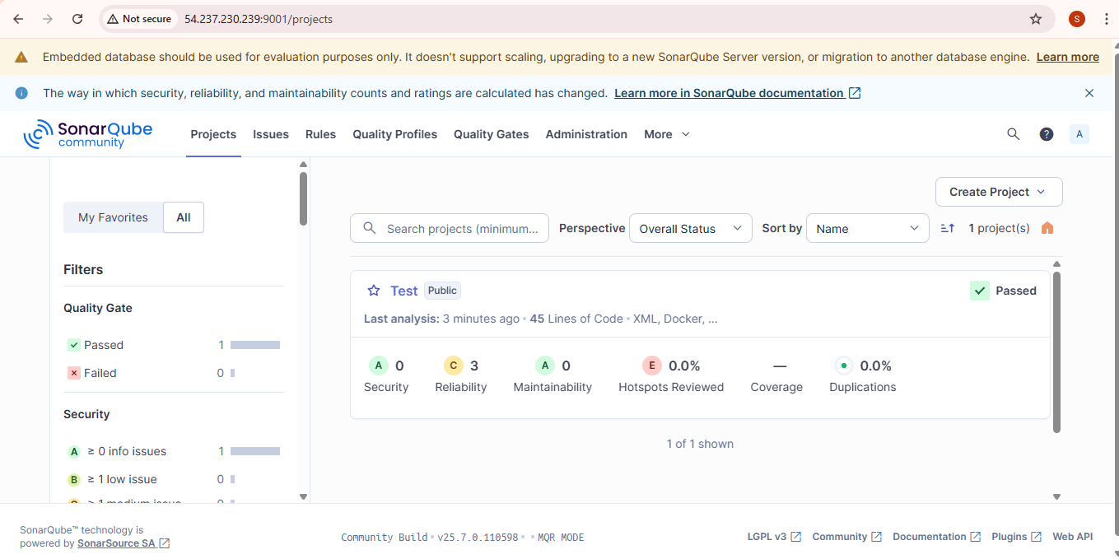

stage3: Slack Integration to send the alerts to slack.

url: <https://techiehorizon.slack.com/archives/C08SJ5DJ3GF/p1751273101372289>

