Hands-On Lab: CricketApp with ES6 Features

Objectives
- List the features of ES6
- Explain JavaScript let
- Identify the differences between var and let
- Explain JavaScript const
- Explain ES6 class fundamentals
- Explain ES6 class inheritance
- Define ES6 arrow functions
- Identify set(), map()

In this hands-on lab, you will learn how to:
- Use map() method of ES6
- Apply arrow functions of ES6
- Implement Destructuring features of ES6

Prerequisites
- Node.js
- NPM
- Visual Studio Code

Commands
npx create-react-app cricketapp
cd cricketapp
npm start

Step 1 — src/ListofPlayers.js
Declares an array of 11 players and renders it using the ES6 map() feature. A second list is built with filter() and an ES6 arrow function, showing only players scoring below 70.
import React from "react";

// Array of 11 players with names and scores
const players = [
{ name: "Rohit Sharma", score: 85 },
{ name: "Virat Kohli", score: 92 },
{ name: "Shubman Gill", score: 65 },
{ name: "KL Rahul", score: 55 },
{ name: "Suryakumar Yadav", score: 78 },
{ name: "Hardik Pandya", score: 60 },
{ name: "Ravindra Jadeja", score: 45 },
{ name: "Axar Patel", score: 50 },
{ name: "Jasprit Bumrah", score: 20 },
{ name: "Mohammed Shami", score: 15 },
{ name: "Kuldeep Yadav", score: 30 },
];

function ListofPlayers() {
// Filter players with scores below 70 using an ES6 arrow function
const lowScorers = players.filter((player) => player.score < 70);

return (
<div>
<h2>List of Players</h2>

{/* Render using the ES6 map() feature */}
<ul>
{players.map((player, index) => (
<li key={index}>
{player.name} - {player.score}
</li>
))}
</ul>

<h3>Players with score below 70</h3>
<ul>
{lowScorers.map((player, index) => (
<li key={index}>
{player.name} - {player.score}
</li>
))}
</ul>
</div>
);
}

export default ListofPlayers;

Step 2 — src/IndianPlayers.js
Uses ES6 array destructuring to split a pool of players into Odd Team and Even Team groups, and the spread operator to merge two squads (T20players and RanjiTrophyPlayers) into one list.
import React from "react";

// A pool of 6 players, alternating between two teams
const teamPlayers = [
"Rohit Sharma",
"Virat Kohli",
"Shubman Gill",
"KL Rahul",
"Ravindra Jadeja",
"Hardik Pandya",
];

// ES6 array destructuring: pull the 6 names out into named variables
const [odd1, even1, odd2, even2, odd3, even3] = teamPlayers;

// Odd Team = 1st, 3rd, 5th players | Even Team = 2nd, 4th, 6th players
const oddTeamPlayers = [odd1, odd2, odd3];
const evenTeamPlayers = [even1, even2, even3];

// Two separate squads
const T20players = ["Suryakumar Yadav", "Ishan Kishan", "Arshdeep Singh"];
const RanjiTrophyPlayers = ["Mayank Agarwal", "Prithvi Shaw", "Sarfaraz Khan"];

// ES6 merge feature: combine both arrays using the spread operator
const allPlayers = [...T20players, ...RanjiTrophyPlayers];

function IndianPlayers() {
return (
<div>
<h2>Indian Players</h2>

<h3>Odd Team Players</h3>
<ul>
{oddTeamPlayers.map((player, index) => (
<li key={index}>{player}</li>
))}
</ul>

<h3>Even Team Players</h3>
<ul>
{evenTeamPlayers.map((player, index) => (
<li key={index}>{player}</li>
))}
</ul>

<h3>T20 + Ranji Trophy Players (Merged)</h3>
<ul>
{allPlayers.map((player, index) => (
<li key={index}>{player}</li>
))}
</ul>
</div>
);
}

export default IndianPlayers;

Step 3 — src/App.js
Both components live on the same home page. A simple flag variable, checked with plain if/else, decides which one renders.
import React from "react";
import ListofPlayers from "./ListofPlayers";
import IndianPlayers from "./IndianPlayers";

// Simple flag variable — flip this between true/false and save
// to switch which component is displayed on the home page.
const flag = true;

function App() {
let content;

if (flag) {
content = <ListofPlayers />;
} else {
content = <IndianPlayers />;
}

return (
<div>
<h1>Cricket App</h1>
{content}
</div>
);
}

export default App;

Output
When flag = true
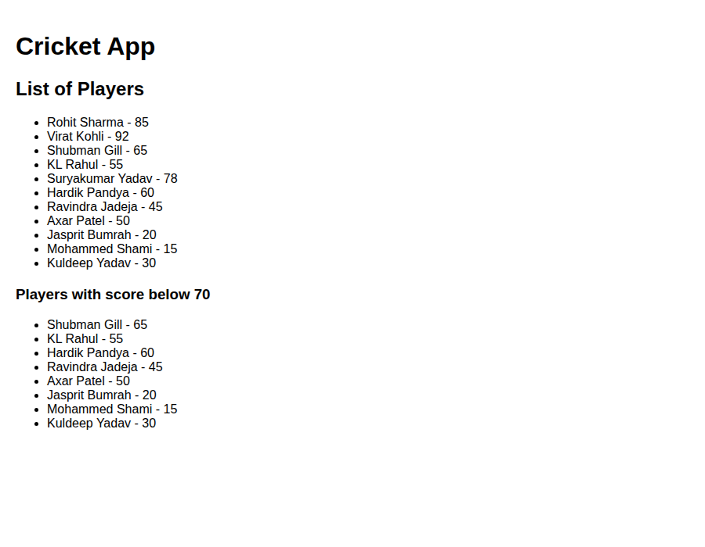
When flag = false
