Hands-On Lab: cohortstracker — Unit Testing with Jest & Enzyme

Objectives
- Explain the need for Unit Testing in React
- Working with Jest and Enzyme in React
- List the types of Router Components

In this hands-on lab, you will learn how to:
- Install and configure Enzyme
- Create unit tests using describe(), test()
- Mount components and test them using matchers
- Capture snapshots of React components

Prerequisites
- Node.js
- NPM
- Visual Studio Code

Commands
# Starter project (cohortstracker) provided in the lab document, extracted and opened in VS Code
cd cohortstracker
npm install
npm install --save-dev enzyme enzyme-adapter-react-16 enzyme-to-json
npm test

Background — the provided starter app
The starter app (Cohort.js, CohortDetails.js, App.js) renders a dashboard of ongoing/completed cohorts using a CohortDetails component. The task: write unit tests for CohortDetails using Enzyme.
class Cohort {
constructor(cohortCode,
startDate,
technology,
trainerName,
coachName,
currentStatus) {
this.cohortCode = cohortCode;
this.coachName = coachName;
this.trainerName = trainerName;
this.technology = technology;
this.startDate = startDate;
this.currentStatus = currentStatus;
}
}
const CohortsData =[
new Cohort('INTADMDF10','22-Feb-2022', '.NET FSD', 'Jojo Jose','Aathma', 'Scheduled'),
new Cohort('ADM21JF014','10-Sep-2021', 'Java FSD', 'Elisa Smith','Apoorv', 'Ongoing'),
new Cohort('CDBJF21025','24-Dec-2021', 'Java FSD', 'John Doe','Aathma', 'Ongoing'),
new Cohort('INTADMJF12','22-Feb-2022', 'Java FSD', 'To Be Assigned','Ibrahim', 'Scheduled'),
new Cohort('CDE22JF011','24-Dec-2021', 'Java FSD', 'Emma Swan','Apoorv', 'Ongoing'),
new Cohort('INTADMDF09','22-Feb-2022', 'Dataware Housing', 'Babjee Rao','Aathma', 'Scheduled'),
new Cohort('ADM22DF001','10-Sep-2021', '.NET FSD', 'Marie Curie','Ibrahim', 'Ongoing'),
];
export {Cohort, CohortsData};

src/CohortDetails.js (component under test)

function CohortDetails(props) {
return (
<div>
<h3>
{props.cohort.cohortCode} -
<span>{props.cohort.technology}</span>
</h3>
<dl>
<dt>Started On</dt>
<dd>{props.cohort.startDate}</dd>
<dt>Current Status</dt>
<dd>{props.cohort.currentStatus}</dd>
<dt>Coach</dt>
<dd>{props.cohort.coachName}</dd>
<dt>Trainer</dt>
<dd>{props.cohort.trainerName}</dd>
</dl>
</div>

);
}
export default CohortDetails;

Step 1 — Install Enzyme and the React 16 adapter
npm install --save-dev enzyme enzyme-adapter-react-16 enzyme-to-json

Step 2 — Configure Enzyme in src/setupTests.js
Registers the Enzyme adapter for React 16 so mount()/shallow() work.
// jest-dom adds custom jest matchers for asserting on DOM nodes.
// allows you to do things like:
// expect(element).toHaveTextContent(/react/i)
// learn more: https://github.com/testing-library/jest-dom
import '@testing-library/jest-dom';

import Enzyme from 'enzyme';
import Adapter from 'enzyme-adapter-react-16';

Enzyme.configure({ adapter: new Adapter() });

Step 3 — package.json snapshot serializer
Adds a jest.snapshotSerializers entry so Enzyme-wrapped snapshots read cleanly, plus the new devDependencies.
{
"name": "cohortstracker",
"version": "0.1.0",
"private": true,
"dependencies": {
"@testing-library/jest-dom": "^5.16.2",
"@testing-library/react": "^12.1.2",
"@testing-library/user-event": "^13.5.0",
"react": "^16.13.0",
"react-dom": "^16.13.0",
"react-scripts": "5.0.0",
"web-vitals": "^2.1.4"
},
"scripts": {
"start": "react-scripts start",
"build": "react-scripts build",
"test": "react-scripts test",
"eject": "react-scripts eject"
},
"eslintConfig": {
"extends": [
"react-app",
"react-app/jest"
]
},
"browserslist": {
"production": [
">0.2%",
"not dead",
"not op_mini all"
],
"development": [
"last 1 chrome version",
"last 1 firefox version",
"last 1 safari version"
]
},
"devDependencies": {
"enzyme": "^3.11.0",
"enzyme-adapter-react-16": "^1.15.7",
"enzyme-to-json": "^3.6.2"
},
"jest": {
"snapshotSerializers": ["enzyme-to-json/serializer"]
}
}

Step 4 — src/CohortDetails.test.js
A test suite named 'Cohort Details Component' with four tests: creating the component in isolation, mounting it and verifying props with matchers, finding the <h3> and checking it displays the cohort code, and a snapshot test.
import React from 'react';
import { mount, shallow } from 'enzyme';
import CohortDetails from './CohortDetails';
import { CohortsData } from './Cohort';

describe('Cohort Details Component', () => {

// Test 1: should create the component
test('should create the component', () => {
const wrapper = shallow(<CohortDetails cohort={CohortsData[0]} />);
expect(wrapper.exists()).toBe(true);
});

// Test 2: should initialize the props
test('should initialize the props', () => {
const cohort = CohortsData[0];
const wrapper = mount(<CohortDetails cohort={cohort} />);
expect(wrapper.props().cohort).toEqual(cohort);
});

// Test 3: should display cohort code in h3
test('should display cohort code in h3', () => {
const cohort = CohortsData[0];
const wrapper = mount(<CohortDetails cohort={cohort} />);
expect(wrapper.find('h3').text()).toContain(cohort.cohortCode);
});

// Test 4: should always render same html (snapshot test)
test('should always render same html', () => {
const wrapper = shallow(<CohortDetails cohort={CohortsData[0]} />);
expect(wrapper).toMatchSnapshot();
});

});

Step 5 — Run the tests
npm test

Output
npm test — all 4 tests pass, including the snapshot test
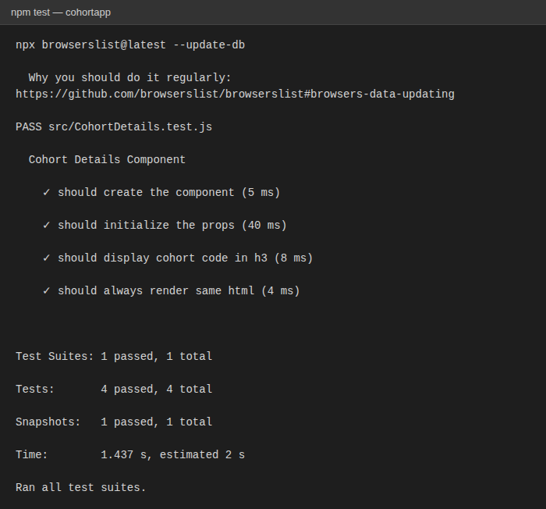
The app itself, rendered in the browser (npm start)
