Hands-On Lab: CounterApp with React State

Objectives
- Explain the State object
- Explain how state updates trigger re-rendering

In this hands-on lab, you will learn how to:
- Initialize state in a constructor
- Update state with setState()

Prerequisites
- Node.js
- NPM
- Visual Studio Code

Commands
npx create-react-app counterapp
cd counterapp
npm start

Step 1 — src/CountPeople.js
import React from "react";

class CountPeople extends React.Component {
constructor(props) {
super(props);
this.state = {
entrycount: 0,
exitcount: 0,
};

// Bind methods so `this` works correctly inside them
this.updateEntry = this.updateEntry.bind(this);
this.updateExit = this.updateExit.bind(this);
}

updateEntry() {
this.setState({ entrycount: this.state.entrycount + 1 });
}

updateExit() {
this.setState({ exitcount: this.state.exitcount + 1 });
}

render() {
return (
<div>
<h2>Mall People Counter</h2>

<button onClick={this.updateEntry}>Login</button>
<button onClick={this.updateExit}>Exit</button>

<p>Number of people entered the mall: {this.state.entrycount}</p>
<p>Number of people exited the mall: {this.state.exitcount}</p>
</div>
);
}
}

export default CountPeople;

Step 2 — src/index.js
import React from "react";
import ReactDOM from "react-dom/client";
import "./index.css";
import CountPeople from "./CountPeople";

const root = ReactDOM.createRoot(document.getElementById("root"));
root.render(
<React.StrictMode>
<CountPeople />
</React.StrictMode>
);

Output
Initial state (0 entries, 0 exits)
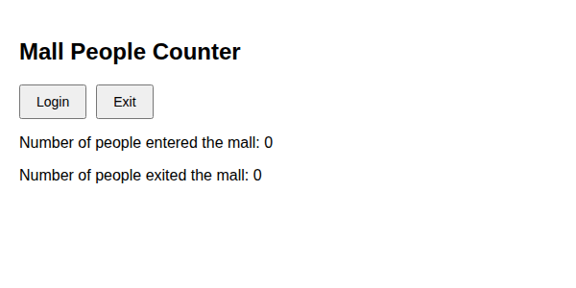
After clicking Login 3 times and Exit 2 times
