Hands-On Lab: employeesapp — Props to Context API

Objectives
- Explain the need and Benefits of React Context API
- Working with createContext()
- List the types of Router Components

In this hands-on lab, you will learn how to:
- Create a context to be used by child components
- Create a provider and consumer of the context

Prerequisites
- Node.js
- NPM
- Visual Studio Code

Commands
# Starter project provided in the lab document was unzipped as employeesapp/
cd employeesapp
npm install
npm start

Background
The starter app passes the theme name ('light' / 'dark') down from App -> EmployeesList -> EmployeeCard purely via props. The task: replace that prop-drilling with React's Context API.
// (see starter App.js / EmployeesList.js / EmployeeCard.js from the provided zip)

Step 1 — Create src/ThemeContext.js
A new context, defaulting to 'light', exported as the default export.
import { createContext } from "react";

// Context to share the current theme name ('light' / 'dark') with any
// nested descendant, without threading it through props at every level.
const ThemeContext = createContext("light");

export default ThemeContext;

Step 2 — Update src/App.js
Import ThemeContext, wrap the JSX in a ThemeContext.Provider supplying the current theme state as its value, and stop passing theme as a prop to EmployeesList.
import './App.css';
import { EmployeesData } from './Employee';
import EmployeesList from './EmployeesList';
import { useState } from 'react';
import ThemeContext from './ThemeContext';

function App() {
const Employees = EmployeesData;
const [theme, setTheme] = useState('light');
return (
<ThemeContext.Provider value={theme}>
<div>
<label>SELECT A THEME </label>
<select onChange={(e) => setTheme(e.target.value)}>
<option value='light'>Light</option>
<option value='dark'>Dark</option>
</select>

</div>
<EmployeesList employees={Employees} />
</ThemeContext.Provider>
);
}

export default App;

Step 3 — Update src/EmployeesList.js
No longer passes theme down explicitly to EmployeeCard.
import EmployeeCard from './EmployeeCard';
function EmployeesList(props) {
return (
<div>
<h1>Employees List</h1>
{
props.employees.map(employee =>
<EmployeeCard employee={employee} key={employee.id} />
)}
</div>
);
}
export default EmployeesList;

Step 4 — Update src/EmployeeCard.js
Imports ThemeContext, retrieves the current value with useContext(), and uses it directly for the Edit/Delete link classNames — no props involved.
import { useContext } from 'react';
import Styles from './EmployeeCard.module.css';
import ThemeContext from './ThemeContext';

function EmployeeCard(props) {
const theme = useContext(ThemeContext);
return (
<div className={Styles.Card}>
<h3>{props.employee.name}</h3>
<p>{props.employee.email}</p>
<p>{props.employee.phone}</p>
<p>
<a href="#" className={theme}>Edit</a>
<a href="#" className={theme}>Delete</a>
</p>
</div>
);
}
export default EmployeeCard;

Output
Theme = Light
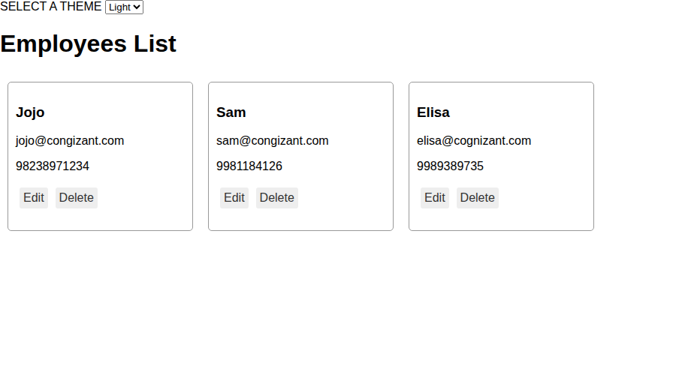
Theme = Dark (selected from the dropdown, no props involved — value now flows through Context)
