Hands-On Lab: eventexamplesapp with React Events

Objectives
- Explain React events
- Explain about event handlers
- Define Synthetic event
- Identify React event naming convention

In this hands-on lab, you will learn how to:
- Implement Event handling concept in React applications
- Use this keyword
- Use synthetic event

Prerequisites
- Node.js
- NPM
- Visual Studio Code

Commands
npx create-react-app eventexamplesapp
cd eventexamplesapp
npm start

Step 1 — src/EventExamples.js
Increment/Decrement buttons for a counter (Increment invokes two methods — increment() and sayHello()), a Say Welcome button that invokes a function with an argument, and an OnPress button demonstrating React's SyntheticEvent.
import React from "react";

class EventExamples extends React.Component {
constructor(props) {
super(props);
this.state = { count: 0, message: "" };

// Bind methods so `this` refers to the component instance inside them
this.increment = this.increment.bind(this);
this.decrement = this.decrement.bind(this);
this.sayHello = this.sayHello.bind(this);
this.handleIncrementClick = this.handleIncrementClick.bind(this);
this.sayMessage = this.sayMessage.bind(this);
this.handleOnPress = this.handleOnPress.bind(this);
}

increment() {
this.setState((prevState) => ({ count: prevState.count + 1 }));
}

decrement() {
this.setState((prevState) => ({ count: prevState.count - 1 }));
}

sayHello() {
this.setState({ message: "Hello! The counter was incremented." });
}

// The Increment button invokes TWO methods on a single click
handleIncrementClick() {
this.increment();
this.sayHello();
}

// Invoked with an argument ("welcome") from the Say Welcome button
sayMessage(text) {
this.setState({ message: `Say ${text}` });
}

// `event` here is a React SyntheticEvent — a cross-browser wrapper
// around the native browser event, with the same interface in every browser.
handleOnPress(event) {
this.setState({ message: "I was clicked" });
}

render() {
return (
<div>
<h2>Event Handling Examples</h2>

<p>Counter: {this.state.count}</p>
<button onClick={this.handleIncrementClick}>Increment</button>
<button onClick={this.decrement}>Decrement</button>

<p>
<button onClick={() => this.sayMessage("welcome")}>Say Welcome</button>
</p>

<p>
<button onClick={this.handleOnPress}>OnPress</button>
</p>

<p>
<strong>Message: {this.state.message}</strong>
</p>
</div>
);
}
}

export default EventExamples;

Step 2 — src/CurrencyConvertor.js
Converts Indian Rupees to Euros when the Convert button is clicked, using handleSubmit to handle the button's click event.
import React from "react";

class CurrencyConvertor extends React.Component {
constructor(props) {
super(props);
this.state = { rupees: "", euros: null };
this.handleChange = this.handleChange.bind(this);
this.handleSubmit = this.handleSubmit.bind(this);
}

handleChange(event) {
this.setState({ rupees: event.target.value });
}

// Handles the Convert button's click event and performs the conversion
handleSubmit(event) {
event.preventDefault();
const conversionRate = 0.011; // approx INR -> EUR
const rupeeValue = parseFloat(this.state.rupees) || 0;
const euros = (rupeeValue * conversionRate).toFixed(2);
this.setState({ euros });
}

render() {
return (
<div>
<h2>Currency Convertor</h2>
<form onSubmit={this.handleSubmit}>
<label>
Amount in Rupees (₹):{" "}
<input
type="number"
value={this.state.rupees}
onChange={this.handleChange}
/>
</label>{" "}
<button type="submit">Convert</button>
</form>

{this.state.euros !== null && (
<p>
₹{this.state.rupees} = €{this.state.euros}
</p>
)}
</div>
);
}
}

export default CurrencyConvertor;

Step 3 — src/App.js
Renders both components on the page.
import React from "react";
import EventExamples from "./EventExamples";
import CurrencyConvertor from "./CurrencyConvertor";

function App() {
return (
<div>
<h1>React Event Handling</h1>
<EventExamples />
<hr />
<CurrencyConvertor />
</div>
);
}

export default App;

Output
Initial state
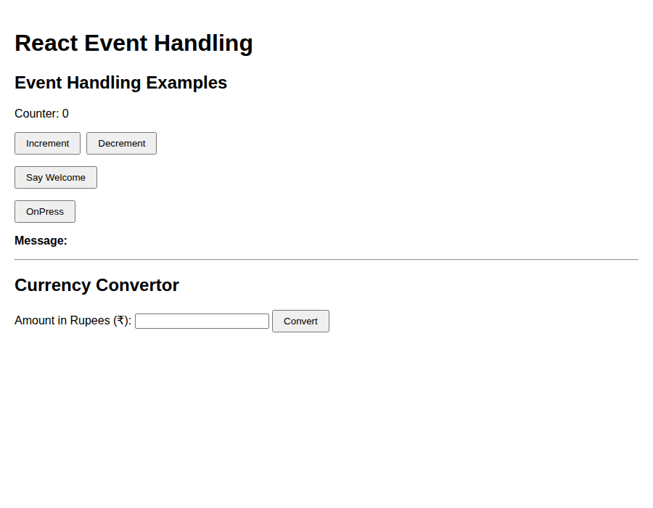
After clicking Increment twice, Say Welcome, OnPress, and converting ₹1000
