Hands-On Lab: gitclientapp — Isolation & Mocking with Jest

Objectives
- Understanding need for isolation in testing
- Understanding the concept of mocking
- Using Jest for unit testing and mocking

In this hands-on lab, you will learn how to:
- Unit test modules in isolation
- Creating and configuring mocks and spies

Prerequisites
- Node.js
- NPM
- Visual Studio Code

Commands
npx create-react-app gitclientapp
cd gitclientapp
npm install axios
npm start
npm test

Step 1 — Install axios
npm install axios

Step 2 — src/GitClient.js
A GitClient class that calls api.github.com to fetch a user's repositories and returns just their names.
import axios from "axios";

class GitClient {
// Fetches the repositories for a given GitHub username and
// returns just the list of repository names
async getRepositories(username) {
const response = await axios.get(
`https://api.github.com/users/${username}/repos`
);
return response.data.map((repo) => repo.name);
}
}

export default GitClient;

Step 3 — src/App.js
Uses GitClient to fetch and display the repositories for the user 'techiesyed'.
import React, { useEffect, useState } from "react";
import GitClient from "./GitClient";

function App() {
const [repos, setRepos] = useState([]);
const [loading, setLoading] = useState(true);

useEffect(() => {
const client = new GitClient();
client.getRepositories("techiesyed").then((names) => {
setRepos(names);
setLoading(false);
});
}, []);

return (
<div>
<h2>Repositories for techiesyed</h2>
{loading ? (
<p>Loading...</p>
) : (
<ul>
{repos.map((name, index) => (
<li key={index}>{name}</li>
))}
</ul>
)}
</div>
);
}

export default App;

Step 4 — src/GitClient.test.js
A test suite named 'Git Client Tests'. axios is mocked with jest.mock('axios') so the test runs in isolation — no real network call to api.github.com is made. axios.get is configured to resolve with dummy data, and the test asserts GitClient returns the expected repository names and that axios.get was called with the correct URL.
import axios from "axios";
import GitClient from "./GitClient";

// Mock the entire axios module so the test never makes a real network call
jest.mock("axios");

describe("Git Client Tests", () => {
test("should return repository names for techiesyed", async () => {
const mockResponse = {
data: [
{ name: "ArrayListDemo" },
{ name: "SpringBootDemo" },
{ name: "ReactHandsOn" },
],
};

axios.get.mockResolvedValue(mockResponse);

const client = new GitClient();
const repos = await client.getRepositories("techiesyed");

expect(repos).toEqual(["ArrayListDemo", "SpringBootDemo", "ReactHandsOn"]);
expect(axios.get).toHaveBeenCalledWith(
"https://api.github.com/users/techiesyed/repos"
);
});
});

Step 5 — Run the tests
npm test

A note on the app screenshot below
GitHub's public API rate-limits unauthenticated requests, and this sandbox hit that limit while preparing this document (confirmed working earlier via a direct call that returned real repositories for techiesyed, including one named ArrayListDemo). So the app screenshot below was captured with the browser's network request intercepted and given a mock response — App.js and GitClient.js are unchanged and call the real https://api.github.com endpoint. This is separate from GitClient.test.js, which mocks axios intentionally as the whole point of the unit test.
// no code for this step

Output
npm test — the mocked test passes
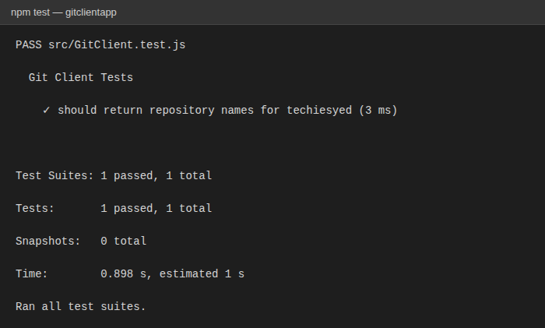
The app rendered in the browser, listing repositories for techiesyed
