Hands-On Lab: mailregisterapp with Form Validation

Objectives
- Explain React Forms validation
- Identify the differences between React Form and HTML Form
- Explain about controlled components
- Identify various React Form input controls
- Explain how to handle React Forms
- Explain about submitting forms in React

In this hands-on lab, you will learn how to:
- Implement React forms validation
- Use various input controls like textbox, button and textarea

Prerequisites
- Node.js
- NPM
- Visual Studio Code

Commands
npx create-react-app mailregisterapp
cd mailregisterapp
npm start

Step 1 — src/register.js
A controlled form (name, email, password) validated on submit: name needs at least 5 characters, email must contain @ and ., and password needs at least 8 characters. Validation runs through the form's change and submit event handlers.
import React, { useState } from "react";

function Register() {
const [name, setName] = useState("");
const [email, setEmail] = useState("");
const [password, setPassword] = useState("");
const [errors, setErrors] = useState({});
const [submitted, setSubmitted] = useState(false);

// Runs the three validation rules and returns an object of error messages
const validate = () => {
const newErrors = {};

if (name.trim().length < 5) {
newErrors.name = "Name should have at least 5 characters";
}
if (!email.includes("@") || !email.includes(".")) {
newErrors.email = "Email should have @ and .";
}
if (password.length < 8) {
newErrors.password = "Password should have at least 8 characters";
}

return newErrors;
};

// A single change handler shared by all three fields
const handleChange = (event) => {
const { name: field, value } = event.target;
if (field === "name") setName(value);
if (field === "email") setEmail(value);
if (field === "password") setPassword(value);
};

// Validation runs on submit
const handleSubmit = (event) => {
event.preventDefault();
const validationErrors = validate();
setErrors(validationErrors);
setSubmitted(Object.keys(validationErrors).length === 0);
};

return (
<div>
<h2>Register</h2>
<form onSubmit={handleSubmit}>
<div>
<label>Name: </label>
<input type="text" name="name" value={name} onChange={handleChange} />
{errors.name && <p style={{ color: "red" }}>{errors.name}</p>}
</div>

<div>
<label>Email: </label>
<input type="text" name="email" value={email} onChange={handleChange} />
{errors.email && <p style={{ color: "red" }}>{errors.email}</p>}
</div>

<div>
<label>Password: </label>
<input
type="password"
name="password"
value={password}
onChange={handleChange}
/>
{errors.password && <p style={{ color: "red" }}>{errors.password}</p>}
</div>

<button type="submit">Register</button>
</form>

{submitted && <p style={{ color: "green" }}>Registration successful!</p>}
</div>
);
}

export default Register;

Step 2 — src/App.js
Renders the Register component.
import React from "react";
import Register from "./register";

function App() {
return (
<div>
<h1>Mail Register App</h1>
<Register />
</div>
);
}

export default App;

Output
Submitting with invalid data (name too short, email missing '.', password too short) — all three validation messages appear
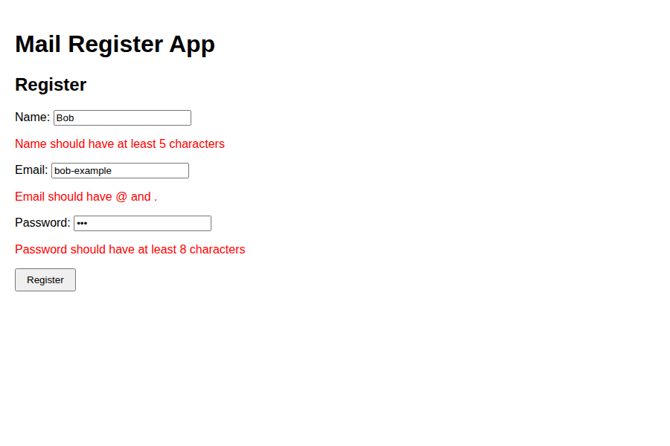
Submitting with valid data — registration succeeds


