Hands-On Lab: ticketbookingapp with Conditional Rendering

Objectives
- Explain about conditional rendering in React
- Define element variables
- Explain how to prevent components from rendering

In this hands-on lab, you will learn how to:
- Implement conditional rendering in React applications

Prerequisites
- Node.js
- NPM
- Visual Studio Code

Commands
npx create-react-app ticketbookingapp
cd ticketbookingapp
npm start

Step 1 — src/flights.js
Shared flight data used by both the Guest and User pages.
const flights = [
{ id: 1, from: "Hyderabad", to: "Delhi", price: 4500 },
{ id: 2, from: "Mumbai", to: "Bengaluru", price: 3800 },
{ id: 3, from: "Chennai", to: "Kolkata", price: 5200 },
];

export default flights;

Step 2 — src/GuestPage.js
The page shown to guests — a read-only list of available flights.
import React from "react";
import flights from "./flights";

function GuestPage() {
return (
<div>
<h2>Available Flights</h2>
<p><em>Login to book a ticket.</em></p>
<ul>
{flights.map((flight) => (
<li key={flight.id}>
{flight.from} → {flight.to} — ₹{flight.price}
</li>
))}
</ul>
</div>
);
}

export default GuestPage;

Step 3 — src/UserPage.js
The page shown to logged-in users — lets them book a flight.
import React, { useState } from "react";
import flights from "./flights";

function UserPage() {
const [booked, setBooked] = useState([]);

const bookFlight = (id) => {
setBooked([...booked, id]);
};

return (
<div>
<h2>Book Your Flight</h2>
<ul>
{flights.map((flight) => (
<li key={flight.id}>
{flight.from} → {flight.to} — ₹{flight.price}{" "}
<button
onClick={() => bookFlight(flight.id)}
disabled={booked.includes(flight.id)}
>
{booked.includes(flight.id) ? "Booked ✓" : "Book"}
</button>
</li>
))}
</ul>
</div>
);
}

export default UserPage;

Step 4 — src/App.js
Login/Logout toggles between the Guest page and the User page using conditional rendering.
import React, { useState } from "react";
import GuestPage from "./GuestPage";
import UserPage from "./UserPage";

function App() {
const [isLoggedIn, setIsLoggedIn] = useState(false);

return (
<div>
<h1>Flight Ticket Booking</h1>

{isLoggedIn ? (
<button onClick={() => setIsLoggedIn(false)}>Logout</button>
) : (
<button onClick={() => setIsLoggedIn(true)}>Login</button>
)}

<hr />

{/* Conditional rendering: show UserPage only when logged in, otherwise GuestPage */}
{isLoggedIn ? <UserPage /> : <GuestPage />}
</div>
);
}

export default App;

Output
Guest view (not logged in)
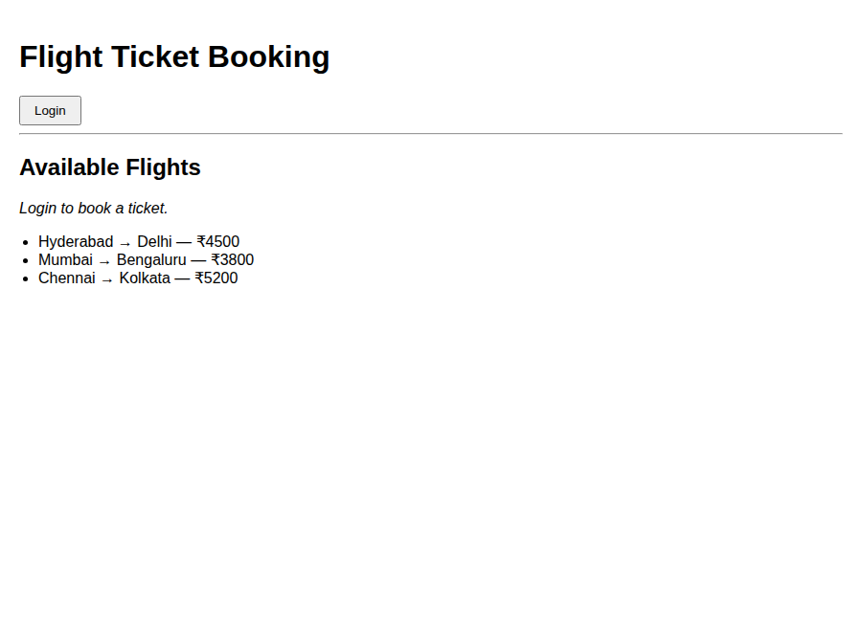
User view (logged in, Hyderabad → Delhi flight booked)
