Hands-On Lab: ticketraisingapp with React Forms

Objectives
- Explain about React forms
- Define controlled components
- Explain about various input controls
- Explain about handling forms
- Explain about submitting forms

In this hands-on lab, you will learn how to:
- Implement React forms
- Use various input controls like textbox, button and textarea

Prerequisites
- Node.js
- NPM
- Visual Studio Code

Commands
npx create-react-app ticketraisingapp
cd ticketraisingapp
npm start

Step 1 — src/ComplaintRegister.js
A controlled form with a textbox for the employee name and a textarea for the complaint. handleSubmit generates a reference number and shows it in an alert box, and also displays it on the page.
import React, { useState } from "react";

function ComplaintRegister() {
const [employeeName, setEmployeeName] = useState("");
const [complaint, setComplaint] = useState("");
const [referenceNumber, setReferenceNumber] = useState(null);

const handleSubmit = (event) => {
event.preventDefault();

const refNumber = "REF" + Math.floor(100000 + Math.random() * 900000);

alert(
`Complaint submitted successfully!\nEmployee: ${employeeName}\nReference Number: ${refNumber}`
);

setReferenceNumber(refNumber);
setEmployeeName("");
setComplaint("");
};

return (
<div>
<h2>Complaint Register</h2>
<form onSubmit={handleSubmit}>
<div>
<label>Employee Name: </label>
<input
type="text"
value={employeeName}
onChange={(e) => setEmployeeName(e.target.value)}
required
/>
</div>
<br />
<div>
<label>Complaint: </label>
<br />
<textarea
value={complaint}
onChange={(e) => setComplaint(e.target.value)}
rows={4}
cols={40}
required
/>
</div>
<br />
<button type="submit">Submit</button>
</form>

{referenceNumber && (
<p>
<strong>
Complaint submitted. Your reference number is: {referenceNumber}
</strong>
</p>
)}
</div>
);
}

export default ComplaintRegister;

Step 2 — src/App.js
Renders the ComplaintRegister component.
import React from "react";
import ComplaintRegister from "./ComplaintRegister";

function App() {
return (
<div>
<h1>Ticket Raising App</h1>
<ComplaintRegister />
</div>
);
}

export default App;

Output
Form filled in, before submitting
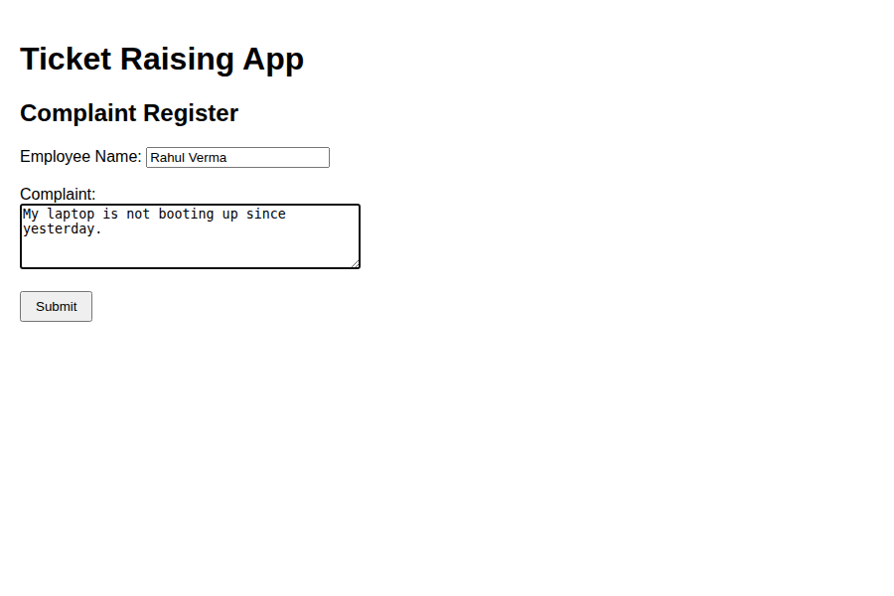
After clicking Submit — the alert box shown ('Complaint submitted successfully! Employee: Rahul Verma, Reference Number: REF385547') and the reference number displayed on the page
